Diabetes Mobile Management App
(DMMA)

CS496 Senior Design

Software Design Specification

Prepared by:
Faculty Advisor(s):
Guo, Huiping P
Zilong Ye

Team Leader:
Gonzalez, Gustavo
Team Member(s):
Ramirez, Oscar
Jimenez, Ceasar

Section 1: Introduction

  - Purpose

This document will outline in detail the software architecture and design for the Diabetes Mobile Management App (DMMA). This document will provide several views of the system's design in order to facilitate communication and understanding of the system. It intends to capture and convey the significant architectural and design decisions that have been made for the DMMA.

  - Scope

This document provides the architecture and design of the DMMA. It will show how the design will accomplish the functional and non-functional requirements detailed in the DMMA Functional Requirements and Design (FRD) document.

  - Intended Audience

This document is written on a technical level to address Medtronic’s technical department and CSULA Computer Science department.

  - References

- Diabetes Mobile Management App (DMMA) Functional Requirements and Design (FRD) Document.

  - Definitions

- DMMA – Diabetes Mobile Management App
- SQL – Structured Query Language
- IDE – Integrated Development Environment

Section 2: System Overview

Diabetes Mobile Management App (DMMA) is being built for the Medtronic Company to aid their type II diabetes patients. Being built on the Android platform, DMMA is the alternative app for patients who do not have an iPhone.

The scope of the project is to make a mobile application for the Android platform where the user can track their blood sugar levels. Users of DMMA will be able to input their food intake, exercise routine, and user inputted thresholds. Algorithms will help determine the User’s high and low blood sugar levels and give a warning if approaching the algorithm’s predictions. Users will also be able to store their blood sugar level readings and view historical data (via visual graphs) for future use.

2.1 Context Diagram (level 0 Data Flow Diagram)
Patient
Input
DMMA App
Server

2.2 Context Diagram (level 1 Data Flow Diagram)

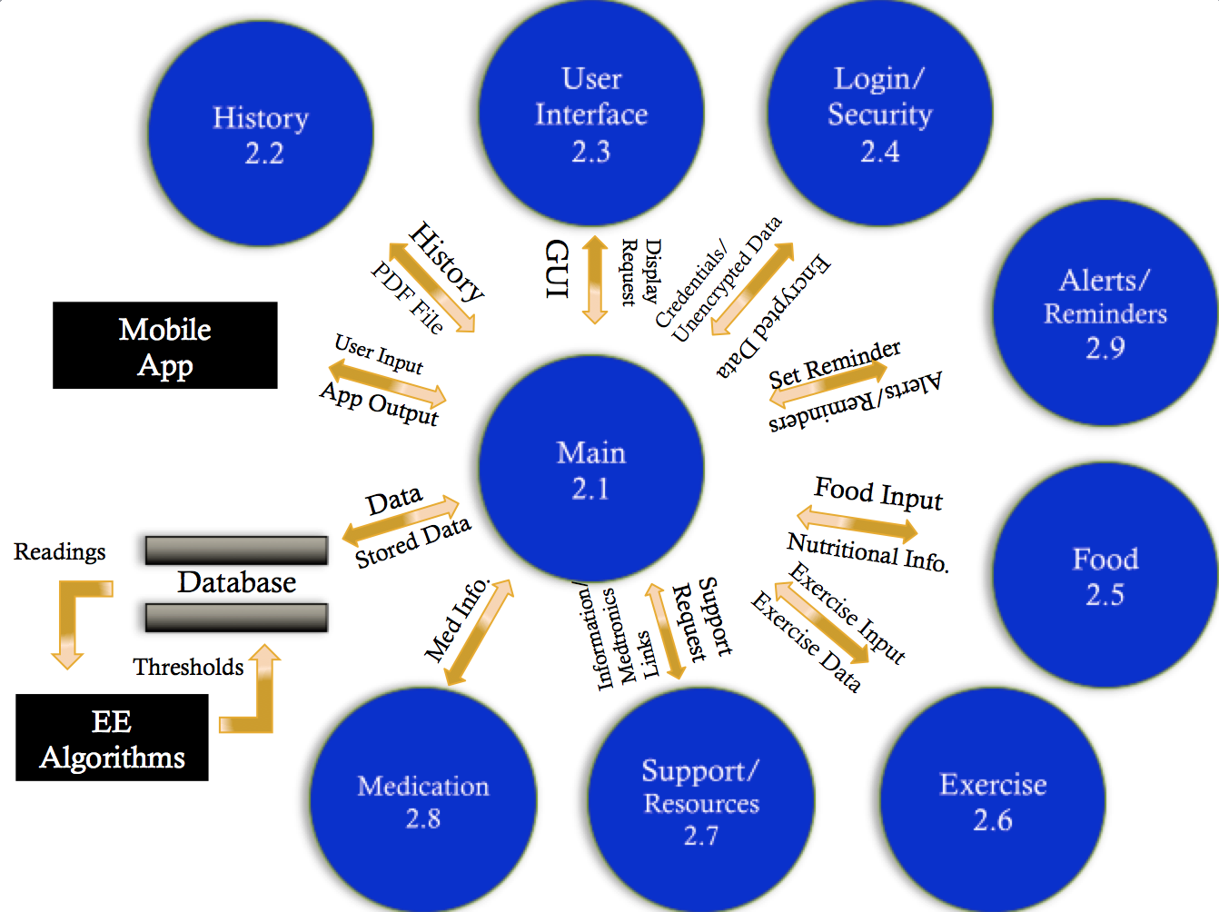

Section 3: Design Considerations

3.1 Goals

- Ease of usability is top priority for the development process. Emphasis is being put in having little knowledge of phone usage to be able to operate DMMA correctly.
- DMMA will have a drop down menu that will allow the user to utilize the function of the app that is required, there will also be a help tab that will give a thorough breakdown of the different functions of DMMA.

3.2 Development Methods

This project is being conducted using a modified waterfall paradigm with two implemental builds (alpha and beta). The development process is formal with document and code reviews.

Section 4: Architectural Strategies
4.1 Use of a particular type of product (programming language, database, library, etc.)

DMMA is being developed on the Android platform for mobile devices using Android Studio as the integrated development environment (IDE). Android is a sub-language derived from the Java programming language. DMMA’s database is being operated on MySQL server.

4.2 Reuse of existing software components to implement various parts/features of the system

DMMA is utilizing GraphView open source ware to produce BG History visual graphs.

4.3 Future plans for extending or enhancing the software

Future plans for DMMA are including but not limited to:

- Improving the cosmetic look of DMMA for a more pleasurable viewing experience.
- Developing a website that will allow users to access the same functions included in DMMA.
- Implementing further predictive algorithms, aiding DMMA users tracking their health.

4.4 User interface paradigms (or system input and output models)

Use of DMMA will be using the graphical display paradigm. DMMA will also communicate via the World Wide Web to servers for data retrieval and storage. Input of data to DMMA for use in functions will be either in user input textboxes or dropdown choice menus. Output of DMMA will be given via visual graphs and alarms (thresholds are being broken).

4.5 Error detection and recovery

Data will be constantly backed to a different server in case of loss of data. Errors will be allowed to be reported to try to fix any issues with DMMA.

4.6 External databases

No external data bases will be utilized unless specified by Medtronic.

4.7 Distributed data or control over a network

No use of distributed data is necessary. Control over a network will be provided to authenticated users via username and password. Authenticated users will only have access to their own data.

4.8 Generalized approaches to control

Approaches to control shall be achieved when the user successfully enters their personal username and password.

4.9 Concurrency and synchronization

The mobile device shall be synchronized to the SQL database server.

4.10 Communication mechanisms

Communications in DMMA will be done over a mobile network or wireless fidelity (Wi-Fi) connection.

Section 5: System Architecture

5.1 component-1 (subsystem-1) Mobile Device (Android Phone)

5.1.1 – The mobile device will be were the application will be installed. The mobile device will provide the user a touch screen interaction with DMMA. The mobile device will also provide the means of communication to the SQL database server via the user’s mobile network or Wi-Fi connection.

5.2 component-2 (subsystem-2) SQL Database Server

5.2.1 – The SQL database server is where all information relative to the application will be store. This will include user’s login information, personal information, user blood sugar level readings, food intake and exercise routines. The data will be accessed via DMMA through JDBC connection embedded in the application’s functions. The SQL database server will allow the DMMA to update, and insert data into predefined tables established.

Section 6: Detailed System Design

6.1 module-1 Main

6.1.1 - The Main Module (MM) will provide linkability of data and other interactions between all other modules in the diagram.

6.2 module-2 History

6.2.1 - The History Module (HM) is responsible for storing medical data in time increments and displaying historical data to the user via the user of GraphView. It is to receive the data from the (MM) and send visual graph representations of the medical data back to the (MM).

6.3 module-3 User Interface

6.3.1 - The User Interface Module (UIM) is responsible for receiving user input and then displaying any of the information given in an easy to look at interface. The (UIM) is to develop the display that the user will be seeing and sending it back to the (MM).

6.4 module-4 Login/Security

6.4.1 - The Login/Security Module (LSM) is responsible for authenticating users at login. Also (LSM) is responsible for encrypting and decrypting sensitive data. (LSM) will work with the (MM) in order to keep data confidential.

6.5 module-5 Food

6.5.1 - The Food Module (FM) is responsible for all things related to food input and food information. The food Module will keep recipes in the database and help calculate nutritional information on food according to the user input. The (FM) then sends back the info to the (MM)

6.6 module-6 Exercise

6.6.1 - The Exercise Module (EM) is responsible for all things related to exercise input and exercise information. The (EM) will keep of exercise regiments in the database and help calculate fitness information on the exercise according to the user input. The (EM) then sends back the info to the (MM)

6.7 module-7 Support/Resources

6.7.1 - The Support/Resource Module(SRM) will be holding useful information for the User to look up in order to be informed more about diabetes.(SRM) will have links to Medtronic’s resources. (SRM) will allow user to set up goals. (SRM) will send back link to resources to the (MM)

6.8 module-8 Medication

6.8.1- The Medication Module (MdM) is responsible for holding all information of the user's medication. (MdM) will receive this information according to the user input. (MdM) will send stored info back to (MM).

6.9 module-9 History

6.9.1 - The Alerts/Reminders- Module (ARM) is responsible for handling all alerts that the user might need. Also it is responsible for setting the notifications in the device in which the user will have the option to turn them off at their choosing. The (ARM) communicates with the (MM) module to send alerts to the device.

Section 7: Graphical User Interface Design
GUI Design.

Section 8: Glossary

- ARM – Alerts Reminders Module
- DMMA – Diabetes Mobile Management App
- EM – Exercise Module
- FM – Food Module
- FRD – Functional Requirements Document
- IDE – Integrated Development Environment
- LSM – Login/Security Module
- MM- Main Module
- SRM – Support/Resources Module
- SQL – Structured Query Language
- UIM – User Interface Module

