CS4961 Course Syllabus
Fall 2022

- Course Information

Instructors | All CS Faculty Advisors
Course number | CS 4961
Course name | Software Design Laboratory I
Credits | 3
Contact hours | 9 hours/week
Coordinator | Chengyu Sun (csun@calstatela.edu)
Textbook | None
Office hours | - Contact a faculty advisor for project related questions.  - Contact Dr. Sun (csun@calstatela.edu) for the course requirement, submission, and deadline questions.  - Contact Prof. Joshua Adachi (jadachi2@ad.calstatela.edu) for writing-related questions.  - Contact Dr. Kang (eykang@calstatela.edu) for any other questions.
Course Information | - Catalog Description  Selection of a design project and develop a software system for a community organization or a corporate partner; determine customer needs; understand software solutions and profession in broader context. Laboratory 9 hours. Grade of C or better in this course satisfies the Graduation Writing Assessment Requirement.  Laboratory 9 hours.  Graded ABC-/NC (undergraduates only).  Meets GE UD C* (cl) (wi) GWAR  - Prerequisites or Co-requisites  Prerequisite(s): Completion of GE 4 basic subjects and a course each from lower-division Blocks B, C and D; and CS 3112 and CS 3220 and CS 3035 and CS 3337 and CS 3186 and CS 3801, all graded C or better. Pre/Co-requisite(s): CS 4440  - Required/Elective: This course is required in the BS program.
Course Goals | The goals of the course are  - To improve the ability of the students to undertake complex software projects by guiding them through the early stages of a project development cycle, which include problem and requirement analysis, and the research of tools, libraries, and technologies.  - To improve the ability of the students to perform independent learning of new technologies and concepts.  - To improve the oral communication skills of the students through oral presentations and interaction with project stake holders.  - To improve the written communication skills of the students through the writing of a Project Requirement Document.  CS4961 and CS4962 serve as capstone courses that weave together students’ undergraduate educational experiences (in both the major and general education) and enable them to integrate and apply the skills and knowledge they have acquired. The course learning outcomes contribute to the achievement of all the BSCS Student Learning Outcomes (listed below):  - Analyze a complex computing problem and to apply principles of computing and other relevant disciplines to identify solutions.  - Design, implement, and evaluate a computing-based solution to meet a given set of computing requirements in the context of the program’s discipline.  - Communicate effectively in a variety of professional contexts.  - Recognize professional responsibilities and make informed judgments in computing practice based on legal and ethical principles.  - Function effectively as a member or leader of a team engaged in activities appropriate to the program’s discipline.  - Apply computer science theory and software development fundamentals to produce computing-based solutions.  In addition, these courses contribute to the achievement of the GE Upper Division Block Learning Outcomes.

- Course Outline

The Senior Design Project gives students an opportunity to design and develop a software project that addresses a realistic problem. The class will be divided into teams. Each team will work with a liaison (representing the "client") and a faculty advisor.

Topics:
- Undertake complex software projects and see them through a complete software development cycle from pre-requirements to delivery.
- Planning and scheduling individual and team efforts to complete required work by the established deadlines
- Working productively within the team despite inevitable conflict
- Learning new technologies and utilizing resources available for the completion of the project.
- Assuming various specialized roles within the group.
- Decision making considering societal, ethical, environmental, political, and economic factors
- Customer relations during the development process
- Broad impacts of computational and software solutions encompassing humanities and social sciences
- Effective communication of project design and findings

The non-traditional nature of the course imposes responsibilities on the students. These include, but are not limited to the following.

- Planning and scheduling individual and team efforts to complete required work by the established deadlines
- Working productively within the team despite inevitable conflict
- Learning new technologies and utilizing resources available for the completion of the project.
- Assuming various specialized roles within the group.

Projects:

Each group works on a senior design project provided by faculty or industry sponsors. Each group should maintain and update its own project page at https://csns.cysun.org/department/cs/projects?year=2023.

Special Lectures on Writing:

There will be several asynchronous lectures on writing. The schedule is available at https://csns.cysun.org/site/f22/cs4961-1.

Course Management System:

- Course homepage: https://csns.cysun.org/site/f22/cs4961-1
- This course is managed on the CSNS. Frequently check the CSNS for course-related updates such as announcements, material distributions, and rubric evaluations.

Team Organization

A typical organizational chart for your group project is described below.

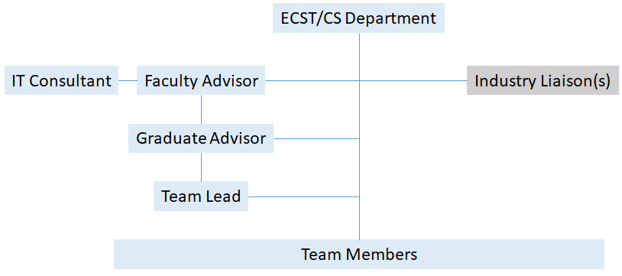

Each team has 8 to 10 members.
- Can be divided into 2 subgroups or 3 subgroups
- Select a team leader to be in charge of the group assignments & maintain CSNS page

Team members will assume responsibility for various roles, such as:
- Project lead (team lead)
- Customer liaison/requirements lead
- Architecture/design lead
- Component leads such as UI, backend, database schema, etc.
- QA lead
- Documentation lead
- Demo/presentation lead

The overall team lead has additional roles
- Update project page on CSNS
- Interact with team leaders from other projects

- Required Time Commitments

- Scheduled class meeting time : Friday 8AM – 10.30AM
- Faculty meet with the team – 3 hours (as above) or any other chosen time
- Students (In addition to above) – 3 hours (as a team) + 3 hours (individual)

Students are expected to commit 9 hours per week working on the project. In particular, each project team is required to meet weekly (both with and without faculty advisor) and meet their project liaison(s) regular. The means of communication can be determined by each team.

- Specially reserved days:
  - Kick-Off day (9/2/2022)
  - Presentations day (TBA)
  - A special lecture on Ethics, SRD, SDD (TBA)

- CS4961 Deliverables and Evaluations

 | Deliverables | Evaluation
CS4961 | Projects page (Group) -Description/Abstract | Feedback by faculty advisor
 | Requirement Document (Group) | Rubric evaluation by faculty advisor
 | Preliminary Design Document (Group) | Feedback by faculty advisor
 | Written Communication (Individual) | Rubric evaluation by technical writer
 | Team Work (Individual) | Rubric evaluation by faculty advisors and team members
 | Oral Communication (Individual) | Rubric evaluation by faculty advisors

Grading

Grades will be based on a number of factors including contribution to the project, teamwork, and performance in oral and written communication. Each faculty advisor will decide the grading policy for their groups, and the grading policy will be explained to the students at the first group meeting of the semester.

- Resources

Projects from Prior Years

http://csns.calstatela.edu/department/cs/projects.

Glazer Family Dreamers Resource Center

The Erika J. Glazer Family Dreamers Resource Center promotes the success of undocumented students and students from mixed-status families at Cal State LA through a variety of resources, services, and community engagement opportunities. Such programs and services are weekly immigration legal clinics, California Dream Act Application for Financial Aid Assistance, and professional and academic development workshops.

Other Support Services
- CETL Student Support Resources
- ITS Resources for Students
- ITS Helpdesk Information
- Office of Students with Disabilities (OSD)
- University Library
- Counseling and Psychological Services(CA PS)
- Student Health Services

- University Policies

Student Conduct

Information on student rights and responsibilities, standards of conduct, etc., can be found by visiting the Cal State LA University Catalog Appendices.

Dropping and Adding

Students are responsible for understanding the policies and procedures about add/drops, academic renewal, etc. Students should be aware of the current deadlines and penalties for adding and dropping classes by visiting the GET home page. (Registrar news and information)

Americans with Disabilities Act (ADA)

Reasonable accommodation will be provided to any student who is registered with the Office of Students with Disabilities and requests needed accommodation. For more information visit the Office for Students with Disabilities home page.

Academic Honesty

Students are expected to do their own work and to abide by the University Policy on academic honesty. You are expected to familiarize yourself with the Cal State LA Academic Honesty Policy including Appendix D – Academic Honesty and Appendix E - Student Conduct / Student Conduct Procedures. All work you submit must be your own scholarly and creative efforts. Cal State LA plagiarism as follows: “At Cal State LA, plagiarism is defined as the act of using ideas, words, or work of another person or persons as if they were one’s own, without giving proper credit to the original sources.”

