Midterm Review – CS4440 Operating Systems
Chapter 1 : Introduction
Operating System : A program that acts as an intermediary between a user of a computer and the computer hardware
Goals of an OS:
Execute user programs and make solving user problems easier
Make the computer system convenient to use
Use the computer hardware in an efficient manner
4 Components of an OS
      - Hardware
      - Operating System
      - Application Programs
      - Users

Kernel : The one program running at all times ( Core of OS)
Volatile Memory: ( RAM, or Random Access Memory)
- Released on Power down/Shut Down
Nonvolatile Memory: ( ROM, or Read-Only Memory)
- Saved between boot ups
System call : request to the OS to allow user to wait for I/O completion
Multiprocessing : Multiple Physical Processors/CPUs
Multiprogramming : Multiple Software Processes on a single core
Degree of Multiprogramming : Number of processes that can be executed on a single CPU.
Dual core : Two Cores in a single chip/CPU
each with its own register and cache
Trap/Exception : Software-Driven Interrupt, usually due to an error
Dual-Mode (aka Kernel/User Mode, System Mode, Privileged Mode)
has a user mode where user programs do not have access to hardware
has a privileged mode
Storage (KB ,MB ,GB ,TB ,PB )
1 bit = “1”/”0”
1 byte = 8 bits
1 KB = 1024 bytes
1 MB= 1024² bytes
1 GB= 1024³ bytes
Storage Hierarchy ( Top 3 are volatile - Registers, Cache, Main)
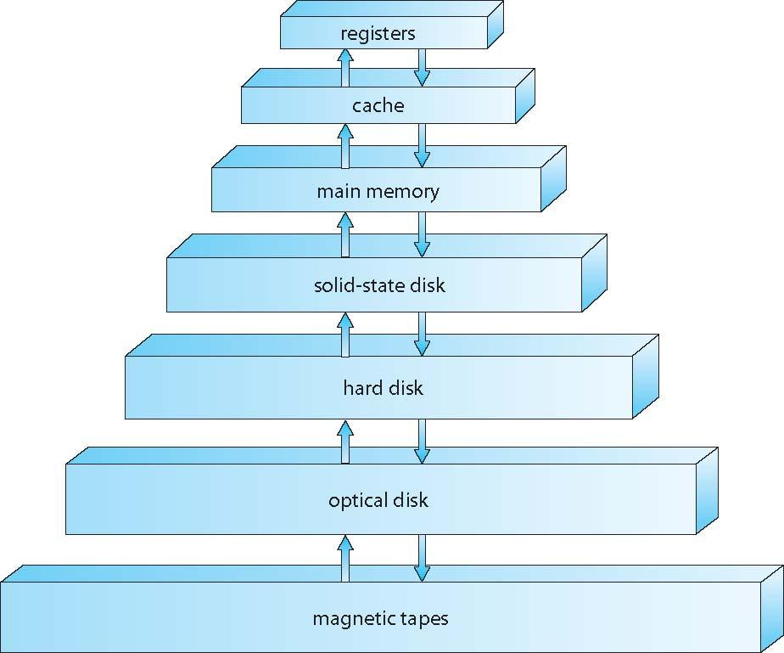

Busy Waiting : Running on the CPU but waiting for a condition
Bitmaps : Used to represent the availability of a resource:
e.g. – 1 0 1 0 0 0 0 0 , where the i^{th} element represents the availability of a resource ( 0 = not , 1 = is )
Mobile OSes :
Android (open-source)
iOS (proprietary)
Open Source OSes : Linux, FreeBSD, UNIX, Solaris (Sun Microsystems) w/ green threads
Real Time Embedded System: serves one a function without GUI. Ex: microwave, fridge
Chapter 2 : Operating System Structures
Services of an Operating System
User Interface, Program Execution, I/O Operations, File-System Manipulation, Communications, Error Detection, Resource Allocation, Accounting, Protection and Security
Command Interpreter/CLI = shell ( takes commands from the user)
e.g BASH ( Bourne Again Shell )
System Call
- calling OS from program
  - via API (interface)
- library needed for fork()
  - #include <unistd.h>
- when fork() ends, it returns to library unistd

Microkernels ( Solaris, Windows, MacOS, Linux)
A smaller, simplified kernel with less code and overhead
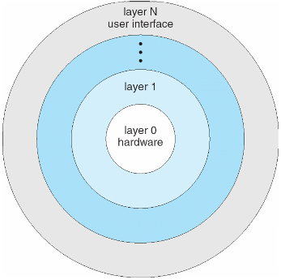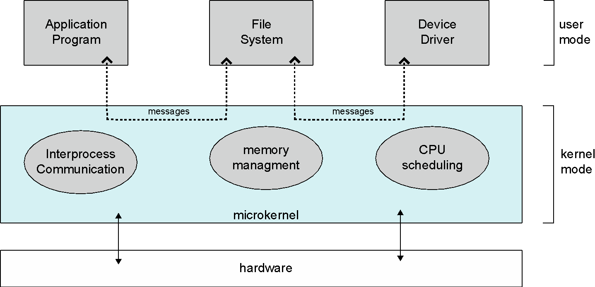
Layered Approach Modular Approach
Layered: Everything is in the system, so it’s faster, but there’s too many layers
Layers: hardware-> OS -> I/O -> File System -> Command Interpreter
Modular: Can change user mode applications without messing with the kernel code
Darwin is the MacOS kernel.
Bootstrap program/Firmware : Software tied to hardware, loaded on power-up, stored in ROM/EPROM (Erasable Programmable)
Solaris:
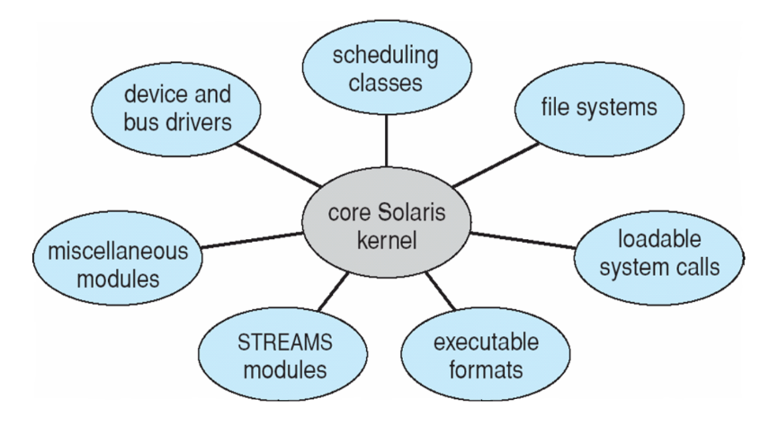
Chapter 3 : Processes
Aqua = MacOS interface
API = Application Program Interface
#include <unistd.h> :: for fork(), I/O operations
it’s an interface/API from the C library
Heap : Dynamic Memory
Stack : Static Memory
Process State Diagram
    - 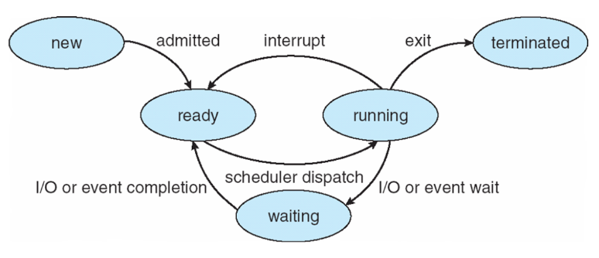
Process Control Block (PCB) – Contains information about each process
Context Switch : Switching Processes:
- Process information is stored
- … //TODO
Multiprocessing in Mobile OSes
Apple/iOS : has the power to, but limits it
Android: no limits
init() = first process to run
//TODO
fork() = 2^{n} calls, where n = number of times forked
Daemon : process that runs in the background
Inter-Process Communication (IPC)
Shared Memory: Share a location in memory = easier to synchronize
Message Passing: Send updates via messages = harder to sync
Chrome Browser Multiprocess (1 Process Per Webpage)
Sandboxed? Yes.
Pipes
Named Pipes – Retains Info
Ordinary Pipes – Process, disappears after process is done
Sockets (Port Numbers)
< 1024 = Well known/Reserved (CANNOT BE USED)
>1024 = Host numbers
>>End Of Chapter Exercises (?)
Chapter 4 : Threads
Thread – Shared memory
Process - Has it’s own memory
4.10 In Chapter 3, we discussed Google’s Chrome browser and its practice of opening each new website in a separate process. Would the same benefits have been achieved if instead Chrome had been designed to open each new website in a separate thread? Explain.
Answer: If it was designed to be a thread per website browser, one webpage crashing will result in all the webpages failing.
Formula: (pg. 166)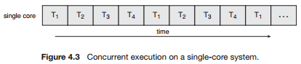
Concurrent Processes – Take turns running each program
//TODO
Parallel Processes – Both processes run at once
//TODO
Exercise: Can a program have concurrency but not parallelism?
Answer: Yes. (e.g. above example)
P- Thread (POSIX Thread)
POSIX (Portable OS Interface) – Standard for Operating Systems
Thread Join = Process Wait
Java Threads managed by JVM/Host machine(pg. 176)
Implicit Threading – The creation of threads during runtime, done by library (NOT HANDLED BY PROGRAMMER)
Examples: Thread Pools, openMP
Thread Pools – Create a number of threads in a pool where they await work
Pragma (OpenMP) (pg. 181)
Runs parallel threads
#pragma omp parallel
Create as many threads as there are cores
#pragma omp parallel for
for(i=0;i<N;i++) {
c[i] = a[i] + b[i];
}
Run for loop in parallel

Grand Central Dispatch ( for Apple)
uses caret ^{} for parallel threads
two types of queue: serial (main queue) and concurrent (low, default, high queue)
Signal : Signals the end of the wait, or when the program is out of the critical section
Critical Section : Part of the shared memory
Lightweight Process (LWP) (pg. 187)
Data Structure
Thread Library
Virtual Process
Upcall : Call made by the kernel
the kernel must inform an application about certain events
Linux Threads
Clone() -> creates threads
Chapter 5 : Introduction
Producer + Consumer (pg. 206)
Producer adds to the buffer
Consumer consumes from the buffer
Race Condition : If the processes are not synchronized, the process that finishes last gets to change the value of the critical section.
Solution to Critical Section Problem
Mutual Exclusion (MutEx)
Progress
Bounded Waiting
Peterson’s Solution (uses Boolean flag and Int Turn )
P_{i} (process)
do {
flag[i] = true;
turn = j;
while (flag[j] && turn = = j);
critical section
flag[i] = false;
remainder section
} while (true);
Semaphores // TODO
signal()/ wait()
creates deadlocks/starvations pg. 217
Deadlock - situation where two or more processes are waiting indefinitely for an event that can be caused only by one of the waiting processes.
starvation - happens when low priority never executes because higher priorities always come
Priority Inversion ( L -> M -> H)
Low priority processes pushed back
(e.g. Code that didn’t print date for 6 years )
Dining Philosophers/Classic Read – Writers problems
Problems it can create
Chapter 6 : CPU Scheduling
Cpu Scheduling/Short Term Scheduling
Schedules tasks
Goal of CPU Scheduling
Maxmizing: CPU Usage
CPU Throughput
Minimizing: Turnaround time
Waiting time
Response Time
Calculate Turnaround + Waiting Times //TODO
Avg Waiting Time Schedule //TODO
Problems with
First Come First Serve (FCFS)
problem is length of process
Round Robin (RR)
- treats processes same as First-Come-First-Serve (FCFS)
- example of dynamic RR
  - if process is short -> goes to short quantum
  - if need more memory -> goes to higher quantum
  - else it goes to background -> FCFS
Shortest Job First (SJF)
  - how do you know how long is each process?
    - we don’t know
  - issue is when many short burst processes
    - long process will be skipped frequently
Shortest Remaining Time (SRT)
- “Preemptive” = Priority
- P1 gets bypassed when P2 arrives, because P2 has shorter process time
- Remainder of P1 is less than P3, so P3 is put on hold until P1 is done
Priority Scheduling
Multilevel Queue -> Process has a predefined priority
- background
  - for batches
  - FCFS
- fore ground
  - interactive
  - RR
Multilevel Feedback -> Processes can switch from one priority to another (e.g. if quantum exceeds an amount)
Aging - As data age, it moves up in priority

