California State University, Los Angeles
Annual Assessment Report

Program: COMPUTER SCIENCE BACHELOR OF SCIENCE Report Semester/Year: SPRING 2020_

College/School: ___ECST_____________ Assessment Coordinator: Dr. Sun/ Dr. Pamula___

Specialized Accreditation: No Yes
please specify Agency/organization and Date ____abet_(Accredited to 2023)___________

Department Mission:
To graduate well educated computer scientists who are prepared to meet the challenges of a rapidly changing, increasingly complex world. This will be accomplished through:
- A well-qualified faculty who care about students and their success.
- A dynamic, up-to-date curriculum that has an optimal balance between theory and practice.
- Laboratories, computer facilities, and instructional classrooms on par with any computer science program in the nation.
- Unique co-curricular opportunities for students such as participation in student design competitions, professional student organizations, and pre-professional employment.
- Opportunities for undergraduate and graduate students to participate in research and industry-funded design clinic projects.
- Mutually beneficial partnerships with area industry that take advantage of our location in one of the most concentrated high-tech centers in the nation.
- Strong cooperative relationships with local high schools, community colleges, and with other four-year institutions.

Please list all Program Learning Outcomes (PLOs):

The Accreditation Board for Engineering and Technology (ABET) Commission has engaged the computing community to modify and update these criteria. These recent changes to the Computer Science program criteria primarily impact student outcomes (what program graduates are expected to know and be able to do by graduation) and curriculum. The new Outcomes from ABET has also been adopted by the Computer Science Bachelor of Science program here at CSULA. The new Outcomes are:
- Analyze a complex computing problem and to apply principles of computing and other relevant disciplines to identify solutions.
- Design, implement, and evaluate a computing-based solution to meet a given set of computing requirements in the context of the program’s discipline.
- Communicate effectively in a variety of professional contexts.
- Recognize professional responsibilities and make informed judgments in computing practice based on legal and ethical principles.
- Function effectively as a member or leader of a team engaged in activities appropriate to the program’s discipline.
- Apply computer science theory and software development fundamentals to produce computing-based solutions.

These new outcomes replaces our old Outcomes listed below.
- Students will be able to apply concepts and techniques from computing and mathematics to both theoretical and practical problems.
- Students will be able to demonstrate fluency in at least one programming language and acquaintance with at least three more.
- Students will have a strong foundation in the design, analysis, and application of many types of algorithms.
- Students will have a fundamental understanding of computer systems.
- Students will have the training to analyze problems and identify and define the computing requirements appropriate to their solutions.
- Students will have the training to design, implement, and evaluate large software systems working both individually and collaboratively.
- Students will be able to communicate effectively orally and in writing.
- Students will have the knowledge, skills, and attitudes for lifelong self-development.
- Students will have the ability to analyze the local and global impact of computing on individuals and society.
- Students will have a fundamental understanding of social, professional, ethical, legal, and security issues in computing.

Alignment of Institutional Learning Outcomes (ILOs) and Program Student Learning Outcomes (see Appendix A for a complete description of each ILO) - Please indicate which of your PLOs best match the following ILOs.
Cal State LA Institutional Learning Outcomes | PLO(s) which match this ILO
- Knowledge: Mastery of content and processes of inquiry | 1, 2, 6
- Proficiency: Intellectual skills | 2, 3
- Place and Community: Urban and global mission | 4, 5
- Transformation: Integrative learning | 4, 5, 6

Assessment Results - Describe any assessment activities conducted within the past 2 academic years for each outcome. See Appendix for examples of assessment measures and use of results. Please attach any additional information as needed.

Assessment Process/Results 2019-2020

- Mapping of courses to the new Outcomes has been completed as shown below.
 | SO #1 | SO#2 | SO#3 | SO#4 | SO#5 | SO#6
CS 1010 | I |  | I | I | I | I
CS 1222 | I | I |  |  |  | I
CS 2011 | I | I | I |  | I | I
CS 2012 | I | I | I |  | I | I
CS 2013 | D | I | D |  |  | I
ENGL 2030 |  |  | D
CS 2148 |  |  |  |  |  | I,D
CS 2445 | D |  |  |  |  | I,D
CS 2470 | D |  |  |  |  | I,D
CS 2661 |  |  |  |  |  | I,D
CS 3035 | D |  |  |  |  | D,M
CS 3112 | D | D |  |  |  | D,M
CS 3186 |  |  |  |  |  | D,M
CS 3220 | D | D |  |  |  | D,M
CS 3337 | D | D | D |  | D | D,M
CS 3801 |  |  | D | D |  | D,M
CS 4440 |  |  |  |  |  | D,M
CS 4961 | M | M | M | M | M
CS 4962 | M | M | M | M | M
CS 4963 |  |  | M |  |  | M
MATH 2110
MATH 2120
MATH 2550
PHYS 2100

- Curricular Changes: A few curricular changes are necessitated by the new Outcomes and new curricular requirements. Faculty and IAB have ratified the changes in Fall 2019. We are in the process of completing the following changes in Spring 2020.
  - Develop new courses (CS2445, CS2470, & CS2661) to be added to the program requirements.
  - Delete PHYS2200, EE3445, Modification and MATH elective from the program requirements.
  - Compete Program Modification

- All the rubrics that are employed for assessment purposes are listed below. The newer versions are updated to meet the new outcomes.

Rubric Name | Published
Ethics in the Computer Age (Ver 1.0) | 2014-09-02
Ethics in the Computer Age (Ver 2.0) | 2017-02-15
Ethics in the Computer Age (Ver 3.0) | 2020-03-20
Knowledge Outcomes | 2014-08-25
Knowledge Outcomes (Ver 2.0) | 2020-05-11
Lifelong Learning | 2016-10-30
Oral Communication (Ver 1.0) | 2014-05-29
Oral Communication (Ver 2.0) | 2015-10-29
Software Engineering - Design (Ver 1.0) | 2014-05-29
Software Engineering - Design (Ver 2.0) | 2017-09-10
Software Engineering - Evaluation | 2020-03-20
Software Engineering - Implementation | 2014-05-29
Software Engineering - Implementation (Ver 2.0) | 2020-03-20
Software Engineering - Requirements (Ver 1.0) | 2014-05-29
Software Engineering - Requirements (Ver 2.0) | 2017-09-10
Team Work | 2014-05-29
Written Communication (Ver 1.0) | 2014-05-29
Written Communication (Ver 2.0) | 2017-06-26

- The assessment measures and where they are employed for the new Outcomes indicated below.
SLO | Data collection | Type | Target Thresholds | Description
SO #1 | 1.CS 3337 & CS 4961 Requirements  2.Satisfaction Survey | Rubric  Survey | 3 or higher on each indicator  3 or higher | Requirements documents evaluated by Instructor  Constituent surveys for this SLO.
SO #2 | 1.CS 3337 & CS 4962 Design  3.Satisfaction Survey | Rubric  Survey | 3 or higher on each indicator  3 or higher | Design documents evaluated by Instructor  Constituent surveys for this SLO.
SO #3 | 1. CS 3337, CS 4961, CS 4962 Oral  2.CS 4961, CS 4962 Written  3.SLO-7 Satisfaction Survey | Rubric  Assignment & Rubric  Survey | 3 or higher on each indicator  3 or higher on each indicator  3 or higher | Project Presentation evaluated by Instructor  Writing assignments evaluated by Instructor  Constituent surveys for this SLO.
SO #4 | 1.CS3801 Ethics  2.Satisfaction Survey | Rubric evaluations  Survey | 3 or higher on each indicator  3 or higher | Instructor conducts assignments, exams, and presentations. The scores are added and normalized on a 5 point scale for each student.  Constituent surveys for this SLO.
SO #5 | 1. CS 3337,CS  4961,CS 4962 Teamwork  2.Satisfaction Survey | Rubric  Survey | 3 or higher  3 or higher | Student and Instructor – rubric evaluations  Constituent surveys for this SLO
SO #6 | 1.CS 4963 Assessment Indicators  2.MFT Assessment Indicators  3.MFT Median Score Percentile  4. Satisfaction Survey | Assignments & Rubric  MFT  MFT  Survey | 3 or higher  50th percentile or higher  50th Percentile or higher  3 or higher | Instructor conducts assignments and exams. They are added and normalized on a 5 point scale for each student.  Assessment Indicators on MFT provides the national percentile the institution is in based on the mean score of the students.  MFT Median data comparison of CSULA students when compared to all other students  Constituent surveys for this SLO.

- All assessment results exceed all the target levels. We are satisfied that students are achieving all the student outcomes. Partial results for some of the outcomes are described below:
SO #3: Communicate effectively in a variety of professional contexts.

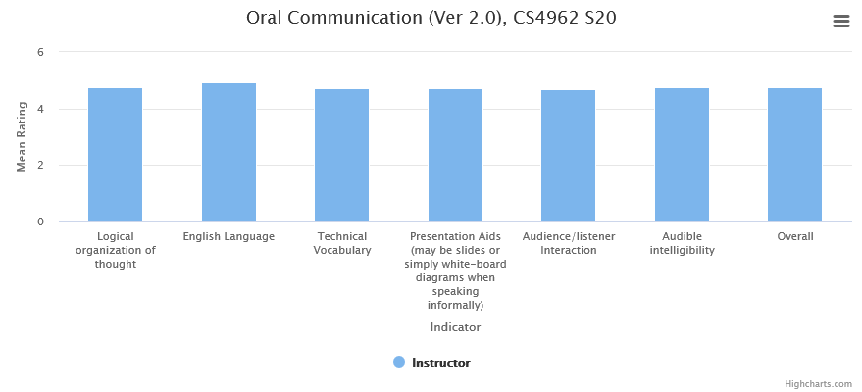

SO#4: Function effectively as a member or leader of a team engaged in activities appropriate to the program’s discipline.

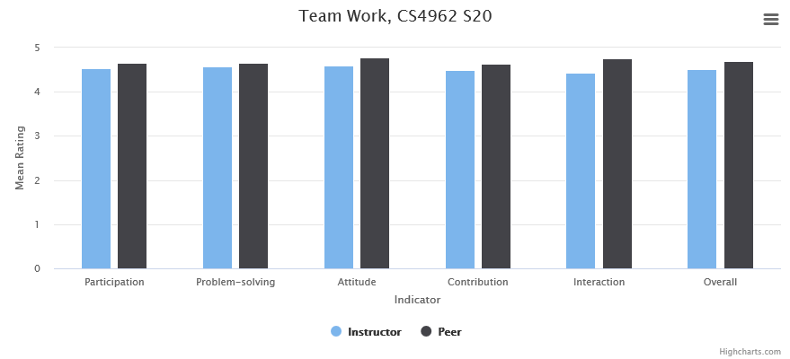

SO #5: Apply computer science theory and software development fundamentals to produce computing-based solutions.

