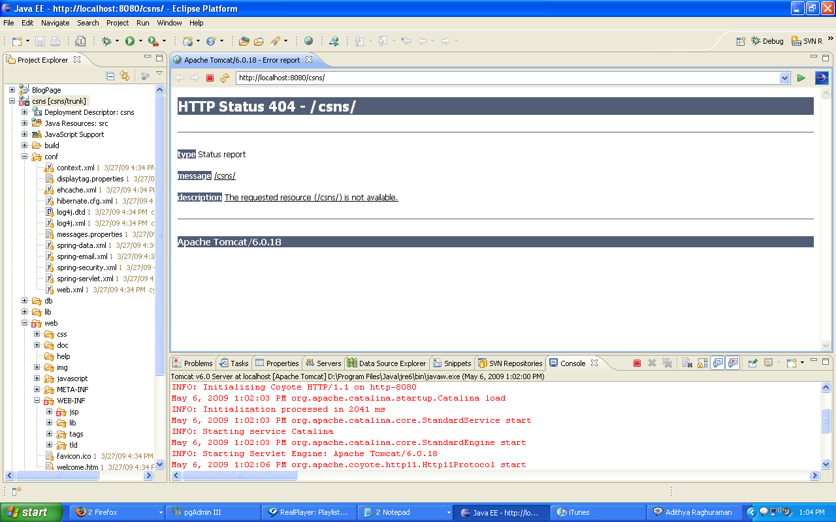

May 6, 2009 1:02:03 PM org.apache.tomcat.util.digester.SetPropertiesRule begin
WARNING: [SetPropertiesRule]{Server/Service/Engine/Host/Context} Setting property 'source' to 'org.eclipse.jst.jee.server:csns' did not find a matching property.
May 6, 2009 1:02:03 PM org.apache.catalina.core.AprLifecycleListener init
INFO: The APR based Apache Tomcat Native library which allows optimal performance in production environments was not found on the java.library.path: D:\Program Files\Java\jre6\bin;.;D:\WINDOWS\Sun\Java\bin;D:\WINDOWS\system32;D:\WINDOWS;D:/Program Files/Java/jre6/bin/client;D:/Program Files/Java/jre6/bin;D:\Program Files\Autodesk\Maya2008\bin;D:\WINDOWS\system32;D:\WINDOWS;D:\WINDOWS\System32\Wbem;d:\Program Files\Microsoft SQL Server\90\Tools\binn\;c:\windows\system32;D:\Program Files\MySQL\MySQL Server 5.0\bin;D:\Program Files\Java\jdk1.6.0_13\bin;D:\apache-ant-1.7.1\bin;D:\Program Files\QuickTime\QTSystem\;D:\Program Files\SSH Communications Security\SSH Secure Shell
May 6, 2009 1:02:03 PM org.apache.coyote.http11.Http11Protocol init
INFO: Initializing Coyote HTTP/1.1 on http-8080
May 6, 2009 1:02:03 PM org.apache.catalina.startup.Catalina load
INFO: Initialization processed in 2041 ms
May 6, 2009 1:02:03 PM org.apache.catalina.core.StandardService start
INFO: Starting service Catalina
May 6, 2009 1:02:03 PM org.apache.catalina.core.StandardEngine start
INFO: Starting Servlet Engine: Apache Tomcat/6.0.18
May 6, 2009 1:02:06 PM org.apache.coyote.http11.Http11Protocol start
INFO: Starting Coyote HTTP/1.1 on http-8080
May 6, 2009 1:02:06 PM org.apache.jk.common.ChannelSocket init
INFO: JK: ajp13 listening on /0.0.0.0:8009
May 6, 2009 1:02:06 PM org.apache.jk.server.JkMain start
INFO: Jk running ID=0 time=0/140 config=null
May 6, 2009 1:02:06 PM org.apache.catalina.startup.Catalina start
INFO: Server startup in 3079 ms

