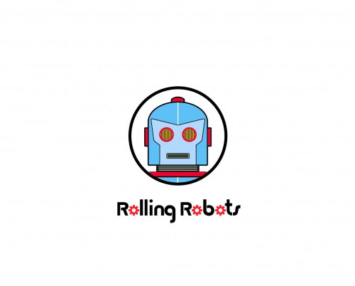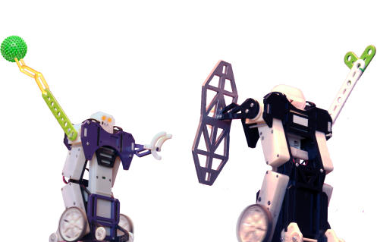

Sales associate/birthday party host/Workshop INstructor for ROBOT entertainment store!

Join us in a novel retail and educational experience delivering robotic games, robot-building parties, classes, and toys. Our customers are mainly boys ages 5 to 15 with an interest in technology, science, and science fiction. If you’re a creative, energetic, friendly sales host with an interest in robots, technology, science fiction, comic books, and fantasy games then this is the job for you. Our curriculum focuses on the STEM (Science, Technology, Engineering, Mathematics) program for our summer school and after school workshops. We’re currently looking for a combination storyteller, sales person, competition referee for our battle arena, techie, and most importantly a teacher.

Duties, Knowledge, Skills & Experience Requirements:

- Interested in Robots and working with children.
- Operate POS system/cash register, sell merchandise, and assist with robotic games.
- Willing to stock shelves and do other tasks to keep the place looking nice.
- Host children's birthday parties/workshops/summer classes with enthusiasm and fun.
- Excellent communication skills with children and parents.
- Flexibility in scheduling.
- Basic math, technology, and computer skills.
- Engineering and/or robotics experience a plus but not required.
- College students/graduates preferred.

Send cover letter and resume to jobs@RollingRobots.com.

Immediate full or part time openings at our Glendale and Palos Verdes locations for entry level positions with many growth opportunities. Visit RollingRobots.com for more info about our store. Job applications can be downloaded at www.RollingRobots.com/jobs.

