Undergraduate Program Assessment Report

Computer Science
2018-2020

Table of Contents Page
- PROGRAM EDUCATIONAL OBJECTIVES 3
- Program Educational Objectives 3
- Review of Program Educational Objectives 3

- STUDENT OUTCOMES 4
- Updated Students Outcomes 4
- Assessment Process/Assessment Architecture 6
- Assessment Results 9
- Continuous Improvement 22

- Constituent Members Comments 22
- Impact of COVID 19 22

PROGRAM EDUCATIONAL OBJECTIVES
- Program Educational Objectives
Program Educational Objectives (PEOs) are broad statements that describe what graduates are expected to achieve within a few years of graduation. They provide guidelines, which offer a vision for the program.
The Program Educational Objectives of the undergraduate program in Computer Science at California State University, Los Angeles are as follows.
- Students who had entered the workforce will have established themselves as effective professionals by having solved real problems through the use of their computer science knowledge and their communication, critical thinking, and problem solving skills.
- Students who had continued in academia will have been successful in pursuing advanced degrees and in demonstrating their ability to master advanced areas of computer science.
- Students will have demonstrated their ability to adapt to a rapidly changing environment by having learned and applied new knowledge and skills.
- Review of Program Educational Objectives
Program Educational Objectives are discussed during the annual faculty retreat and the annual Industry Advisory Board meeting. A formal review process is conducted every three to five years. In each review cycle, Department Assessment Committee consider the following input and propose possible revisions:
- Existing Program Educational Objectives and Student Learning Outcomes
- Mission statements of the University, College and Department
- ACM curricular guidelines
- ABET accreditation standards
- Feedback from constituency surveys
- Feedback from IAB (Industrial Advisory Board) meetings
Proposed revisions are discussed at annual department faculty retreat, and the faculty vote on whether to adopt the revisions.
The department had conducted reviews of Program Educational Objectives in this cycle. These changes were made during the Spring 2017 are appropriate and all the three PEOs were readopted. The timeline is described in the table below:

Date | Activities
Fall 2019/  Fall 2020 | IAB meetings; Review PEOs  (https://csns.calstatela.edu/wiki/content/department/cs/assessment/iab/)
Spring 2019/  Spring 2020 | Annual Faculty retreat; Review PEOs  (https://csns.calstatela.edu/wiki/content/department/cs/assessment/retreat_presentations/)
Table: Program Educational Objectives review timeline

STUDENT OUTCOMES
ABET CAC approved revisions to the criteria for accrediting computing programs leading to new CAC criteria (Version 2.0). The new criteria will be in place as we move forward in the accreditation process. These changes to Criteria 3 (Student Outcomes) and Criteria 5 (Curriculum) have been motivated by two independent considerations: (i) Structural issues in the way that Criteria 3 is described lead to confusion between the terminologies “characteristics” (defined by a..k) and “Student Outcomes”. (ii) Changes in Criteria 5 to include new topics as proposed in the ACM/IEEE Computer Society’s Computer Science Curricula.
During Fall 2019, we transitioned the BSCS program to the new ABET criteria by adopting the new ABET proposed student outcomes.
A. Updated Student Outcomes
Student Learning Outcomes (SLOs) are specific skills that students will possess at the end of the degree program. Student Learning Outcomes provide curricular guidelines with respect to the program. The Student Learning Outcomes of the undergraduate program in Computer Science at California State University, Los Angeles are:
New Student Outcomes (Fall 2019 – current)
- Analyze a complex computing problem and to apply principles of computing and other relevant disciplines to identify solutions.
- Design, implement, and evaluate a computing-based solution to meet a given set of computing requirements in the context of the program’s discipline.
- Communicate effectively in a variety of professional contexts.
- Recognize professional responsibilities and make informed judgments in computing practice based on legal and ethical principles.
- Function effectively as a member or leader of a team engaged in activities appropriate to the program’s discipline.
- Apply computer science theory and software development fundamentals to produce computing-based solutions.
Old Student Outcomes (Prior to Fall 2019)

- Students will be able to apply concepts and techniques from computing and mathematics to both theoretical and practical problems.
- Students will be able to demonstrate fluency in at least one programming language and acquaintance with at least three more.
- Students will have a strong foundation in the design, analysis, and application of many types of algorithms.
- Students will have a fundamental understanding of computer systems.
- Students will have the training to analyze problems and identify and define the computing requirements appropriate to their solutions.
- Students will have the training to design, implement, and evaluate large software systems working both individually and collaboratively.
- Students will be able to communicate effectively, both orally and in writing.
- Students will have the knowledge, skills, and attitudes for lifelong self-development.
- Students will have the ability to analyze the local and global impact of computing on individuals and society.
- Students will have a fundamental understanding of social, professional, ethical, legal, and security issues in computing.

We followed our established practices of reviewing our Student Outcomes as outlined in the table below:
Date | Activities
2018 to 2019  (Fall Semester) | Annual IAB meetings
2018 to 2020  (Spring Semester) | IAB meeting + Senior Design project presentations
2018 to 2020  (Spring Semester) | Annual constituency surveys are conducted
2018 to 2020  (Spring Semester) | Annual Faculty retreats
- Table 3.1: Student Learning Outcomes review timeline

B. Assessment Process/Assessment Architecture
Adopting the new outcomes required changes in the curriculum and the assessment architecture that we have employed on CSNS. Significant changes are outlined below:

- Mapping of courses to the new Outcomes has been completed as shown below.
 | SO #1 | SO#2 | SO#3 | SO#4 | SO#5 | SO#6
CS 1010 | I |  | I | I | I | I
CS 1222 | I | I |  |  |  | I
CS 2011 | I | I | I |  | I | I
CS 2012 | I | I | I |  | I | I
CS 2013 | D | I | D |  |  | I
ENGL 2030 |  |  | D
CS 2148 |  |  |  |  |  | I,D
CS 2445 | D |  |  |  |  | I,D
CS 2470 | D |  |  |  |  | I,D
CS 3035 | D |  |  |  |  | D,M
CS 3112 | D | D |  |  |  | D,M
CS 3186 |  |  |  |  |  | D,M
CS 3220 | D | D |  |  |  | D,M
CS 3337 | D | D | D |  | D | D,M
CS 3801 |  |  | D | D |  | D,M
CS 4440 |  |  |  |  |  | D,M
CS 4961 | M | M | M | M | M
CS 4962 | M | M | M | M | M
CS 4963 |  |  | M |  |  | M
MATH 2110
MATH 2120
MATH 2550
PHYS 2100

- Curricular Changes: A few curricular changes are necessitated by the new Outcomes and new curricular requirements. Faculty and IAB have ratified the changes in Fall 2019. We are in the process of completing the following changes in Spring 2020.
  - Develop new courses (CS2445 & CS2470)) to be added to the program requirements.
  - Delete PHYS2200, EE3445, Modification and MATH elective from the program requirements.
  - Compete Program Modification

- All the rubrics that are employed for assessment purposes are listed below. The newer versions are updated to meet the new outcomes.

Name | Published
Ethics in the Computer Age (Ver 3.0) | 2020-03-20
Knowledge Outcomes (Ver 2.0) | 2020-05-11
Oral Communication (Ver 2.0) | 2015-10-29
Software Engineering - Analysis | 2020-07-20
Software Engineering - Design (Ver 2.0) | 2017-09-10
Software Engineering - Evaluation | 2020-03-20
Software Engineering - Implementation (Ver 2.0) | 2020-03-20
Team Work | 2014-05-29
Written Communication (Ver 2.0) | 2017-06-26

- The assessment measures and where they are employed for the new Outcomes indicated below.
SLO | Data collection | Type | Target Thresholds | Description
SO #1 | 1.CS 3337 & CS 4961 Requirements  2.Satisfaction Survey | Rubric  Survey | 3 or higher on each indicator  3 or higher | Requirements documents evaluated by Instructor  Constituent surveys for this SLO.
SO #2 | 1.CS 3337 & CS 4962 Design  3.Satisfaction Survey | Rubric  Survey | 3 or higher on each indicator  3 or higher | Design documents evaluated by Instructor  Constituent surveys for this SLO.
SO #3 | 1. CS 3337, CS 4961, CS 4962 Oral  2.CS 4961, CS 4962 Written  3.SLO-7 Satisfaction Survey | Rubric  Assignment & Rubric  Survey | 3 or higher on each indicator  3 or higher on each indicator  3 or higher | Project Presentation evaluated by Instructor  Writing assignments evaluated by Instructor  Constituent surveys for this SLO.
SO #4 | 1.CS3801 Ethics  2.Satisfaction Survey | Rubric evaluations  Survey | 3 or higher on each indicator  3 or higher | Instructor conducts assignments, exams, and presentations. The scores are added and normalized on a 5 point scale for each student.  Constituent surveys for this SLO.
SO #5 | 1. CS 3337,CS  4961,CS 4962  2.Satisfaction Survey | Rubric  Survey | 3 or higher  3 or higher | Student and Instructor – rubric evaluations  Constituent surveys for this SLO
SO #6 | 1.CS 4963 Assessment Indicators  2.MFT Assessment Indicators  3.MFT Median Score Percentile  4. Satisfaction Survey | Assignments & Rubric  MFT  MFT  Survey | 3 or higher  50th percentile or higher  50th Percentile or higher  3 or higher | Instructor conducts assignments and exams. They are added and normalized on a 5 point scale for each student.  Assessment Indicators on MFT provides the national percentile the institution is in based on the mean score of the students.  MFT Median data comparison of CSULA students when compared to all other students  Constituent surveys for this SLO.

- Embed assessment activities and data collection in certain key core courses.

Outcomes | SO #1 | SO#2 | SO#3 | SO#4 | SO#5 | SO#6
Rubric | R, A | D,I | O,W | E | T | K
Courses | CS3337  CS4961 | CS3337  CS4962 | CS3337  CS4961  CS4962 | CS3801  CS4962 | CS3337  CS4961  CS4962 | CS4963

- Assessment Results

- Analyze a complex computing problem and to apply principles of computing and other relevant disciplines to identify solutions.
(a) Assessment Measures
- Rubric: Software Engineering – Analysis (in CS 3337 and CS 4961)
- Survey
(b) Dates of Assessment
This is a transition year for us as we migrate from the old outcomes to the new ones. Surveys were conducted in Fall 2019 using the new outcomes, but some rubrics such as Software Engineering – Analysis were not developed until Fall 2020. We expect a full assessment with the new outcomes and measure in the 2020-2021 academic year.
(c) Assessment Results
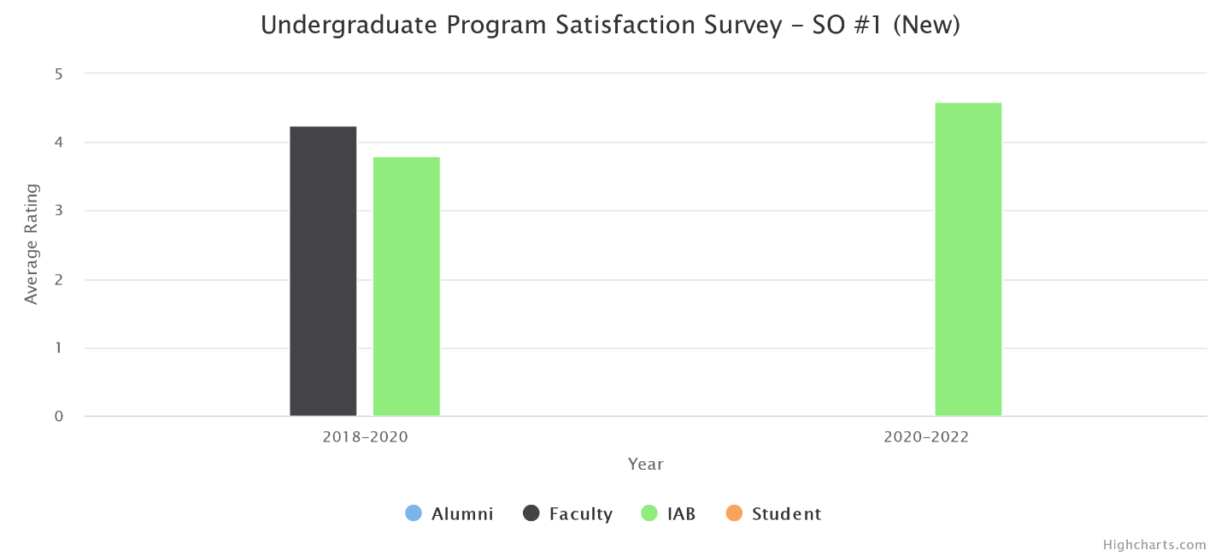
(d) Changes Made
No instructional, programmatic, or curricular changes were made as the survey results met our target of 3 or higher.
- Design, implement, and evaluate a computing-based solution to meet a given set of computing requirements in the context of the program’s discipline.
(a) Assessment Measures
- Rubric: Software Engineering - Design (Ver 2.0) (in CS 3337 and CS 4962)
- Rubric: Software Engineering - Implementation (Ver 2.0) (in CS 3337 and CS 4962)
- Rubric: Software Engineering – Evaluation (in CS 337 and CS 4962)
- Survey
(b) Dates of Assessment
This is a transition year for us as we migrate from the old outcomes to the new ones. Surveys were conducted in Fall 2019 using the new outcomes, but some rubrics such as Software Engineering – Evaluation were not developed until Fall 2020. We expect a full assessment with the new outcomes and measure in the 2020-2021 academic year.

(c) Assessment Results

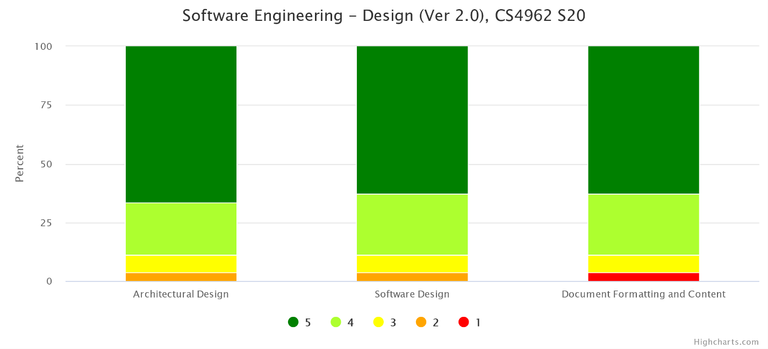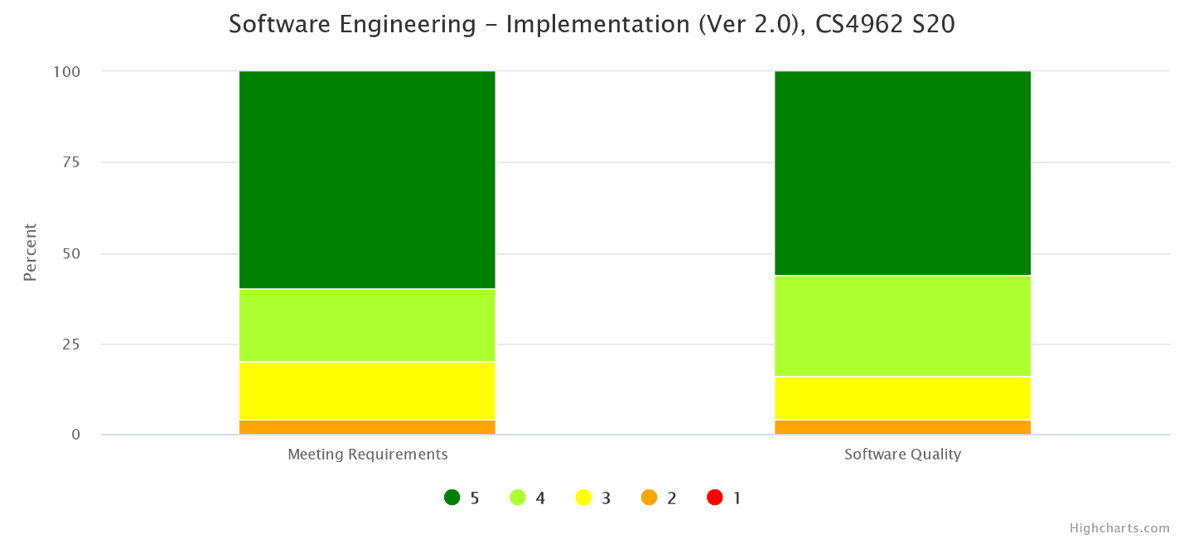
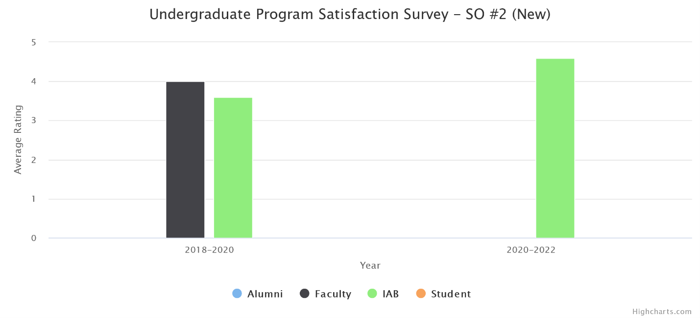
(d) Changes Made
No instructional, programmatic, or curricular changes were made as both rubric assessment and the survey results met our target thresholds.
- Communicate effectively in a variety of professional contexts.
(a) Assessment Measures
- Rubric: Oral Communication (Ver 2.0) (in CS 3337, CS 4961, CS 4962)
- Rubric: Written Communication (Ver 2.0) (in CS 3337, CS 4961, CS 4962)
- Survey
(b) Dates of Assessment
- Rubric: Oral Communication (Ver 2.0)
  - Fall 2019 in CS 4961
  - Spring 2020 in CS 3337, CS 4962
- Rubric: Written Communication (Ver 2.0)
  - Fall 2019 in CS 4961
  - Spring 2020 in CS 4962
- Survey: Fall 2019
(c) Assessment Results
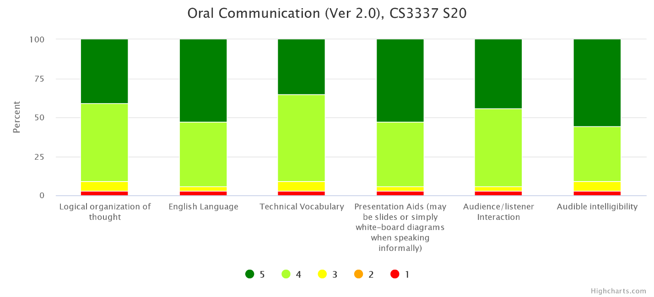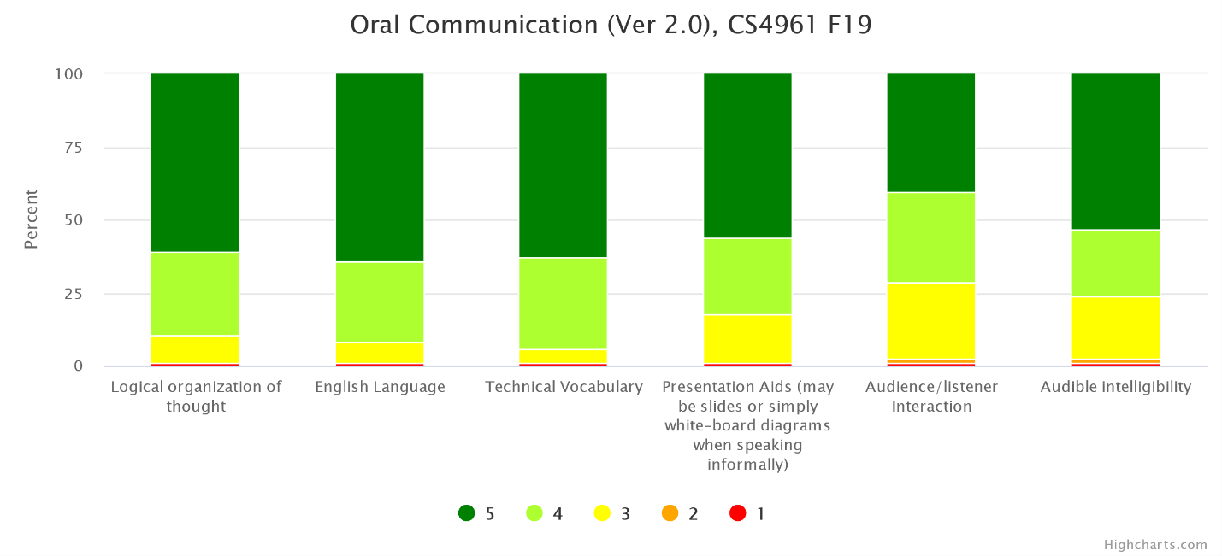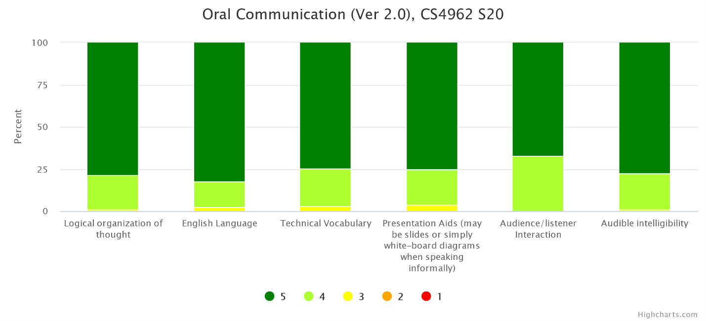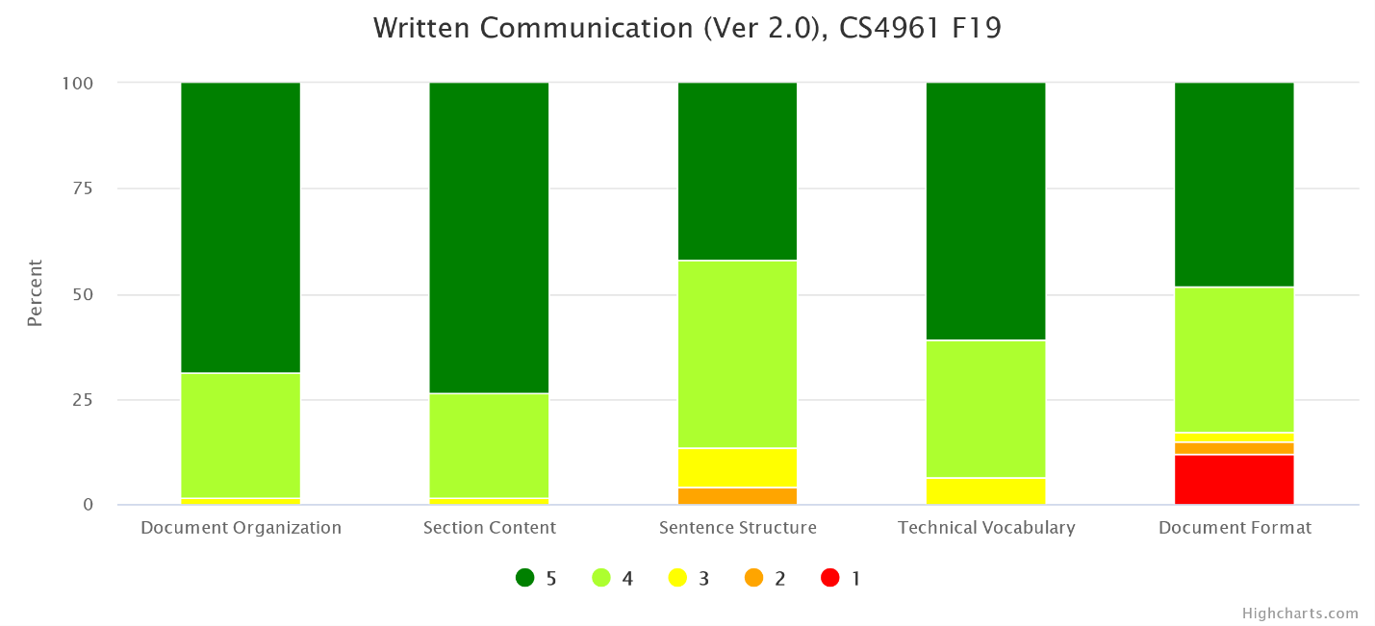
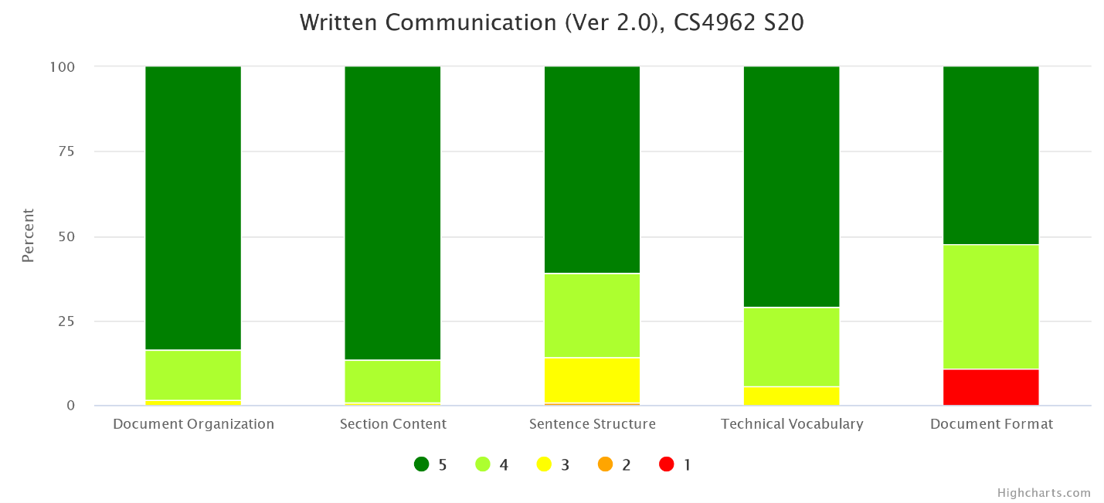
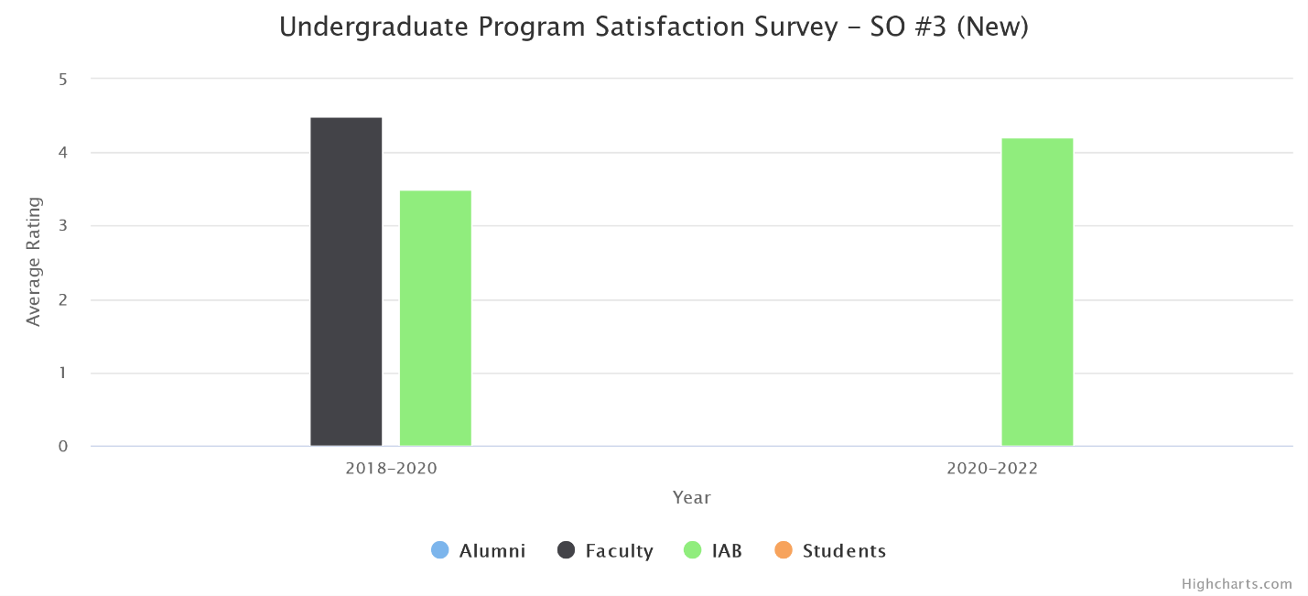
(d) Changes Made
No instructional, programmatic, or curricular changes were made as both rubric assessment and the survey results met our target thresholds.

- Recognize professional responsibilities and make informed judgments in computing practice based on legal and ethical principles.
(a) Assessment Measures
- Rubric: Ethics in the Computer Age (Ver 3.0) (in CS 3801, CS 4962)
- Survey
(b) Dates of Assessment
- Rubric: Ethics in the Computer Age (Ver 3.0)
  - Spring 2020 in CS 3801
- Survey: Fall 2019
Ethics in the Computer Age (Ver 3.0) is a new rubric developed for the new outcomes. Previously it was assessed only in CS 3801. This semester the department has decided to assess it also in CS 4962.

(c) Assessment Results
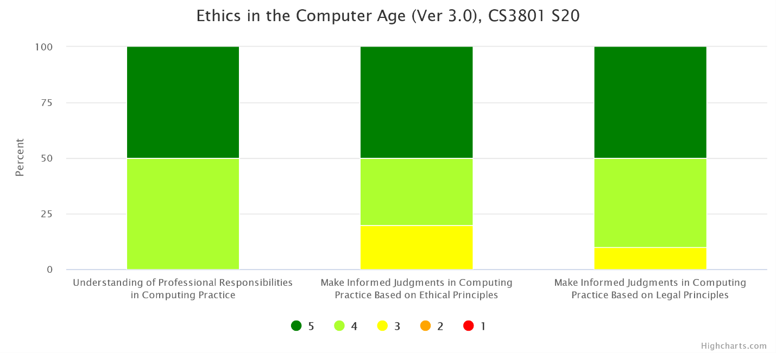
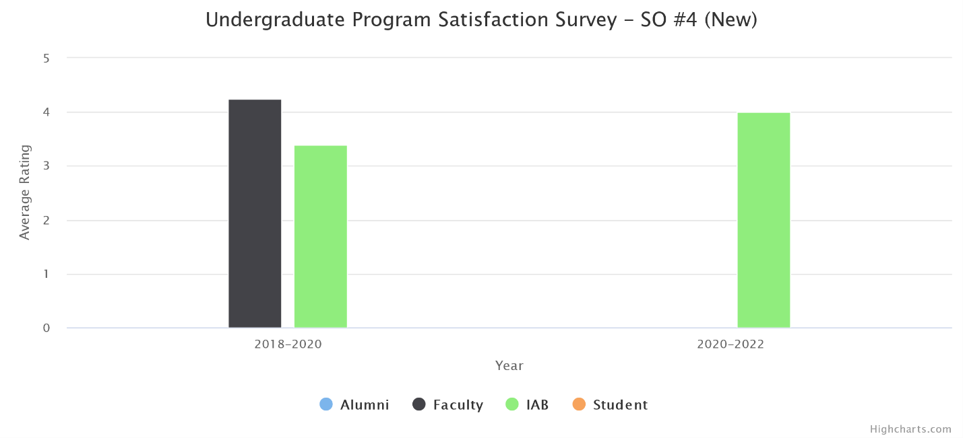
(d) Changes Made
No instructional, programmatic, or curricular changes were made as both rubric assessment and the survey results met our target thresholds.
- Function effectively as a member or leader of a team engaged in activities appropriate to the program’s discipline.
(a) Assessment Measures
- Rubric: Teamwork (in CS 3337, CS 4961, CS 4962)
- Survey
(b) Dates of Assessment
- Rubric: Teamwork
  - Fall 2019 in CS 4961
  - Spring 2020 in CS 4962
- Survey: Fall 2019
(c) Assessment Results
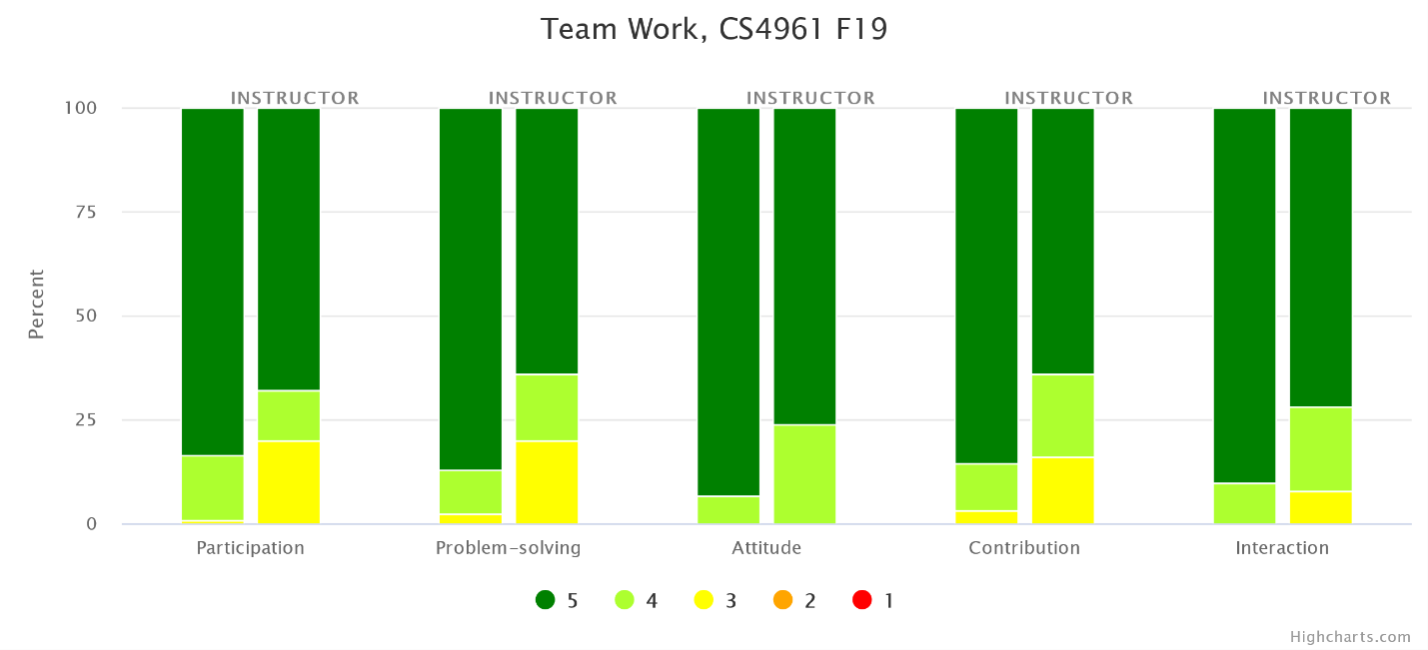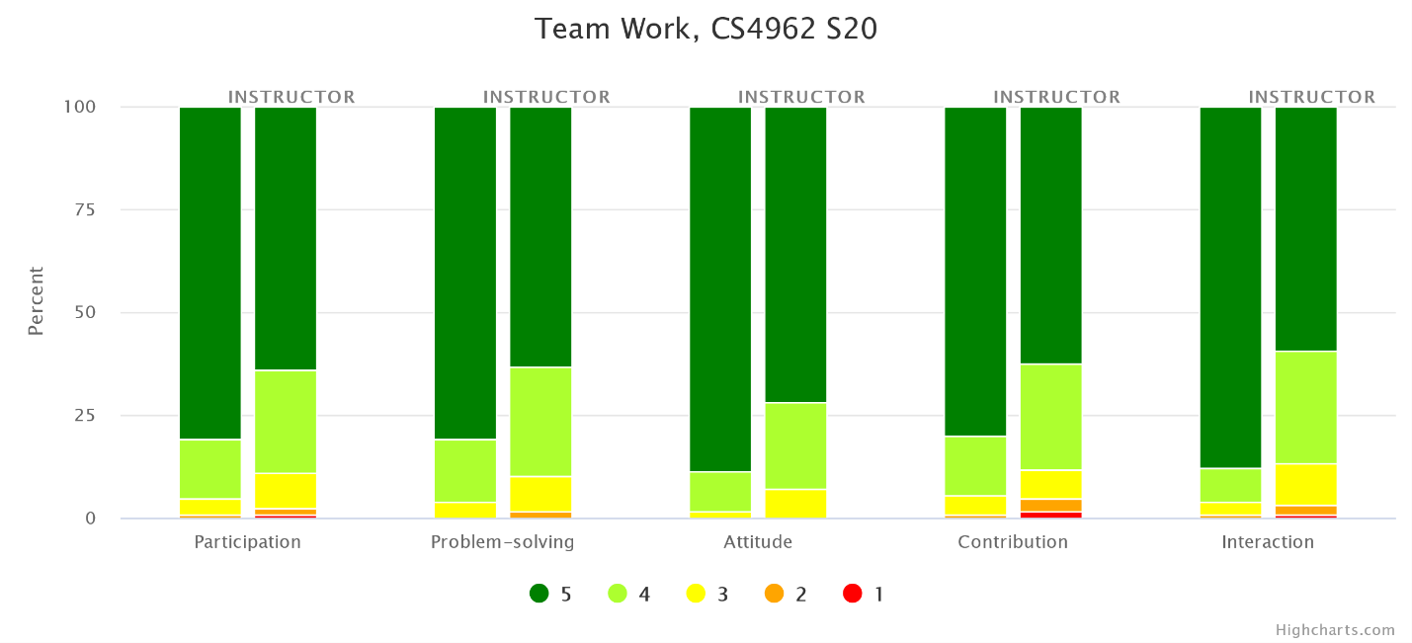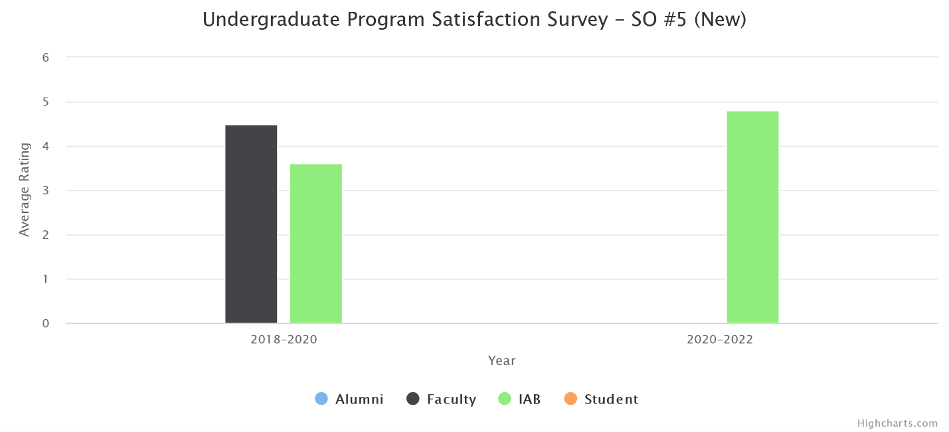
(d) Changes Made
No instructional, programmatic, or curricular changes were made as both rubric assessment and the survey results met our target thresholds.
- Apply computer science theory and software development fundamentals to produce computing-based solutions.
(a) Assessment Measures
- Rubric: Knowledge Outcomes (Ver 2.0) (in CS 4963)
- Survey
- Major Field Test (MFT)
(b) Dates of Assessment
- Rubric: Knowledge Outcomes (Ver 2.0)
  - Spring 2020 in CS 4963
- Survey: Fall 2019
- MFT: Spring 2020
(c) Assessment Results
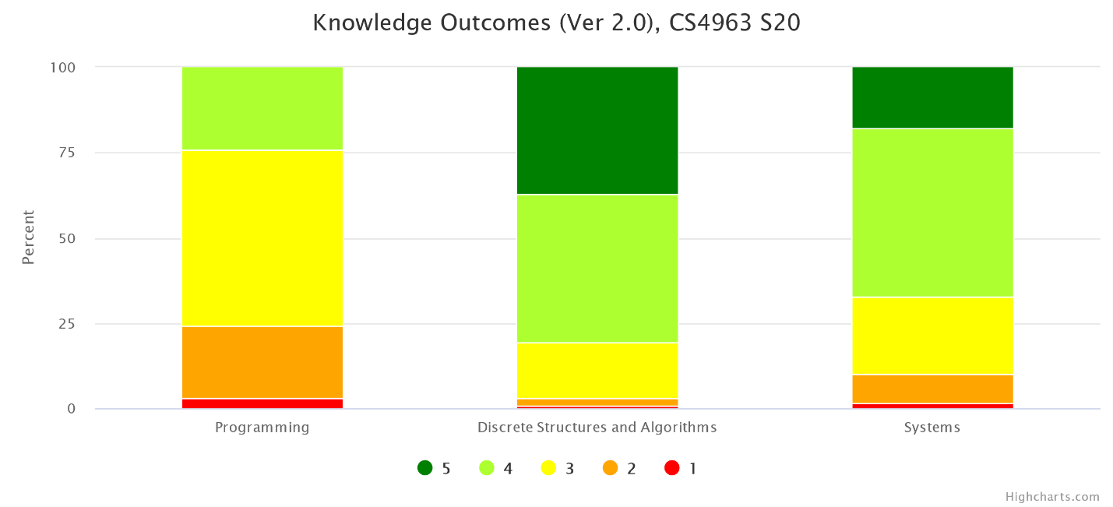
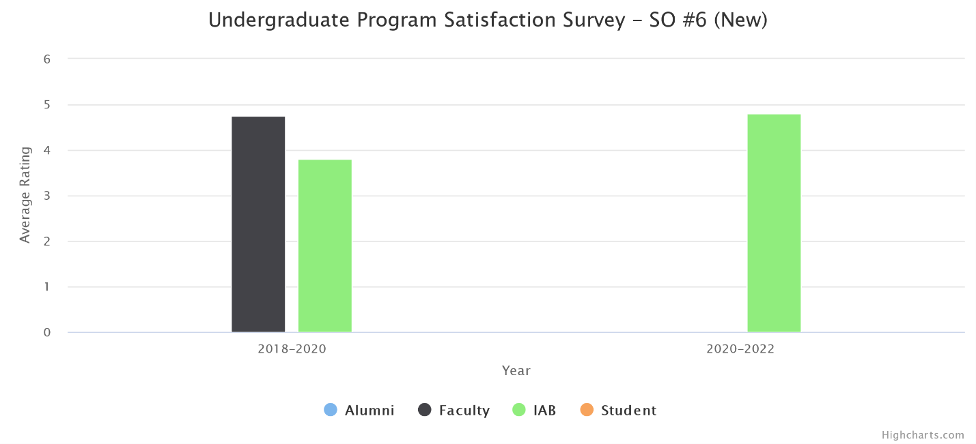
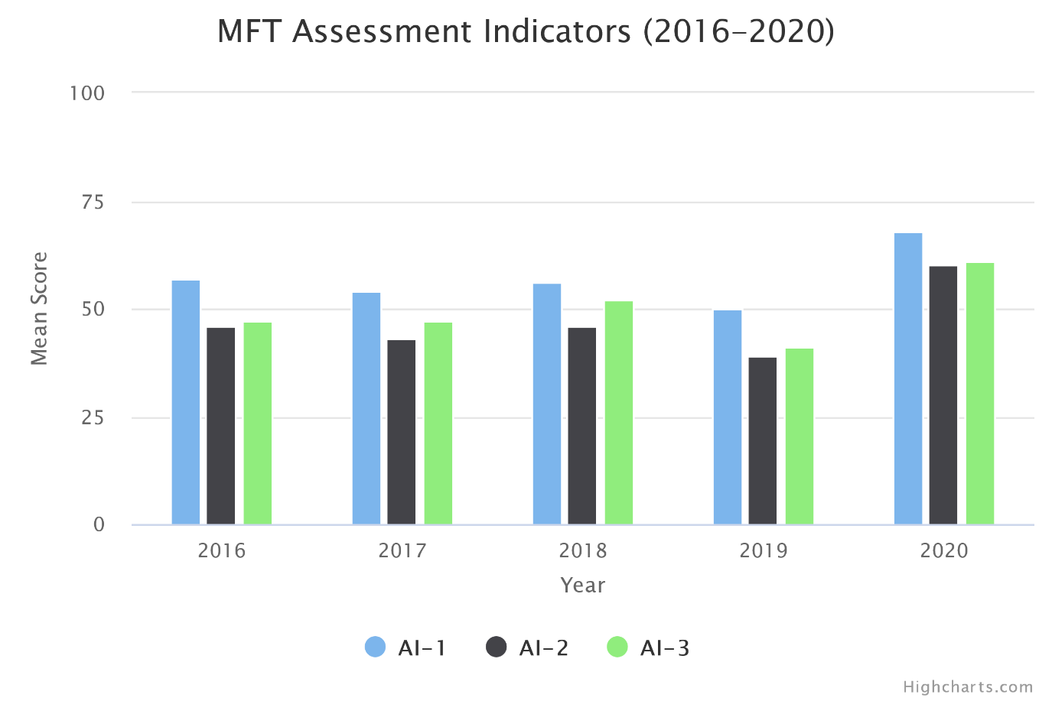
(d) Changes Made
No instructional, programmatic, or curricular changes were made as both rubric assessment and the survey results met our target thresholds.

D: Continuous Improvement

- All assessment results described in the above exceed the target levels. We are satisfied that students are achieving all the student outcomes.
- The 2018-2020 assessment cycle follows a very successful ABET accreditation in Spring 2018.
- We continued to analyze the assessment data collected from various measures followed by faculty retreat discussions, and Industry Advisory Board reviews.
- A few curricular changes are necessitated by the new Outcomes and new curricular requirements. Faculty and IAB have ratified the changes in Fall 2019. We have submitted all the modification proposals early Fall 2020. The new curricular requirements will be effective Fall 2021 semester term.
- Develop new courses (CS2445 and CS2470) to be added to the program requirements.
- Delete PHYS2200, EE3445, Modification and MATH elective from the program requirements.

Impact of COVID 19

This section addresses the challenges faced with respect to ensuring continued student learning and ensuring the Student Outcomes were met.
- For remote teaching, instructors have been utilizing CSNS (in-house Course Management System), Canvas, Zoom, YouTube, and Camtasia extensively. Some instructors also use Discord to facilitate communications among students.
- Most Computer Science instructors are very familiar with online teaching tools and quickly adapt to new technology. A couple of faculty needed extra help to get familiar with Canvas and Zoom and they were provided additional resources.
- Instruction-related surveys were conducted more frequently to assess students' online readiness for different situations such as lectures, exams, presentations, and group projects.
- In many programming-heavy courses, traditional exams have been converted to programming projects and take-home exams.
- Several instructors have explored online books or online programming lab tools provided by publishers.
- In Summer 2020, nineteen CS faculty completed the Alt Instruction Summer Institute and converted their course materials and teaching pedagogy to be more suitable for remote teaching. In Fall 2020, two CS faculty have been participating in the CETL's DOC (Designing Online Courses) Certificate program.

