**2nd Annual Social Theory Conference**

Sustainable Development and Social Justice in the Age of Trump

California State University Los Angeles

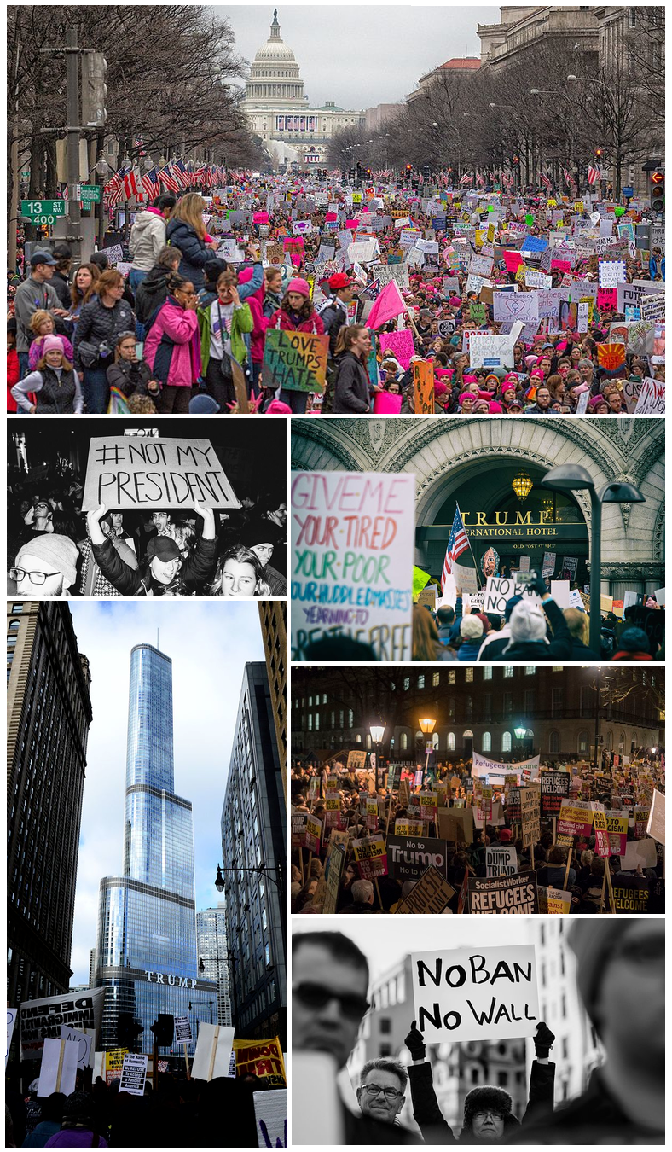

**Time**: Thursday, April 27, 2017, 9:30am--5:30pm

**Venue**: Montebello Room, University Student Union

**Sponsors**: Sociology Club, Department of Sociology, Institute for Urban Sustainability

With the Trump administration taking the helm of the government, the questions of sustainable development and social justice have gained increasing attention. Will the environment be sacrificed for corporate profits under this administration? Is there a growth in attacks on marginalized communities? The goal of this conference is to bring together faculty and students from different academic fields to have an interdisciplinary dialogue about these urgent issues and to explore, from a longer-term perspective, the possibilities of building alternative socio-economic institutions that defy the market logic of boom and bust in the hope of finding a path that will lead to sustainable growth and prosperity for all.

**Presenters and discussants include the following faculty and students**:

Keynote Speaker: **Niki Okuk,** Los Angeles Union Cooperative Initiative

**Hugo Aguas**, Sociology; **Russ Abbott**, Computer Science; **Summer Brantner**, Sociology; **Beatriz Corrales**, Sociology; **Kimberly Cortez**, Chicana/o Studies (CSUDH); **Taylor Dark**, Political Science; **Janelle Delgado**, Political Science; **Louis Esparza,** Sociology; **Gabriela Fried**, Sociology; **Zaira Guevara,** Political Science; **Arezoo Khodayari,** Civil Engineering; **Liam Leonard**, Sociology; **Alex Mai**, History; **Guadalope Pena**, History; **Ralph Pioquinto**, Sociology;  **Anthony Robles**, Sociology; **Tonatiuh Rodriguez-Nikl,** Civil Engineering; **Monica Sandoval,** Sociology; **Nelly Tchougwon**, English (Heidelberg University); **Alfredo Torres**, Sociology; **Robert Weide**, Sociology; **Katherine Yang**, History**.**