**Department of Computer Science**

**California State University, Los Angeles**

Degree Programs:

Master of Science in Computer Science (initiated in 2003)

Last Program Review Self Study Report was generated on Spring 2009

Prepared by:

Dr. Raj Pamula

Submitted on 03/01/2020

Dean, College of Engineering, Computer Science and Technology

**VERIFICATION OF FACULTY REVIEW**

Each full-time faculty member on duty in the Department of Computer Science has been asked to sign the following statement:

By my signature below, I am verifying that I have had the opportunity to see and read the department’s Self-Study Report that is being submitted to the University Program Review Subcommittee.

|  |  |
| --- | --- |
| **Signature** | **Date** |
| Eun-Young “Elaine” Kang |  |
| Russell J. Abbott |  |
| Vladimir Akis |  |
| Navid Amini |  |
| Huiping Guo |  |
| Jiang Guo |  |
| Raj S Pamula |  |
| Behzad Parviz |  |
| Mohammad Pourhomayoun |  |
| Chengyu Sun |  |
| Zilong Ye |  |
| Yuqing Zhu |  |

**Table of Contents**

1.0 History, Mission, Goals, and Objectives 4

2.0 Program Data 14

3.0 Curriculum and Instruction 16

4.0 Assessment of Student Outcomes (SOs) 24

5.0 Department Faculty 39

6.0 Student Engagement, Outreach and Recruitment 49

7.0 Program Self-Recommendations 51

Five-Year Plan 51

Appendices 54

Appendix A. Report from Previous Program Review 54

Appendix B. Students in the Major 62

Appendix C. Graduation and Persistence Rates 65

Appendix D. Faculty Utilization 67

Appendix E. Catalog Description of Each Program 68

Appendix F. GE Assessment 69

Appendix G. Masters Theses, Projects and Dissertations 70

Appendix H. Curriculum Map for Each Academic Degree Program 75

Appendix I. Assessment Plan(s) 76

Appendix J. Faculty Composition 82

Appendix K. Faculty Summary Vitae 83

Appendix L. Instructional Faculty Types in the Programs’ Courses 133

Appendix M. Recommendations for External Reviewers 134

Appendix N. Graduate Program Modification 135

# **1.0 History, Mission, Goals, and Objectives**

**1.1 Overview of the field and department history**

With the recent rapid advances in computer hardware and computer software technology, Computer Science has become one of the most exciting and dynamic research areas—and one that seems set to affect the lives of everyone.

A central and integrating element of Computer Science is the design and development of software to manipulate, store, and communicate digital information. Software enables the representation of abstract ideas in a language capable of execution by a computer. Other than perhaps musical notation, it is arguably the only such symbolic language.

The Department of Computer Science offers three programs of study: a graduate (MS) degree program, an undergraduate (BS) degree program, and a blended (BS+MS) degree program. These degree programs have been designed to prepare qualified students for careers involving the design of computer systems and their application to science and industry. The programs are structured with a maximum of flexibility to insure that students have the opportunity to tailor their studies to suit their particular needs and interests. The MS and the BS degree programs stress both theory and practice and were developed in accordance with curriculum guidelines recommended by the Association for Computing Machinery (ACM), the authority on computer science education.

The Department of Computer Science was first established as an independent department in 2001. Before Fall 2001, the undergraduate Bachelor of Science in Computer Science degree program was housed in the Department of Mathematics and Computer Science within the College of Natural and Social Sciences (NSS). In Fall 2001, the Department of Computer Science was formed and moved to the College of Engineering, Computer Science and Technology (ECST).

The following is a brief chronology of the evolution of the Department of Computer Science from 2001-2019.

Undergraduate (CS BS) Program:

* The undergraduate program (CS BS) received its first ABET accreditation in October 2006. The program received a full six year accreditation.
* The undergraduate program (CS BS) was reaccredited twice, once in 2012 and 2018.
* The current accreditation is valid through September 30th, 2025. Refer to the Undergraduate Program Review documents (Accreditation Self Study Report, MSSR Correspondence Matrix, Undergraduate Assessment Reports) for additional details.
* Many major revisions to the undergraduate curriculum (CS BS) were implemented between 2006 and 2019.

Graduate (CS MS) Program:

* A new graduate program (CS MS) was implemented in Fall 2003.
* The graduate program (CS MS) underwent a comprehensive program review in 2009.
* A Blended BS-MS program was created in 2012.
* Many revisions to the graduate curriculum (CS MS) were implemented between 2006 and 2019.

**1.2 Mission**

Our department mission is *To graduate well educated computer scientists who are prepared to meet the challenges of a rapidly changing, increasingly complex world.* This will be accomplished through:

* A well-qualified faculty who care about students and their success.
* A dynamic, up-to-date curriculum that has an optimal balance between theory and practice.
* Laboratories, computer facilities, and instructional classrooms on par with any computer science program in the nation.
* Unique co-curricular opportunities for students such as participation in student design competitions, professional student organizations, and pre-professional employment.
* Opportunities for undergraduate and graduate students to participate in research and industry-funded design clinic projects.
* Mutually beneficial partnerships with area industry that take advantage of our location in one of the most concentrated high-tech centers in the nation.
* Strong cooperative relationships with local high schools, community colleges, and with other four-year institutions.

The department’s mission statement supports those of the College and the University.

Our college mission is *To successfully prepare the next generation of engineering, computer science and technology professionals for Los Angeles and beyond.*

Figure 1.1 shows the college Vision and Mission statements as developed through a 2014 comprehensive strategic planning process involving ECST faculty, staff, and students.

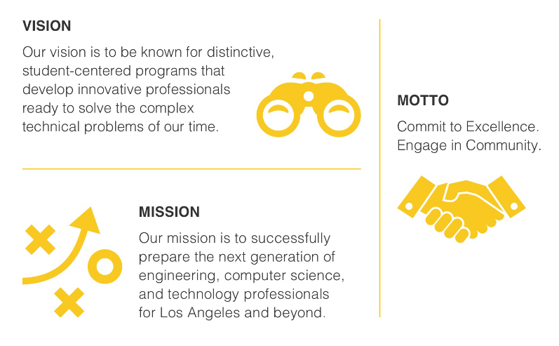

Figure 1.1: College of ECST Vision and Mission Statements.

**1.3 Goals and Program Learning Outcomes (PLOs)**

This uses ABET terminologies, which have been adopted by our department for a number of years (as described below).

* Goals are referred to as *Program Educational Objectives (PEOs)*.
* Program Learning Outcomes or Student Learning Outcomes are referred to *Student Outcomes (SOs)*.

Program Educational Objectives (PEOs) are broad goal statements that describe what graduates are expected to achieve within a few years of graduation. They provide guidelines, which offer a vision for the program.

Student Outcomes (SOs) are specific skills that students will possess at the end of the degree program. Student Outcomes provide curricular guidelines with respect to the program.

Our Program Educational Objectives are as follows.

1. *Students who had entered the workforce will have established themselves as effective professionals by having solved real problems through the use of their computer science knowledge and their communication, critical thinking, and problem solving skills.*
2. *Students who had continued in academia will have been successful in pursuing advanced degrees and in demonstrating their ability to master advanced areas of computer science.*
3. *Students will have demonstrated their ability to adapt to a rapidly changing environment by having learned and applied new knowledge and skills.*

The Program Educational Objectives are consistent with the mission statements of the department, college and the university. In particular:

* The first Program Educational Objective *Students who had entered the workforce will have established themselves as effective professionals…* is consistent with (a) the Department’s Mission statement *to graduate well educated computer scientists*; (b) the College’s Mission statement *To prepare the next generation of … computer science … professionals* and (c) the University Mission/Vision/Values Statement *A Culture of Excellence – We encourage and expect all members of our University community to pursue academic, professional, and personal excellence*.
* The second Program Educational Objective *Students who had continued in academia will have been successful in pursuing advanced degrees ...* is consistent with (a) Department’s Mission statement *…who are prepared to meet the challenges …*, (b) the College’s Mission statement *… prepare the next generation of ..computer science.. professionals …* and (c) the University Mission/Vision/Values Statement *Students First – We put our students' academic success, career-readiness, and well-being at the center of everything we do.*
* The third Program Educational Objective *Students will have demonstrated their ability to adapt to a rapidly changing environment …* is consistent with (a) the Department’s Mission statement *… meet the challenges of a rapidly changing …,* (b) the College’s Mission statement *prepare the next generation of … computer science… professionals for Los Angeles and beyond …*  and (c) the University Mission/Vision/Values Statement *Academic Distinction – We foster and promote academic distinction through innovation, academic rigor and the pursuit of lifelong learning.*

The consistency of Mission statements, Program Educational Objectives, Student Outcomes, and Course Objectives is best described by the pyramid shown in Figure 1.2.

Course Objectives contribute to the satisfaction of Student Outcomes, which in turn contribute to the satisfaction of Program Educational Objectives. Satisfaction of Objectives leads to the accomplishment of the Missions of the department, college, and university.

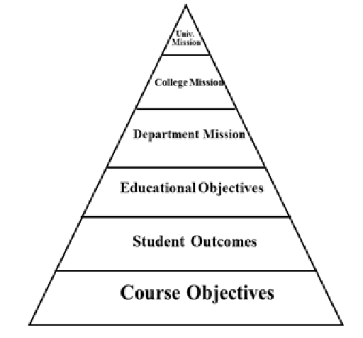

Figure 1.2: Mission-Objectives Pyramid Structure

The Student Outcomes of the graduate program in Computer Science (CS MS) are:

1. Students will have the ability to write and analyze sophisticated algorithms.
2. Student will have the ability to design, develop, and analyze complex software systems.
3. Students will have acquired advanced knowledge and skills in one or more areas of computer science.
4. Students will be able to communicate effectively both orally and in writing.

We are currently conducting strategic planning meetings at the department level. The main purpose is to review the department Vision, Mission, and Commitments.

**1.4 Changes in goals (referred to by PEOs) and Student Outcomes (SOs)**

The department has established a two-loop process for program assessment and evaluation, as described in Appendix I. The actual mechanism for revision of the program educational objectives and student outcomes is described in Appendix I by Loop #2 of Figure I.1. This process ensures that the program educational objectives and student outcomes are periodically reviewed and updated to meet the current needs of all constituencies.

The department had conducted two major reviews of Loop #2 activities. The first one took place in Spring 2012 during our accreditation cycle. The second review of PEOs and SOs took place in 2015-2016 during the Q2S conversion process. As a result of these assessment activities, the PEOs and SOs have been modified from those that existed during the previous program review.

The Program Educational Objectives and Student Outcomes during the last program review (2009) and current (2019) are shown below:

Program Educational Objectives in 2009:

1. *Graduating students have the knowledge and skills to pursue a career in industry and/or continue their education in PhD programs.*
2. *Graduates have the knowledge and skills that enable them to participate in research, life-long learning and to adapt to an ever-changing technological environment.*

Program Educational Objectives in 2019 (current):

1. *Students who had entered the workforce will have established themselves as effective professionals by having solved real problems through the use of their computer science knowledge and their communication, critical thinking, and problem solving skills.*
2. *Students who had continued in academia will have been successful in pursuing advanced degrees and in demonstrating their ability to master advanced areas of computer science.*
3. *Students will have demonstrated their ability to adapt to a rapidly changing environment by having learned and applied new knowledge and skills.*

Student Outcomes in 2009:

1. *Students will be able to apply concepts and techniques from computing to both theoretical and practical problems.*
2. *Students will develop advanced skills and knowledge in at least one specialized area of computer science.*
3. *Students will be able to communicate effectively orally and in writing.*
4. *Students will be able to pursue careers in industry or higher graduate degrees.*

Student Outcomes in in 2019 (current):

1. *Students will have the ability to write and analyze sophisticated algorithms.*
2. *Student will have the ability to design, develop, and analyze complex software systems.*
3. *Students will have acquired advanced knowledge and skills in one or more areas of computer science.*
4. *Students will be able to communicate effectively both orally and in writing.*

**1.5 Recommendations from last program review and accrediting body recommendations (if applicable) and actions taken by Programs**

The recommendations along with the actions are listed below:

Recommendation #1: Actively pursue marketing CSNS to other campus entities and perhaps beyond.

CSNS, developed by Prof. Chengyu Sun, is a web-based software system that integrates program assessment with learning management. It simplifies and improves the processes involved in the collection, analysis, and presentation of assessment data. In addition, the assessment functions built into the learning management system, which faculty and students use on a daily basis, encourage and facilitate a continuous and sustainable assessment process.

CSNS is a significant advance over previously available program assessment systems. Dr. Sun, who is also our assessment coordinator, has presented our work on CSNS in the following two forums:

* “Building Assessment Functions into LMS for Efficient and Sustainable Assessment Processes,” *ABET Symposium* 2016
* “Combining Program Assessment with Learning Management for Efficient and Sustainable Accreditation Processes,” *ASEE* 2016
* “Building Assessment Functions into LMS for Efficient and Sustainable Accreditation Processes”, 3rd Annual Assessment Faire, Cal State LA, 2018.

The ABET Program Evaluators cited CSNS as one of the program strengths: *“The CSNS [CS Network Services] software which the department has developed provides an efficient “one-stop shop” for student management and continuous improvement of the program. It serves as a learning management system, a place for advisers to track student progress and formation of teams, a repository for course documentation, and more. As an integrated system it dramatically improves the workflow of the department.”*

Certain features of CSNS are currently being utilized by a few other departments within the College. Also, with support of the department, Prof. Sun has been looking into ways to incorporate CSNS with Canvas LMS to promote CSNS usages on campus and beyond.

Recommendation #2: Investigate the feasibility of offering more online courses.

All lower division Computer Science courses have laboratory components. In addition, most of the upper division and graduate courses are project based. They are not well suited be offered as online courses. Faculty feel that the courses are better offered in a face-to-face format and that students should enroll with the intent to be on campus.

Online courses need effective use of the technologies and requires more faculty time and commitment, for example: creating engaging activities and collaborative projects through asynchronous group conversations using platforms such as Zoom or VoiceThread; Group activities, audio-video discussions, and multiple methods of communicating with the instructor created opportunities to interact with their instructor and students; etc. A few faculty have investigated delivering some portion of the course online.

Recommendation #3: Investigate the feasibility of offering a General Education elective course in computer literacy.

The Computer Science faculty have long felt that a computing course is needed in General Education. The departments of Computer Science and Computer Information Science have proposed CS/CIS 1200 as a General Education course. However, the course did not align with the existing General Education Block designations. We are planning to push for its inclusion next year.

Recent papers and articles show that computer competency courses or basic “code literacy” is becoming a requirement for 21st century culture. The abstract from a technical paper “Including a Programming Course in General Education: Are We Doing Enough?”, published in *Information Systems Education Journal* (May 2015) offers a compelling case.

*The issue with general education is not with the concept of creating students with a well-rounded, life preparing experience. The problem is that general education does not produce this type of student in all majors. For a major in a technical field, general education serves these students very well, the courses are truly outside of their major. However, the problem is that for many majors, typically in a non-technical field, such as: history, foreign language, arts, philosophy, religious studies, etc., general education fails to give these majors a well-rounded, life-preparing experience with relevant skills. Regardless of choice of major, students should learn to use computing systems to access, process, and analyze information as an essential aspect of critical thinking and problem solving. In many disciplines, students should also learn how to design algorithms, to write programs, and implement computing solutions applicable to their professions.*

*Increasingly, an understanding of programming logic is seen as a requirement for participation in today’s digital world. Due to efforts of organizations such as Code.org and many educational institutions around the country, courses in coding look less like an extracurricular activity and more like a basic life skill. Some school districts have expanded such efforts to as early as second grade. This literature shows the trend toward basic “code literacy” for a generally educated person will only get stronger.*

Recommendation #4: Investigate the feasibility of setting up a senior design project laboratory with a dedicated server to house such projects.

This recommendation has been met. ET B10, ET A310, and ET C245 support the Senior Design Project sequence of courses (CS4961-CS4962). They are equipped with modern conferencing facilities, which are used by students to interact with industry liaisons.

Every Senior Design project has access to either a physical or virtual server.

Recommendation #5: For students taking the MS thesis option, provide a broader pool of faculty research interests and opportunities.

This recommendation has been met. The Department currently has twelve full-time faculty with broader interests. In addition, we are recruiting for two more positions to start in Fall 2020. The list of students who completed a thesis indicates a number of faculty are involved in student thesis guidance. (See Appendix M)

Faculty student interaction is quite high on the graduate research thesis/projects.

In the last five years, three of our faculty (Dr. Kang, Dr. Sun and Dr. Pourhomayoun) have been recognized for mentorship of graduate students in the areas of Research, Scholarship and Creative Activity.

Recommendation #6: Ensure that the faculty hiring plan adequately covers potential growth of current and new programs, including the potential for increasing the part-time faculty pool to supplement full-time faculty.

The Department updates a three-year revolving hiring plan on an annual basis. Considerations include such factors such as unmet instructional needs, enrollment, planned program expansion, and faculty retirement projections. This plan is provided to the Dean for incorporation into the College Hiring Plan, which serves as the basis for our annual recruitment requests to the Provost.

Recent history confirms the university’s commitment to maintaining adequate faculty staffing levels.

* During the past six years (2013-2019) we carried out a search every year, and successfully hired four tenure-track faculty (an 80% successful search record). (In two of those years our preferred candidates chose other universities.)
* We have increased our full-time faculty by 50%, from eight to twelve between 2013 and 2019.
* The Department is currently recruiting for two tenure track faculty to start in fall 2020.
* The Department hiring plan includes recruitment of an additional tenure-track faculty each year over the subsequent three years.
* During the past five years (2013-2018) we increased the number of faculty lecturers from twelve to eighteen.
* The Los Angeles area provides a deep pool of talented potential lecturers, which can be tapped as needed.
* The Department’s expenditures for instructional faculty (tenure-track and lecturers) increased from $1,281,950 in 2015-2016 to $1,639,332 in 2017-2018.

To optimize the use of faculty time and to maximize the value of faculty contributions we have adopted a multi-level undergraduate advising model.

We believe that the structures and processes outlined above meet our current and anticipated faculty needs.

Recommendation #7: Use selected senior design projects (see Curriculum and Instruction above) as a recruitment tool.

This recommendation has been met. We showcase our senior design projects in multiple recruitment venues.

Recommendation #8: Investigate the feasibility of using a standardized examination such as the GRE to more easily (and with less workload) determine graduate students’ readiness.

We determined that a general GRE exam is not a good indicator for Computer Science readiness.

We tried using an assessment test to identify areas in which students needed additional work during the first semester. The results were disappointing, and we have stopped this practice and rely on a thorough transcript evaluation and a supplemental application.

# **2.0 Program Data**

**2.1 Student data in the Program**

The discussion below is based on the data in the Appendices B-D.

Undergraduate students:

* The number of new undergraduate enrollments has increased over the past five years. Including First Time Freshmen and Transfer students, there was an increase of 23% from 198 students to 244 students. (See Appendix B.1).
* Our undergraduate annualized FTES (Table B.1.2) has increased by over 50%. (443 in 2014 to 703 in 2018).
* Our undergraduate graduation rates (Table C.1.1 and Table C.1.2) have steadily improved. Most recent data (for 2012 cohort) indicates a 6 yr. graduation rate of 50% for First Time Freshmen and a 3 yr. graduation rate (for 2015 cohort) of 40.5% for transfer students.
* Our undergraduate 6-year graduation rates (50%) for First Time Freshmen is on par with the university rates (49%) while our transfer student 4-year graduation rates (39%) are lower than the university rates (64%).
* We are taking further advising activities to improve the graduation rates as we strive to meet the GI2025 challenge. The Major Specific Criteria introduced for transfer students will boost the graduation rates of transfer students. We are also enforcing the same criteria to our pre-majors, which will improve the graduation initiative.
* A reverse analysis of all 101 students that graduated in 2017-2018 indicates that the average graduation time is around 5.5 years for First Time Freshmen and around 3 years for transfer students.

Graduate students:

* During the 2014-2018 period the head count of graduate students (Table B.2.2) has declined (235 in 2014 to 100 in 2018). This decline over a five year period is due by a number of factors.
  + We have tightened the admission criteria so as to limit the number of students from non-Computer Science disciplines. These students were formerly admitted as “conditional” and were required to complete a list of undergraduate core courses. These students would often spend an extended period of time completing the undergraduate requirements before starting the graduate program. A loose admission standard resulted in a first year dropout rate of approximately 22% (2014 cohort). Even though the remaining 77% of the students graduated in less than 3 years, this approach posed a significant retention issue. By tightening the admission standards, fewer than 10% (2017 cohort) dropped out during their first year.
  + Typical of many Computer Science graduate programs, there was an over-reliance on international students. The number of international students has dropped with the changing political climate. This mirrors the national trend in the computing disciplines.
  + We still have the highest yearly rate of incoming graduate students in the College of ECST.
  + We are making significant recruitment efforts to increase the number of incoming local and international students. (See Section 6.2).
* The persistence rate for graduate students after their first year (Table C.2.1) has increased steadily and is now better than 90% (2017 cohort).
* Our graduate student graduation rate (Table C.2.1) has increased over the past five years. Of the 2015 year cohort, 88.8% of the students graduated in 3 years or less.
* It is noteworthy that all the students who were retained after first year went on to graduate in three years or less.
  + For the 2014 cohort of 144 students, 110 students graduated in 3 years or less.
  + For the 2015 cohort of 89 students, 79 students graduated in 3 years or less.
* For the 2015 cohort, our 3 year graduation rate is much higher when compared to the other disciplines within ECST (78.8%) and the University (75.9%).
* A reverse analysis of students who graduated indicates that the average graduation time to a CS MS degree is less than 3 years.
* A somewhat unique program allows some of our talented CS BS students to join the CS MS graduate program as an integrated program. With some overlap between the two programs, the students graduate with a CS BS and CS MS at the same time. During this period, we have typically 2 to 3 students that join this program every year and graduate with both degrees by adding one to one and half year to get the additional master’s degree.

**2.2 Impact of enrollment trends**

The total headcount of undergraduate and graduate students during the 2014-2018 period increased from 757 students to 890 students. We also serve about 50 international exchange students every year.

During the same period (2014-2018) (Appendix J), full-time tenured/tenure-track faculty increased from 8 to 12. We are also recruiting two new tenure-track faculty to start in Fall 2020.

During the same period (2014-2018), our FTEF (Appendix D) increased from 15 to almost 20. The increase in FTEF was facilitated by a pool of talented lecturers. (See Appendix L)

The Department updates a three-year revolving faculty hiring plan on an annual basis. Considerations include such factors such as unmet instructional needs, enrollment, planned program expansion, and faculty retirement projections. Recent history confirms the university’s commitment to maintaining adequate faculty staffing levels and meet the enrollment demands of the discipline.

We believe that the structures and processes outlined above meet our anticipated student and faculty needs.

# **3.0 Curriculum and Instruction**

**3.1 Curriculum**

**3.1.1 Curriculum Description**

The current CS MS degree requires completion of 30-33 units as described in (i) through (ii) below. No more than 6 units of acceptable post-baccalaureate transfer course work completed prior to entrance into classified standing may be included in the master’s degree program.

(i) Breadth Requirement (9 units)

Select three courses from the following five areas of study.

Algorithms:

* [CS 5112 - Design and Analysis of Algorithms](http://ecatalog.calstatela.edu/preview_program.php?catoid=11&poid=3445) (3)

Network Systems:

* [CS 5780 - Advanced Information Security](http://ecatalog.calstatela.edu/preview_program.php?catoid=11&poid=3445) (3)

Web Systems:

* [CS 5220 - Advanced Topics in Web Programming](http://ecatalog.calstatela.edu/preview_program.php?catoid=11&poid=3445) (3)

Advanced Programming:

* [CS 5035 - Topics in Functional Programming](http://ecatalog.calstatela.edu/preview_program.php?catoid=11&poid=3445) (3)

Software Engineering:

* [CS 5337 - Advanced Software Engineering](http://ecatalog.calstatela.edu/preview_program.php?catoid=11&poid=3445) (3)

(ii) Choose one of the following two options:

Option 1: Thesis/Project Option

* [CS 5990 - Thesis or Project I](http://ecatalog.calstatela.edu/preview_program.php?catoid=11&poid=3445) (2+1) – Registered over two terms
* With the approval of the CS advisor, choose 18 units of 4000/5000 level courses with a minimum of 9 units from 5000 level courses.

Option 2: Comprehensive Exam Option

* With the approval of the CS advisor, choose 24 units of 4000/5000 level courses with a minimum of 12 units from 5000 level courses.
* CS 5960 - Comprehensive Examination (0)

**3.1.2 Curriculum Roadmaps**

Graduation roadmaps are suggested academic plans. Students are expected to design their own plans to complete the degree requirements in a timely fashion.

* Students should take note of the course scheduling patterns and ensure that courses will be available when they need them. (See Graduate Student Handbook - <http://www.calstatela.edu/ecst/cs/student-handbook-0>)
* Students should also plan to complete all prerequisite courses prior to started graduate courses.
* It is strongly recommended that students enroll in no more than three courses during any term.
* Summer term courses can accelerate completion of the requirements.
* All pre-requisite courses must be completed during a student’s first semester unless a longer time is approved by the graduate advisor.

 Plan 1: Thesis Option Roadmap

|  |  |  |  |
| --- | --- | --- | --- |
| year  1 | summer | fall | spring |
|  | CS 5xxx (core) | CS 5xxx (core) |
|  | CS 4xxx/5xxx | CS 4xxx/5xxx |
|  | CS 4xxx/5xxx | CS 4xxx/5xxx |
|  |  | WPE |
|  |  |  |

|  |  |  |  |
| --- | --- | --- | --- |
| year  2 | summer | fall | spring |
|  | CS 5xxx (core) | CS 4xxx/5xxx |
|  | CS 4xxx/5xxx | CS 5990 |
|  | CS 5990 |  |
|  |  |  |
|  |  |  |

### 

Plan 2: Comprehensive Exam Option Roadmap

|  |  |  |  |
| --- | --- | --- | --- |
| year  1 | summer | fall | spring |
|  | CS 5xxx (core) | CS 5xxx (core) |
|  | CS 4xxx/5xxx | CS 4xxx/5xxx |
|  | CS 4xxx/5xxx | CS 4xxx/5xxx |
|  |  | WPE |
|  |  |  |

|  |  |  |  |
| --- | --- | --- | --- |
| year  2 | summer | fall | spring |
|  | CS 5xxx (core) | CS 4xxx/5xxx |
|  | CS 4xxx/5xxx | CS 4xxx/5xxx |
|  | CS 4xxx/5xxx | CS 5960 |
|  |  |  |
|  |  |  |

**3.2 Compliance with EO 1071**

* The CS MS degree requires completion of 30 units under the thesis option and 33 units under the comprehensive exam option.
* There are no options or concentrations in the program.
* The CIP code 11.0701 for Computer Science is described below:
  + *A program that focuses on computer theory, computing problems and solutions, and the design of computer systems and user interfaces from a scientific perspective. Includes instruction in the principles of computational science, computer development and programming, and applications to a variety of end-use situations.*
* As described by the CIP code, Computer Science has a very broad description, which has become even broader with newer technologies. All the CS5xxx level courses fall under the description of the CIP code for Computer Science.
* To provide some flexibility, we have defined five breadth areas of which students are required to select three. We ensured that the Student Outcomes are met by any combination of the three chosen breadth areas.
* Our current program does not meet the 50% core indicated in EO 1071. In order to comply with EO 1071, we have submitted a program modification that defines a core of 18 units (out of the required 30 units). The 18-unit core requires two courses each from the following three thematic categories. (See Appendix N)

|  |  |
| --- | --- |
| **Area** | **Existing Courses** |
| Software design and implementation.    (These courses are in the core tradition of CS, i.e., writing software.) | * Programming paradigms-CS5035 * Algorithms-CS5112 * Web-based systems-CS5220 * Software Engineering-CS5337 |
| System infrastructure.    (These courses are in subjects that enable computer systems to operate and that support their operation.) | * Network Protocols-CS5470 or Networks Management-CS5781 * Security-CS5780 * Operating Systems-CS 5440 |
| Computing in the world.    (These courses reflect the revolution in CS over the past decade. We now interact much more strongly and frequently with the physical and human world.) | * AI-CS5660 * Data Science –CS5661 * Computer Graphics – CS5550 or Visualization –CS551 |

**3.3 Comparison with peer institutions**

All Computer Science undergraduate (BS) degree programs are ABET accredited.

Among the graduate programs across the CSU

* There is some commonality in the graduate programs (MS).
* All graduate courses emphasize both theory and practice. Typically, all graduate courses involve advanced course work and demand a capacity for critical analysis and advanced computer programming to a variety of end-use situations.

**3.4 GE courses**

We do not offer any GE courses at this time. See Section 1.5 (Recommendation #3)

**3.5 Service courses**

The following table lists our service courses.

|  |  |  |  |
| --- | --- | --- | --- |
| Courses | Semesters Offered | # of Students Enrolled  (one year) | Major/ Dept(s) Served |
| CS 1550 | Once a year | 20 | GRAPH BS |
| CS 1220 | Once a year | 20 | GRAPH BS |
| CS 2550 | Once a year | 15 | GRAPH BS |
| CS3801 | Once a year | 10 | GRAPH BS |
| CS2011 | Twice a year | 10 | MATH BS |
| CS2012 | Twice a year | 5 | MATH BS |

The department offers undergraduate courses as service courses for the MATH BS and GRAPH BS programs. Based on the feedback from these departments/programs, these courses have been effective.

* MATH BS:
  + Allows CS classes (CS2011, CS2012) as one of the choices in their program.
  + These courses are also taken by CS majors. The number of MATH BS majors is a small percentage of the courses.
* GRAPH BS:
  + A few CS courses (CS1220, CS1550, CS2010) are required in the GRAPH BS program. These courses are tailored to meet the needs of this program and were been updated during semester conversion. The other CS courses are required in the GRAPH BS program under the CS option. The coordinator of the GRAPH BS program has been in consultation regarding these courses.
* A few other engineering programs allows some upper division CS courses as electives. This pertains to a very small number of students.

**3.6 Minors, credential or certificate programs**

A Computer Science minor, available for students majoring in other fields, consists of 24 units; 9 are upper division. Some of the courses required for the minor are also designated for CS majors.

Over the last five years, only seven students graduated with a minor in Computer Science. There are thus very few students opting for a minor.

**3.7 Opportunities for student research/scholarly/creative activity (RSCA)**

Undergraduate and graduate students have different varieties of research experiences as described below:

Undergraduate Students:

All students are required to complete a senior design group project--which is advised by a faculty member. To this end, all faculty collaborate in securing sponsored Senior Design projects from industry, the government, non-profits, small businesses, and individuals.

The Senior Design sequence (CS 4961, CS 4962) gives students an opportunity to design a software system that addresses a realistic problem. Students address various topics/issues and explain their design/implementation methodologies. The culminating college wide event is referred to as a Senior Design Expo. Student teams make a poster and make a formal presentation of their project in front of the Industry Advisory Board and project liaisons.

For the year 2018-2019, 102 students were divided into 21 team projects with many faculty advising one or more projects. (See <https://csns.calstatela.edu/department/cs/projects>).

Graduate Students:

Faculty RSCA (Research, Scholarship and Creative Activities) provides for creative research activities with graduate students. During the last five years, Dr. Abbott, Dr. Amini, Dr. H. Guo, Dr. J. Guo, Dr. Kang, Dr. Pourhomayoun, Dr. Sun, Dr. Ye, and Dr. Zhu have received unit creative leave awards to pursue a professional activities that involved graduate students.

Three of our faculty (Dr. Sun, Dr. Kang and Dr. Pourhomayoun) received the Faculty Mentor recognition from the Office of Graduate Studies in the last five years. This award is granted for outstanding graduate student mentoring.

Many faculty collaborate with graduate students and guide them in meaningful thesis projects.

Many graduate students are involved in faculty sponsored projects, which are supported by grants. A summary of activities is described below.

* Dr. Elaine Kang: Dr. Kang has led “[Visual Media Laboratory](http://www.calstatela.edu/research/visualmedia-laboratory)” focusing on visual software developing including video games and AR/VR. 15 students mentored on a variety of projects sponsored by different funding agencies.
  + JPL (Jet Propulsion Laboratory) projects
  + CEAS project
  + NSF GK-12 IMPACT LA Project
  + Lockheed Martin Imaging Project
  + NSF TUES Project
* Mohammad Pourhomayoun: Established and directed a new research group/lab at CSULA named *“Data Science Research Lab”* (www.calstatela.edu/research/data-science). 17 graduate students have worked on projects through the lab. These were sponsored by Toyota, City of LA, County of LA, Medtronic, and Caltrans. This is an impressive list of projects in the last three years. The projects include the following topics.
  + Machine Learning and Computer Vision for Traffic Management and Accident Prevention
  + Machine Learning for Predicting, Detecting, and Managing Cancer
  + Predictive Analytics for Chronic Disease Management
  + Big Data Analytics for Understanding/Predicting the Genetic Basis of Disease
  + Data Science for Remote Health Monitoring
  + Context-Aware Analytics for Patient Monitoring:
  + Automatic Pedestrian/Bicyclist Recognition in Video Streams
  + Interactive Map for Traffic Data Analytics and Visualization
  + Predictive Analytics for Marketing and Business Intelligence
* Chengyu Sun: Three student projects have led directly to the development of major scholarly software products:
  + SCRS: The SharePoint Curriculum Review System modernizes the curriculum review workflow and replaces the previous cumbersome paper-based system. SCRS played an important role during Q2S. It was used by almost all departments and colleges across the university. SCRS also includes many features that were not used during Q2S but that will be employed after conversion is complete.
  + CESAR: CESAR is an online advisement system developed for the ECST Student Advisement and Recruitment Center (which has been recently renamed as SSC: Student Success Center).
  + Golden Eagle Flight Plan Online: A Web-Based Advisement/tracking/career-preparation tool for the College of ECST.
* Navid Amini – Two graduate students collaborated on two externally sponsored projects in the year 2018-2019.
  + Sponsored by Vodafone - Assistive Technology for the Visually Impaired.
  + Sponsored by RSCA: Glaucoma Progression Detection with Bayesian Analysis.
  + Submitted a paper to the Investigative Ophthalmology & Visual Science Journal In collaboration with UCLA physicians and researchers.
  + The projects significantly helped the students in landing their first job
* Jiang Guo – Six graduate students collaborated on sponsored projects in the last three years.
  + Sponsored by [NASA Data Intensive Research and Education Center](http://www.calstatela.edu/centers/NASA_DIRECT_STEM)
* Zilong Ye –Two graduate students collaborated on sponsored projects in the last three years.
  + Sponsored by Fujitsu, Jovian, NEC Laboratories America.

Many faculty have collaborated with graduate students on scholarly activities leading to more than 40 peer-reviewed conference publications (These are listed under each faculty in Appendix K)

See Appendix G for a list of all completed graduate student thesis along with their faculty advisor.

**3.8 Academic advising**

At least one full-time faculty member serves as the graduate program advising coordinator. All graduate students undergo a first-time advisement session when they arrive on campus. They are pointed to the Graduate Student Handbook on the department website for their program needs.

Graduate students are required to meet with the principal graduate advisor as they change their graduate standing from G1 to G2 to G3. During this visit, students refine their plans for satisfying the remaining requirements.

Students meet with the principal graduate program advisors or the Department chair for all advising related issues.

Academic student advising is also a part of all faculty members’ responsibilities. All faculty members can be approached for advisement issues during their office hours.

Graduate students also meet with the College Graduate Program Coordinator to resolve any issues that may arise.

All students thus receive academic advisement to help them make informed academic choices.

Students and Alumni surveys have all been satisfactory in this regard.

**3.9 Masters theses, projects and dissertations**

All students under the project/thesis option register for a two semester course sequence (CS5990). Students usually start working on their thesis (prior to registering for CS5990) early in their graduate program.

The Thesis is evaluated by the faculty using the following rubrics:

* Competency in Advanced Areas
* Program Development and Description
* Software Design and Implementation
* Written Communication
* Oral Communication

See Section 4.3 for evaluation of these rubrics.

See Appendix G for a complete list of Theses completed during the last five years.

**3.10 Innovations in the curriculum**

All our courses are offered in a face-to-face format. The university’s conversion from Quarters to Semesters allowed us a chance to re-examine and strengthen our program. We (i) modified course content and/or its delivery, (ii) added new courses, deleted course that had become outdated, and (iii) revised or modified modes of instruction (e.g., adding laboratory components).

Faculty have enhanced existing skills and learned new ones: in technical areas, in the development of innovative teaching and learning strategies, and in the appropriate use of technology in classrooms.

Many faculty are involved in student capstone projects both at the undergraduate (senior design team projects) and graduate (individual thesis/projects) levels. Most of the projects are externally sponsored. These projects require high student-faculty interactions and bring out the ingenuity and innovation of our graduating class.

To foster development in innovative teaching and learning strategies, some faculty attend regional and national engineering educational seminars. The Center for Effective Teaching and Learning (CETL) was established to help achieve this goal. CETL advances the scholarship of teaching and learning by offering a variety of services to assist faculty in developing their full teaching potential. Since 2015, all Computer Science new faculty have attended the ECST Teaching and Learning (T&L) Academy, which offers professional development for faculty across all disciplines in the college. The ECST T&L Academy offers a summer workshop that includes hands-on practice on evidence-based teaching as well as series of monthly learning-community meetings. Both full-time faculty and lecturers share best practices and discuss issues related to teaching and learning during these meetings. Many of our faculty, such as Drs. Russ Abbot, Zilong Ye, and Elaine Kang have become active contributor to T&L Academy by leading sessions in summer workshop or facilitating faculty learning community meetings.

Many new courses were developed (or modified courses) to meet the changing demand of the CS workforce. Machine Learning and Data Science have become increasingly important sub-disciplines of computer science. In addition to the existing CS4660 (Artificial Intelligence), CS4661 (Introduction to Data Science), we have developed two new courses [CS 4662 (Advanced Machine Learning) and CS 4663 (Deep Learning]) In addition, Data Visualization (CS 4664) has been developed as a new course which will communicate data or information by encoding it as visual objects

# **4.0 Assessment of Student Outcomes**

**4.1 Student Outcomes and Curriculum Map**

The mapping between Core courses and Outcomes is shown in the following table.

|  |  |  |  |  |  |  |  |
| --- | --- | --- | --- | --- | --- | --- | --- |
| Outcomes/Courses | CS5035 | CS5112 | CS5220 | CS5337 | CS5780 | CS5990 | CS5960 |
| #1 | I, D | I, D |  |  | I, D | M | M |
| #2 | I, D |  | I, D | I, D |  | M | M |
| #3 | D | D | D | D | D | M | M |
| #4 (Oral) | I, D |  | I, D | I, D |  | M | M |
| #4 (Written) | I, D |  |  | I, D | I, D | M | M |

The core courses that contribute to the achievement of Outcomes are specified. The table indicates where the Learning Outcomes are Introduced (I), Developed (D), and Mastered in the curriculum

**4.2 Comprehensive Assessment Plan**

Appendix I describes the Comprehensive Assessment Plan for CS programs.

Loop #1 (Appendix I - Figure I.1) assesses the attainment of student outcomes on an annual basis.

1. Implement assessment measures (rubrics, assignments, surveys) on CSNS. (See Appendix I – Loop 1.2)
2. Collect assessment data in core courses (See Appendix I -Table I.2)
3. Graphically/visually represent the assessment data (See Appendix I – Loop I.3) and analyze the data (See Section 4.3 for each Student Outcome)
4. Close the loop for continuous improvement of the program. The process is described in Appendix I – Loop I.4. (See Section 4.3.2 for examples of continuous improvement.)

Loop #2 (Appendix I - Figure I.1) ensures that the program educational objectives and student outcomes are periodically reviewed and updated to meet the current needs of all constituencies. This is completed on a 3 year cycle in 2012 and 2015. (This Loop #2 has been discussed earlier in Section 1.4)

**4.3 Student Outcomes Assessment**

This section describes the level of attainment for each of the student outcomes.

**4.3.1 Evaluation of achievement of SOs**

Data collected from various measures is analyzed to determine whether the achievement target for each Student Outcome is met.

SO data is depicted as graphs with the following characteristics:

* Data is represented on a 5 point scale that signifies various levels of attainment. (1. Unsatisfactory 2. Poor 3. Satisfactory 4. Good 5. Excellent.)
* The Stacked Bar graph represents individual student attainments. Each bar represents 100% of the students with each of the five segments of the graph representing the different levels of attainment of the “performance indicator”. Different colors in segments illustrate the different attainments [Dark Red(1), Light Red(2), Yellow(3), Light Green (4), Dark Green(5)]
* The Bar Graphs typically represents class averages with each vertical bar indicating different “performance indicator” as indicated on the X-axis.
* Labels on the Y-axis refer to the scale that was employed—either a 5 point scale or a 100% scale.
* The graph titles refer to the rubric name, the course, term and year when the data was collected. (For example: “Graduate Program – Program Development and Description” is the rubric name, “CS5035” is the course in which data was collected in “S19”)
* Satisfaction survey from each constituent is indicated by bar graphs.

Student Outcome #1

*Students will have the ability to write and analyze sophisticated algorithms.*

The development and analysis of algorithms is fundamental to all aspects of computer science. (An algorithm is a formally specified procedure for solving a well-defined computational problem.) Algorithm development is more than just programming. It requires an understanding of the alternatives available for solving a computational problem, including the programming languages and performance constraints that accompany any particular solution. It also requires understanding what it means for an algorithm to be “correct” in the sense that it fully and efficiently solves the problem at hand.

CS 5035, CS5112, CS5780, CS5960 and CS5990 have sophisticated assignments that develop students’ ability to analyze a problem and write algorithms for its solution.

Graphs:

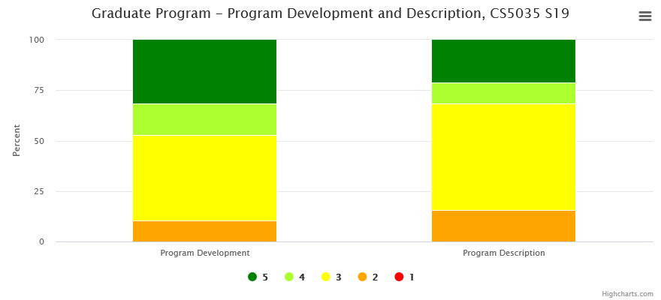

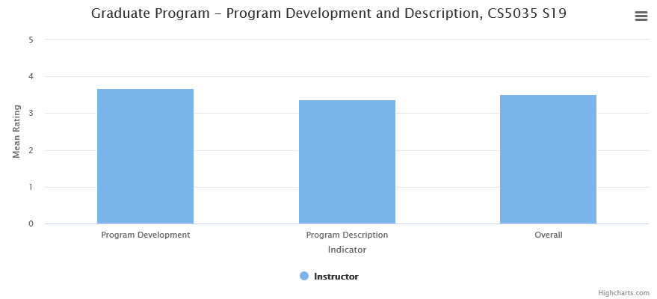

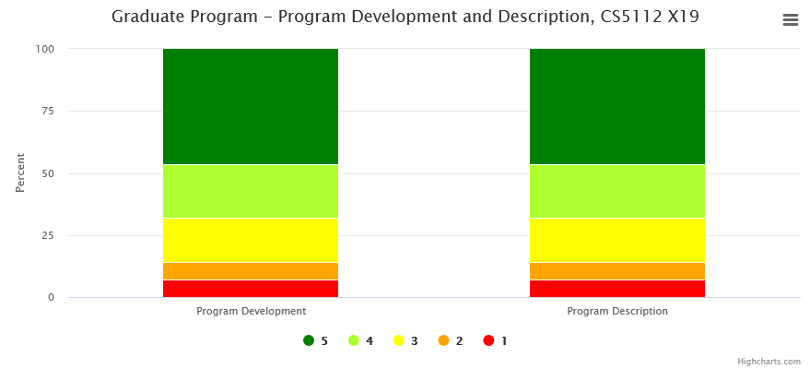

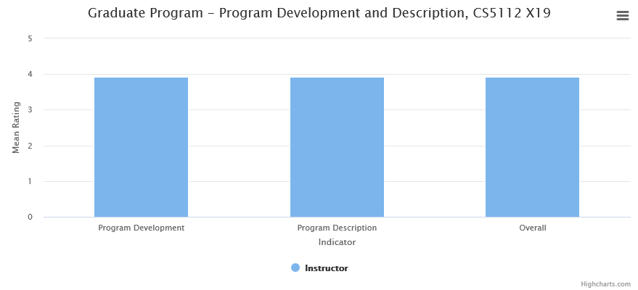

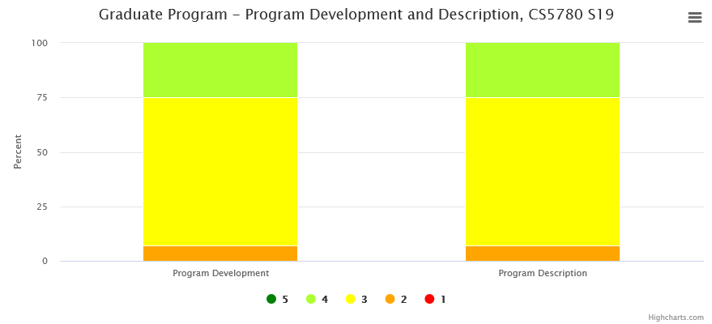

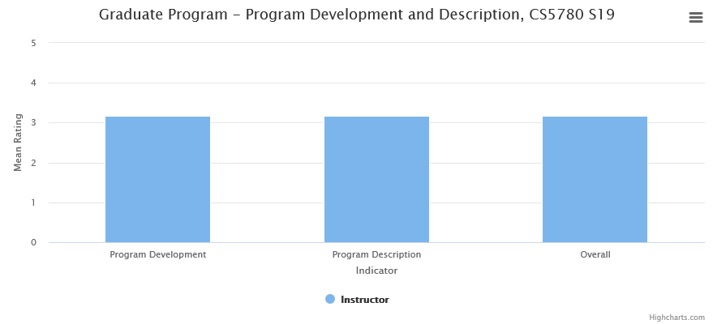

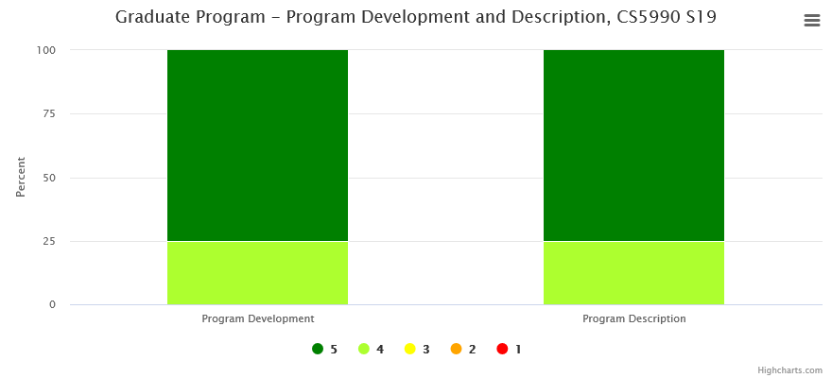

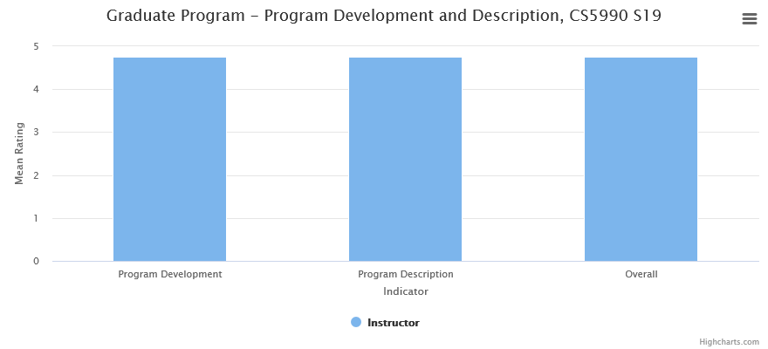

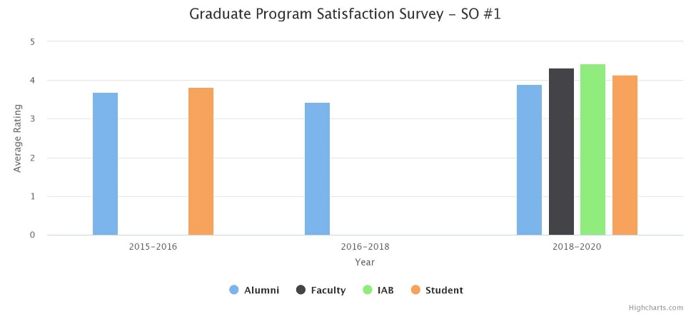

Analysis:

* The results on our assessment process in CS 5035, CS5112, and CS5780 courses indicate that the student average is around 3.5/5 with more than 95% of the students achieving “satisfactory” or above performance.
* CS5990 requires a minimum of two semesters of original research. Faculty assessment indicates that student possess an excellent understanding of the subject area. More than 95% of the students achieve better than “good” performance and 75% of the students achieving “excellent” performance.
* CS5960 is a comprehensive exam and all students have to achieve satisfactory or better performance. (A few students who scored less than satisfactory performance will discuss with the graduate advisors, prepare better and retake the exam in the subsequent term)
* All results exceed the target levels. CS 5035, CS5112, and CS5780 courses continue to evolve with evolving language paradigms and new technologies.
* Students, Alumni, Faculty, and IAB surveys have all been satisfactory. (IAB and faculty surveys was only available for the 2018-2020 cycle).

Student Outcome #2

*Student will have the ability to design, develop, and analyze complex software systems*

Students work on complex software projects and produce deliverables ensuring that the requirements, design and development are appropriate.

These projects demonstrate the students’ ability to analyze, design, implement, and evaluate a computer-based system, process, component, or program to meet desired needs.

CS 5035, CS5220, CS5337, and CS5990 have projects that develops students’ ability to develop and analyze complex software systems.

Graphs:

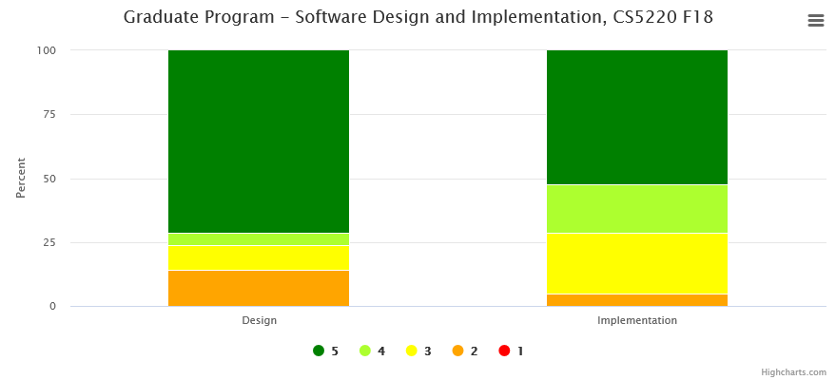

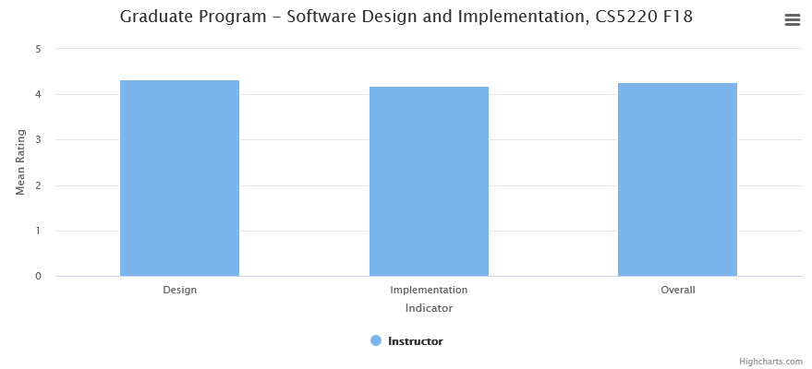

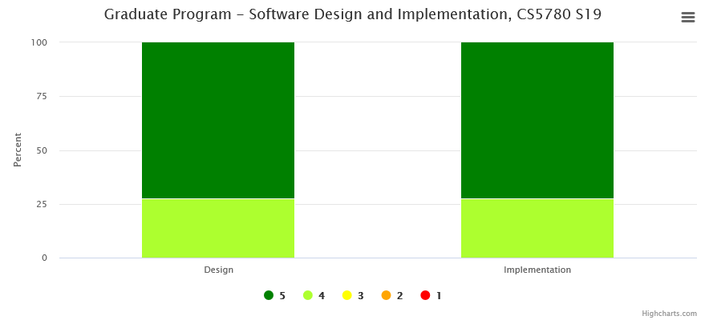

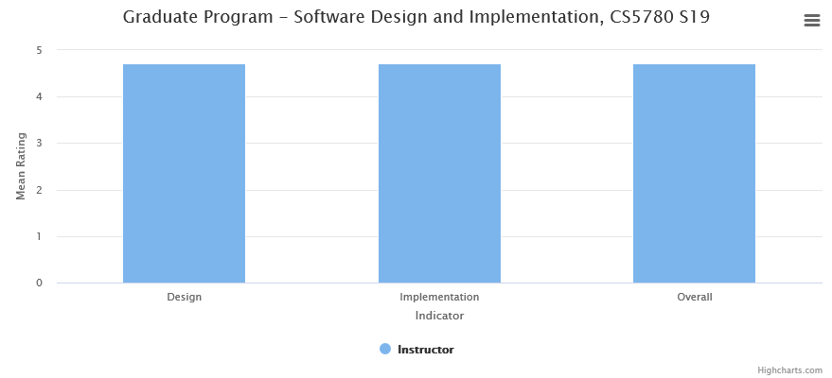

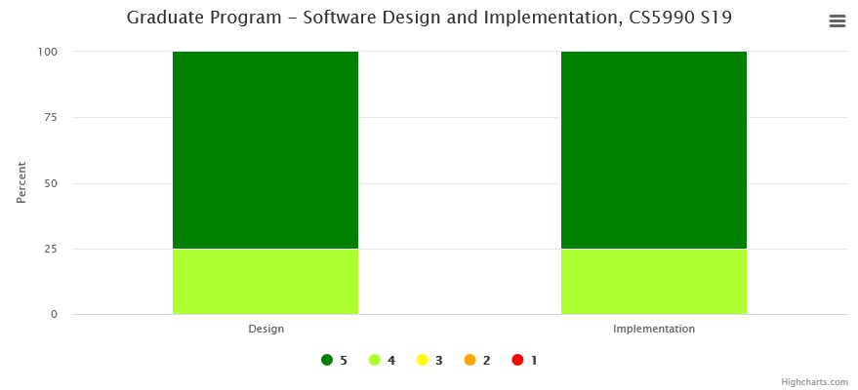

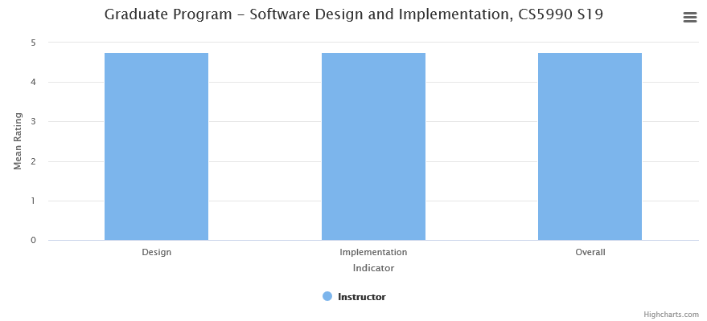

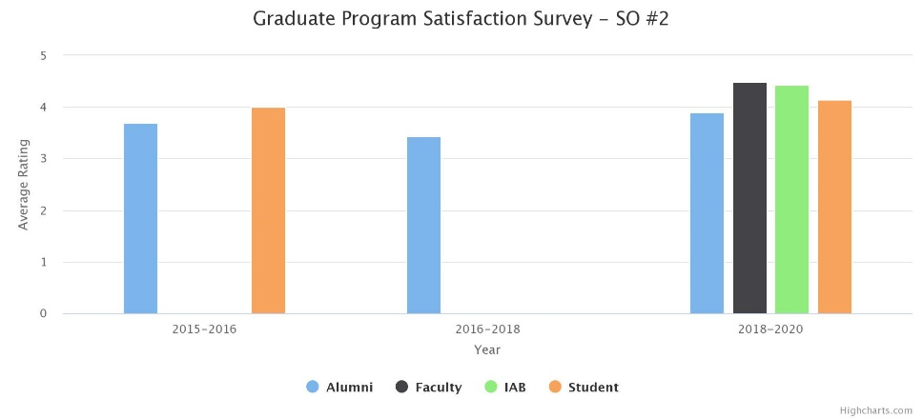

Analysis:

* The results on our assessment process in CS 5035, CS5220, and CS5337 courses indicate that the student average is around 3.5/5 with more than 90% of the students achieving “satisfactory” or above performance.
* In CS5990, each student must prepare a written thesis that documents the methods, analysis, and results in building a software system. Faculty assessment indicates that better than 95% of the students achieve better than “good” performance and 75% of the students achieving “excellent” performance.
* All results exceed the target levels. CS 5035, CS5220, and CS5337 courses continue to evolve with evolving language paradigms and new technologies.
* Students, Alumni, Faculty, and IAB surveys have all been satisfactory.

Student Outcome #3

*Students will have acquired advanced knowledge and skills in one or more areas of computer science*

Principal areas of study within Computer Science include algorithm analysis, artificial intelligence, computer systems and networks, security, database systems, web systems, human computer interaction, vision and graphics, numerical analysis, programming languages, software engineering, bioinformatics and theory of computing.

CS 5035, CS5112, CS5220, CS5337, and CS5780 core courses emphasize five of the above mentioned areas.

Graphs:

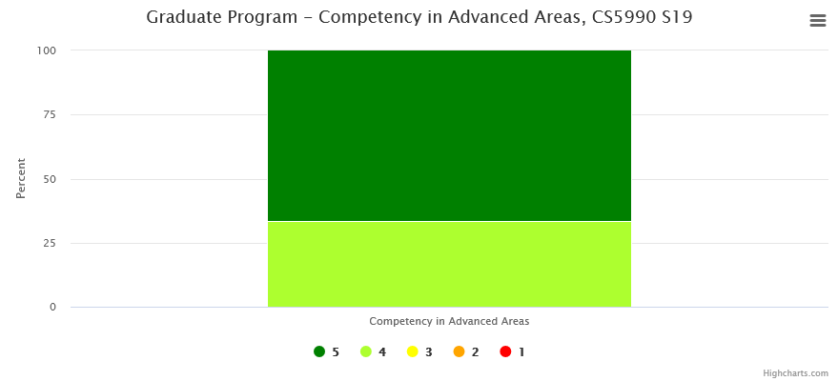

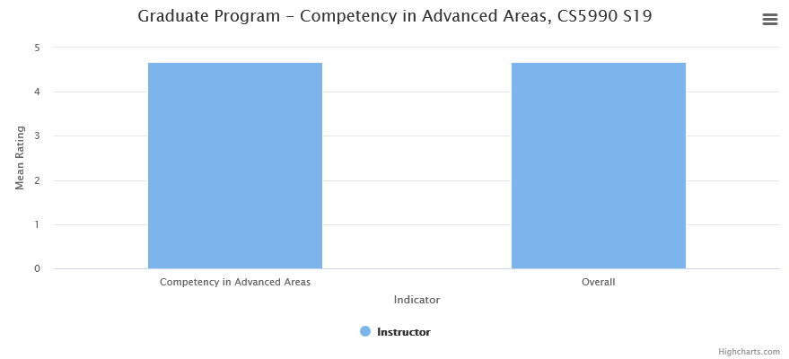

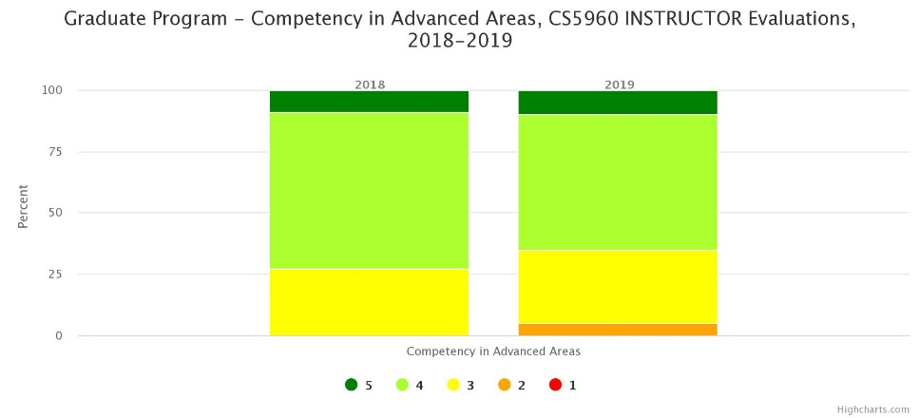

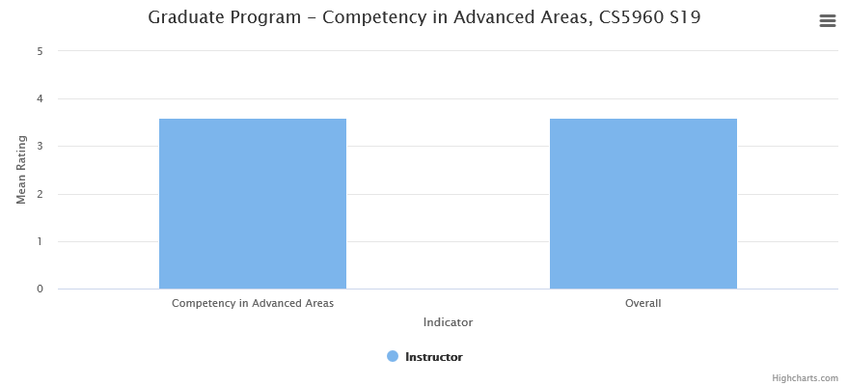

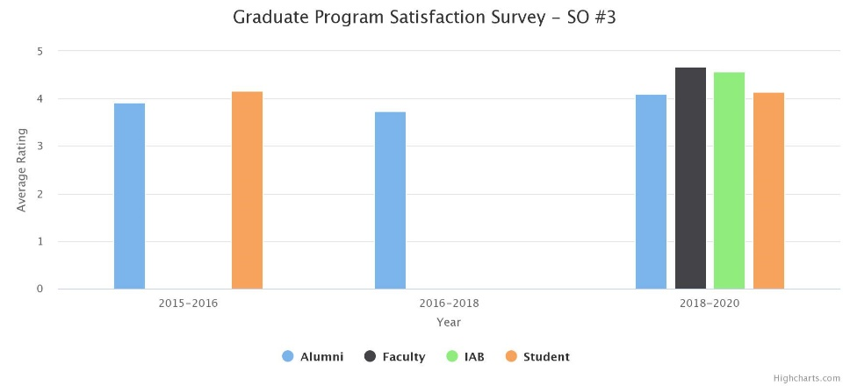

Analysis:

* In CS5990, each student develops and completes of a formal research paper in an advanced area of computer science. Faculty assessment indicates that better than 95% of the students achieve better than “good” performance and 75% of the students achieving “excellent” performance.
* In CS5960, each student has to satisfactorily complete a comprehensive exam that is designed to test the student’s knowledge acquired in the program. The comprehensive exam is a practical exam designed to evaluate each student's ability to apply what they have learned in three of the five breadth areas. All students achieve better than “satisfactory” performance.
* Technology has been growing so exponentially over recent years leading to newer areas in computer science. In the new program modification, students will be exposed to additional emerging areas of computer science.
* Students, Alumni, Faculty, and IAB surveys have all been satisfactory.

Student Outcome #4

*Students will be able to communicate effectively both orally and in writing*

Oral and written communication is an important factor in almost all Computer Science courses. Students demonstrate the skills especially in CS 5035, CS 5220, CS5337, CS 5780, and CS 5990. Students are evaluated based on a rubric with many indicators. Oral communication is evaluated for Knowledge and Delivery. Written communication is evaluated for Content Organization, Language Proficiency and Document Format.

Graphs:

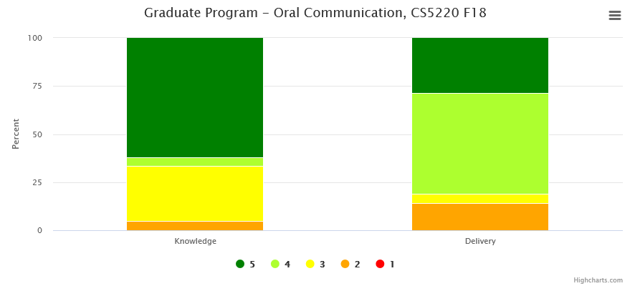

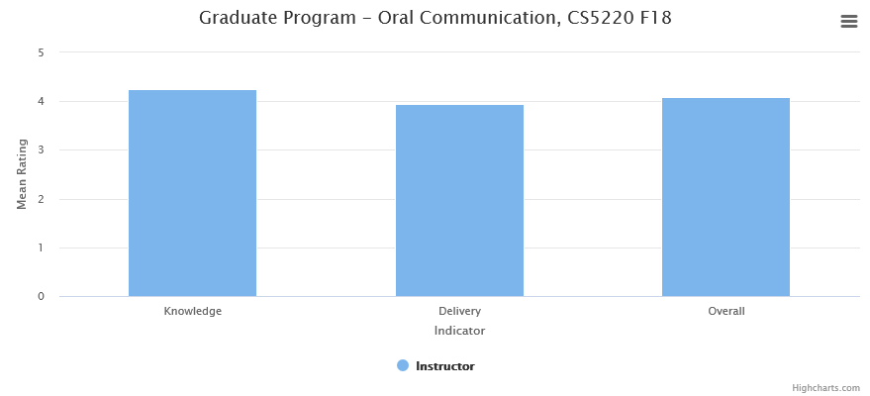

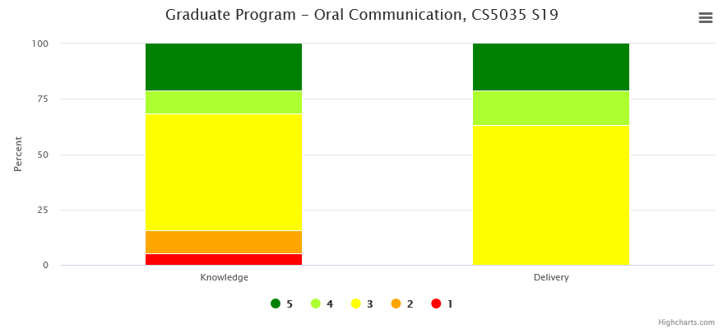

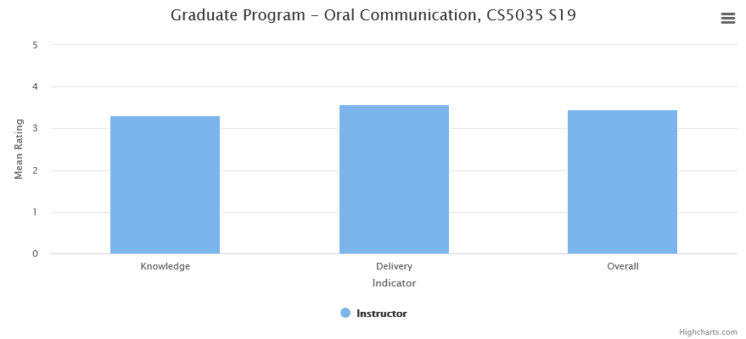

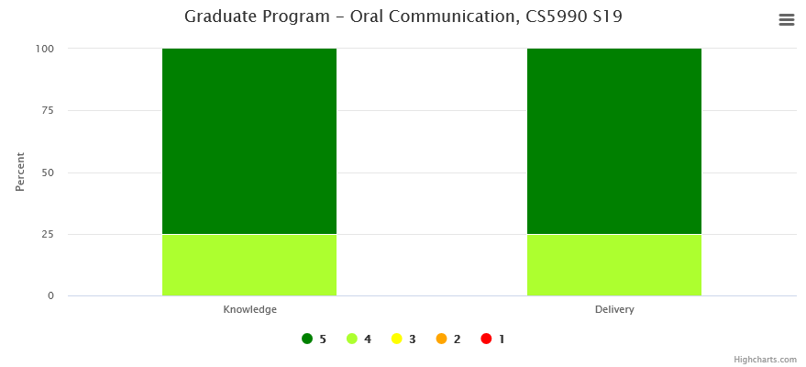

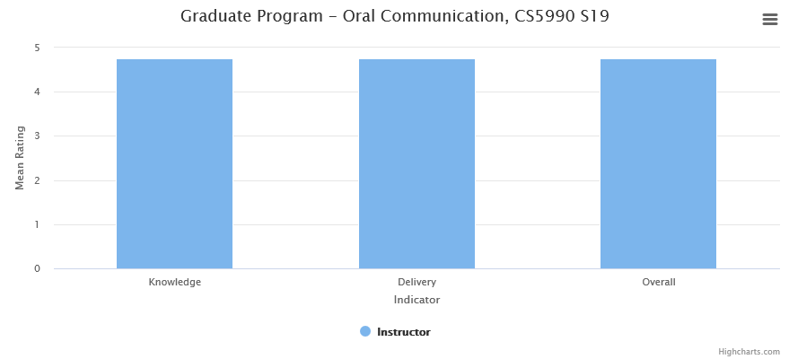

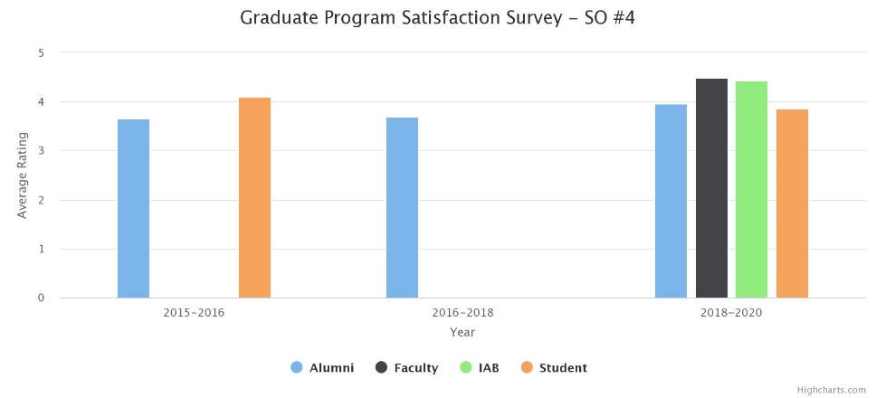

Analysis:

* CS5035, CS5220, and CS5337 courses emphasizes critical thinking and deliver professional-level oral presentations. Students are required to do several assignments culminating in oral presentations. Oral Communication Rubric evaluations are satisfactory.
* CS5035, CS5337 and CS5780 requires students to plan, organize, and compose software written documents. Written Communication Rubric evaluations are satisfactory on each of the performance indicators.
* Students make formal presentations in each of the semesters in which they enroll in CS5990. Oral Communication is evaluated at the second semester presentation during the department wide thesis presentations. Students generally received excellent evaluations for these presentations.
* Each student in CS5990 prepares a written thesis that documents the methods, analysis, and results of the research they carried out for their MS thesis. Faculty assessment indicates that better than 95% of the students achieve better than “good” performance on each of the performance indicators.
* Students, Alumni, Faculty, and IAB surveys have all been satisfactory.

**4.3.2 Closing the Loop – Continuous improvement examples**

The methodology of “Closing the Loop” is described in Appendix I. The assessment data collected from various measures is analyzed followed by faculty retreat discussions, and Industry Advisory Board reviews. We have made course and program revisions following both Loop #1 and Loop #2 activities.

*Loop #1*

1. *Attainment of SOs*

As per the analysis of Section 4.3.1, all SOs have attained satisfactory thresholds. There is still considerable room for improvement at the course levels in both pedagogy and content.

1. *Curriculum Modifications*

*2016:* The prior program requirements in 2012 consisted of three core courses (CS512, CS520, CS537) and the selection of one of three concentrations (Theory, Applications, Systems). During faculty retreat discussions, and Industry Advisory Board reviews, it was decided to expand the core and eliminate the concentrations. As a result the core required students to choose three areas out of the five breadth requirements.

*2019-2020:* The program requirements were reframed in terms of three thematic areas. The 18-unit core still preserved some flexibility among each of the newly defined core areas. (See the attached Program Modification)

1. *Special Topics Courses*

The department is committed to offering special topics classes (CS 4540/CS5540), which can be used both to teach a specialized course on a one-time basis and to test out courses in various emerging areas in Computer Science. Successful offerings can be converted to regular courses. For example: Computer Gaming, Mobile Development, and Data Visualization courses were all offered as Special Topics courses and are now regular courses.

This strengthens student outcomes SO #3.

1. *Data Science Courses*

Machine Learning and Data Science have become increasingly important computer science sub-disciplines. Employers in our Industry Advisory Board have expressed a strong interest in having students who are knowledgeable in these areas. We strengthened our offerings in this area. In addition to the existing CS4660 (Artificial Intelligence) and CS4661 (Introduction to Data Science), we developed two new courses [CS 4662 (Advanced Machine Learning) and CS 4663 (Deep Learning)] and modified CS5661 (Advanced topics in Data Science).

This modification has resulted in moving this area into the proposed core requirement.

1. *Built CSNS into an Assessment Management System that works alongside a Learning Management System*

This integration of assessment and learning management simplifies and streamlines the assessment process. CSNS now provides the following tools.

1. Course-level assessment tools such as rubrics and course journals.
2. General-purposed tools that can also be used for program assessment, e.g. surveys, a file manager, a wiki, and mailing lists.
3. Tools for data visualization.

Building assessment into a system that is used on a daily basis for learning management encourages and facilitates a continuous and sustainable assessment process.

*Loop #2*

Closing Loop #2 ensures that the program educational objectives and student outcomes are periodically reviewed and updated to meet the current needs of all constituencies.

This periodic activity was conducted once in 2011-2012 and again in 2015-2016 year. As a result or each review, the PEOs and SOs were modified.

The changes have been described in Section 1.4.We are conducting another review cycle during the 2019-2020 academic year.

**4.4 Faculty involvement in assessment**

All faculty are involved in the program assessment process. This continuous improvement process combines an evaluation and analysis of program assessment results with student feedback, faculty analysis, university approval, and Advisory Board review. This information is then integrated into changes to be made to the program. This activity closes the loop in the program assessment process. Faculty are involved in the following ways.

* Faculty surveys – All faculty provide input on the constituent survey that is collected by the Assessment Committee.
* *Assessment Committee:* The Assessment Committee (comprising of three faculty members + Department Chair) ensures that all student outcomes are evaluated at the appropriate points as mentioned in the previous section. The committee then conducts annual evaluation of all student. These evaluations are presented at the annual faculty retreat and IAB meeting.
* IAB meetings: All faculty take part in the annual Industry Advisory Board meeting. IAB consists of current employers of our alumni and potential employers of our current students. They are asked to provide input to the PEOs and SOs.
* *Faculty Retreat:* This is an annual or semi-annual event as described at <https://csns.calstatela.edu/wiki/content/department/cs/assessment/retreat_presentations/>
  + The assessment coordinator and the Department Chair make a presentation detailing the SO evaluations.
  + Faculty retreats provide a forum for faculty interactions and an opportunity to consider the results of the assessment process. This gives the faculty an opportunity to look at the SOs from a program perspective and to consider strengthening the courses.
  + Proposed curricular changes are voted on by the faculty.

We continue to revise our assessment process to ensure consistent assessment across the curriculum. See examples in Section 4.3.2.

**4.5 Further education of alumni**

The alumni survey asked the following question.

1. Have you receive any advanced degrees, additional professional development, or other degrees after graduation with CS MS?

Seven (around 9%) of the respondents indicated the following:

* Ph.D.
* MBA
* CCNA Certification
* Hadoop Certification
* Project Management Certification
* Apache Cassandra Professional Certification
* Advanced technical/extension courses.

These responses indicate the successful attainment of the following two Program Educational Objectives, which alumni are expected to achieve within a few years of graduation.

* *Students who had continued in academia will have been successful in pursuing advanced degrees and in demonstrating their ability to master advanced areas of computer science.*
* *Students will have demonstrated their ability to adapt to a rapidly changing environment by having learned and applied new knowledge and skills.*

**4.6 Student and alumni awards/achievements**

The alumni survey (2018) asked the following questions:

1. How long did it take to get your first job offer after graduation with CS MS?

The responses are indicated below:

* Immediately after graduation - 45%
* Less than 6 months – 35%
* Between 6 and 12 months – 11%
* More than 12 months – 6%

2. Did you receive any awards/achievements after graduation with CS MS?

About 7% of the respondents indicated they received internal awards in their organization.

3. What is your current job title?

Typical responses included: Software Engineer, Programmer Analyst, Data Analyst, Data Engineer, Web Developer, Information Technologist etc.,

These responses indicate the successful attainment of the following Program Educational Objective

* *Students who had entered the workforce will have established themselves as effective professionals by having solved real problems through the use of their computer science knowledge and their communication, critical thinking, and problem solving skills.*

**4.7 GE Program PLO Assessment**

- Not Applicable -

# **5.0 Department Faculty**

**5.1 Student feedback on instruction**

The responses to the survey questions are satisfactory. Students and alumni were asked to rate/comment on the following questions:

* + 1. Courses were offered with sufficient frequency for you to complete the program in a timely manner.

Students and Alumni gave an average rating of 3.75/5.

* + 1. You have had access to qualified advising when you need to make course decisions.

Students and Alumni gave an average rating of 3.9/5.

* + 1. The laboratory facilities were sufficient to meet the needs of the program.

Students and Alumni gave an average rating of 3.7/5.

* + 1. Reflect on your stay here at Cal State LA and list any positive or negative experiences that you would like to share with us.

A few positive comments are indicated below:

* It was really good studying here, It made me learn a lot, and helped me advance in the field I liked.
* Industry oriented curriculum
* Several courses that focus on project based work
* As an international student, it was hard for me to find a companies which sponsor me a visa. If CSULA can attract companies for career fair which can support international student then that would be one of the best thing.
* I have had a great experience over all
* It helped me very much gaining lot of exposure and understand how things work
* Very rigorous and detailed courses which was a big positive. The professors also gave us a scope to develop our analysis and communication skills which is very important.
* During my masters, I learned so many things and it's helping me during my day to day work life.

A few negative comments are indicated below:

* The curriculum is expected to cater to the industry, which is good. However, there are areas for improvement too, such as offering more updated courses on current industry standards, best practices within the industry for a certain tech,
* Students should be given an opportunity to choose a specialization. Like web development and focus on all subjects related to web development. AI/ ML etc. etc. The academic plan should be set at the beginning of the course work letting the student know what he would be on the completion of the course rather than choosing on the availability of the subjects and going with the flow.
* Study and course curriculum was good but I felt that university should include the course and skills which are required for real time job. These days in jobs, leadership and management qualities are necessary, so if CSULA can make 1/2 management related course mandatory in MS curriculum then it would be perfect for students.
* Classes are cramped and uncomfortable for laptop usage. There's not enough electrical outlets for every student. The classrooms could use some upgrades.

**5.2 Trends in percent of courses taught by faculty rank**

* Ten of the twelve full-time faculty members hold PhD’s in Computer Science; one has a PhD in Electrical and Computer Engineering with a Post-Doc in Computer Science, and the other one has a PhD in Mathematics.
* Two of the twelve faculty have commitments with the Mathematics Department. One of them has a 50% joint appointment with the Mathematics Department and the other has a 25% to 33% teaching commitment with the Mathematics Department. In effect, we have 10.75 full-time faculty.
* The Department has several (twelve in 2019-2020) part-time faculty (lecturers) who routinely teach Computer Science classes. The part-time faculty hold M.S. and Ph.D. degrees in Computer Science; many of whom are working professionals in the software industry. Many of these part-time faculty are full-time if classified by their teaching load and take an active role in curriculum development and assessment.
* As Table 5.1 indicates the entire faculty has many years of teaching experience. As described in Table 5.2, all full-time faculty have a two semester teaching load with twelve weighted teaching units (WTU) per term. This typically involves teaching three to four separate courses every semester. Faculty who receive internal grants (Creative Leave or Sabbatical Leave), external grants (funding from the NSF or other agencies) and course release time (offered for specific duties such as Assessment Coordinator, Principal Advisor, Senior Design Project Advisor, and Graduate Thesis Advisor) have a reduced teaching load. (Note that Table 5.1 and Table 5.2 reflect the data of 2017-2018 which is a representative sample submitted to ABET during Spring 2018).
* As indicated in Table 5.1, all faculty are highly qualified and dedicated to maintaining outstanding undergraduate and graduate programs. Faculty expertise covers all the major areas of computer science.
* As indicated in Table 5.2, all courses are taught by tenured/tenure track full-time faculty or highly qualified part-time faculty current in the field.
* Graduate teaching associates are utilized for laboratory components and are well trained before they can be the instructor of record.
* We have been trying to recruit every year for the last six years. We have been successful four times during that period.
* In 2018-2019, the number of full-time and lecturers were 12 each. As indicated in Appendix L, full-time faculty taught around 43% of the classes while the lecturers taught 53% of the classes.
* We are currently recruiting two full-time faculty for 2020-2021. We are also recruiting qualified part-time faculty to increase our pool.
* As indicated in Appendix J, we expect 4 faculty retirements by Spring 2021. Our faculty recruitment plan will be updated to hire 2 more tenure track faculty in the 2021-2022 cycle.

|  |  |  |  |  |  |  |  |  |  |  |  |  |
| --- | --- | --- | --- | --- | --- | --- | --- | --- | --- | --- | --- | --- |
| Faculty Name | Highest Degree Earned- Field and Year | Rank 1 | Type of Academic Appointment2  T, TT, NTT | FT or PT | Years of Experience | | | Professional Registration/ Certification | Level of Activity  H, M, or L | | | |
| Govt./Ind. Practice | Teaching | This Institution | Professional Organizations | Professional Development | Consulting/ summer work in industry |
| Russell J. Abbott | Ph.D. – 1973  Computer Science | P | T | FT | 30 | 38 | 31 | - | H | H | L (now)  H (prev) |
| Vladimir Akis | Ph.D.- 1982  Mathematics | P | T | FT | 0 | 40 | 35 | - | M | M | M |
| Navid Amini | PhD – 2013 Computer Science | AST | TT | FT | 3 | 8 | 2 | - | H | H | M |
| Huiping Guo | Ph.D.- 2003  Computer Science | P | T | FT | 4 | 13 | 13 | - | L | M | M |
| Jiang Guo | Ph.D.- 1996  Computer Science | P | T | FT | 3 | 17 | 16 | - | M | M | L |
| Eun-Young “Elaine” Kang | Ph.D. – 2003  Computer Science | P | T | FT | 1 | 17 | 13 | - | M | M | L |
| Raj S Pamula | Ph.D. – 1987  Computer Science | P | T | FT | 1 | 31 | 31 | - | M | M | L |
| Behzad Parviz | Ph.D. – 1986  Computer Science | P | T | FT | 10 | 32 | 31 | - | L | M | L (now)  H (prev) |
| Mohammad Pourhomayoun | Post-Doc – 2015  Computer Science  PhD – 2013, Elect. Eng. | AST | TT | FT | 1 | 5 | 2 | - | H | H | M |
| Chengyu Sun | Ph.D.- 2004  Computer Science | P | T | FT | 1 | 13 | 13 | - | M | H | L |
| Zilong Ye | Ph.D.- 2015  Computer Science | AST | TT | FT | 0 | 3 | 3 | - | H | H | L |
| Yuqing Zhu | Ph.D.- 2014  Computer Science | AST | TT | FT | 0 | 4 | 4 | - | M | H | L |
| Albert Cervantes | MS – 2006  Electrical Engg. | A | NTT | PT | 7 | 11 | 10 |  | L | H | H |
| Richard Cross | MS – 2016  Computer Science | A | NTT | PT | 12 | 1 | 1 |  | L | L | L |
| Edmund Gean | MS – 1991  Computer Science | A | NTT | PT | 26 | 15 | 15 | MCPE  CCNA | M | H | H |
| John Hurley | MS-2012  Computer Science | A | NTT | PT | 26 | 15 | 15 | - | L | L | L |
| Keenan Knaur | MS – 2012  Computer Science | A | NTT | PT | 5 | 5 | 5 |  | L | H | L |
| Jung Soo Lim | PH.D – 2012  Computer Science | A | NTT | PT | 28 | 3 | 3 |  | M | M | L |
| Jose M. Macias | Ph.D – 1998  Mathematics | A | NTT | PT | 31 | 30 | 30 |  | M | H | H |
| Mark Sargent | MS – 2015  Computer Science  Ph.D – 2007 Phil. | A | NTT | PT | 2 | 13 | 4 |  |  |  |  |
| Jithika Thomas | PH.D –  Computer Science | A | NTT | PT | 3 | 18 | 1 | PGD | L | M | L |
| Eric Liao | MS – 2014  Computer Science | A | NTT | PT | 6 | 2 | 2 |  |  |  |  |
| Randall Moss | MS – 2016  Computer Science | A | NTT | PT | 1 | 1 | 1 | CSM | L | H | H |

Table 6.1: Faculty Qualifications

1. Code: P = Professor ASC = Associate Professor AST = Assistant Professor I = Instructor A = Adjunct O = Other
2. Code: TT = Tenure Track T = Tenured NTT = Non Tenure Track
3. The level of activity, high, medium or low, reflects an average over the year prior to the visit plus the two previous years at the institution.

|  |  |  |  |  |  |  |
| --- | --- | --- | --- | --- | --- | --- |
| Faculty Member (name) | PT or FT | Classes Taught (Course No./Credit Hrs.)  (Fall 2017, Spring 2018) | Program Activity Distribution | | | % of Time Devoted  to the Program |
| Teaching | Research or Scholarship | Other  (Service/  Sabbatical  leave) |
| Russell J. Abbott | FT | Fall 2017 – CS 4961 (3), CS 5035 (3,3)  Spring 2018 – CS 4635 (3), CS 4962 (3) | 80% | 20% | - | 100% |
| Vladimir Akis | FT | Fall 2017 – CS 2148 (3,3)  Spring 2018 – CS 2013 (3) | 80% | 20% | - | 50% |
| Huiping Guo | FT | Fall 2017 – CS 4222 (3), CS 4470 (3), CS 4780 (3,3)  Spring 2018 – CS 2011 (3), CS 5540 (3,3), CS 5780 (3) | 80% | 20% | - | 100% |
| Jiang Guo | FT | Fall 2017 – CS 2012 (3), CS 4222 (3), CS 4440 (3)  Spring 2018 – CS 2012 (3), CS 4440 (3,3), CS 4962 (3) | 80% | 20% | - | 100% |
| Eun-Young “Elaine” Kang | FT | Fall 2017 – CS 4550 (3), CS 4555 (3), CS 4961 (3), CS 5550 (3)  Spring 2018 – CS 4551 (3,3), CS 4962 (3), CS 5540 (3) | 80% | 20% | - | 100% |
| Raj S Pamula | FT | Fall 2017 – CS 5960 (0)  Spring 2018 – CS 4963 (3) | 10% | 3% | 87% | 100% |
| Behzad Parviz | FT | Fall 2017 – CS 1010 (2), CS 3112 (3)  Spring 2018 – CS 3112 (3), CS 4962 (3) | 80% | 20% | - | 75% |
| Mohammad Pourhomayoun | FT | Fall 2017 – CS 4661 (3,3)  Spring 2018 – CS 4963 (3), CS 5661 (3,3) | 80% | 20% | - | 100% |
| Chengyu Sun | FT | Fall 2017 – CS 4961 (3)  Spring 2018 – CS 3220 (3), CS 4963 (3), CS 5220 (3) | 80% | 20% | - | 100% |
| Zilong Ye | FT | Fall 2017 – CS 1010 (3), CS 2011 (3), CS 4470 (3)  Spring 2018 – CS 1010 (3), CS 4962 (3), CS 4963 (3) | 80% | 20% | - | 100% |
| Yuqing Zhu | FT | Fall 2017 – CS 2148 (3), CS 4075 (3), CS 4222 (3)  Spring 2018 – CS 2148 (3,3),CS 3112 (3) | 80% | 20% | - | 100% |
| Albert Cervantes | PT | Fall 2017 – CS 3220 (3,3,3)  Spring 2018 – CS 3220 (3,3), CS 4220 (3) | 100% | - | - | 73% |
| Richard Cross | PT | Fall 2017 – CS 1010 (3,3,3), CS 3337 (3,3)  Spring 2018 – CS 1010 (3,3,3),, CS 3337 (3), CS 4540 (3) | 100% | - | - | 100% |
| Edmund Gean | PT | Fall 2017 – CS 5781 (3)  Spring 2018 – CS 4471 (3) | 100% | - | - | 20% |
| John Hurley | PT | Fall 2018 – CS 2012 (3,3), CS 3034 (3), CS 4961 (3)  Spring 2018 – CS 2011 (3,3), CS 2012 (2,2), CS 3801 (3), CS 4962 (3) | 100% | - | - | 100% |
| Keenan Knaur | PT | Fall 2017 – CS 2011 (3,3), CS 2013 (3,3), CS 4961 (3)  Spring 2018 – CS 2011 (3), CS 2012 (3), CS 2013 (3), CS 4962 (3) | 100% | - | - | 100% |
| Jung Soo Lim | PT | Fall 2017 – CS 2013 (3,3), CS 3112 (3,3), CS 4961 (3)  Spring 2018 – CS 2013 (3,3), CS 3112 (3), CS 4962 (3) | 100% | - | - | 100% |
| Jose M. Macias | PT | Fall 2017 – CS 3186 (3), CS 3337 (3), CS 5337 (3)  Spring 2018 – CS 3186 (3), CS 3337 (3), CS 4540 (3) | 100% | - | - | 100% |
| Mark Sargent | PT | Fall 2017 – CS 3035 (3,3), CS 4660 (3), CS 4961 (3)  Spring 2018 – CS 3035 (3,3), CS 3801 (3), CS 4962 (3) | 100% | - | - | 100% |
| Jithika Thomas | PT | Fall 2017 – CS 1222 (3), CS 2010 (3), CS 4440 (3)  Spring 2018 – CS 1200 (3), CS 4440 (3) | 100% | - | - | 66% |
| Eric Liao | PT | Fall 2017 – CS 1222 (3), CS 4660 (3)  Spring 2018 – CS, 1222 (3), CS 3220 (3) | 100% | - | - | 63% |
| Randal Moss | PT | Fall 2017 – CS 1222 (3,3)  Spring 2018 – CS 1222 (3,3) | 100% | - | - | 50% |
| Yu, Senhua | PT | Fall 2017 – CS 4470 (3)  Spring 2018 – CS 4471 (3,3) | 100% | - | - | 30% |

Table 6.2: Faculty Workload Summary

**5.3 Faculty scholarly activities**

Several faculty have secured external grants, internal grants and sabbatical leaves during the past five years to enhance their professional development.

* Dr. Kang and Dr.Ye have received external NSF grants that allowed for a 3-unit release time per semester for a few years.
* Dr. J. Guo and Dr. Pourhomayoun are Co-Investigators of [NASA Data Intensive Research and Education Center](http://www.calstatela.edu/centers/NASA_DIRECT_STEM) to give students direct NASA research experience in scientific computing and data analysis.
* Dr. Abbott, Dr. H. Guo, Dr. J. Guo, Dr. Kang, Dr. Pourhomayoun, Dr. Sun, Dr. Ye, and Dr. Zhu have each received a 3-unit creative leave award (RSCA) to pursue a professional activity.
* Dr. Akis, Dr. Abbott, Dr. J. Guo, Dr. Pamula, Dr. Parviz, and Dr. Sun have each received a sabbatical leave of one semester to pursue their stated professional activity.
* Dr. Pourhomayoun has received several external research grants from governmental organizations as well as industry including research grants from NASA, LA City, California Transportation Dept (CalTrans), LADOT, and TOYOTA. Big portion of these grants have been used to support graduate and undergrad students.

Many faculty are involved in student capstone projects at both the undergraduate (senior design team projects) and graduate (individual thesis/projects) levels. Most of the projects are externally sponsored. These projects are a significant source of scholarly work. During the last five years, faculty have supervised 95 senior design group projects and 59 individual master’s thesis. Faculty are rewarded with 3-unit release time for each senior design group project and 1-unit release time for each individual graduate thesis.

Dr. Pourhomayoun created a Data Science Research Lab (<http://www.calstatela.edu/research/data-science>) after establishing a steady funding stream from LA County, LA city Department of Transportation, Medtronics, Toyota and other agencies. This research lab includes both undergraduate students and graduate students.

Dr. Abbott has a lifetime publication record of more than 100 scholarly papers and 1,500 citations to his work.

The report from the University’s most recent (2010) review of our program included the following.

*Full-time Computer Science faculty members are current in their respective fields and actively involved in research. A significant amount of this research involves students.*

*Commendation: For engaging graduate students and guiding them in meaningful thesis projects and for obtaining high praise from external reviewers and Industry Advisory Board members, both of whom noted that some of the projects were at the level of doctoral research.*

*Commendation: For engaging students in research including a dozen presentations at international conferences.*

The report from ABET in 2018 stated the following:

*Commendation*: *“The students thus get real-world experience in their senior design projects, and a final Expo Conference provides a conference- like experience for (undergraduate) students in presenting their projects. Not only is this a notable benefit to students, arranging and mentoring these projects demonstrates the commitment of the faculty to the program by maintaining these external connections.”*

All faculty have been quite productive in their professional development work and have exhibited excellent scholarship. Faculty members frequently attend academic conferences/workshops and publish their research results in journals and peer reviewed conference proceedings. It is important to note that many of the conference/journal articles include graduate students as co-authors. Faculty scholarly work is evident in the faculty vita detailed in Appendix K.

**5.4 Faculty Service to the University.**

All faculty members are involved in service activities in various capacities for the department, college, and university. (See Appendix K)

An overall recap of the activities are given below:

* + University: Academic Advisement Subcommittee, Univ. Student Educational Equity Advisory Board Committee, Student Policy Committee, External Awards Nominating Committee, Univ. Q2S Task Force, Academic Senate, Curriculum Subcommittee,
  + College : RTP committee, Student Affairs, Instructional Affairs, Student Council, Advising Task Force, Advising Council, Assessment Task Force, Boeing Outreach
  + Department: Industry Advisory Board, RTP Committee, Assessment Committee, Instructional Affairs Committee Part-time Faculty Review Committee, Hiring Committee, Undergraduate Advisor, Course coordinator, Senior Design Projects, ProgFest Outreach.

# **6.0 Student Engagement, Outreach and Recruitment**

**6.1 Description of activities – Outreach/Recruitment/Retention**

**6.1.1 Outreach/Recruitment**

The majority of the Department’s outreach and recruitment activities are coordinated through the University and College outreach activities. The Department is an active participant in the planning and execution of these events, which include:

* Open Houses for high school and community college students (normally twice per academic year) that are attended by several hundred prospective students, and classroom visitations at high schools and community colleges. These events are organized as Boeing day, ECST week etc.
* The Department of Computer Science conducts an annual Programming Festival (<http://progfest.calstatela.edu/>) during the ECST week activities. This is open to California high school and community college students and offers them the opportunity to solve college-level and real-world programming problems by applying the principles of computer science. We believe today's high school and college students have great potential, and we hope this experience will help them in their future studies of computer science and software engineering.
* LAunchPad is a two-week summer program at our college level where high school students learn the exciting ways engineers and computer scientists make the world a better place. They explore the field of computing and data science, and discover how they can use it to bring your project to life. This program is coordinated with two of our Computer Science faculty (Dr. Ye and Dr. Pourhomayoun)
* ECST Boeing Day is a one day outreach event for Community College, High School and Middle School students. There are wide ranging activities for the range of students and is attended to by a number of faculty.
* The department website, <http://www.calstatela.edu/cs/>, is itself a recruitment tool as we post lots of interesting information (including Senior Design Projects).

Graduate student recruitment is primarily dependent on advertising through the department website. The Industry Advisory Boards at the department and the college levels are also used as a means to advertising our programs.

College Outreach and Recruitment

The graduate programs in College of ECST experienced enrollment drop since 2016. To increase the visibility of our graduate programs and to attract more qualified students to apply, the College has been working with the departments to conduct the following outreach and recruitment activities:

1. Develop promotion materials of MS program: with the support of College Communication Specialist, all departments have developed new flyers to highlight the value and career opportunities offered by MS programs. In addition, application postcard was also developed to highlight the application information for all MS programs. These materials have been used in various outreach events.
2. Develop college graduate studies website: In 2018, the College Graduate Coordinator worked with the departments and the College Communication Specialist to develop a centralized website to display program highlights, career benefits, Research labs and application information. This website is disseminated broadly to prospective students.
3. Active Participation in Local and National Recruitment Fair: in collaboration with the departments, the College Graduate Coordinator has been regularly participating in various outreach and recruitment events, including Annual GradFair at Cal State LA, CSUN, Fullerton, Long Beach, as well as national conferences such as HENNAC. In addition, we have been attending Virtual Grad Fair (hosted by Graduate Studies) and Virtual International Grad Fair (hosted by International Student Office) to introduce our MS programs.
4. Outreach Campaign with our own students and alumni: since 2017, the College and the departments have initially reached out to our own students, graduates and alumni to introduce MS programs and the career benefits. So far we have implemented the following communication campaigns:
   1. Letter from Associate Dean to new graduates that introduces the MS programs and encourage the students receiving BS degrees to consider pursuing advanced degrees.
   2. Short presentation (by graduate coordinator or department faculty) in Senior Design class to introduce MS program and application information.
   3. Student newsletter and social media are utilized to promote and disseminate MS program application information.

In addition, the College and the departments are collaboratively exploring new ways of recruitment. The plan to enhance recruitment is described below:

1. Continuously improve the promotion materials for MS programs including the department website.
2. Looking into other options to increase the visibility of MS programs, including video advertisement
3. Targeted communication campaigns with alumni graduated within 6 years, and schools with only BS programs in engineering/CS.
4. Encourage our own students to consider MS programs at early stage of their undergraduate studies and offer more research opportunities for undergraduates.

**6.1.2 Retention**

See Section D-1 of the undergraduate program self-study report submitted to ABET. The department and college coordinate to improve the retention of students by many activities (Mandatory advisement, First Year Learning Communities, Academic Excellence Workshops etc.,)

Graduate student retention activities include mandatory group advising and tracking first year students.

During 2014 to 2016, The College of ECST saw a sharp increase of international students’ enrollment in MS programs. In Fall 2016, we had about 800 graduate students, most of whom were international students. To improve the retention and academic success of graduate students, in particular those with challenges in a new educational system, the College of ECST initiated a peer-mentor programs since 2015 with the campus support. The Graduate Peer Mentor Program consisted of two graduate students in each department (CE, ME, EE, CS, and Tech) who offered essential academic and social support for graduate students in their major, promote students’ self-confidence, and help the international students adapt to the new learning environment. The tasks of the peer-mentors included: 1. Assist at grad student orientation and support new students with schedule planning and preparation 2. Act as an informed resource for all students regarding matters related to registration. 3. Act as a referral source throughout the academic year to support the faculty advisor. 4. Guide students in accessing the many academic resources available in the university.

With the diminishing student success fee and the reduction of graduate enrollment, the peer mentor program is no longer in place after 2017.

**6.2 Effectiveness of activities**

Data from <http://www.calstatela.edu/InstitutionalEffectiveness/admission> for Fall 2018 is described in the following table.

|  |  |  |  |
| --- | --- | --- | --- |
| Students | First Time Freshmen | Transfer | Graduate |
| Admitted | 763 | 227 | 139 |
| Admission Rate | 45% | 51% | 65% |
| Enrolled | 183 | 54 | 43 |
| Yield Rate | 24% | 24% | 30% |

We have very little control over admission of First Time Freshmen. The number of First Time Freshmen enrolled is very healthy. We would like to improve the yield rates of the transfer students and the graduate students with some pre-advising activities.

Strategies outlined in Section 6.1 have resulted in an increase of retention of the students. For graduate students (Table C.2.1), there is an increase of first year retention from 78% in 2014 to almost 91% in 2017.

Effectiveness of outreach & recruitment

We expect our effort in outreach and recruitment to have long term impact in increasing the visibility of our graduate programs, establishing better understanding among our undergraduate students on the career opportunities and professional growth offered by graduate programs, and attracting more qualified applicants. In short term, we do see more inquiries from prospective students but overall our departments have not met the desirable target of the graduate enrollment. The College and the departments will work together to review the effectiveness of our recruitment strategies, and continuously make efforts to improve.

Effectiveness of Peer-Mentoring Program

Based on the feedback from department chairs, faculty advisors and graduate students, the Graduate Peer-Mentoring program has been very effective. It offered essential support to a large population of international graduate students in the college of ECST, and helped to create a supportive environment for all graduate students. The reported benefits of the peer-mentor program are summarized as follows:

1) The peer mentors played a significant role to help international students overcome initial cultural and language barriers. Speaking the same language, the peer mentors could clearly explain the academic requirements to the new students and help them navigate the campus resources. With the peer mentors, the orientation hosted by the departments became more effective.

2) Due to the significant increase of graduate population in 2015, the original advising structure was far from adequate to support 800 students. With the addition of peer mentors, the advising structure was expended to provide timely answer to students’ questions, to share effective learning practice to help the new graduate students succeed, and to provide better access for students to receive useful information.

3) The peer mentors also collected feedback from graduate students and reported to the faculty advisors. Since students were more open to share their thoughts with their peers, this structure allowed the departments to better understand the needs of our graduate students and then devise action plan to improve student service or curriculum.

4) The peer mentors served as role models for the international students, helped to promote a culture of excellence. Also, they benefited significantly from the experience of serving as mentors, and developed valuable skills for their future career.

# **7.0 Program Self-Recommendations**

**Five-Year Plan**

Since Fall 2019, each department of the ECST college has worked on strategic planning for the next five years. The Computer Science department has conducted numerous meetings at the entire department level and various committee levels. The following summarizes strategic plans that the department aims to focus on. It is assumed that the department chair will oversee all the initiatives very closely.

1. **Curriculum**

Traditional Computer Science courses and programs dealt with a core tradition of writing software. In addition, Computer Science adds new fields and areas quite often. Computer Science is growing and changing rapidly as technology continues to advance. Computers now interact strongly with the physical and human world leading to new areas such as: machine learning, Internet of Things (IoT), robotics, cloud computing, and others.

* + The CS MS graduate program is to be modified to incorporate the newer areas while streamlining the existing areas. This is a challenge as there is no easy solution. The faculty are currently in discussion to revise the curriculum. This revision will also be in compliant with the EO1071. We plan to submit this modification by Spring 2020 and make the new program effective in Fall 2021. The whole department is involved in this but the department IAC (Instructional Affair Committee) and the Graduate Studies Committee are leading the initiative.
  + Based on the new ABET guidelines, the CS BS program has to be realigned. Program modification is currently in discussion and will be implemented next year. This process also requires adding new courses to the core requirements and aligning the four year road maps accordingly. We plan to submit this modification by Spring 2020 and make the new program effective in Fall 2021. The whole department is involved in this but the department IAC (Instructional Affair Committee) is leading the initiative.
  + We expect to implement new courses in cloud computing, AWS, security, IoT, visualization, and other areas in the next few years (2019-2021). Individual faculty (course creator) and the IAC lead this initiative.
  + We expect to implement new Certificate Programs to be offered through PAGE. We submitted three proposed certificate programs: in Data Science, Cyber Security, Computer Science Supplementary Authorization for K-12 teachers. The whole department is involved in this but the department IAC (Instructional Affair Committee) and the Graduate Studies Committee are leading the initiative.
  + We plan to offer some courses in hybrid/online format. Currently, several courses utilize online lecture format in part. The department will seek a viable option to create hybrid/online for these courses without sacrificing teaching and learning quality. ). Individual faculty (course creator) and the IAC lead this initiative

1. **Students**

We plan to implement the following initiatives.

* + Enhance recruitment activities to the CS MS program to increase both resident students and international students for the next five years.
  + Improve student retention after the first year in both CS MS and CS BS programs.
  + Further improve undergraduate graduation rates in the next five years.
  + Meet the Graduation Initiative 2025. It is an ambitious plan to increase the first-time freshmen 6-year graduation rate from 50% (currently) to 62%. On the same token, we need to improve the transfer graduation rate from 40% (currently) to 77%. (Our graduate student graduation rate is already as high as 90% in 3 years or less.)
  + The department aims to achieve several initiatives mentioned above by more proactive advisement, course redesign for introductory levels, and promoting welcoming instruction environment. These initiatives are on-going efforts and the whole department leads them.
  + Help students with their job search and PhD applications. This will be led by the graduate studies committee.
  + Gathering advice from recent graduates who succeeded in landing their first job. This will be led by the graduate studies committee.
  + Gather input from students regularly and reflect their needs into the curriculum.  Starting from Fall 2020, this will be led by the department Student Affairs Committee.

1. **Faculty**

Our initial plan had us searching for two tenure-track faculty searches in 2019-2020. This initiative was successfully completed and we were able to hire three tenure-track faculty. This initiative was successfully led by the Search Committee.

We plan to implement the following faculty initiatives:

* + Request additional tenure-track faculty—five for the next three years. This will offset the potential retirement of four faculty in the next several years (2021-2025). This is led by the Search Committee.
  + Increase the part-time faculty pool for the next five years (2021-2025). This is led by the Department Chair.
  + Improve the faculty research environment by re-evaluating term workload, faculty supervision and encouraging MS Students’ participating in thesis option. This is led by the Department chair and the graduate studies committee. Starting from Fall 2019, this will be an on-going effort.
  + Increase faculty support for professional development (learn new technologies, create new courses, write grant proposals etc) . Starting from Fall 2019, this will be an on-going effort. This is led by the research committee.
  + Promote faculty research activities for securing external grants. . Starting from Fall 2019, this will be an on-going effort. This is led by the research committee.

1. **Department/Resources**

We plan to implement the following initiatives.

* + Complete the development of a CS Strategic Plan (2019-2020).
  + Increase Industry Advisory Board partnerships. Starting from Fall 2019, this will be an on-going effort. This is led by the IAB.
  + Establish an active alumni network. Starting from Fall 2019, this will be an on-going effort. This is led by the IAB.
  + Enhance Senior Design Projects sustainability through revamping section format of the senior design courses and seeking external funding more actively for the next five years. This is led by the Senior Design Committee and the IAB.
  + Find extra funding resources through new Certificate Programs, online courses, and faculty grants in the next five years. The department plans to offer certificate programs from 2021. This is led by the IAC and the research committee.
  + Increase department visibility in the next five years. Increased visibility would help increase the yield rates among the admitted students. Starting from Fall 2020, the department will start more active advertisements to local community and beyond (e.g. visiting campuses and redesigning web pages).

# **Appendices**

# **Appendix A. Report from Previous Program Review**

California State University, Los Angeles

Program Review Subcommittee

Summary Report on the Programs in the

Department of Computer Science

June, 2010

Initiated Modified

Bachelor of Science in Computer Science 1982 Winter 2008,   
 Fall 2010

* Minor in Computer Science 1985 Summer 2003
* Blended Bachelor of Science /  
  Master of Science in Computer Science 2009 --

Master of Science in Computer Science 2003 Fall 2008

In AY 1979/80, the Department of Mathematics was renamed the Department of Mathematics and Computer Science. Prior to this time, various options in computer science were available in the BA and BS degrees in mathematics, starting in AY 1975/76. The independent BS in CS started in 1982, as noted above. In 1987, the options in computer science were dropped from the BA and BS degrees in mathematics.

This report is based on the modified self-study report prepared by the Department of Computer Science, the report of the ABET Computing Accreditation Commission (CAC), responses to questions from the Program Review Subcommittee, and iterative meetings with the College and Department representatives to develop this document.

1. History, Mission, Goals, and Objectives

The mission of the Department of Computer Science is to graduate well-educated computer scientists who are prepared to meet the challenges of a rapidly changing, increasingly technologically complex world. The BS and MS degrees in Computer Science prepare students for pursuing a career in industry and/or continuing their education and provide them with the knowledge and skills needed to enable them to participate in life-long learning.

Commendation: For well-articulated mission, goals and objectives that align well with those of the College and University.

Commendation: For significant positive changes in about a decade since the Department moved in 2001 from the College of Natural and Social Sciences as part of the Department of Mathematics and gained independent status in the College of Engineering, Computer Science and Technology. These changes include the following:

* + - Major revisions of the undergraduate program
    - Implementation of the graduate program which has shown steady enrollment growth since its inception (2003)
    - More than doubling the number of full-time faculty
    - Implementation of an exemplary assessment plan
    - Obtaining ABET Computing Accreditation Commission (CAC) accreditation for the maximum 6-year period (2006)
    - Development of a comprehensive Five-Year Plan with realistic and prioritized planning in the areas of curriculum, students, faculty and resources

Progress on Recommendations from Previous Program Review

The Department of Computer Science has made considerable progress in meeting the recommendations of the last Program Review Subcommittee Report.

Commendation: For responding completely to previous program review recommendations and concerns (see below), including addressing all the course-specific recommendations from the external reviewers.

These accomplishments include the following:

* Develop and implement a plan for separating the computer science program from the mathematics program. – Accomplished with the formation in 2001 of the Department of Computer Science in the renamed College of Engineering, Computer Science and Technology.
* Review and revise on a regular basis the Department’s Vision Statement to reflect changing Department needs and planning. – The newly formed Department developed a 5-year vision statement which is reviewed and revised annually.
* Develop and implement a hiring plan. This plan should target areas that need strengthening and should actively seek out women, and African American and Latino faculty. – Over the period under review, the Department recruited several new faculty, essentially doubling its size since it became an independent department. It continues to actively seek minority faculty, with nearly 90% non-white and 25% female.
* Implement the Department’s Assessment Plan with no further delay. – Completed, with commendations.
* Continue the overall review of the program’s content with an eye to paring down the total number of required units (e.g., to 186 units) in order to meet the Chancellors Office edict on reduction of high-unit majors and decreasing time-to-graduation. – Accomplished.
* Develop a comprehensive laboratory resources plan that adequately supports the curriculum, e.g., that looks to providing laboratory components in most lower division courses and to establish a single exclusively [sic] laboratory facility that supports all Computer Science curricular needs. – The revised curriculum accomplishes these objectives.
* Investigate the feasibility of implementing decentralized advising distributed over the faculty rather [than] centralizing all undergraduate and all graduate advising (for mathematics) in two individuals. – The Department continues to function with a principal undergraduate advisor and a principal graduate advisor, and continues to receive very positive comments from students and external reviewers about the effectiveness and quality of this approach.
* Develop the area’s website as a major repository for student information about degrees, courses and syllabi. – Accomplished, in addition to developing the Computer Science Network Services (CSNS) system.
* Ensure that faculty comply with the requirements of the “Faculty Handbook” regarding course syllabi, and especially encourage that they be typewritten. – Accomplished.
* In order to reduce some units from the program, consider requesting a waiver on the General Education Block A critical thinking requirement. – Requested and received waiver.
* Infuse the curriculum with, and expand upon and promote additional courses in, multicultural issues in computer science (e.g., as in CS 160). – Accomplished. In addition, the student demographics (undergraduate and graduate) mirror gender ratios for the College and fairly closely track ethnicity ratios for the College and University.
* Evaluate additional course-specific recommendations of the External Reviewers and implement appropriate ones. For example, explore the merits of “team based programming” and possibly the inclusion of oral presentations in the beginning programming classes. – The revised curriculum addressed all these issues, including additional laboratory time to encourage team-based programming and oral presentations.

2. Program Data

The Department provided extensive data to support the narrative submitted under this modified self-study. It is evident that the Department regularly uses this data to inform programmatic changes.

Commendation: For creating, developing and effectively using the Computer Science Network Services (CSNS) system to capture, organize and manage student data, to enhance program assessment processes, and facilitate student/faculty and faculty/student interactions.

Department Recommendation #1: Actively pursue marketing CSNS to other campus entities and perhaps beyond.

College Recommendation #1: Assist the Department in marketing CSNS to other campus entities. Investigate the feasibility of marketing it beyond the campus.

3. Curriculum and Instruction

The Department of Computer Science offers undergraduate (BS), graduate (MS), and blended (BS + MS) programs of study. The BS and MS programs stress both theory and practice and were developed in accordance with curriculum guidelines recommended by the Association for Computing Machinery (ACM). The BSCS is accredited by the Computing Accreditation Commission (CAC) of the Accreditation Board for Engineering and Technology (ABET) for the period 2006-2013. At present, CAC-ABET does not accredit both BS and MS programs at the same time and hence the MS program is not accredited. When and if CAC-ABET changes this practice, the Department will seek accreditation for the MS program as well.

As noted by the external reviewers, “[t]he graduate and undergraduate curricula can be considered main stream in the computer science discipline….A particularly strong aspect of instruction is the coordination between the college and department on industry sponsored project courses.”

Commendation: For creating a thesis and comprehensive examination option and considerably improving the comprehensive examination (first time) pass rate.

Commendation: For maintaining small class sizes and providing students with real world experiences through group and individual software development projects that continue to garner praise and support from the Industry Advisory Board.

Department Recommendation #2: Investigate the feasibility of offering more online courses.

Department Recommendation #3: Investigate the feasibility of offering a General Education elective course in computer literacy.

College Recommendation #2: In order to provide adequate technical support to curricular offerings, seek to have a permanent full-time Information Technology Consultant (ITC) assigned to the Department.

University Recommendation #1: Provide adequate fiscal and other necessary support to the College for assigning a permanent full-time ITC to the Department.

Department Recommendation #4: Investigate the feasibility of setting up a senior design project laboratory with a dedicated server to house such projects.

College Recommendation #3: Provide appropriate and necessary support to the Department to establish a senior design project laboratory with dedicated server.

4. Assessment of Student Learning Outcomes

The Department has established a comprehensive assessment plan for both the undergraduate and the graduate programs. Assessment tools have been implemented under the CSNS framework. The assessment process and additional reports are readily available on the Department website at cs.calstatela.edu/abet (undergraduate program) and cs.calstatela.edu/grad (graduate program). As noted by the external reviewers: “The department does an excellent job of assessment.”

Commendation: For the exceptionally well-designed and effective program assessment process with active faculty involvement for accreditation and continuous improvement of the undergraduate and graduate programs.

Commendation: For student learning outcomes mapped to a wide variety of courses at all levels.

Commendation: For well-crafted measures to continuously survey students, alumni, employers, faculty and Industry Advisory Board members and assess program success and satisfaction.

5. Department Faculty

The nine full-time Computer Science faculty members are current in their respective fields and actively involved in research. A significant amount of this research involves students. In addition, the faculty are involved in service activities at the department, college and university levels. The faculty have a clear understanding of their mission at both the undergraduate and graduate levels. The dedication and industry of the Computer Science faculty is exemplary.

Commendation: For engaging graduate students and guiding them in meaningful thesis projects and for obtaining high praise from external reviewers and Industry Advisory Board members, both of whom noted that some of the projects were at the level of doctoral research.

Commendation: For engaging students in research including a dozen presentations at international conferences over 3 years, with one garnering a “best paper” award.

Commendation: For being very accessible to the students who uniformly praised the faculty for this very positive aspect of their educational experience at CSULA.

Commendation: For preparing students for continuing study whereby 25% of the graduating class goes on for masters studies and all outstanding seniors since 1990 have completed or are enrolled in an MS program in a computing discipline.

Department Recommendation #5: For students in the thesis option, provide a broader pool of faculty research interests and opportunities.

Department Recommendation #6: Ensure that the faculty hiring plan adequately covers potential growth of current and new programs, including the potential for increasing the part-time faculty pool from industry to supplement full-time faculty.

College Recommendation #4: Provide adequate resources to faculty to ensure sufficient time and workload reduction for advising and supervising MS students, especially those in the thesis option. This recommendation is also reflected in the recommendations from the ABET evaluators in 2006.

College Recommendation #5: Provide adequate resources in order to support Department-justified (tenure-track and temporary) faculty hiring needs as set forth in the Department’s faculty hiring plan.

6. Outreach and Recruitment

The majority of the Department’s outreach activities are coordinated through College and University activities, e.g., ECST Open House, VIP Day, etc. The Department also undertakes specialized recruitment activities. In addition, and as noted by the external reviewers, the Department does an excellent job of outreach, particularly to alumni, most notably through the CSNS system.

Commendation: For establishing and continuing to successfully carry out ProgFest (“programming festival”), an annual programming challenge that offers high school and community college students an opportunity to solve college-level and real-world programming problems by applying the principles of computer science.

Department Recommendation #7: Use selected (and excellent) senior design projects (see Curriculum and Instruction above) as an additional recruitment tool.

The external reviewers noted that the graduate advisor individually screens all graduate student applicants to determine if any remedial course work is necessary. They recommended the use of a standardized examination (e.g., GRE) to reduce the workload in assessing graduate applicants.

Department Recommendation #8: Investigate the feasibility of using a standardized examination such as the GRE to more easily (and with less workload) determine graduate students’ readiness.

7. Program Recommendations

The Department has a detailed set of recommendations in its current Five-Year Plan that cover the following areas: curriculum, students, faculty and resources. These are articulated in the foregoing sections of this report and summarized below. Some of these will additionally require College and University support, as shown.

Department

Recommendation #1: Actively pursue marketing CSNS to other campus entities and perhaps beyond.

Recommendation #2: Investigate the feasibility of offering more online courses.

Recommendation #3: Investigate the feasibility of offering a General Education elective course in computer literacy.

Recommendation #4: Investigate the feasibility of setting up a senior design project laboratory with a dedicated server to house such projects.

Recommendation #5: For students in the thesis option, provide a broader pool of faculty research interests and opportunities.

Recommendation #6: Ensure that the faculty hiring plan adequately covers potential growth of current and new programs, including the potential for increasing the part-time faculty pool from industry to supplement full-time faculty.

Recommendation #7: Use selected (and excellent) senior design projects (see Curriculum and Instruction above) as an additional recruitment tool.

Recommendation #8: Investigate the feasibility of using a standardized examination such as the GRE to more easily (and with less workload) determine graduate students’ readiness.

College

Recommendation #1: Assist the Department in marketing CSNS to other campus entities. Investigate the feasibility of marketing it beyond the campus.

Recommendation #2: In order to provide adequate technical support to curricular offerings, seek to have a permanent full-time Information Technology Consultant (ITC) assigned to the Department.

Recommendation #3: Provide appropriate and necessary support to the Department to establish a senior design project laboratory with dedicated server.

Recommendation #4: Provide adequate resources to faculty to ensure sufficient time and workload reduction for advising and supervising MS students, especially those in the thesis option. This recommendation is also reflected in the recommendations from the ABET evaluators in 2006.

Recommendation #5: Provide adequate resources in order to support Department-justified (tenure-track and temporary) faculty hiring needs as set forth in the Department’s faculty hiring plan.

University

Recommendation #1: Provide adequate fiscal and other necessary support to the College for assigning a permanent full-time ITC to the Department.

Computer Science Final Summary Report 2010.doc (KR)

# **Appendix B. Students in the Major**

**Appendix B.1 Undergraduate Students**

# B.1.1 New Undergraduate Enrollments

Enrollment Status

Term Year First-Time Freshmen Transfer

|  |  |  |
| --- | --- | --- |
| Fall 2014 | 133 | 65 |
| Fall 2015 | 167 | 74 |
| Fall 2016 | 185 | 73 |
| Fall 2017 | 167 | 78 |
| Fall 2018 | 190 | 54 |

# B.1.2 Undergraduate Student Enrollments in headcount and FTES

Division

|  |  |  |  |  |
| --- | --- | --- | --- | --- |
| AY | Lower-Division  Annualized  Headcount FTES | Upper-Division  Annualized  Headcount FTES | Annualized Headcount | Grand Total  Annualized FTES |
| AY2014-15 | 237.7 220.0 | 269.7 223.7 | 507.3 | 443.7 |
| AY2015-16 | 294.7 270.9 | 336.7 299.6 | 631.3 | 570.5 |
| AY2016-17 | 339.5 305.2 | 387.0 328.0 | 726.5 | 633.2 |
| AY2017-18 | 353.5 326.5 | 435.0 361.9 | 788.5 | 688.4 |
| AY2018-19 | 360.0 337.9 | 430.5 365.9 | 790.5 | 703.8 |

B.1.3 Undergraduate Course Enrollment by Course-based FTES

Course Level

|  |  |  |  |
| --- | --- | --- | --- |
| AY | Lower-Division | Upper-Division | Grand Total |
| Y 2014 - 2015 | 142.1 | 206.7 | 348.8 |
| AY 2015 - 2016 | 133.5 | 275.6 | 409.1 |
| AY 2016 - 2017 | 133.7 | 263.7 | 397.4 |
| AY 2017 - 2018 | 133.1 | 270.3 | 403.4 |
| AY 2018 - 2019 | 124.2 | 287.8 | 412.0 |

# B.1.4 Undergraduate Degree

CY

|  |  |
| --- | --- |
| CY 2014-2015 | 23 |
| CY 2015-2016 | 42 |
| CY 2016-2017 | 58 |
| CY 2017-2018 | 101 |
| CY 2018-2019 | 122 |

**Appendix B.2 Graduate Students**

B.2.1 New Graduate Enrollments

Enrollment Status

AY New Master

|  |  |
| --- | --- |
| AY2014-15 | 189 |
| AY2015-16 | 90 |
| AY2016-17 | 65 |
| AY2017-18 | 49 |
| AY2018-19 | 48 |

B.2.2 Graduate Student Enrollments in

Head count and FTES

|  |  |  |
| --- | --- | --- |
| AY | Master Annualized Headcount | Annualized FTES |
| AY2014-15 | 235.3 | 176.7 |
| AY2015-16 | 236.7 | 183.9 |
| AY2016-17 | 158.5 | 113.2 |
| AY2017-18 | 112.5 | 83.1 |
| AY2018-19 | 100.5 | 72.7 |

B.2.3 Grade Degree

Degree level

CY Master's Degree

|  |  |
| --- | --- |
| CY 2014-2015 | 43 |
| CY 2015-2016 | 94 |
| CY 2016-2017 | 119 |
| CY 2017-2018 | 53 |
| CY 2018-2019 | 60 |

**Appendix C. Graduation and Persistence Rates**

# Table C.1.1 FTF Graduation Rates

# 

# Table C.1.2 Transfer Graduation Rates

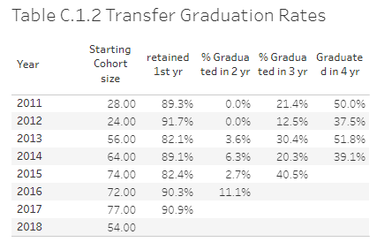

# Table C.2.1 Graduation Rates for Master's

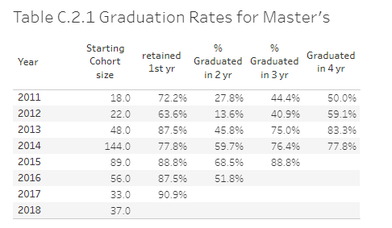

# **Appendix D. Faculty Utilization**

|  |  |  |  |
| --- | --- | --- | --- |
| FALL term | FTES | FTEF | SFR |
| 2019 | 400.0 | 19.0 | 21.1 |
| 2018 | 397.6 | 19.7 | 20.2 |
| 2016 | 382.4 | 19.3 | 19.8 |
| 2014 | 354.0 | 15.1 | 23.5 |

# **Appendix E**

# Catalog Description of CS MS Program (current)

The information requested here can be obtained from the on-line catalog and reproduced here. This information is important as background for your curriculum section (3.0) and to familiarize the reviewers with the particulars of your academic program(s).

# Program Requirements

The CS MS degree requires completion of  30-33 units as described in (I) through (II) below. No more than 6 units of acceptable post-baccalaureate course work completed prior to entrance into classified standing may be included in the master’s degree program.

**(I) Breadth Requirement (9 units)**

Select one course each from three of the following five areas of study.

* Algorithms: [CS 5112 - Design and Analysis of Algorithms](http://ecatalog.calstatela.edu/preview_program.php?catoid=11&poid=3445) (3)
* Network Systems: [CS 5780 - Advanced Information Security](http://ecatalog.calstatela.edu/preview_program.php?catoid=11&poid=3445) (3)
* Web Systems: [CS 5220 - Advanced Topics in Web Programming](http://ecatalog.calstatela.edu/preview_program.php?catoid=11&poid=3445) (3)
* Advanced Programming: [CS 5035 - Topics in Functional Programming](http://ecatalog.calstatela.edu/preview_program.php?catoid=11&poid=3445) (3)
* Software Engineering: [CS 5337 - Advanced Software Engineering](http://ecatalog.calstatela.edu/preview_program.php?catoid=11&poid=3445) (3)

**(II) Choose one of the following two options:**

**Option 1: Thesis/Project Option**

With the approval of the CS advisor, choose 18 units of 4000/5000 level courses with a minimum of 9 units from 5000 level courses. Select one of CS5990 or CS5995 for 3 units.

* [CS 5990 - Thesis](http://ecatalog.calstatela.edu/preview_program.php?catoid=11&poid=3445)  (1-3)
* [CS 5995 - Project](http://ecatalog.calstatela.edu/preview_program.php?catoid=11&poid=3445) (1-3)

**Option 2: Comprehensive Option**

With the approval of the CS advisor, choose 24 units of 4000/5000 level courses with a minimum of 12 units from 5000 level courses. Select CS5960.

* [CS 5960 - Comprehensive Examination](http://ecatalog.calstatela.edu/preview_program.php?catoid=11&poid=3445) (0)

# **Appendix F. GE Assessment**

* + Not Applicable

# **Appendix G. Masters Theses, Projects and Dissertations**

|  |  |  |  |  |  |
| --- | --- | --- | --- | --- | --- |
| Degree Date | Student Last Name | Student First Name | Thesis Title | Advisor 1 | Advisor 2 |
| 2014 | Mac | Long | An account of the Engaging Math Games Project and its potential effect on the future of educational software | Abbott, Russell |  |
| 2014 | Liao | Hsiang-Yu | AI-Contest Platform | Abbott, Russell |  |
| 2014 | Nguyen | Thanh | Secure sharing for H.264 video | Guo, Huiping |  |
| 2014 | Tam | Kwok-Kuen | Hardware and Software Co-design in Cloud Computing | Guo, Jiang |  |
| 2014 | Auman | Cydney | Re-Architecture of Weapon Impact Scoring SystemRussell | Guo, Jiang |  |
| 2014 | Clark | Nehemiah | Verification and Validation In Cloud Computing | Guo, Jiang |  |
| 2014 | Modi | Hardik | "CHIP-SEQ ANALYZER": AN EFFICIENT TOOL TO MANAGE, ANALYZE AND PRESENT MAPPED SEQUENCE DATA | Abbott, Russell | Sharp, Sandra |
| 2014 | Hsu | Michael | CPM: an online platform for curriculum review | Sun, Chengyu |  |
| 2015 | Padilla | Armando | Word Prediction Using Parts of Speech Tagging for Mobile Devices | Abbott, Russell |  |
| 2015 | Briggs | Loran | Flight Operations Automation Testing Suite and Automation of Complex User Interface | Abbott, Russell |  |
| 2015 | Goldsmith | Christopher | Generating Interest in Computing Through Programming Robots | Abbott, Russell |  |
| 2015 | Juster | Leora | Application of Data Mining and Machine Learning Methods for the Improvement of NASA Instrument Software Cost Estimation | Abbott, Russell |  |
| 2015 | Sargent | Mark | Android Sensor Classification Toolset | Abbott, Russell |  |
| 2015 | Xia | Yinchu | Candle.js & DS4.js: A Pseudo 3d Ray Casting Game Engine for Web Browsers using JavaScript | Kang, Eun-Young |  |
| 2015 | Saeedi | Saman | Application of Machine Learning in Automatic Recognition of Sub-Kilometer Lunar Impact Craters | Kang, Eun-Young |  |
| 2015 | Bayaizan | Elnaz | Towards log monitoring with Pub/Sub systems | Parviz, Behzard |  |
| 2015 | Xu | Yuanlin | Sentiment Analysis Using A Vector Clustering Approach | Sun, Chengyu |  |
| 2015 | Alexanian | Ishag | California Tree Squirrel Project | Sun, Chengyu |  |
| 2015 | Tian | Xiangyan | Predicting Student Dropout: An Application of Data Mining Techniques on GET Data | Sun, Chengyu |  |
| 2016 | Moss | Randal | A Machine Learning Model for the Classification of Text Documents as Either ITAR or Non-ITAR | Abbott, Russell |  |
| 2016 | Thangvijit | Ummata | CSULA Contest Platform | Abbott, Russell |  |
| 2016 | Young | Jonathan | Teaching Methods and How People Learning New Things, A Study Based on the Racket Programming Language | Abbott, Russell |  |
| 2016 | Habahbeh | Layla | An Exploration of Developmental Stages Within Computational Thinking | Abbott, Russell |  |
| 2016 | Devpal | Gayatri | Data Security in Cloud Computing | Guo, Huiping |  |
| 2016 | Ijaz | Ansab | Invisible walls: 3D model alignment with 2D image | Kang, Eun-Young |  |
| 2016 | Cross | Richard | Extension of Existing JPL Lunar Lighting Tool for Illumination of Mars Surface | Kang, Eun-Young |  |
| 2016 | Nataraj | Sai | Development of a Low-Cost Control and Communication System for Concentrating Solar Power Fields | Pamula, Raj | Zhu, Yuging |
| 2016 | Gadhia | Harsh | Golden Eagle Flight Plan: A Web Based Developmental Advisement Tool | Sun, Chengyu |  |
| 2016 | Jamali | Mahdiye | New tools and features in csns for user administration and outreach | Sun, Chengyu |  |
| 2016 | Jose | Hani | Recommendation Based ERP System- Admin | Ye, Zelong | Zhu, Yuqing |
| 2016 | Guardado | Anthony | Mobile named data networking using wifi direct | Ye, Zilong |  |
| 2016 | Guha Thakurta | Debasish | Recommendation based enterprise resource planning system | Zhu, Yuqing | Ye, Zelong |
| 2017 | Sunthonlap | James | Test Framework for Availability, Reliability, and Performance of Cloud-Based Services | Guo, Jiang |  |
| 2017 | Maltez | Nelson | Frequency Distribution and Capacity of Users Requests for QoS Suite of Cloud Software Services | Guo, Jiang |  |
| 2017 | Berman | Adam | A Tool for Composition of Cloud-Based Services | Guo, Jiang |  |
| 2017 | Fong | Michael | Modernizing the JPL Planetary Surface Lighting Tool | Kang, Eun-Young |  |
| 2017 | Gallegos | Natalie | Parallel Processing and Multi-Resolution Image Pyramids: A Framework for Crater Detection, Recognition, and Profiling | Kang, Eun-Young |  |
| 2017 | Shim | Steve | Predicting Market Revenue Using Social Media Data | Pourhomayoun, Mohammad |  |
| 2017 | Balasubramani | Arish | Modeling Electrical Vehicle Demand for Optimal Energy Planning in Charging Station | Ye, Zilong |  |
| 2017 | Galdamez | Carlos | Cost-Efficient Virtual Network Function Chaining Over NFV-Based Network Infrastructures | Ye, Zilong |  |
| 2018 | Togunloju | Adekola | Design and Implementation of a Quality of Service Testing Suite for Cloud Computing Services | Guo, Jiang |  |
| 2018 | Louie | Davis | Visualization of the Composition of Cloud Computing Services | Guo, Jiang |  |
| 2018 | Sawada | Kae | Utilization of Cluster Analysis and Machine Learning to Clarify Mutational Linkages Between Osteoporosis and Cardiovascular Disease in Human Population | Pourhomayoun, Mohammad |  |
| 2018 | Wang | Haiyan | Traffic Vision, Tracking and Counting Using Machine Learning and Machine Vision | Pourhomayoun, Mohammad |  |
| 2018 | Subramani | Naveen Kumar | Pedestrian Detection Using Deep Residual Network with Transfer Learning and Faster RCNN | Pourhomayoun, Mohammad |  |
| 2018 | Jose | Cheryl Maria | Accident Forecast Model | Pourhomayoun, Mohammad |  |
| 2018 | Kwon | Minji | Multi-label Classification of Single and Clustered Cervical Cells Using Deep Convolutional Networks | Pourhomayoun, Mohammad |  |
| 2018 | Alqahtani | Abdullah | Predicting Health Condition of AIDS Patients Using Machine Learning Algorithms | Pourhomayoun, Mohammad |  |
| 2018 | Saravanan | Vignesh | A Proposed Method to Improve Highway Construction Quality using Machine Learning | Pourhomayoun, Mohammed |  |
| 2018 | Mnatsakanyan | Sevak | Cloud Scene Complexity and Airs Level Two Product Quality | Ye, Zilong |  |
| 2018 | Rahpiefard | Nazli | HHCNN: Home Health Care Nurse Network, a Web-based Home Health Care Platform to Cover Nurses in Case of Absence | Zhu, Yuqing |  |
| 2019 | Quach | Alvin | Virtual Reality System for Planetary Surface Visualization and Analysis | Kang, Eun-Young |  |
| 2019 | KALATZIS | APOSTOLOS | Interactive dimensionality Reduction for Improving Patient Adherence in Remote Health Monitoring | Pourhomayoun, Mohammad |  |
| 2019 | Mahbub | Safa | Analyzing The Bone Mineral Density For Osteoporosis Based On General Laboratory Data And Examinations In United States Population Using Big Data Processing And Predictive Analytics | Pourhomayoun, Mohammad |  |
| 2019 | Mahbub | Saba | A Comparison of Machine Learning Techniques when Determining Network Routing Through a Simulation | Ye, Zilong |  |
| 2019 | Fisher | Luis | Predictive Analytics for Underground Transportation Infrastructure (UTI) | Pourhomayoun, Mohammad |  |
| 2019 | Vahedi | Mohammadreza | Real-Time Data Analytics for Traffic Monitoring for Pedestrian and Cyclist Safety | Pourhomayoun, Mohammad |  |
| 2019 | Kuko | Mohammed | Using Artificial Intelligence to Detect Cancer in Screening Procedure | Pourhomayoun, Mohammad |  |

# **Appendix H. Curriculum Map for Each Academic Degree Program**

Curriculum Map: Indicating the courses in which students achieve the programmatic

Student Outcomes

Student Outcomes

1. *Students will have the ability to write and analyze sophisticated algorithms.*
2. *Student will have the ability to design, develop, and analyze complex software systems.*
3. *Students will have acquired advanced knowledge and skills in one or more areas of computer science.*
4. *Students will be able to communicate effectively both orally and in writing.*

Core courses –Outcomes mapping is shown in the tables below:

|  |  |  |  |  |  |  |  |
| --- | --- | --- | --- | --- | --- | --- | --- |
| Outcomes/Courses | CS5035 | CS5112 | CS5220 | CS5337 | CS5780 | CS5990 | CS5960 |
| SO 1 | I,D | I,D |  |  | I,D | M | M |
| SO 2 | I,D |  | I,D | I,D |  | M | M |
| SO 3 | D | D | D | D | D | M | M |
| SO 4(Oral) | I,D |  | I,D | I,D |  | M | M |
| SO 4(Written) | I,D |  |  | I,D | I,D | M | M |

The core courses that contribute to the achievement of Outcomes are specified. The table indicates where the Learning Outcomes are Introduced(I), Developed (D) and Mastered in the curriculum

# **Appendix I. Assessment Plan(s)**

Our department has a Comprehensive Assessment Plan for all the programs. We utilize Computer Science Network Services (CSNS), a system developed by one of our faculty Prof. Chengyu Sun. CSNS is a web-based software system that integrates program assessment with learning management. It simplifies and improves the processes involved in the collection, analysis, and presentation of assessment data. In addition, the assessment functions built into the learning management system, which faculty and students use on a daily basis, encourage and facilitate a continuous and sustainable assessment process.

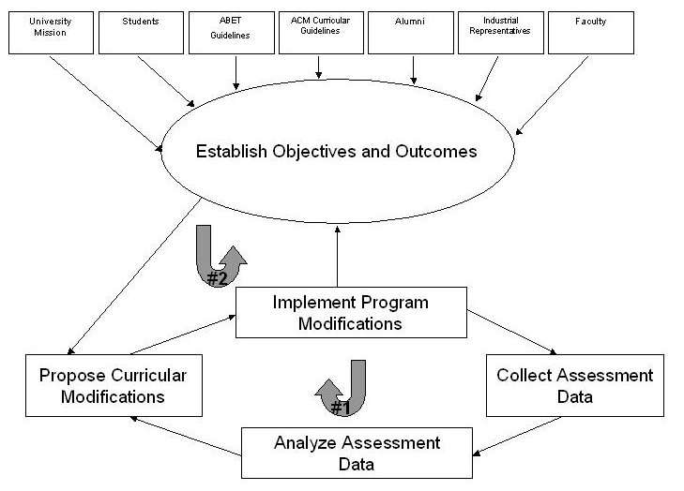The department has established a two-loop process for program assessment and evaluation, as shown in Figure I.1 below:

Figure I.1 Assessment Process

LOOP #2: In this loop, the program educational objectives and student outcomes are periodically reviewed and updated to meet the current needs of all constituencies. In this loop, data is collected and reviewed once every three years.

This process follows the following steps:

1. Our Assessment Committee (Raj Pamula, Chengyu Sun, and Russ Abbott) develops revised Program Educational Objectives and Student Outcomes by considering the following input.
   1. Existing Program Educational Objectives and Student Outcomes
   2. Mission statements (from the University, College and Department)
   3. ACM (Association of Computing Machinery) curricular guidelines
   4. ABET accreditation standards.
   5. Feedback from surveys - Online surveys of Alumni, Faculty and Industry Advisory Board(IAB)
   6. IAB meetings
      1. The Industry Advisory Board consists of current employers of our alumni and potential employers of our current students. They are asked to provide input to the PEOs and SOs.
2. Faculty retreat. During the annual retreat, faculty consider possible revisions to the Program Educational Objectives and Student Outcomes as proposed by the Assessment Committee. Faculty vote on whether to adopt the proposed changes.

The department had conducted two major reviews of Program Educational Objectives and Student Outcomes. The first one took place in Spring 2012 during the ABET accreditation cycle. The second review took place in 2015-2016 during the Q2S conversion process.

Loop #1: In this loop, the assessment process ensures that the student outcomes are well attained through our curriculum and educational practice is continuously improved based on assessment findings. In this loop, the assessment data are collected and analyzed annually.

This loop is facilitated by the following four steps.

Loop1.1: Mapping of the program required courses to SOs

Loop1.2: Description of measures used in data collection

Loop1.3: Data collection process

Loop1.4: Closing the loop – Continuous Improvement Process

Loop1.1: Mapping of the program required courses to SOs

In order to ensure that the Student Outcomes are met, a curricular map must be defined. This curricular map ensures that all Student Outcomes are evaluated irrespective of the combination of courses chosen. Note that the students select three courses out of CS5035 CS5112, CS5220, CS5337, and CS5780. In addition the students select one of CS5960 and CS5990.

Table I.1 below lists the courses that contribute to the achievement of SOs.

|  |  |  |  |  |  |
| --- | --- | --- | --- | --- | --- |
| Course/Outcomes | #1 | #2 | #3 | #4(Oral) | #4(Written) |
| CS 5035 | 🗹 | 🗹 |  | 🗹 | 🗹 |
| CS 5112 | 🗹 |  |  |  |  |
| CS 5220 |  | 🗹 |  | 🗹 |  |
| CS 5337 |  | 🗹 |  | 🗹 | 🗹 |
| CS 5780 | 🗹 |  |  |  | 🗹 |
| CS 5990 | 🗹 | 🗹 | 🗹 | 🗹 | 🗹 |
| CS 5960 | 🗹 |  | 🗹 |  |  |

Table I.1 – Curricular map

Loop1.2: Description of Measures in data collection

In order to evaluate the Student Outcomes, proper assessment measures must be defined. We use Rubrics, Course assignments, and Surveys as assessment measures.

*Rubrics*

Each rubric measures some aspect of student work. Each rubric has one or more performance indicators, each of which is evaluated on a scale of 1 to 5. For each rating a description characterizes the sort of work for which that rating applies. We developed many rubrics as documented at <https://csns.calstatela.edu/department/cs/rubric/list> . The rubrics that are employed in the graduate program core courses for evaluating the Learning Outcomes are listed below:

* Graduate Program - Program Development and Description (Learning Outcome #1)
* Graduate Program - Software Design and Implementation(Learning Outcome #2)
* Graduate Program – Competency in Advanced Areas (Learning Outcome #3)
* Graduate Program - Oral Communication (Learning Outcome #4)
* Graduate Program - Written Communication (Learning Outcome #4)

*Course Assignments*

Since courses contribute to the achievement of Student Outcomes, data can be compiled from courses to evaluate those outcomes. These direct measures are in the form of course assignments such as projects, papers, exams, presentations, and portfolios. In some cases, the artifacts collected from these measures are evaluated by a rubric.

*Surveys*

Surveys are indirect measures that gather perceptions, opinions, and reflections on learning. Surveys also provide a means to ask qualitative open-ended questions. Every year we survey four of our constituencies (students, faculty, alumni, and industry partners) on their satisfaction with our learning outcomes. The feedback indicates how well we achieve each learning outcome.

* These surveys are conducted annually on CSNS.
* CSNS mailing lists are used to invite student and alumni to take the surveys.
* Faculty surveys are conducted following the annual faculty retreats.
* The surveys of industry partners are conducted following the annual Industrial Advisory Board (IAB) meetings.
* The survey results are aggregated, tabulated, and charted in CSNS.

Loop1.3: Data collection process

Data is collected from measures taken in a number of courses. These courses are scheduled for data collection at least once a year. Surveys are collected annually and reported on a two year cycle.

The SO data collection process is described below in the Table I.2. A few characteristics of Table I.2 are as follows.

* Row describes the information for each SO
* Columns provides the information on:
  + Data – Indicates what was collected
  + Type – Indicates the type of data
  + Target - Refers to the threshold or satisfactory level for achievement by the measure. Note that the target value is normally indicated as a number on a 5 point scale, if not specified otherwise.
  + Description – Provides a brief description as to where/how the data is collected.

|  |  |  |  |  |
| --- | --- | --- | --- | --- |
| SO | Data | Type | Target Thresholds | Description |
| 1. | 1.[CS5035, CS5112, CS5780, CS5960, CS5990 assignments/ projects/ exams](http://csns.calstatela.edu/wiki/content/assessment/undergrad/Learning_Outcomes_Graphs/cs337_pra)  2.[SO-1 Satisfaction Survey](http://csns.calstatela.edu/wiki/content/assessment/undergrad/Learning_Outcomes_Graphs/slo5) | Rubric  Survey | 3 or higher on each indicator  3 or higher | Evaluated by Instructor (Rubric )  Constituent surveys for this SO. |
| 2. | 1.[CS5035, CS5220, CS5337, CS5990 assignments/ projects/ exams](http://csns.calstatela.edu/wiki/content/assessment/undergrad/Learning_Outcomes_Graphs/cs337_pra)  2.[SO-2 Satisfaction Survey](http://csns.calstatela.edu/wiki/content/assessment/undergrad/Learning_Outcomes_Graphs/slo5) | Rubric  Survey | 3 or higher on each indicator  3 or higher | Evaluated by Instructor (Rubric )  Constituent surveys for this SO. |
| 3. | 1.[CS5960, CS5990 projects/ exams](http://csns.calstatela.edu/wiki/content/assessment/undergrad/Learning_Outcomes_Graphs/cs337_pra)  2.[SO-3 Satisfaction Survey](http://csns.calstatela.edu/wiki/content/assessment/undergrad/Learning_Outcomes_Graphs/slo5) | Rubric  Survey | 3 or higher on each indicator  3 or higher | Evaluated by Instructor (Rubric )  Constituent surveys for this SO. |
| 4. | 1.[CS5035, CS5220, CS5780, CS5990 assignments/ projects/ exams](http://csns.calstatela.edu/wiki/content/assessment/undergrad/Learning_Outcomes_Graphs/cs337_pra)  2.[SO-4 Satisfaction Survey](http://csns.calstatela.edu/wiki/content/assessment/undergrad/Learning_Outcomes_Graphs/slo5) | Rubric  Survey | 3 or higher on each indicator  3 or higher | Evaluated by Instructor (Rubric )  Constituent surveys for this SO. |

Table I.2: Data Collection

SO data is then depicted as graphs with the following characteristics:

* Data is represented on a 5 point scale that signifies various levels of attainment. (1. Unsatisfactory 2. Poor 3. Satisfactory 4. Good 5. Excellent.)
* The Bar Graphs typically represents class averages with each vertical bar indicating different entities as defined in the legends.
* The Stacked Bar graph represents individual student attainments. Each bar represents 100% of the students with each of the five segments of the graph representing the different levels of attainment. Different colors in segments illustrate the different attainments [Dark Red(1), Light Red(2), Yellow(3), Light Green (4), Dark Green(5)]

Loop 1.4: Closing the loop – Continuous Improvement Process

Our continuous improvement process combines an evaluation and analysis of program assessment results with student feedback, faculty analysis, university approval, and Advisory Board review. This information is then integrated in changes to be made to the program. This activity closes the loop in the program assessment process as described by *Loop #1*.

This process is achieved by the following steps:

* *Assessment Committee*
* *The* Assessment Committee ensures that all student outcomes are evaluated at the appropriate points. The committee then conducts annual evaluation of all student outcomes. This committee will review the data and identify where improvement is needed. These are compiled into an Assessment Report. Typically, the Assessment Reports are published on the web as a two year report. All reports are accessible to ABET evaluators by logging on to the CSNS server at <https://csns.calstatela.edu/department/cs/assessment/program/list> or <https://csns.calstatela.edu/wiki/content/department/cs/assessment/documents/>
  + Assessment Report, 2018-2020
* *Industry* Advisory *Board (IAB) meeting:* This is an annual or a semi-annual event as described at <https://csns.calstatela.edu/wiki/content/department/cs/assessment/iab/>.
  + The assessment coordinator and the department chair make a presentation detailing the curriculum and SO evaluations.
  + Some of the IAB meetings coincide with the Senior Design Project presentations, which give a better perspective of student skills.
  + Input is solicited from IAB membership.
* *Faculty Retreat:* This is an annual or sometimes a semi-annual event as described at <https://csns.calstatela.edu/wiki/content/department/cs/assessment/retreat_presentations/>
  + The assessment coordinator and the department chair make a presentation detailing the SO evaluations including a feedback from all constituents.
  + Faculty retreats provide a forum for faculty interactions and an opportunity to consider the results of the assessment process. This gives the faculty an opportunity to look at the SOs from a program perspective and to consider strengthening the courses.
  + The continuous improvement results in changes that include program/course modifications, course teaching pedagogies and changes to the assessment plans.
  + Proposed changes are voted on by the faculty.

# **Appendix J. Faculty Composition**

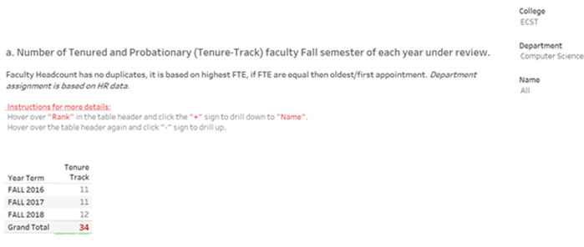

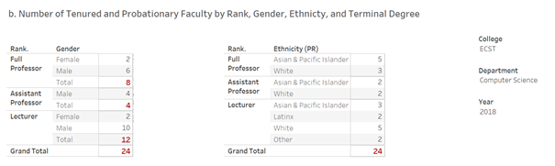

All faculty have Doctorate terminal degrees.

c. Number of anticipated faculty retirements before the next program review: _____4______

# **Appendix K. Faculty Summary Vitae**

This section contains curriculum vita for all faculty in the Department of Computer Science. They are listed in the order below:

Full-time Faculty

Russell J. Abbott

Vladimir Akis

Navid Amini

Huiping Guo

Jiang Guo

Eun-Young “Elaine” Kang

Raj S Pamula

Behzad Parviz

Mohammad Pourhomayoun

Chengyu Sun

Zilong Ye

Yuqing Zhu

Adjunct Faculty

Albert Cervantes

Richard Cross

Edmund Gean

John Hurley

Keenan Knaur

Jung Soo Lim

Jose M. Macias

Mark Sargent

Jithika Thomas

Eric Liao

Randall Moss

### Russ Abbott

rabbott@calstatela.edu

Education

* + Ph.D, Computer Science, University of Southern California, 1973
  + MA, Applied Mathematics, Harvard University, 1963
  + BA, Mathematics, Columbia University, 1962

Academic experience

* + 1987-1991 – Professor – Probationary – full time
  + 1991-current – Professor – Tenure – full time

Non-academic experience

* + 1978 – 2010. The Aerospace Corporation. Computer software consultant. Both full and part time—e,g, full time over the summer..

Primary Area of Teaching and Department Courses Taught

* + Programming paradigms (CS3035, CS5035), Artificial Intelligence (CS4660), Computer Ethics (CS3801), Senior design projects (2 to 4 projects per year)

Selected Presentations/Publications by mentored students

* + Masters thesis supervisor on 10 graduate students over the last five years.
  + Include presentations/publications…..

Honors and awards

* + Best paper. "If a Tree Grows Rings, is it Telling the Time?" International Journal of Unconventional Computation, July 2008. Adapted from paper presented at the Conference on Unconventional Computation, September 2006.

Service activities

* + Course coordinator for CS 3035, CS 3801, CS 4660, CS 4665, CS5035.
  + Contributions to academic governance by participation in department/college/university committees
* Dept. Assessment committee (ongoing).
* Dept. Search committee (2015-2017)
* Dept. & Univ. Semester conversion (2013-2016)
* College RTP committee (approx. alternate years)
* Academic Senate (2010-2011)

Publications/Presentations 2016-2018

* + What’s so complex about complex systems? Submitted for publication.
  + Symbols, computing, and software. Submitted for publication.
  + Meaning, autonomy, symbolic causality, and free will. In Baumeister, Roy (ed) Special issue on the meaning of meaning, *Review of General Psychology*. (to appear)
  + A software-inspired constructive view of nature. In Berkich, Don (ed) *Computing and Philosophy: Selected papers from IACAP 2016*. (to appear)
  + Autonomous Causality, *Swarmfest*," Aug 2016.
  + The end of (traditional) emergence; introducing reactive emergence. *Journal for Public Policy and Complex Systems*. 2/2, 91-107. 2016.

Other professional development activities

* + Computability in Europe 2016
  + Institute for the History and Philosophy of Science and Technology, University of Paris (Sorbonne) (3/2015).
  + York Complex Systems Seminar, University of York (1/2015)
  + Swarmfest 2011
  + AAAI Fall Symposium, November, 2011

Areas of interest, i.e., areas in which I am interested in teaching courses, advising student projects, and (in some cases) doing research

* + Artificial intelligence, including constraint programming and rule-based systems
  + Complex systems, including agent-based modeling and evolutionary programming
  + Computing and philosophy, including multi-level ontologies and downward entailment
  + Programming languages, especially functional and logic programming

### Vladimir Akis

vakis@calstatela.edu

Education

* B.A. (mathematics), California State Univ., Sacramento, 1976.
* M.A. (mathematics), University of California, Berkeley, 1977.
* Ph.D. (mathematics), University of California, Davis, 1982.
* M.F.A. (art), UCLA, 1995.

Academic experience

* Professor of Mathematics and Computer Science, California State University, Los Angeles, 1982-2017.
* Director of the Mathematics and Statistics Unit , Athens Institute for Education and Research (ATINER), Athens, Greece. 2006 – 2014.
* Associate Professor of Mathematics, San Jose State University, 1986-1987.

Primary Area of Teaching and Department Courses Taught

* + Programming sequence (CS201X), Discrete Mathematics (CS2148), Algorithms (CS3112, CS5112), Formal languages & theory (CS3186), Mathematics

Publications

* Book Chapter : “The Cycles in Matrix Transposition,” in Global Information Technology, Innovation and Entrepreneurship, Edited by P.Petratos and D. Michalopoulos, (2005). ISBN: 960-88672-3-1. (Co-author: Jiang Guo)
* Book Chapter: “Towards Computer-Supported Cooperative Systems” in Current Computing Developments in E-Commerce, Security, HCI, DB, Collaborative and Cooperative Systems, Edited by Panagiotis Petratos, ISBN: 960-6672-07-7, (2006).
* (Co-authors: Jiang Guo, Sosuke Tokunara)
* “Essays in Mathematics and Statistics”, ATINER (2009), ISBN: 978-960-6672-52-1.
* “Essays in Mathematics and Statistics vol. 2”, ATINER (2011),
  + ISBN: 978-960-9549-73-8.
* “Essays in Mathematics and Statistics vol. 3”, ATINER (2012),
  + ISBN: 978-960-9549-34-9.
* “Essays in Mathematics and Statistics vol. 4”, ATINER (2013),
  + ISBN: 978-618-5065-18-8.
* "On the Variation of Vector Fields and Fixed Points of Analytic Maps." (2018)

(In preparation).

Service activities

* Course coordinator for CS 2148, CS 3186
* Contributions to academic governance by participation in department/college/university committees
  + Dept. RTP committee (approx. alternate years).
  + Dept. & Univ. Semester conversion (2013-2016)
  + College RTP committee (approx. alternate years)
  + College Faculty Affairs Committee( approx. alternate years)
  + University Faculty Policy Committee (2010-2017)

Areas of interest, i.e., areas in which I am interested in teaching courses, advising student projects, and (in some cases) doing research

* Complexity Theory, Algorithms
* Theory of Computation, Automata
* Computer Graphics
* Database Theory

### Navid Amini

namini@calstatela.edu

<http://www.calstatela.edu/faculty/navid-amini>

Education

* + Post-Doctoral Fellowship, School of Medicine, UCLA, 2015.
  + PhD, Computer Science, UCLA, 2013.
  + MSc, Computer Science, UCLA, 2010.
  + BSc, Computer Eng. Department, Sharif University of Technology, Iran, 2007.

Academic experience

* Aug. 2018 – present: Assistant Professor, Computer Science, Cal State LA. (CSULA).
* Jun. 2015 – Aug 2018: Research Scientist, Computer Science Department, University of California, Los Angeles (UCLA).
* Jan. 2013 – Jun. 2015: Post-Doctoral Fellow, Stein Eye Institute and Center for Smart Health, University of California, Los Angeles (UCLA).
* Sep. 2007 – January 2013: Graduate Research and Teaching Assistant, Computer Science Department, University of California, Los Angeles (UCLA).

Non-academic experience

MediSens Wireless (2009 – 2015), Data and Software Engineer: Machine Learning for Wireless Health-Monitoring Systems (http://www.medisens.com/).

Primary area of teaching

* + Intro to Programming (CS2011), Programming II (CS2012), Introduction to Computer Graphics (CS4550), Topics in Advanced Computer Science (Introduction to Data Visualization - CS4540), Advanced Computer Graphics (CS5550), Machine Learning (CS4661), Software Design Laboratory I & II (CS4961 & CS4692)

Selected presentations/publications by mentored students

1. Masters thesis/project supervisor for 4 graduate students in the past year at CSULA and 9 graduate students at UCLA.
2. J. Nunez, N. Amini, D. Won, Y. Wang, “Bioengineering Workshop on Machine Learning”, To be held as part of the Annual CSU Biotechnology Symposium January 2020.
3. N. Amini, J. Caprioli, A.L. Coleman, K. Delao, S.K. Law, G. Mahmoudinezhad, J. Martinyan, V. Mohammadzadeh, E. Morales, K. Nouri-Mahdavi, B. Zhou, “Comparison of Longitudinal GCIPL Rates of Change between Spectralis and Cirrus SD-OCT OCTs”, Submitted to the Investigative Ophthalmology & Visual Science Journal.
4. N. Amini, K. Delao, K. Nouri-Mahdavi, “Salience-Based Pedometry for Head-Mounted Displays”, Submitted to the 13th International Conference on Biomedical Electronics and Devices (BioDevices 2020).
5. V. Saravanan, Segmentation of Retinal Layers in Optical Coherence Tomography Images”, UCLA Vision Rehabilitation Center, UCLA, Dec. 2018.
6. Z. Ghassabi, A. Nguyen, N. Amini, S. Henry, J. Caprioli, K. Nouri-Mahdavi, “The Fovea-BMO Axis Angle and Macular Thickness Vertical Asymmetry Across the Temporal Raphe” Journal of Glaucoma: Nov. 2018, 27(11), pp 993–998.

Current membership in professional organizations

* + Member, ACM (Association for Computing Machinery)
  + Member, IEEE (Institute of Electrical and Electronics Engineers)
  + Member, ARVO (The Association for Research in Vision and Ophthalmology)

• Member, SPIE (Society of Photographic Instrumentation Engineers)

Honors and awards

* + CSULA ORSCA Minigrant, Apr. 2019
  + UCLA Innovation Fund, First Place Winner, Feb. 2018.
  + UCLA Innovation Fund, Finalist, Oct. 2017
  + UCLA CTSI Core Voucher Award, Jul. 2017
  + Winner, Vodafone Wireless Innovation Project, Jun. 2016
  + Alcon Young Investigator Award, Sept. 2016
  + UCLA Excellence in Research Award, Jun. 2015
  + UCLA Chancellor’s Award for Postdoctoral Research, May 2015
  + Fight for Sight Postdoctoral Fellowship Award, Jun. 2014
  + Edward K. Rice Award (the highest honor and recognition at UCLA

Engineering), Nov. 2013

Service activities

* + Course coordinator for CS4550/5550
  + Redesign taskforce lead for programming course: CS2011 and CS2012
  + Committee member, CS IAB Committee
  + Classroom visitation taskforce member
  + Contributions to academic governance by participation in department/college/university committees.

Five sample publications/presentations

1. N. Amini, J. Caprioli, A.L. Coleman, K. Delao, S.K. Law, G. Mahmoudinezhad, J. Martinyan, V. Mohammadzadeh, E. Morales, K. Nouri-Mahdavi, B. Zhou, “Comparison of Longitudinal GCIPL Rates of Change between Spectralis and Cirrus SD-OCT OCTs”, Submitted to the Investigative Ophthalmology & Visual Science Journal.
2. N. Amini, K. Delao, K. Nouri-Mahdavi, “Salience-Based Pedometry for Head-Mounted Displays”, Submitted to the 13th International Conference on Biomedical Electronics and Devices (BioDevices 2020).
3. N. Amini, R. Alizadeh, N. Parivisutt, E. Kim, K. Nouri-Mahdavi, J. Caprioli, Optic Disc Image Subtraction as an Aid to Detect Glaucoma Progression, Journal of Translational Vision Science & Technology (TVST), In Press, The Association for Research in Vision and Ophthalmology.
4. N. Amini, N. Fatehi, S. Henry, J. Caprioli, K.Nouri-Mahdavi, “Foveal Slope as A Biomarker for Detection of Glaucoma Progression with Macular OCT Imaging,” Journal of Investigative Ophthalmology & Visual Science 59(9), pp. 2107-08, Jun. 2018.
5. N. Amini, R. Daneshvar, P. Romero, F. Sharifipour, Caprioli, K. Nouri-Mahdavi, Machine Learning Methods to Explore Structure-Function Relationships in Perimetric Glaucoma, Investigative Ophthalmology & Visual Science (IOVS), Sept. 2017, Vol.58, pp. 4623-4631.

Other professional development activities

* + Founder of Project EyeSee, a global health initiative to assist people with peripheral vision loss
  + Served as Journal Editorial Board Member, Technical Program Committee Member (TPC), and Reviewer for several journals, conferences, and workshops
  + Invited Speaker at Worcester Polytechnic Institute, Digital Health and IoT Conference
  + Invited Speaker, CREST Center of Energy and Sustainability (CREST) at CSULA
  + Workshop Organizing Committee,Annual CSU Biotechnology Symposium January 2020

Areas of interest, i.e., areas in which I am interested in teaching courses, advising student projects, and doing research

* + Machine Learning
  + Mobile Computing
  + Data Visualization

### Huiping Guo

hpguo@calstatela.edu

Education

* + Ph.D, Computer Science, University of Ottawa, 2003
  + MA, Computer Science and Engineering, Nanjing University of Aero.& Astro., P.R.China, 1999
  + BA, Computer Science and Engineering, Nanjing University of Aero.& Astro., P.R.China, 1992

Academic experience

* + 2016 – current – Professor – Tenure – full time
  + 2011-2016 – Association Professor – Tenure – full time
  + 2005-2011 – Assistant Professor – Probationary – full time
  + 2003-2005 – Post-Doctoral researcher – full time

Non-academic experience

* + 1992 – 1996. software engineer, Luoyang Electro - Optical Technology Development Center (LEODC), P.R. China

Primary Area of Teaching and Department Courses Taught

* + Programming sequence (CS201x), Computer Networks and Security (CS4470, CS4780, CS5540, CS5780), Database systems (CS1222, CS4222), Senior design project

Selected Presentations/Publications by mentored students

* + Masters thesis supervisor on 2 graduate students over the last five years.

1. Fatemah Alharbi and [**Huiping Guo**](http://dblp.uni-trier.de/pers/hd/g/Guo:Huiping)**,** “RSA Based Key Compromised Resistant Protocol(KCR) For Large Databases”, International Conference on Computer Science and Applications, Oct 21-23, San Francisco
2. [Sweta Shinde](http://www.informatik.uni-trier.de/%7Eley/db/indices/a-tree/s/Shinde:Sweta.html), [Chengyu Sun](http://www.informatik.uni-trier.de/%7Eley/db/indices/a-tree/s/Sun:Chengyu.html) and **Huiping Guo**, “Web Usage Mining with Fine-Grained Browsing Activity Tracking”. [*IKE 2010*](http://www.informatik.uni-trier.de/%7Eley/db/conf/ike/ike2010.html#ShindeSG10) *11-17,* 12-15 July, Las Vegas, 2010
3. Z[hou Fang](http://www.informatik.uni-trier.de/%7Eley/db/indices/a-tree/f/Fang:Zhou.html), **Huiping Guo**, [Behzad Parviz](http://www.informatik.uni-trier.de/%7Eley/db/indices/a-tree/p/Parviz:Behzad.html): “Internet Voting Protocol Design and Implementation”. *International Conference on Security and Management (SAM’10)*: 406-412, 12-15 July, Las Vegas, 2010
4. [Huijie Cui](http://www.informatik.uni-trier.de/%7Eley/db/indices/a-tree/c/Cui:Huijie.html), **Huiping Guo**, [Chengyu Sun](http://www.informatik.uni-trier.de/%7Eley/db/indices/a-tree/s/Sun:Chengyu.html) and [Behzad Parviz](http://www.informatik.uni-trier.de/%7Eley/db/indices/a-tree/p/Parviz:Behzad.html): “A New Approach to Detecting Malicious Modification to Streaming Data Using Integer Stuffing”. *International Conference on Security and Management (SAM’10)*: 393-399, 12-15 July, Las Vegas, 2010
5. Madhavi Nidamarthy, **Huiping Guo** and Chengyu Sun “Multiple Watermarking for Relational Data”, *International Conference on security and management (SAM’09),* 13-16 July, Las Vegas, 2009
6. Kanaka Rajanala, **Huiping Guo** and Chengyu Sun “Tamper Detection and Localization for Categorical Data Using Fragile Watermarks for Multi Owner Databases”,  *International Conference on security and management (SAM’09)*, 13-16 July, Las Vegas, 2009

Current membership in professional organizations

* + ASEE

Honors and awards

* Co-PI, Enhancement of Computer Networking Curriculum through OPNET PBL, funded by NSF, 09/2010 – 08/2012
* Co-PI, 2009 HP Innovations in Education , 09/2009 – 08/2011
* Co-PI, IMPACT LA – Improving Minority Partnerships and Access through CISE-related Teaching, funded by NSF, 05/2008 – 04/2013
* Personnel, First in the World program, funded by NSF, 09/01/2015 – 08/31/2019

Service activities

* + Course coordinator for CS 4222, CS 4780
  + Contributions to academic governance by participation in department/college/university committees

Selected publications/Presentations

1. Yingjiu Li, Huiping Guo and Shuhong Wang, "A Multiple Bits Watermark for Relational Data", *Journal of Database Management* , 19(3), pages 1-21,  July-September, 2008
2. Jane Dong and Huiping Guo, “Effective Collaborative Inquiry-based Learning in Undergraduate Computer Networking Curriculum”, *ASEE 2013 Annual Conference & Exposition*, June 23-26 2013, Atlanta
3. Jane Dong and Huiping Guo, “Effective Collaborative Inquiry-based Learning in Undergraduate Computer Networking Curriculum”, *ASEE 2014 Annual Conference & Exposition*, June 15-18 2014, Indianapolis
4. Yuqing Zhu, [Deying Li](http://dblp.uni-trier.de/pers/hd/l/Li:Deying), [Huiping Guo](http://dblp.uni-trier.de/pers/hd/g/Guo:Huiping) and [Raj Pamula](http://dblp.uni-trier.de/pers/hd/p/Pamula:Raj), “New Competitive Influence Propagation Models in Social Networks”, *International Conference on Mobile Ad-hoc and Sensor Networks*, Oct 19-22, 2015, Dallas

Areas of interest, i.e., areas in which I am interested in teaching courses, advising student projects, and (in some cases) doing research

* + Database security and privacy
  + Digital rights management
  + Wireless sensor network security
  + Multimedia communications

### Jiang Guo

jguo@calstatela.edu

Education

* + Ph.D., Computer Science, Beijing University of Aeronautics and Astronautics, 1996
  + M.S., Computer Science, Chinese Academy of Sciences, Beijing, 1992
  + B.S., Computer Science, University of Science and Technology of China, 1989

Academic experience

* + 2002-2007 – Assistant Professor – Probationary – full time
  + 2007-2011 – Associate Professor – Tenure – full time
  + 2011-current – Professor – Tenure – full time

Primary Area of Teaching and Department Courses Taught

* + Programming sequence (CS201X), Operating Systems (CS4440, CS5440), Software Engineering (CS3337, CS5337), Database systems (CS4222), Senior design projects (1 to 2 projects per year)

Selected Presentations/Publications by mentored students

* + Masters thesis supervisor on 12 graduate students over the last five years.
  + Include presentations/publications…..

Certifications or professional registrations

* + MCSE

Current membership in professional organizations

* + ASEE

Service activities

* + Course coordinator for CS 3337, CS 4440
  + Contributions to academic governance by participation in department/college/university committees
* Dept. RTP committee.
* College RTP committee
* University Award committee

Publications/Presentations

* + "NASA Sponsored Student Research Experience in Cloud Computing", Proceedings of 2016 American Society for Engineering Education Pacific Southwest Conference, Pomona, CA, April 21-23, 2016.
  + “Automatic Integration of Web Services,” The Int'l Conference on Internet Technology and Applications (iTAP2011), Wuhan, China, August 16-18, 2011.
  + “Context-Aware System: CSULA Smart Parking (CSP),” The 15th IASTED International Conference on Internet and Multimedia Systems and Applications (IMSA 2011), Washington, DC, USA, May 16 – 18, 2011.

Other professional development activities

* + Emerging Information Technologies and their Trends, The Forum of Development of Internet and Information Industry, Ningxia, June 21, 2016
  + Context Aware Systems and Applications, Jiangsu Province Software and Information Summit on Collaborative Innovation, May 24-25, 2014.

Areas of interest, i.e., areas in which I am interested in teaching courses, advising student projects, and (in some cases) doing research

* + Software engineering, including software architecture, software patterns.
  + Cloud computing, including QoS of cloud computing
  + IoT, including context aware systems
  + Data science, SVM, Naive Bayes.

### Eun-Young Elaine Kang

eykang@calstatela.edu

Education

* + Ph.D, Computer Science, University of Southern California, 2003
  + MS, Computer Science, Hongik University, Korea, 1995
  + BS, Mathematics, Sejong University, Korea, 1992

Academic experience

* + 08/2019-Present, Chair, Department of Computer Science, Cal State LA
  + 09/2014–08/2019, Professor, Computer Science, Cal State LA
  + 09/2009–09/2014, Associate Professor, Computer Science, Cal State LA
  + 09/2004–08/2009, Assistant Professor, Computer Science, Cal State LA
  + 01/2004–05/2004, Lecturer, Computer Science, University of Southern California
  + 03/1995–06/1996, Part-time Faculty, Computer Science, Sejong University, Korea

Non-academic experience

* 03/1992-02/1993, Researcher, Computer Information Center, Sejong University, Korea

Primary Area of Teaching and Department Courses Taught

* + Programming sequence (CS201X), Graphics/Multimedia/Gaming Systems (CS4550, CS4540, CS4551, CS5550, CS5660), Senior design projects (1 to 2 projects per year)

Selected Presentations/Publications by mentored students

1. Masters thesis supervisor on 8 graduate students over the last five years.
2. Mark Abbott, Nancy Warter-Perez, Eun-Young Kang, and Jianyu Dong, "Integrating Power Engineering into Middle and High School Math Curriculums, ASEE (American Society for Engineering Education) Annual Conference & Exposition (Session Title: K-12 Experiences in Energy Education), San Antonio, TX, June 10-13, 2012.
3. V. Mejia and E.Y. Kang, “Automatic Moving Object Detection Using Motion and Color Features and Bi-Modal Gaussian Approximation”, In Proceedings of the IEEE International Conference on Systems, Man, and Cybernetics, Anchorage, Alaska, October 9-11, 2011.
4. Pallavi Bhole and Eun-Young Elaine Kang, “Analysis of Super Resolution Reconstruction Based on Multi-frame Interpolation Using Different Orthonormal Wavelets”, In Proceedings of the 2011 International Conference on Image Processing, Computer Vision, and Pattern Recognition (IPCV'11), Las Vegas, USA, July 18-21, 2011.
5. Prajakta Sawant and Eun-Young Elaine Kang, “Integrating Bilateral Interpolation into Multi-frame Non-uniform Interpolation for Super Resolution”, In Proceedings of the 2011 International Conference on Image Processing, Computer Vision, and Pattern Recognition (IPCV'11), Las Vegas, USA, July 18-21, 2011.
6. Victor Mejia and Eun-Young Kang, “Automatic Detection for Tracking Moving Objects in H.264 Video Sequences Using Multi-Features and Bi-Modal Gaussian Approximation”, In Proceedings of the 2011 International Conference on Image Processing, Computer Vision, and Pattern Recognition (IPCV'11), Las Vegas, USA, July 18-21, 2011.
7. V. Mejia, J. Alvarenga , J. Dong, H. Guo, I. Hernandez, E.Y. Kang, P, Pollavith, A. Trejo, and N. Warter-Perez. "Using Digital Images to Teach Abstract Math and Inspire Students towards Careers in Computer Science and Engineering", ASEE (American Society for Engineering Education) Annual Conference & Exposition (Session Title: Thinking Outside the Box! Innovative Curriculum Exchange for K12 Engineering), Vancouver, Canada, June 26-29, 2011.
8. J. Alvarenga, M. Abbott, A. Abramyan, J. Dong, O. Gontar, H. Guo, E.Y. Kang, V. Mejia, P. Pollavith, R. Sanchez, J. Zamalloa, and N. Warter-Perez. "Engaging Underrepresented Middle School Students in Engineering and Science through a Two-day Summer Camp", ASEE (American Society for Engineering Education) Annual Conference & Exposition (Session Title: Attracting Young Minds: Part II), Vancouver, Canada, June 26-29, 2011.
9. V. Mejia and E.Y. Kang. "Detection for Tracking Moving Objects in H.264 Video Sequences Using Multiple Features and Gaussian Approximation", presented in the 25th Annual California State University Student Research Competition, Engineering and Computer Science - Graduate (Oral Presentation, 2nd Place Winner), May 6-7, 2011, California State University, Fresno.

Grants

* "Culturally Adaptive Pathway to Success (CAPS)", PI, NSF SSTEM Grant, 6/2018 - 5/2023
* "Development of a Virtual Reality Application for the Moon and Mars" funded by NASA Jet Propulsion Laboratory, PI, 10/2016 - 9/2017
* "Transforming Experience of Computer Science Software Development through Multiplayer Online Game Classroom Collaboration in Industrial Format", Co-PI in collaboration with Prof. I. Yoon (PI, Computer Science, San Francisco State University), NSF TUES Grant, September 2012-August 2015
* Sabbatical Grant, California State University, Los Angeles, Fall 2011
* Seed Grant, California State University, Los Angeles, Spring 2011
* "Imaging Process Project", funded by Lockheed Martin, Co-PI in collaboration with P. Liu (PI), Fall 2009
* "IMPACT LA: Improving Minority Partnership and Access through CISE-related Teaching", NSF GK-12 Grant, a Co-PI in collaboration with N. Warter-Perez(PI), J. Dong(Co-PI), and H. Guo(Co-PI), June 2008 - April 2013
* Seed Grant, California State University, Los Angeles, 2007
* "Integrated Training Pipeline for Scientific Visualization", NSF AST Grant, a Co-PI in collaboration with M. Mijic (PI) and T. Longson (Co-PI), September 2006 - August 2010

### Raj S Pamula

http://www.calstatela.edu/faculty/rpamula

rpamula@calstatela.edu

Education

* 1987 : Ph.D in Computer Science, Southern Illinois University, Carbondale.
* 1982 : M.Tech in Computer Engineering, Indian Institute of Technology, India.
* 1980 : B.Tech in Electronics and Communication Engineering, India.

Academic experience

* 2019-present: Professor and Principal Undergraduate/Graduate Advisor, Department of Computer Science, California State University, Los Angeles.
* 2001-2019: Chair, Department of Computer Science, California State University, Los Angeles. Provided leadership in various activities
* 1999-2001: Professor, Principal Computer Science Undergraduate Advisor, Department of Mathematics and Computer Science, California State University, Los Angeles.
* 1987-1999: Assistant/Associate Professor, Department of Mathematics and Computer Science, California State University, Los Angeles.

Primary Area of Teaching and Department Courses Taught

* + Introduction to Higher Education (CS1010), Programming sequence (CS201X), Computer Science Recapitulation (CS4963), Operating Systems (CS5440)

Selected Presentations/Publications by mentored students

* + Masters thesis supervisor on two graduate students.

Honors and Awards

* + *“Favorite Computer Science Professor Award”* in 2011 and 2012 as voted by the students of Engineering, Computer Science and Technology.

Service activities

* + Course coordinator for undergraduate courses: CS 4188, CS 4961, CS 4962
  + Course coordinator for service courses: CS 1090, CS 1200, CS 2540, CS 3980, CS 4990
  + Contributions to academic governance by participating in department/college/university committees
* College Advisement Council (ongoing)
* Dept. and College Assessment committee (ongoing).
* Dept. Search committee (2015-2017)
* Dept. and College Semester conversion (2013-2016)
* College RTP committee (approx. alternate years)

Publications

* “Cost-Efﬁcient Virtual Network Function Chaining over NFV-based Telecommunications Network”. Submitted to IEEE International Conference on Advanced Networks and Telecommunications Systems (ANTS), 2017
* “Virtual Infrastructure Mapping in Software-Deﬁned Elastic Optical Networks”, Journal of Springer Photonic Network Communications, 2017.
* “Combining Program Assessment with Learning Management for Eﬃcient and Sustainable Accreditation Processes”, Proceedings of the American Society for Engineering Education (ASEE) 2016.
* “Building Assessment Functions into LMS for Eﬃcient and Sustainable Accreditation Processes”, Invited paper to ABET Symposium, 2016.
* “New Competitive Influence Propagation Models in Social Networks” Proceedings of International Conference Mobile Ad-hoc and Sensor Networks, 2014
* "Automatic Integration of Web Services", Proceedings of the International Conference on Internet Technology and Applications, 2011.

Areas of interest

(Areas in which I am interested in teaching courses, advising student projects, and research)

* + Cluster Computing
  + Parallel Algorithms
  + Computer Networks
  + Information Security
  + Operating Systems

### Behzad Parviz

bparviz@calstatela.edu

Education

* + Ph.D., Computer Science, State University of New York, Binghamton, NY 1986
  + M.S., Computer Science, State University of New York, Binghamton, NY 1979
  + M.S., Managerial Science, Marywood University, Scranton, PA, 1976
  + B.S., Cost Accounting, College of Accounting, Tehran, Iran, 1974

Academic experience

* + 1986 - 1994 – Assistant Professor – Probationary (full time)
  + 1994 - 2007 – Associate Professor (full time)
  + 2007 - Present – Professor (full time)

Non-academic experience

* + 1987 – 1996 Universal Software Engineering. President and professional software development consultant. Part time.

Primary Area of Teaching and Department Courses Taught

* + Programming sequence (CS201X), Discrete Mathematics (CS2148), Algorithms (CS3112, CS5112), Operating Systems (CS4440, CS5440), Software Engineering, and Mathematics.

Selected Presentations/Publications by mentored students

* + Masters thesis supervisor on two graduate students.

Service activities

* Course coordinator for CS 2148, CS 3112, and CS5112.
* One of the four founding faculty members of the Computer Science Department.
* Principal graduate advisor.
* Contributions to academic governance by participation in department/college/university committees

Publications/Presentations

* “Towards Log Monitoring with Pub/sub Systems,” To be submitted to the Fifteenth International Conference on Technology, Knowledge & Society, New York, NY, USA.
  + “ A *New Approach to Detecting Malicious Modification to Streaming Data Using Integer Stuffing,”* Proceeding of the 2010 International Conference on Security and Management (SAM 2010), Las Vegas, Nevada, USA, 2010.
  + *“Internet Voting Protocol Design and Implementation,”* Proceeding of the 2010 International Conference on Security and Management (SAM 2010), Las Vegas, Nevada, USA, 2010.
  + “*Building a Peer to Peer Message Passing Environment by Utilizing Reflection in .NET,”* Proceedings of the 2006 International Conference on Parallel and Distributed Processing Techniques and Applications (PDPTA’06), Las Vegas, Nevada, USA,2006.
  + *“A Collaboration-Oriented Software Architecture Modeling System-JArchiDesigner,”* Proceedings of the 13th Annual IEEE International Conference and Workshop on the Engineering of Computer Based Systems (ECBS 2006), Potsdam, Germany, 2006.
  + *“A Performance Validation Tool for J2EE Applications,”* To be published in the Proceedings of the 13th Annual IEEE International Conference and Workshop on the Engineering of Computer Based Systems (ECBS 2006), Potsdam, Germany, 2006.

Other professional development activities

* + Conference on Security and Management, 2010
  + Conference on Parallel and Distributed Processing Techniques and Applications, 2006

Areas of interest, i.e., areas in which I am interested in teaching courses, advising student projects, and (in some cases) doing research

* + Analysis of Algorithms
  + Complex systems analysis
  + Operating Systems
  + Software engineering
  + Database systems

### Mohammad Pourhomayoun

mpourho@calstatela.edu

Education

* + Post-Doctoral, Computer Science Department, UCLA, 2015.
  + Ph.D, Electrical & Computer Eng. Depart., State Univ. of New York at Binghamton, 2013.
  + MS, Electrical & Computer Eng. Department, Isfahan University of Technology, 2005.
  + BS, Electrical & Computer Eng. Department, Isfahan University of Technology, 2003.

Academic experience

* Sep. 2016 - present: Assistant Professor, Computer Science, Cal State LA. (CSULA).
* Sep. 2015 - 2016: Visiting Research Scientist, Computer Science Department, UCLA.
* Sep. 2013 - 2015: Post-Doctoral Researcher, Computer Science, UCLA.
* Jun 2012 - Aug 2013: Research Scientist, Bioacoustic Research Team, Cornell Univ.
* Sep. 2009 - May 2013: Graduate Research and Teaching Assistant, Department of Electrical and Computer Engineering, State University of New York at Binghamton.
* 2005 - 2008: Adjunct Faculty, Electrical and Computer Engineering, University of Applied Science and Technology, Iran.

Non-academic experience

* + WANDA Inc. (2015-2016), Senior Data Scientist and Research Manager: Big Data Analytics for Healthcare Applications, Big Data Analytics and Machine Learning for Remote Health Monitoring Systems (www.yourwanda.com).

Primary Area of Teaching and Department Courses Taught

* + Discrete Mathematics (CS2148), Data Science/Machine Learning/Deep Learning (CS4661,CS4662, CS4663, CS5661), Senior design projects (1 to 2 per year)

Selected Presentations/Publications by mentored students

1. Masters thesis supervisor on 16 graduate students in the last four years.
2. A. Kalatzis, B. Mortazavi, M. Pourhomayoun, “Interactive Dimensionality Reduction for Improving Patient Adherence in Remote Health Monitoring,” CSCI'18 Conference, 2018.
3. V. Saravanan, M. Pourhomayoun, M. Mazari, “A Proposed Method to Improve Highway Construction Quality Using Machine Learning,” CSCI'18 Conference, 2018.
4. K. Sawada, M. W. Clark, Z. Ye, N. Alshurafa, and M. Pourhomayoun, " Analyzing the Potential Occurrence of Osteoporosis and Its Correlation to Cardiovascular Disease Using Predictive Analytics," the International Journal On Advances in Life Sciences, vol 10, 2018.
5. M. Pourhomayoun, H. Wang, M. Vahedi, H. Owens, M. Mazari, J. Smith, W. Chernicoff, “Real-Time Big Data Analytics for Traffic Monitoring and Management for Pedestrian and Cyclist Safety,” Conf. on Big Data, Small Data, Linked Data and Open Data (ALLDATA 2019).
6. J. S. Lim, H. Cruze, M. Pourhomayoun, M. Mazari, “Application of IoT for Concrete Structural Health Monitoring,” CSCI'18 Conference, Las Vegas, Dec 2018.
7. M. R. Vahedi, et al., “Predicting Glucose Levels in Patients with Type1 Diabetes Based on Physiological and Activity Data”, ACM MobiHoc2018.
8. J. Garrido, M. Mazari, M. Pourhomayoun, “Multivariate Assessment and Spatiotemporal Visualization of Traffic Injury Frequency,” TRB 2019, Washington, D.C.
9. Y. Ma, Zh. Esna Ashari, M. Pedram, N. Amini, D. Tarquinio, K. Nouri-Mahdavi, M. Pourhomayoun, R. Catena, H. Ghasemzadeh, “CyclePro: A Robust Framework for DomainAgnostic Gait Cycle Detection”, IEEE Sensors Journal (JSEN), Jan 2019.
10. Kwon, M. Kuko, T. H. Kim, S. E. Martin, M. Pourhomayoun, V. K. Martin, “A More Comprehensive Cervical Cell Classification Using Convolutional Neural Network,” American Society of Cytopathology (ASC) 66th Annual Scientific Meeting, 2018.
11. M. Ibrahim, A. Fathi, M. Pourhomayoun, M. Mazari, “A Data Driven Risk Assessment Approach for Evaluating Resilience of Transportation Infrastructure”ICSI2019 Conference.
12. M. Mazari, S. Agarwal, M. Pourhomayoun, H. Hashemian, “A Multidisciplinary Approach for Integration of SHRP2 Solutions in Engineering Education,” SHRP2 workshop, 2017.
13. S. Yoo , A. Kalatzis, N. Amini, M. Pourhomayoun, “Interactive Predictive Analytics for Enhancing Patient Adherence in Remote Health Monitoring”, MobiHoc2018 Conference.
14. Kwon, M. Kuko, V. Martin, T. H. Kim, S. E. Martin, M. Pourhomayoun, “Multi-label Classification of Single & Clustered Cervical Cells Using Deep Conv. Networks,”ICDATA’18.
15. L. Fisher, M. A. Mooney, M. Mazari, T. Rodriguez-Nikl, M. Pourhomayoun, “Predicting Soil Structure & Condition Using Recurrent Neural Network (RNN)” UTC-UTI Workshop, 2018.
16. E. Sokolova, A. Nguyen, K. Gamboa, K. Lam, K. Macias, M. Pourhomayoun, Parameterized Model for Mobility Project Scoring and Estimation of Benefits, ESRI-UC 2018.
17. K. Sawada, M. W. Clark, Z. Ye, N. Alshurafa, and M. Pourhomayoun, “Predictive Analytics to Determine the Potential Occurrence of Genetic Disease and their Correlation: Osteoporosis and Cardiovascular Disease,” BIOTECHNO 2018 Conference.
18. H. Wang, H. Owens, J. Smith, W. Chernicoff, M. Mazari, M. Pourhomayoun, “An End-to-End Traffic Vision and Counting System Using Computer Vision and Machine Learning: The Challenges in Real-Time Processing”, SIGNAL 2018 Conference (Best Paper Award).
19. J. Sunthonlap, P. Nguyen, H. Wangy, M. Pourhomanyoun, Y. Zhu, Z. Ye “SAND: A Social-Aware and Distributed Scheme for Device Discovery in the Internet of Things,” ICNC 2018..
20. K. Sawada, M. W. Clark, and M. Pourhomayoun, “Analyzing the Mutation Frequencies and Correlation of Genetic Diseases in Worldwide Populations Using Big Data Processing, Clustering, and Predictive Analytics,” Conf. on Computational Sci. & Intelligence, 2017.
21. Shim, M. Pourhomayoun, “Predicting Movie Market Revenue Using Social Media Data,” IEEE Int. Conference on Information Reuse & Integration (IRI 2017), 2017.
22. M. Kuko, M. Pourhomayoun, “An Ensemble Machine Learning Method for Single and Clustered Cervical Cell Classification” IEEE Conf. on Bio. & Health Informatics BHI 2019.
23. Daniel R. Chang, Mohammad Pourhomayoun, “Risk Prediction of Critical Vital Signs for ICU Patients Using Recurrent Neural Network,” ICSI2019 Conference, 2019.
24. K. Nagrecha, L. Fisher, M. Mooney, E. Alavi, T. Rodriguez-Nikl, M. Mazari, M. Pourhomayoun, “As-Encountered Prediction of Tunnel Boring Machine Performance Parameters Using Recurrent Neural Networks,” TRB 2020.

Current membership in professional organizations

• Member, ACM (Association for Computing Machinery)

• Member, IEEE (Institute of Electrical and Electronics Engineers)

Honors and awards

* + Recognized by the Office of Graduate Studies for Outstanding Mentorship of Grad Students in the Areas of Research, Scholarship and Creative Activity, 2018-2019.
  + Best Paper Award at Int. Conf. on Advances in Signal, Image & Video Proc. 2018.
  + Best Paper Award at International Data Analytics Conference 2015.
  + Best Paper Award at International BodyNets Conference 2017.
  + Nominated for Chancellor’s Award for Outstanding UCLA Post-Doctoral of 2015.
  + Outstanding Teaching Assistant of the Year Award 2010, State Univ. of New York.
  + Outstanding PhD Researcher of the Year Award 2013, State Univ. of New York.
  + Engineering Excellence Award by President of Isfahan Univ. of Tech. (IUT).

Service activities

* + Course coordinator for CS 3660, CS 4660, CS 4665, CS 4661, CS 4662, CS5661, CS5660.
  + Contributions to academic governance by participation in department/college/university committees.

Five Sample Publications/Presentations

* M. Pourhomayoun, et al., “Real-Time Big Data Analytics for Traffic Monitoring and Management for Pedestrian and Cyclist Safety,” Proceeding of ALLDATA Conf., 2019.
* F. Day, M. Pourhomayoun, D. Keeves, A. F. Lees, M. Sarrafzadeh, D. BellAn, M. Pfeffer, “Feasibility Study of an EHR-Integrated Mobile Shared Decision Making Application,” Elsevier International Journal of Medical Informatics (IJMI), 2019.
  + M. Pourhomayoun, E. Nemati, B. Mortazavi, M. Sarrafzadeh, "Context-Aware Data Analytics for Activity Recognition," DATA ANALYTICS 2015 Conf, 2015 (Best Paper Award).
  + M. Pourhomayoun, et al, "Multiple Model Analytics for Adverse Event Prediction in Remote Health Monitoring Systems," IEEE EMBS HI-POCT Conference, 2014.
  + M. Pourhomayoun, et al, “Why Do We Need a Remote Health Monitoring System? A Study on Predictive Analytics for Heart Failure Patients,” BodyNets 2016 Conf., Dec 2016.

Other professional development activities

* + Founder and Direct of “*Data Science Research Group*” at Cal State LA ([www.calstatela.edu/research/data-science](http://www.calstatela.edu/research/data-science)).
  + Served as Journal Editorial Board Member, Technical Program Committee Member (TPC), and Reviewer for more than 20 Scientific Journals and Conferences.
  + Keynote Speaker at *Data Science Federation Seminar 2017* at Los Angeles City Hall.
  + Keynote Speaker and Panelist at *Women in Data Science Conference* (WiDS 2017)

Areas of interest, i.e., areas in which I am interested in teaching courses, advising student projects, and (in some cases) doing research

* + Machine Learning, Data Mining, Artificial Intelligence.
  + Data Science, Predictive Analytics, Big Data Analytics.
  + Big Data Analytics and Risk Prediction for Healthcare applications.

### Remote Health Management Systems & Data-driven Approaches for Healthcare.

### Chengyu Sun

http://www.calstatela.edu/faculty/csun

csun@calstatela.edu

Education

* + Ph.D., Computer Science, University of California, Santa Barbara, 2004
  + BE, Electronic Engineering, Tsinghua University, P.R. China, 1992

Academic experience

* + 2016-present – Professor – Tenure – full time, Computer Science Department, California State University, Los Angeles
  + 2010-2016 – Associate Professor – Tenure – full time, Computer Science Department, California State University, Los Angeles
  + 2004-2010 – Assistant Professor – Probationary – full time, Computer Science Department, California State University, Los Angeles

Non-academic experience

* + 1995 – 1996. Network Engineer, SinoChem-Hero Intelligent System Co., Beijing, P.R. China

Primary Area of Teaching and Department Courses Taught

* + Programming sequence (CS201X), Database systems (CS1222, CS4222, CS5450), Web programming (CS1220. CS3220, CS5220), Senior design projects (1 to 2 per year)

Selected Presentations/Publications by mentored students

* + Masters thesis supervisor on seven graduate students.
  + Web Usage Mining with Fine-Grained Browsing Activity Tracking. (Graduate Student: Sweta Shinde), The 2010 International Conference on Information and Knowledge Engineering (IKE'10)
  + Distribution of Introduced Tree Squirrels in California - A Citizen Science Approach to Gathering Data (Graduate student: Ishag Alexanian). The Annual Meeting (2014) of Southern California Academy of Sciences (SCAS)
  + My Golden Eagle Flight Plan: A Developmental Advisement Tool. (Graduate student: Harsh Gadhia). The 7th Annual First Year Engineering Experience Conference (FYEE'15) and The 123rd Annual Conference and Exposition of The American Society for Engineering Education (ASEE 2016)
  + Three student projects have led directly to the development of major scholarly software products:
* SCRS: The SharePoint Curriculum Review System modernizes the curriculum review workflow and replaces the previous cumbersome paper-based system. SCRS played an important role during Q2S. It was used by almost all departments and colleges across the university. SCRS also includes many features that were not used during Q2S but that will be employed after conversion is complete.
* CESAR: CESAR is an online advisement system developed for the ECST Student Advisement and Recruitment Center (which has been recently renamed as SSC: Student Success Center).
* Golden Eagle Flight Plan Online: A Web-Based Advisement/tracking/career-preparation tool for the College of ECST.

Current membership in professional organizations

* + Association for Computing Machinery (ACM)

Honors and awards

* ICDE 2002 Best Research Paper Award. *Exploring Spatial Datasets with Histograms*. In Proceedings of the 18th International Conference on Data Engineering, 2002.

Service activities

* + Course coordinator for CS 1220, CS 1222, CS 3220, and CS 4220.
  + Contributions to academic governance by participation in department/college/university committees
* University Student Policy Committee (2012-2014)
* University Curriculum Subcommittee (2014)
* College Assessment Task Force (2014-2017)
* Department Search Committee (2014-2017)
* Department Assessment Committee (ongoing).

Publications/Presentations

* Chengyu Sun, Raj Pamula, Russ Abbott. *Combining Program Assessment with Learning Management for Efficient and Sustainable Accreditation Processes*. In Proceedings of the American Society for Engineering Education (ASEE) 2016 Pacific Southwest Conference.
* Chengyu Sun, Raj Pamula, Russ Abbott. *Building Assessment Functions into LMS for Efficient and Sustainable Accreditation Processes*. Presented at 2016 ABET Symposium.
* Harsh Gadhia, Chengyu Sun, Emily Allen, Deborah Won. *Golden Eagle Flight Plan Online: A Web-Based Advisement Tool to Facilitate Developmental Advising*. In Proceedings of the 123rd Annual Conference and Exposition of The American Society for Engineering Education (ASEE), 2016.
* Cong Chen, Yinfeng Xu, Yuqing Zhu, Chengyu Sun. *Online MapReduce Scheduling Problem of Minimizing The Makespan*. In Journal of Combinatorial Optimization, DOI 10.1007/s10878-015-9982-7, 2015.
* Yuqing Zhu, Chengyu Sun, Deying Li, Cong Chen, Yin-Feng Xu. *Searching Graph Communities by Modularity Maximization via Convex Optimization*. In Proceedings of the 9th International Conference on Combinatorial Optimization and Applications (COCOA'15).
* Rosemary Garcia, Ishag Alexanian, Chengyu Sun, Hong-Lie Qiu, Alan Muchlinski. *Distribution of Introduced Tree Squirrels in California – A Citizen Science Approach to Gathering Data*. Presented at the Annual Meeting of Southern California Academy of Sciences (SCAS), 2014.

Other professional development activities

* + External reviewer for international database conferences and journals: SIGMOD, VLDB, PODS, ICDE, and TODS.
  + Developer and maintainer of CSNetwork Services (CSNS), a web-based system that facilitates teaching, learning, student administration, and program assessment at the Computer Science Department, CSULA.

Areas of interest, i.e., areas in which I am interested in teaching courses, advising student projects, and (in some cases) doing research

* + Database systems
  + Data mining
  + Web development
  + Cross-platform mobile development
  + Cloud computing

### Zilong Ye

zye5@calstatela.edu

Education

* + Ph.D, Computer Science, University at Buffalo, SUNY, 2015
  + MS, Control Theory and Engineering, Shanghai Jiao Tong University, 2010
  + BS, Control Theory and Engineering, Shandong University, 2007

Academic experience

* + 2015-present – Assistant Professor – Tenure-track – California State University Los Angeles – full time

Non-academic experience

* + 05/2015-09/2015 – Postdoctoral Research Associate – Fujitsu Laboratories America – full time

Honors and awards

* + Best Demo Award. L. Liu, L. Xie, M. Bahrami, Y. Peng, A. Ito, S. Mnatsakanyan, G. Qu, Z. Ye and H. Guo, “Demonstration of a Functional Chaining System Enabled by Named-Data Networking,” ACM ICN, 2016.

Primary Area of Teaching and Department Courses Taught

* + Introduction to Higher Education (CS1010), Programming sequence (CS201X), Operating Systems (CS4440), Network systems (CS4470, CS4471, CS5781), Computer Science Recapitulation (CS4963), Senior design projects (1 to 2 per year)

Selected Presentations/Publications by mentored students

* + Masters thesis supervisor on five graduate students and co-supervised on two more graduate students.
  + xxxx

Service activities

* + Course coordinator for CS 1010, CS 4470, CS 4471, CS 4963
  + Contributions to academic governance by participation in department/college/university committees
* Dept. Adjunct Professor Assessment committee (2015-present).
* College Instructional Affairs Committee (2016-present)
* University Student Policy Committee (Spring 2016)

Publications/Presentations

* G. Zhao, Z. Xu, Z. Ye, K. Wang and J. Wu, "A Load-Balancing Algorithm Based on Key-Link and Resource Contribution Degree for Virtual Optical Networks Mapping," IEEE CITS, 2017.
* C. Galdamez and Z. Ye, "Resilient Virtual Network Mapping Against Large-scale Regional Failures," IEEE WOCC, 2017. (Invited)
* L. Liu, M. Bahrami, Y Peng, L. Xie, A. Ito, S. Mnatsakanyan, G. Qu, Z. Ye, H. Guo, "ICN-FC: An Information-Centric Networking Based Framework for Efficient Functional Chaining," IEEE ICC, 2017.
* Z. Ye, Y. Zhu, P. N. Ji, C. Sun and R. Pamula, "Virtual Infrastructure Mapping in Software-Defined Elastic Optical Networks," Springer Photonic Network Communications Journal (PNC), 2017.
* M. Bahrami, L. Xie, L. Liu, A. Ito, Y Peng, S. Mnatsakanyan, G. Qu, Z. Ye, H. Guo, "Secure Functional Chaining Enabled by Information-Centric Networking," IEEE ICNC, 2017.
* M. Bahrami, L. Xie, L. Liu, A. Ito, Y. Peng, S. Mnatsakanyan, G. Qu, Z. Ye and H. Guo, “Secure Function Chaining Enabled by Information-Centric Networking,” IEEE ICNC, 2017.
* H. Wang, Z. Ye, "Renewable Energy-Aware Demand Response for Distributed Data Centers in Smart Grid," IEEE Green Energy and System Conference (GESC), 2016.
* A. Guardado, Z. Ye, H. Guo, L. Liu, L. Xie and A. Ito, "NDNWiFi: Named Data Networking enabled WiFi in Challenged Communication Environments," IEEE GLOBECOMworkshop on ICN solutions for Real-world Applications 2016.
* L. Liu, L. Xie, M. Bahrami, Y Peng, A. Ito, S. Mnatsakanyan, G. Qu, Z. Ye, H. Guo, "Demonstration of a Functional Chaining System Enabled by Named-Data Networking," ACM ICN, 2016. (Best Demo Award)
* Z. Ye, X. Cao and C. Qiao, "Joint Topology Design and Mapping of Service Function Chains in Network Function Virtualization," IEEE GLOBECOM, 2016.
* Z. Ye and Philip N. Ji, "Multilayer Virtual Infrastructure Mapping in IP over WDM Networks," IEEE/OSA OECC 2016.
* Z. Ye, X. Cao, J. Wang, H. Yu and C. Qiao, "Joint Topology Design and Mapping of Service Function Chains for Efficient, Scalable and Reliable Network Function Virtualization," IEEE Network, 2016.

Other professional development activities

* + TPC co-chair of the 1st International Symposium on 5G Emerging Technologies (5GET), 2017.
  + TPC co-chair of the 1st International Workshop on Software-Defined Networks and Network Function Virtualization, 2017.
  + Publicity co-chair of the 2nd IEEE International Conference on Fog and Mobile Edge Computing (FMEC’17), 2017.

Areas of interest, i.e., areas in which I am interested in teaching courses, advising student projects, and (in some cases) doing research

* + Computer networking
  + Internet of Things
  + Software-Defined Networking
  + Information-Centric Networking

### Yuqing Zhu

yuqing.zhu@calstatela.edu

Education

* + Ph.D, Computer Science, University of Texas at Dallas, 2014
  + MS, Computer Science, Chinese Academy of Sciences, 2011
  + BS, Computer Science, Renmin University of China, 2008

Academic experience

* + 2014-current – Tenure Track Assistant Professor – full time

Current membership in professional organizations

* + IEEE, ACM

Honors and awards

* + Distinguished TPC Member of IEEE International Conference on Computer Communications (INFOCOM) 2016

Primary Area of Teaching and Department Courses Taught

* + Programming sequence (CS201X), Discrete Mathematics (CS2148), Algorithms (CS3112), Operating Systems (CS4440), Database systems (CS1222, CS4222), Computer Science Recapitulation (CS4963), Senior design projects (1 to 2 per year)

Selected Presentations/Publications by mentored students

* + Masters thesis supervisor on one graduate students and co-supervised on two more graduate students.

Service activities

* + Course coordinator for CS 2010, CS 2011, CS 2012, CS 2013, CS 4075.
  + Contributions to academic governance by participation in department/college/university committees.
* Boeing Day, Progfest.
* College scholarship committee (ongoing)
* Academic Senate (2015 Spring)

Publications/Presentations

* + On Theoretical Trajectory Planning of Multiple Drones to Minimize Latency in Search-and-reconnaissance Operations, IEEE Transactions on Mobile Computing, to appear.
  + Makespan minimization for MapReduce systems with different servers, Elsevier Journal of Future Generation Computer Systems, 2017.
  + Maximizing the Influence and Profit in Social Networks. IEEE Transactions on Computational Social Systems, 2017.
  + Efficient Client Assignment for Client-Server Systems. IEEE Transactions on Network and Service Management, 2016.
  + A Double-Auction-Based Mechanism to Stimulate Secondary Users for Cooperative Sensing in Cognitive Radio Networks. IEEE Transactions on Vehicular Technology, 2015.
  + Minimum cost seed set for competitive social influence. Proceedings of the IEEE International Conference on Computer Communications (INFOCOM 2016), (Acceptance Ratio: 18.3%).
  + PTZ Camera Scheduling for Selected Area Coverage in Visual Sensor Networks, Proceedings of the 35th IEEE International Conference on Distributed Computing Systems (ICDCS 2015), (Acceptance Ratio: 12.89%).

Professional Services

* + Technical Program Committee members for many international academic conferences like the Annual International Conference on Combinatorial Optimization and Applications (COCOA) 2017/2016/2015, the IEEE International Conference on Computer Communications (INFOCOM) 2016/2015, the International Conference on Database Systems for Advanced Applications (DASFAA) 2016, the International Conference on Computer Communications and Networks (ICCCN) 2016, etc.
  + Program Co-Chair of the 1st International workshop on Job Scheduling in Big Data Center (JOSBAC 2016).

Areas of interest, i.e., areas in which I am interested in teaching courses, advising student projects, and (in some cases) doing research

* + Social Data Analysis, especially on viral marketing and game theory on graphs
  + Randomized and Statistical Algorithms
  + Distributed Systems and Wireless Networks

### Albert F. Cervantes

albert.cervantes@gmail.com

Education

* + Masters of Science Electrical Engineering, Spring 2006, California State University, L.A.
  + Bachelor of Science Computer Engineering, Summer 2004, University of California, Irvine

Skills

* + Innovative entrepreneur with strong leadership qualities. Takes initiative whenever opportunity presents itself. Identifies and resolves issues effectively and efficiently. Able to learn and perfect new subject matter quickly. Works well within diverse groups, and independently. Meets deadlines under extreme pressure while maintaining the highest quality of work.

Languages

* + C/C++/C#, BASH, HTML, CSS, Javascript, Java, Python, OpenGL, MFCs, MIPS

Work Experience

* + Western Digital Corporation, Irvine, Ca, Senior Manager - Software Engineering April 2010 - Present
  + California State University, Los Angeles CA, Adjunct Professor, Computer Science Department, March 2007- Present
  + California State University, Fullerton CA, Adjunct Professor, Computer Science Department, Aug 2014 - Dec 2014

Posters & Publications

* + A.F. Cervantes, M.J. Buehler and W.A. Goddard, III. "The Computational Materials Design Facility (CMDF) and Parallelization with Pyre: A new Multi-scale Multi-Paradigm Simulation Framework”, Computational Nanotechnology and Molecular Engineering Workshop, Cali, Colombia. February 15–18, 2005.
  + A.F. Cervantes, M. Sainz. “Multi-Modal Image Registration and Segmentation of the Visible Human Dataset”. Computational Nanotechnology and Molecular Engineering Workshop, Cali. Colombia. February 15-18, 2005.
  + J. Dodson, A.F. Cervantes, M.J. Buehler, W.A. Goddard III. “Development of a New Central Data Structure for the Computational Materials Design Facility Based on OpenBabel”, Annual Materials and Process Simulation Center Research Conference, California Institute of Technology, Pasadena, CA. March 17-18, 2005.
  + Sainz M., Susin A., Cervantes, A. and Bagherzadeh N., Persepolis: Recovering history with a handheld camera. In Posters of Eurographics 2003 (EG’03).

### Richard Cross

richardkjcross@gmail.com

Education

* + MS, Computer Science, Cal State – Los Angeles, 2016
  + BS, Computer Science, Cal State – Los Angeles, 2016

Academic experience

* + 2016-current – Adjunct Professor – part time

Non-academic experience

* + 1989 – 2000. Freelance Motion Picture Special Effects Technician

Service activities

* + Contributions to academic governance by participation in department/college/ activities
  + Senior Design Project advisor
  + Introduction to Higher Education coordinator

Areas of interest, i.e., areas in which I am interested in teaching courses, advising student projects, and (in some cases) doing research

* + Introduction to Higher Education
  + Robotics
  + Artificial intelligence
  + Software Engineering
  + Senior design projects

### Edmund Gean

egean@calstatela.edu

Education

* + MS, Computer Science, University of Southern California, 1991
  + BS, Electrical Engineering and Computer Science, UC Berkeley, 1985

Academic experience

* + 1998-current – Lecturer – part time

Non-academic experience

* + 1993-present. California State University. Network/Security Administrator - full time.

Manage CSULA’s campus data network including routers, switches, firewalls, wireless, load balancer, packet shapers, and VPN appliances

Certifications or professional registrations

* + Cisco CCNA

Current membership in professional organizations

* + Southern California Cisco User Group

Service activities

* + Liaison to Computer Science Senior Design Project

Other professional development activities

* + Attended RSA Security Conference 2017
  + Attended Defcon Security Conference 2016
  + Attended Palo Alto Networks firewall training
  + Attended Alcatel Networks training
  + Attended Juniper Firewall training
  + Attended Aruba Wireless Controller training 2008
  + Attended EnCase Security Forensics training 2005
  + Attended Cisco router, switch, and firewall training

Areas of interest, i.e., areas in which I am interested in teaching courses, advising student projects, and (in some cases) doing research

* + Computer Security
  + Data Networks

### John Hurley

hurley_j@sbcglobal.net

Education

* + MA in Philosophy, California State University at Los Angeles expected 2022
  + MS, Computer Science, California State University at Los Angeles, 2012
  + MA, History, Harvard University, 1991
  + BA, English, University of California at Berkeley, 1987

Academic Experience

* + 2012-current - Lecturer in Computer Science, California State University at Los Angeles

Courses recently taught: CS 2011-2-3, Introduction to Programming; CS 3034, Widely-Used Programming Languages; 4961-2, Senior Design

* + 2010-2012 – Teaching Assistant in Computer Science, California State University at Los Angeles
  + 1996-2000 - Adjunct Instructor in History at Solano Community College, Pasadena City College, and City Colleges of Chicago-US Military Distance Learning Program
  + 1991-1995 – Teaching Fellow in History, Harvard University

Student Advisement

*Cal State LA Computer Science Department Senior Design projects:*

* *2019-20: GloBalTraQs, an LGBTQ-themed social media application using Python, Django REST Framework, Open Street Map APIs, React JS, and iOS and Android native app platforms. Sponsored by Dr. Cynthia Wang, Department of Communications, Cal State LA.*
* *2018-19: BAD Area Detector, a crime-tracking application. Originally a funded contest entry using GE Predix for the 2019 GE Digital CSU Challenge, which was canceled. Revised to use IBM Cloud IoT platform and SpringBoot.*
* *2017-2018: Library Card Registration System, a database-driven application for online library card registration using Django. Sponsored by LA County Library.*
* *2016-2017: Public Library Geographical Photo Archive, a Java servlet-based application to add geographical search and annotation functionality to an online photo collection. Sponsored by LA County Library. This project led to a large-scale project for county government sponsorship of Cal State LA Senior Design projects.*
* *2015-2016: Phenological Monitoring of Plants at Cal State LA, an application using Django REST and iOS and Android native app platforms for students to enter data on plant specimens observed in the field. Sponsored by Cal State LA Department of Biology.*
* *2014-2015: CHLA Trauma App, a Java servlet-based app to provide information for parents about children’s medical conditions. Sponsored by Children’s Hospital of Los Angeles.*
* *Entries in GE Digital CSU Challenge. Each entry was funded by a grant from GE:*
* *2018: San Diego Smart Analysis, an application using GE’s Predix IoT platform to use data on parking in downtown San Diego to identify potential improvements in public transit routing.*
* *2016: Alternative Energy Solutions Kit, a Predix application with hardware kit to help homeowners evaluate the cost effectiveness of solar and wind electricity generation installations. This entry won second place in the contest and a special category prize for most original idea; students won $7,000 in cash prizes.*

Non-Academic Experience

* + 2000-2010, Wholesaler and Advanced Sales Manager with several life insurance carriers and sales agencies

Service Activities

* + Course Coordinator for CSx0xx programming courses, 1010, 1090, 2010, 2011, 2012, 2013, 3034, 3035, 4075, 5035

Current Membership in Professional Organizations

* + Association for Computing Machinery

Other Professional Development Activities

* + Recent MOOC courses in Machine Learning, noSql databases, and algorithms for asynchronous programming

Areas of interest, i.e., areas in which I am interested in teaching courses, advising student projects, and (in some cases) doing research

* + Programming languages
  + Operating Systems and Systems Programming
  + Ethical issues in software development
  + Chatbot development
  + Senior design projects

### Keenan Knaur

kknaur@gmail.com

Education

• MS in Computer Science, California State University, 2012

• BA in Music Performance, California State University, 2008

Academic Experience

• Adjunct Instructor in Computer Science, California State University, Los Angeles

◦ 09/2012 – Present

◦ Teach introductory courses in HTML, CSS, JavaScript

◦ Teach introductory to advanced courses in Java: basics, object-oriented programming, data structures, GUI programming

◦ Teach introductory to advanced courses in C++: basics, object-oriented programming, STL

◦ Teach introductory course in FORTRAN

◦ Teach advanced course in Python

Service Activities

• Co-Advisor for the student chapter of ACM

• Course Coordinator for CS 2011 and CS 2013 (Unofficial)

• Senior Design Advisor (and other work for the course, grading, coordination, etc).

Other Employment

• California State University, Los Angeles, John F. Kennedy Memorial Library

◦ 09/2006 – 08/2012

◦ Worked in the Music and Media Center helping students and faculty to find media items.

◦ Helped coordinate class reserves for faculty.

◦ Worked at the reference desk helping students and faculty with all aspects of the library experience.

Areas of interest, i.e., areas in which I am interested in teaching courses, advising student projects, and (in some cases) doing research

* + Programming languages
  + Operating Systems
  + Ethical issues in software development
  + Senior design projects

### Jungsoo Lim

Jlim34@calstatela.edu

Education

* + Ph.D., Computer Science, University of California, Los Angeles, 2012
  + M.S, Computer Science, University of California, Los Angeles, 2004
  + B.S., Computer Science, California State University, Los Angeles, 1997

Academic experience

* + 2015 – current – Adjunct Professor –part time – California State University, Los Angeles
  + 2014 – 2015 – Lecturer – part time – California State University, Los Angeles
  + 2011 – 2012 – Teaching Assistant – University of California, Los Angeles

Non-academic experience

* + 1999 – 2016. City of Los Angeles. Senior Systems Analyst.
  + 1997 – 1999. City of Los Angeles. Systems Analyst.
  + 1995 – 1997. City of Los Angeles. Systems Aid

Service activities

* + Contributions to academic governance by participation in department/college/university committees.
  + Senior Design Project advisor – (2015 – current)

Publications/Presentations

* Jung Soo Lim, Jihyoung Kim, Jonathan Friedman, Uichin Lee, Luiz Vieira, Diego Rosso, Mario Gerla, Mani B Srivastava "SewerSnort: A Drifting Sensor for In-situ Wastewater Collection System Gas Monitoring" Ad Hoc Networks Journal (Elsevier), Special Issue on Challenged Environments, Volume 11, Issue 4, Pages 1456–1471, June 2011
* Jihyung. Kim, Jung Soo Lim, Jonathan Friedman, Uichin Lee, Luiz Vieira, Diego Rosso, Mario Gerla, Mani B. Srivastava, "SewerSnort: A Drifting Sensor for In-situ Sewer Gas Monitoring," 2009 6th Annual IEEE Communications Society Conference on Sensor, Mesh and Ad Hoc Communications and Networks, Rome, 2009, pp. 1-9.
* Jungsoo Lim, Uichin Lee, Mario Gerla, William J. Kaiser “Sewage Grid: mobile floating sensors that Monitor the Wastewater Collection System, IEEE /IFIP WONS 2008, Fifth Annual Conference, Germany”

Areas of interest, i.e., areas in which I am interested in teaching courses, advising student projects, and (in some cases) doing research

* + Analysis and Design of Algorithms including multithreaded algorithms, linear programming, dynamic programming, and approximation algorithms
  + Programming with Data Structures including various lists, queues, stacks, sets, trees, balanced trees, hash tables, and augmented data structures
  + Discrete Mathematics including logic, proofs, counting, and discrete probability
  + Automata theory including theory of computations, theory of complexity, and its applications
  + Computer Organization
  + Computer Networking Protocols including TCP/IP, UDP, HTTP, and various link layer protocols (CDMA, CSMA/CD, etc.)
  + Computer Networking Management including network administration, network support, and network troubleshooting.
  + Senior design projects.

### JOSE M. MACIAS

jose.m.macias@jpl.nasa.gov

EDUCATION

Ph.D., Applied Mathematics, Claremont Graduate School; Claremont, CA (Thesis: "An Approximation Method for Solving Non-Homogeneous Wave Equations and Related Inverse Problems".

M.A., Applied Mathematics, Claremont Graduate School; Claremont, CA

Ph.D. Candidate, Computer Sciences, University of Southern California, Los Angeles, CA

M.S., Computer Sciences, University of Southern California; Los Angeles, CA

M.B.A., Business Administration, California State University, Los Angeles, CA

M.S., Electrical-Electronics Engineering, University of Chile; Santiago, Chile (Thesis: "Design and Implementation of a Decoding System for Data Generated at Ground Platforms and Received via the Lansat Satellite.")

B.S., Physics, University of Chile; Santiago, Chile

Additional graduate and professional education in Economics, Management and Personnel Administration, Control and Computer Engineering, and Mathematics for Computers.

EXPERIENCE

1977-Present JET PROPULSION LABORATORY; Pasadena, California

8/04-Present Mission Operations Assurance Manager (MOAM) for JPL Projects.

10/15 – present: Grace, QuikScat, Spitzer, NuStar, TES, MLS, & MSL (Rover on Mars)

10/11-10/15: IND Chief MOAM: IND programs included DSN, MGSS, SNIP, LCRD, LOGS.

8/04 – 10/11: Mars Odyssey, Acrimsat, Rosetta, AIRS, Voyager, Ulysses, Epoxi, NexT.

04/04-08/04 System Engineer for JIMO’s Level 3 Space System Requirements. Assessment and detailed analysis of Spacecraft level 3 requirements for JIMO Space System. Essential contribution to generate one of the most important Requirements documents in the spacecraft area.

TEACHING EXPERIENCE

UNIVERSITY OF SOUTHERN CALIFORNIA (1999-2009), Los Angeles, California.

CALIFORNIA STATE UNIVERSITY, LOS ANGELES (1981 – present), Los Angeles, California

Subjects taught: Graduate and undergraduate Computer Science and Mathematics courses (Databases, Compilers, Software Engineering, Computer Architecture, Operating Systems, Discrete Math, Numerical Analysis, Automata Theory, Theory of Algorithms, Data Structures, Programming Languages, etc.).

Areas of interest, i.e., areas in which I am interested in teaching courses, advising student projects, and (in some cases) doing research

* + Algorithm alanlysis
  + Automata theory
  + Robotics
  + Artificial intelligence
  + Software Engineering
  + Senior design projects

### Mark Sargent

msargen2@calstatela.edu

Education

* + MS, Computer Science, California State University, Los Angeles, 2015
  + Ph.D, Philosophy, University of Illinois, Urbana-Champaign, 2007
  + MA, Philosophy of Religion and Ethics, Talbot School of Theology, 1998
  + BS, Biological Sciences, University of California, Irvine, 1992

Academic experience

* 2013-current – Lecturer – part time – California State University
* 2004-current – Adjunct Professor – part time, Los Angeles Trade Technical College
* 2005-2014 – Adjunct Professor – part time, Long Beach City College
* 2004-2008 – Adjunct Professor – part time, Mount San Antonio College

Non-academic experience

* + 2010-2012 – Developer – part time – Krew Media
  + 1993-1995 – Professional (Chemist) – full time, temporary -- Allergan Pharmaceuticals

Certifications or professional registrations

* + Coursera course in Machine Learning

Current membership in professional organizations

* American Philosophical Association (1998 - 2010)

Honors and awards

* + Dissertation Summer Fellowship Award, University of Illinois, Urbana-Champaign 2002

Service activities

* + Course coordinator for CS 3801

Publications/Presentations

* + “Answering the Bayesian Challenge,” Erkenntnis, 2009

Other professional development activities

* + Robosub, 2017-2018

Areas of interest, i.e., areas in which I am interested in teaching courses, advising student projects, and (in some cases) doing research

* + Artificial intelligence/machine learning/computer vision: Using Histogram of Oriented Gradients as features for object detection
  + Artificial intelligence/machine learning/computer vision: Using CNN’s for object detection
  + Android application development
  + Programming language paradigms
  + Ethics
  + Senior design projects

### Jithika Thomas

jthoma35@calstatela.edu

Education

* + Ph.D. Computer Science, CACS, University of Louisiana at Lafayette, LA, 2001
  + M.S. Computer Science, CACS, University of Louisiana at Lafayette, LA, 1996
  + BS Computer Science, ULL, 1995

Academic experience

* + 2009 - 2011 – Associate Professor – full time
  + 2002 - 2004, 2005 – 2008 Assistant Professor – full time
  + 2016 - current – part time adjunct faculty

Non-academic experience

* + 1998 – 1999 Programmer/Analyst, Information Systems, AAAMS, LA

Certifications or professional registrations

* + PGD
  + CloudThat Technologies’ certification

Honors and awards

* + University of Louisiana System Service awardee

Service activities

* + Member of Curriculum Committee, Research and Development Committee, Conference Committee, Graduation Committee, Awards Committee, Faculty Consulting, Student Club Advisory group, Information Technology Development Committee, Accreditation Committee, and Recruiting and Fundraising volunteer programs (2009 – 2011)

Other professional development activities

* + International Conference on Caribbean Literature, Culture, and Identity, held at Grand Cayman, British West Indies (2010)
  + International Conference on Leadership, Governance, and Empowerment in the Caribbean, held at Grand Cayman, BWI (2011)

Publications/Presentations

* Intelligent Data Insights. *Southern California Big Data Discovery Summit, Azusa, CA,*  Nov, 2017 (to appear)

Areas of interest, i.e., areas in which I am interested in teaching courses, advising student projects, and (in some cases) doing research

* + Data Mining
  + Programming languages
  + Data Communications and Networking
  + Web Programming
  + Algorithms
  + Artificial Intelligence
  + Operating Systems
  + Analytics, Big Data, Data Science, & Machine Learning

### Randal Moss

rmoss@calstatela.edu

Education

* + MS, Computer Science, California State University, Los Angeles, 2016
  + BS, Computer Science, California State University, Los Angeles, 2014

Academic experience

* + 2014-2016 – Teaching Assistant – part time
  + 2017-current – Part-time Lecturer – part time

Non-academic experience

* + 2016-current. JPL. Data Scientist – full time

Certifications or professional registrations

* + Certified Scrummaster

Honors and awards

* + NASA Honor Award. JPL Search Team – Group Achievement Award, October 2016. For the development of critical search capabilities, simplifying the process of finding information and setting up an extensible core framework for future efforts.

Other professional development activities

* + O’Reilly Security Conference, November, 2016

Areas of interest, i.e., areas in which I am interested in teaching courses, advising student projects, and (in some cases) doing research

* + Database systems
  + Web development, RESTful frontend frameworks like Polymer
  + Dev-Ops, containerization with Docker, orchestration, CI/CD
  + Programming languages, JAVA and python

# **Appendix L. Instructional Faculty Types in the Programs’ Courses**

In this section, complete the following table for the past two years (total number of classes, not average). Use this data in Section 5 in describing student evaluation of your faculty’s classroom effectiveness.

Proportion of Classes* Taught by Faculty Rank

FALL 2018 - SPRING 2019

|  |  |  |  |  |
| --- | --- | --- | --- | --- |
| Appt. Level | Number of classes | Major (1000-4000 level) Classes | Graduate (5000 level) Classes | Service/GE Classes |
| FERP | 0 | 0% | 0% | 0% |
| Tenured/Tenure-Track | 54 | 35% | 8% | 0% |
| Temporary without Terminal Degree | 67 | 46% | 2% | 4% |
| Teaching Associates | 5 | 3% | 0% | 1% |

*: Data does not include senior design class (CS4961 – CS4962) as there are multiple faculty assigned to advise senior projects.

# **Appendix M. Recommendations for External Reviewers**

In the table below, please provide the name, contact information, and CVs of six potential external reviewers who are willing to serve on your program’s review team. Three recommended external reviewers should be from institutions within the CSU system and three recommendations should be from institutions outside of the CSU system.

Recommendations for External Reviewers

|  |  |  |  |  |
| --- | --- | --- | --- | --- |
| Name | Institution | Email Address | Phone Number | Institutional Affiliation |
| Arno Puder | Professor & Chair, Computer Science Department, SFSU | [arno@sfsu.edu](mailto:arno@sfsu.edu) | (415) 338-7688 | CSU |
| Mohsen Beheshti | Professor & Chair, Computer Science Department  California State University, Dominguez Hills | [mbeheshti@csudh.edu](http://www.csc.csudh.edumbeheshti@csudh.edu/) | (310) 243-3398 | CSU |
| Christopher Ryu | Chair & Professor​  Department of Computer Science  California State University, Fullerton | tryu@fullerton.edu | *(657) 278-3556* | CSU |
| Jeffrey Miller | Associate Professor  Computer Science and Information Technology, USC Viterbi School of Engineering,  University of Southern California | [jeffrey.miller@usc.edu](mailto:jeffrey.miller@usc.edu) | 213-740-4542 (office) | Non-CSU |
| Emily S Law | JPL (Jet Propulsion Laboratory) | emily.s.law@jpl.nasa.gov | 818-354-6208 | Non-CSU |

# **Appendix N. Graduate Program Modification**

(Approved by Department and College – Spring 2020)



 