Parameterized Transportation Model

(Capital Project Development Map)

Project Lead: Elizaveta Sokolova (sokolovatennis@yandex.ru)

Documentation Lead: Kevin Gamboa (kbgamboa92@gmail.com)

QA Lead: Kevin Lam (kevin.lam825@gmail.com)

Architecture / Design lead: Alvin Nguyen (anguyen8613@gmail.com)

Advisor:

Dr. Mohammad Pourhomayoun

Liaisons:

Hunter Owens - hunter.owens@lacity.org

Karina Macias - karina.macias@lacity.org

David Somers - david.somers@lacity.org

**Table of Contents**

1. Introduction

2. Related Works and Technologies

3. System Architecture

4. Results and Conclusions

5. References

**1. Introduction**

The Los Angeles Department of Transportation (LADOT) has partnered with the City’s Information Technology Agency Data Science Federation and California State University Los Angeles to develop a Parameterized Model for mobility project scoring and estimation of benefits. In Fall 2017, LADOT developed an interactive web map of spatial data layers related to the City’s mobility policies. LADOT project managers were asked to use the web map to visually assess their project’s site context in relation to the project’s description and to enter these attributes into an online form. LADOT Planning & Policy staff gathered all project ranking attributes, applied weighted scoring model scenarios to manually score the project list, and demonstrated this objective screening method could support a strategic mobility investment planning process.

This project will create a web map based on ESRI ArcGIS mapping tools that allows LADOT project managers to locate mobility investments within the City and use automate overlay analysis to apply a weighted scoring model to the proposed projects, calculating how consistent the investment is with the City’s mobility goals and policies. The overlay analysis includes data layers relating to the City’s vision for its transportation system, as described in the adopted Mobility Plan 2035: the Circulation Element of the General Plan, and goals for mobility as described in the LADOT 2018 - 2020 Strategic Plan. The project will enable LADOT staff to justify mobility investment according to their relative advancement of City mobility policy priorities and anticipated benefits to Angelenos in terms of safety, access, sustainability, and livability. The project would also use data on existing conditions to forecast the influence of individual projects to street users’ experience by travel mode.

The deliverables of this project is an automated mapping tool based on ArcGIS that gathers transportation capital project data and score projects based on LADOT priorities and City mobility goals. This mapping tool can automate weighted score modeling of proposed transportation projects based on City mobility policy priorities, support strategic mobility investment planning and project development, and forecast influence of project on existing transportation system and travel behavior using empirical methods. In the next stage of the project, we also plan to use data-driven approaches including machine learning algorithms to automatically design the best weights and scores rather than using pre-defined parameters.

**2. Related Works and Technologies**

For this project, we primarily used ESRI’s ArcGIS API for JavaScript to create our web map. Using ArcGIS, it helped the team develop multifunctional features within the web map that we have created. It helped us solve specific problems dealing with geographical features in our project. There were also documentation and libraries that were valuable for the team that would contribute to the implementation of the Parameterized Transportation Model.

Our predictive model was composed of Python libraries such as Scikit-Learn, Numpy, and Pandas. These libraries were used to deliver better accuracy and modeling when predicting the possible collision reduction within the city.

**3. System Architecture**

The system architecture is straightforward. There are 4 main modules : User, Interactive Web Map, GeoHub Database, and Esri ArcGIS API. The User interacts with components of the Interactive Web Map and each component may or may not interact with the GeoHub Database and/or Esri ArcGIS API.

The components in the interactive Web Map includes : Generate Score, Upload Shapefile, Draw Template, Display, Layers, Update Weights, and Extract Projects.

The following diagram illustrates the interactions between the stated modules and components.

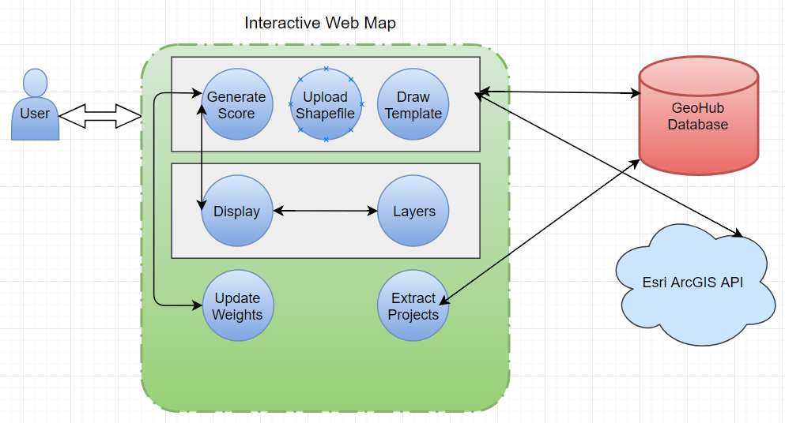

**4. Results and Conclusions**

Over the course of the two semesters, we were able to develop Automated mapping tool based on ArcGIS that gathers transportation capital project data and scores projects based on LADOT priorities and City mobility goals.

Our web map allows LADOT project managers to locate mobility investments within the City and use automate overlay analysis to apply a weighted scoring model to the proposed projects, calculating how consistent the investment is with the City’s mobility goals and policies. The overlay analysis includes data layers relating to the City’s vision for its transportation system, as described in the adopted Mobility Plan 2035: the Circulation Element of the General Plan, and goals for mobility as described in the LADOT 2018 - 2020 Strategic Plan. The project enables LADOT staff to justify mobility investment according to their relative advancement of City mobility policy priorities and anticipated benefits to Angelenos in terms of safety, access, sustainability, and livability.We have also used data on existing conditions to forecast the influence of individual projects to street users’ experience by travel mode.

**5. References**

Esri ArcGis API <https://developers.arcgis.com/javascript/>

Scikit Learn API <http://scikit-learn.org/stable/modules/classes.html>

Collision Data <http://iswitrs.chp.ca.gov/Reports/jsp/userLogin.jsp>

Mobility Plan 2035

The Plan for Healthy Los Angeles

City of Los Angeles Travel Demand Forecasting Model

U.C. Census, American Communities Survey

California Health Disadvantage Index (HDI)

LADOT Safe Routes to School

LADOT Vision Zero

Council for Watershed Health

Los Angeles County GIS Portal

USGS Land Processes Distributed Active Archive Center