Software Requirements Specification

For City Pave
Version Version 1 approved

Prepared by <city pave Online Application for Street and Highway Pavements Design.>

Department of Civil Engineering, CSULA
5/11/2021

Revision History
Name Date Reason For Changes Version
Name | Date | Reason For Changes | Version
City Pave | 12/9/2020 | Setting up pages | v1
City Pave | 4/3/2021 | Pages has become live | v2
City Pave | 5/11/2021 | Homepage update | v3

Software Requirements Specification 1
For City Pave 1
1. Introduction 3
1.1 Purpose 3
1.2 Intended Audience and Reading Suggestions 3
1.4 Definitions, Acronyms, and Abbreviations 3
1.5 References 4
2. Overall Description 5
2.1 System Analysis 5
2.3 Product Functions 6
2.4 User Classes and Characteristics 6
2.5 Operating Environment 6
2.6 Design and Implementation Constraints 6
2.7 User Documentation 6
2.8 Assumptions and Dependencies 7
3. External Interface Requirements 9
3.1 User Interfaces 9
3.2 Hardware Interfaces 9
3.3 Software Interfaces 9
3.4 Communications Interfaces 10
4. Requirements Specification 11
4.1 Functional Requirements 11
User 11
4.2 External Interface Requirements 12
4.3 Logical Database Requirements 12
4.4 Design Constraints 12
5. Other Nonfunctional Requirements 13
5.1 Performance Requirements 13
5.3 Security Requirements 13
5.4 Software Quality Attributes 13
5.5 Business Rules 13
6. Legal and Ethical Considerations 13
Appendix A: Glossary 14
Appendix B: Analysis Models 15
Appendix C: To Be Determined List 16

1. Introduction
Creating an easy to use Website for individuals who want to do basic pavement designs. This website calculates information for the individuals in an easy to use manner by giving only values that they need to put in and our program will calculate for the user. The website will also store the users information.

1.1 Purpose
The purpose of this document is to inform individuals about what this project is about. Which allows individuals to get a better understanding of the program.

1.2 Intended Audience and Reading Suggestions
The document is intended for future developers of the project, Sponsors, City Counsel Engineers, and Contractors.

1.3 Product Scope
The software is a web application that helps monitor and helps calculate information about pavements. The Application will be used by contractors and city council to make it easier to make pavement calculations while following specific guidelines.
- Software is necessary to help manage projects
  - The benefits
    - Makes it easier to make calculations
    - Easier to understand specific requirements
    - Simple and clear information about pavements specifications
  - Goals
    - Get sponsored by the city
    - Make it easier and more accessible to individuals who do not understand how to calculate for pavement design

1.4 Definitions, Acronyms, and Abbreviations

Data Type- Specified defined value
City Council- individuals who work for the city
Contractor- Individuals who perform work based on contracts
Pavement- A paved surface that has been hardened
UX- User experience
Style guide- Color coordinated guidelines to follow
ADA- American disability act
AASHTO-American Association of State Highway and Transportation Officials.

1.5 References
References
Name of reference | Reason
Jungsoo Soo Lim Smart Pavement Project program | For Smart Pavement Project (used to create formula for calculations)
Vue.js | Creating the front end of the website
MySQL | Database for the website
CSULA style guide lines | Used to design correctly colored theme

2. Overall Description

City Pave application will be implemented as a web application. This web application will be able to calculate pavement calculations, and store the user project data in an accessible online. This section will give a general idea what the program is about

2.1 System Analysis
The problem that this project tackles is the outdated way of how to calculate pavement calculations and save this information for future uses. The way that this program tackles the problem is by making the process in which you calculate things easier and store the data that you input for future use and reference.

2.2 Product Perspective
There are many other web applications like City Pave, but the way that we stand apart from other web applications is by how we have usable pavement calculations and ease of use. We do this by creating working functions, safely securing person information, and developing intuitive software that is easy to use.

2.3 Product Functions
- Create new user
- Login
- Logout
- Calculate
- Email forwarding
- Tooltip
- Remember me
- Password reset
- Map View

2.4 User Classes and Characteristics
The user class of City Pave are individuals who are from city council, engineering backgrounds and architects. Individuals will be able to make an account that stores information on the database. The user can use that information that is stored to help calculate pavement calculations.
- User Interface
  - Be able to create an account
  - Be able to login and logout
  - Be able to create project
  - Be able to store data of project
- Contact
  - Be able to forward emails to an email address
- Database
  - SQL to store user information
- Calculations
  - Calculate all standardized calculations for pavement standards base on AASHTO 93 and 98

2.5 Operating Environment

City Pave is as for now is going to a web-based application and running on a host.

2.6 Design and Implementation Constraints

- City Pave requires AWS to be able to host the website and its database.
- City Pave Requires individuals to have internet access

2.7 User Documentation
Rough draft of website layout
Website - Google Drive
Information about calculations
Appendix C - NHI-05-037 - Geotech - Bridges & Structures - Federal Highway Administration (dot.gov)
Github beginner guide
Git and GitHub for Beginners - Crash Course - YouTube
Styler extension to make reading code easier
vscode-icons - Visual Studio Marketplace
Style guide that we followed based on liaison request to follow school colors
Colors & Typography | Cal State LA
Mailing service is that we needed to create a way to forward emails to individuals
Transactional Email API Service For Developers | Mailgun
Teaching and understanding router and routes in express js
https://www.youtube.com/watch?v=iM_S4RczozU
For how to set up and register user
https://www.youtube.com/playlist?list=PLD9SRxG6ST3GBsczn8OUKLaErhrvOz9zQ
How to set up Vue JS
https://www.youtube.com/watch?v=pD94EojHEsc
Vue JS information for DB
(362) Full Stack Vue.js, Express & MongoDB - YouTube
Authentication with vue js
https://www.youtube.com/watch?v=W5Ky44mWQZE
How to connect data bases together
https://www.youtube.com/playlist?list=PLaRVQcAuLimG_qplzZFU-p6lsSS4czT7e
Tutorials on how to create database pages.
https://bezkoder.com/vue-js-node-js-express-mysql-crud-example/

2.8 Assumptions and Dependencies
The dependencies that this project has is the type of database. The reason is that this is directly routed from our host to our website. If they change our database location we would have to change the location of our database. Another dependency is the fact that if a new formula for calculating pavement design changes we have to change the code based on that formula. In addition, there may be certain laws that are passed on a state level which the formula does not take into account, since we as the designers have not been informed of this information.

2.9 Apportioning of Requirements
User management, control panel for user (not end user control panel), and adaptable formula based on state regulation. The user management is not developed in this version, since we as designers were only told to create a website based on pavexpress. However, as the site grows in popularity individuals who maintain the site should be able to remove, modify, or insert information as needed to respective users' projects. Another thing that should be added is a backend user control panel. This would allow individuals to calculate information on what demographic is using this site to be able to use it as a marketing device for future projects. Finally, an adaptable formula should be added based on location of the pavement project. The reason is that different locations have different legal restrictions for certain types of road construction.

3. External Interface Requirements
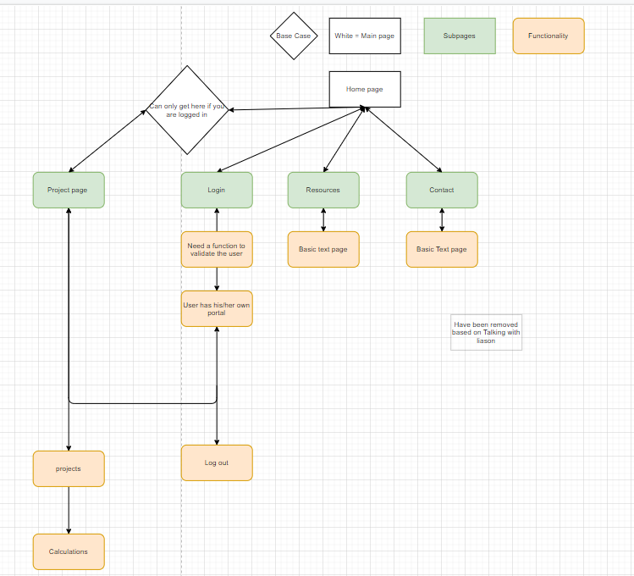

3.1 User Interfaces
- Current City Pave application is hosted online.
- Users will be able to store and use data for calculations of pavement.
- City Pave graphics are currently based on the csula style guidelines.
- The GUI is designed around easy to use for Users experience.

3.2 Hardware Interfaces
The hardware interface that is needed is a browser which supports CGI, HTML & Javascript.

3.3 Software Interfaces

Software interface | Description for software interface
Javascript-Node.js | This is the interface that we used to design the website
MySQL | How we created the database
Vue.js | Help create the front end of the project
Express | Used for the backend
NPM(Node Package Manager) | Is used for backend
AWS | Used to store Data into the cloud that can be accessed by end users.

3.4 Communications Interfaces

City Pave Web Application is supported by all types of browser that support html and javascript. We field forms to store information to be processed in the future upon request.

4. Requirements Specification
1.1.1 User shall be able to create an account.
1.1.2 User shall be able to add information to the database
1.1.3 User must be able to login with account information
1.1.4.User should be able to validate user information
1.2.1 Number must be inputted
1.2.2 Numbers must be in range
1.2.3 Number data must be able to generate answers
1.2.4 Numbers can change measurement parameters
1.2.5 Calculations must be stored
1.3.1 Project information must be saved
1.3.2 Project must be able to modify information
1.3.3 Project must be able to delete information
1.4.1 Contacts must be able to fill out form
1.4.2 Contact information will be sent to Corresponding email address
1.5.1 Database shall store all user information
1.5.2 Database shall be able to modify stored information
1.5.3 Database shall be able to delete information.

4.1 Functional Requirements

User
  - User can create an ID with information provided
  - User must be added to database
  - User must be able to login with account and given information
  - User shall be able to validate user information
  - User password is Encrypt passwords
- Calculation
  - Data Type must be correct
  - Calculations must validates specific numbers inputted
  - Calculation must generate information
  - Calculation must be able to change based on pavement information
  - Calculate formula based on information given
- Projects
  - Save information for project
  - Modify information for project
  - Delete information for project
- Contacts
  - Be able to forward information
  - Be able to send correct information based on form
  - Form is easy to use.
- Database
  - To store all of user information
  - To modify stored information
  - To delete stored information

4.2 External Interface Requirements

Users will be able to input data in text fields to be stored/calculated. The web applications will be able to output information based on stored information. The information used for the calculation can be stored for future uses.

4.3 Logical Database Requirements
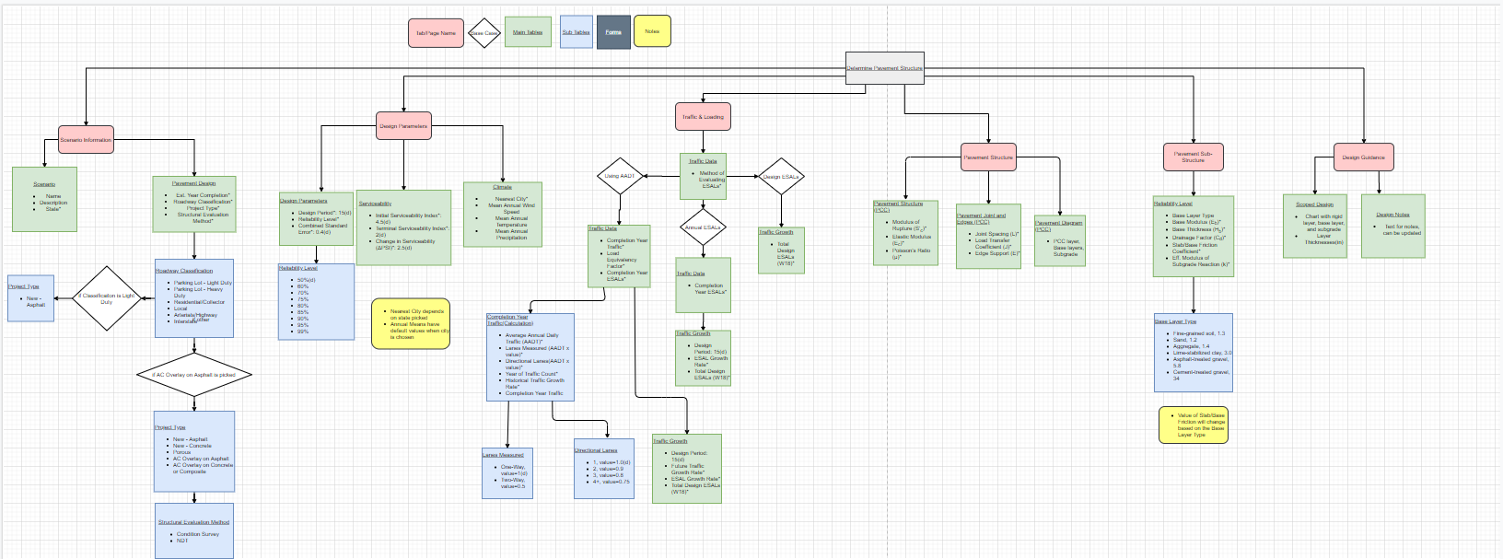

4.4 Design Constraints
The only constraint on hosting a web application from third party is that it requires users to be able to:
    - Have to have internet
    - Have to have access to a function computer
    - Understanding of how website works

5. Other Nonfunctional Requirements

5.1 Performance Requirements
Performance is based on service providers since we are not hosting the website ourselves and are not liable for any connection issues.

5.2 Safety Requirements
If an unthinkable event were to occur to the database on the hosting, the website can be backed up by just downloaded from the host. This creates a safeguard if the hosting site were to lose its servers hosting the web application or stop providing service to our web application.The reason is that the information can be reuploaded in case of a system failure.

5.3 Security Requirements
All passwords and user info are encrypted so that end users can not fish for identity. With databases being stored by service providers, individuals with unauthorized access can not access the database.

5.4 Software Quality Attributes
City Pave’s objective is to have an easy to use web application that people can use to figure out pavement calculations. It’s goal is to make an easy to access calculator for individuals who would need help calculating and keeping track of pavement projects.

5.5 Business Rules
All users have the same setting as of the current iteration of the product. The reason is there is no need for tiered users as of right now.

6. Legal and Ethical Considerations
One ethical issue that this project involves is that inside information of certain projects that could happen. This is an issue because individuals can be notified beforehand that certain projects are about to happen or could happen. The reason it's okay to go through with this is because individuals still have the choice to choose which contractor they want.

Appendix A: Glossary
Data Type- Specified defined value
City Council- individuals who work for the city
Contractor- In who perform work based on contracts
Pavement- A paved surface that has been hardened
UX- User experience
Style guide- Color coordinated guidelines to follow
ADA- American disability act
AASHTO-American Association of state Highway and Transportation Officials.

Appendix B: Analysis Models
Basic mapping of website

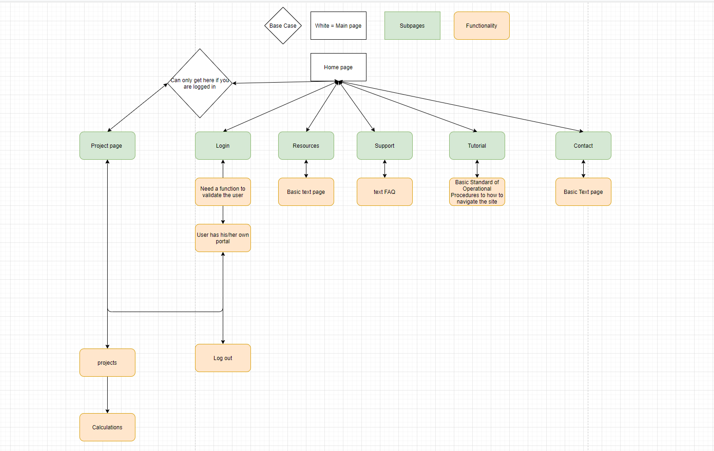

Product page

Appendix C: To Be Determined List
- Needs to create Map API
- Needs to update pavement calculations

