Software Requirements Specification

for

QTC PDF Web Viewer

Version 1.0 approved

Prepared by Cristian Corrales, Chandel Buelna, Phoebe Castanedo, Brandon Gonzalez, David Sanchez, Joaquin Robles, Sean Ybarra, Roman Arias, and Ares Ton-That
Sponsored by QTC
11/13/2020

Table of Contents
Table of Contents................................................................................................................. pg 2
Revision History................................................................................................................... pg 3
1. Introduction............................................................................................................ pg 4
1.1. Purpose........................................................................................................... pg 4
1.2. Intended Audience and Reading Suggestions.............................................. pg 4
1.3. Product Scope................................................................................................ pg 4
1.4. Definitions, Acronyms, and Abbreviations .................................................. pg 5
1.5. References...................................................................................................... pg 5
2. Overall Description.................................................................................................... pg 5
2.1. System Analysis…......................................................................................... pg 5
2.2. Product Perspective........................................................................................... pg 6
2.3. Product Functions........................................................................................... pg 6
2.4. User Classes and Characteristics.................................................................... pg 6
2.5. Operating Environment.................................................................................. pg 6
2.6. Design and Implementation Constraints........................................................ pg 7
2.7. User Documentation...................................................................................... pg 7
2.8. Assumptions and Dependencies.................................................................... pg 7
2.9. Apportioning of Requirements...................................................................... pg 7
3. External Interface Requirements.............................................................................. pg 8
3.1. User Interfaces............................................................................................... pg 8
3.2. Hardware Interfaces....................................................................................... pg 8
3.3. Software Interfaces........................................................................................ pg 9
3.4. Communications Interfaces........................................................................... pg 9
4. Requirements Specification....................................................................................... pg 9
4.1. Functional Requirements............................................................................... pg 9
4.2. External Interface Requirements................................................................... pg 10
4.3. Logical Database Requirements.................................................................... pg 10
4.4. Design Constraints......................................................................................... pg 11
5. Other Nonfunctional Requirements........................................................................... pg 11
5.1. Performance Requirements............................................................................ pg 11
5.2. Safety Requirements...................................................................................... pg 12
5.3. Security Requirements................................................................................... pg 12
5.4. Software Quality Attributes........................................................................... pg 12
5.5. Business Rules............................................................................................... pg 12
6. Legal and Ethical Considerations.….......................................................................... pg 13
Appendix A: Glossary........................................................................................................ pg 13
Appendix B: Analysis Models........................................................................................... pg 14
Appendix C: To Be Determined List................................................................................. pg 15

Revision History
Name | Date | Reason For Changes | Version
Initial Draft | 11/20/2020 | This is the initial draft of the document created. | 1.0
Requirements | 12/26/2020 | Revision of initial requirements based on feedback and additions from QTC. | 1.0
Final Draft | 4/18/20 | Revisions of overall Product introduction, scope, and major functions. Clarifications for the purpose of the application and the requirements it fulfilled. | 1.0

1. Introduction
1.1 Purpose
This document is designed to explain the functionality of the QTC PDF Web Viewer and elaborate on QTC’s requirements for how the software will work. The PDF Web Viewer is currently in development as a version 1.0 software tool. This document contains all the requirements of the software as well as explanations for how the interfaces and databases will work. A glossary for technical vocabulary will be provided towards the end of the document to improve user readability and understanding.
1.2 Intended Audience and Reading Suggestions
Developers should iterate through the entire document to improve their understanding of the PDF Web Viewer’s functionality. Project managers and marketing staff should read the requirements and description section. In addition, project managers may find the interfaces section useful and should read up on the legal and ethical issues posed by the implementation of this software. Users will find the description and interfaces sections useful. Testers should read the requirements section as well as the description section. Lastly, documentation writers will find the description and requirements section useful in addition to the appendix. Section 2 of the document contains a detailed section about what the product is and what it should be able to do. Section 3 contains information about the interfaces and databases used by the PDF Web Viewer. Sections 4 and 5 contain detailed descriptions of the requirements for the product. Lastly, Section 6 contains information about the legal and ethical implications of the software.
1.3 Product Scope
The PDF Web Viewer is a software used to view PDFs on standard web pages across various internet browsers, including, but not limited to, Mozilla Firefox, Apple Safari, Microsoft Edge, and Google Chrome. The PDF Web Viewer is currently designed for private use by QTC and its associates. This software allows multiple PDFs to be viewed on a single webpage, and although the PDFs are displayed one at a time, the program keeps a list of all files that allows it to add functionality such as allowing users to simply scroll down to view the other PDF files. There will be a filter by category function that allows users to select a category, limiting the number of PDFs that can be viewed within the webpage. For example, if a user selects “physicians'' from the category pool, the Viewer will automatically adjust the list of files to contain all PDFs that are related to “physicians'' and have them ready to be displayed. In addition, another search function will be implemented to allow users to find specific words or sections within the documents, simply by typing the keyword or phrases into the search bar. QTC values the use of the PDF Web Viewer since QTC personnel typically require access to multiple PDF records at the same time. The Viewer allows them to access such records simultaneously.

1.4 Definitions, Acronyms, and Abbreviations
All definitions, acronyms, and abbreviations are listed at the end of the document in Appendix A
glossary.
1.5 References
At the time of writing, this document does not have any references that can be added to the list.

2. Overall Description
In the most general sense, this software product is a web-based application which provides a robust and convenient viewer for PDF files. While files are to be displayed individually to give the user coherent individual file distinction, the application contains logic that allows the user to seamlessly move from one document onto the next. The application provides a scrolling functionality that allows the user to simply scroll past one file to see the next one in line. This allows the user to scroll through multiple files with ease in order to increase efficiency within the user’s workflow. Additionally, the program provides functionality to allow the user to find specific information much faster. Such functionality consists of a category filter that allows the user to choose a category and have the application show the user only those PDF files that belong to the chosen category. Furthermore, the application has a keyword search functionality that allows the user to search for text specific keywords across all the PDF files that are in line, giving the user yet again further control when looking for specific data. Lastly, PDF file information, such as its physical file path and the category it belongs to, is stored in a database.
2.1 System Analysis
Currently, with a large collection of PDF files, there is no convenient way to sort or navigate through them. This is especially true if their contents are not standardized, or if information is needed from more than one file. This software is designed to solve this problem with the following goals in mind:
- Providing a PDF viewer which can seamlessly display multiple PDFs in one continuous scrolling view which is presented to the user.
- Storing the file’s information in a SQL-based database.
- Making use of the information collected by implementing a filtering system which will show only relevant PDFs to the user based on category blacklisting or whitelisting.
- Provide a text specific keyword search that finds instances of the given keyword across all PDF files.
Technical hurdles possible in this project include the cataloguing of PDF files which shall be accomplished via a SQL-based database. This database must be robust enough to adequately categorize every PDF file, but not so convoluted that the efficiency of querying it suffers as a result. This requires a resource-efficient schema.

2.2 Product Perspective
This product was developed for the use of disability and occupational health service provider QTC. With their perspective in mind, which involves the maintenance of provider credentials and medical records, this software is designed to streamline their employees’ work in regards to extracting and viewing needed information from relevant files. While it is not a component of a larger system or piece of software per se, this product will be used in a very specific context within QTC’s requirements.
There are plenty of solutions that currently exist in the market, however, they all fall short of completing the requirements QTC has proposed, including QTC’s own in-house solution.
The first market solution is Adobe Acrobat, which is a very popular PDF solution that provides many tools for editing, signing, and manipulating PDFs. However, while the software provides very extensible tools for editing PDFs, the software is limited to displaying one PDF file at a time. That is, the user must first click on a file to view, to which the software will then open up a window and display the file. If the user then decides they want to look at another file, they first need to close the window displaying the current file, and once that has been closed, the user must then click on the second file to which the program will then bring up another window for the user to see. As you can see, if the user has to go through hundreds of files, this becomes a very effort and time consuming task. Our application focuses on giving the user functionality, such as a scrolling mechanism, that will not only display multiple PDFs in one window, but it will allow them to go through multiple files with less effort and less time.
QTC sought out to create a solution that will allow them to view multiple PDF files continuously to streamline the work of their users, and while they succeeded, their solution brought upon further constraints. Their current solution grabs a multitude of PDF files and combines them all together into one larger PDF file that then is shown to their users. However, this causes two problems. The first problem it causes is with individual file distinction. With such a huge file, it's hard to determine when one file ends and another one begins. Additionally, when looking for specific data, it is hard to tell which file that data belongs to. The second problem this solution causes is with space. Combining hundreds of PDF files into one causes the resulting file to be several gigabytes in size. Thus, the application not only requires space for the original files that must be kept separate, but additionally, it now needs more space to store the combined files that are being created constantly depending on what the user needs to see at a current time.

2.3 Product Functions
The software uses the Atalasoft SDK third party tool which provides a simple web based ASP .NET solution for PDF viewing. Additionally, the Atalasoft library provides many methods that allow for the full customization of the viewer. The software takes advantage of these to fulfill other requirements.

The program will display a single PDF file at a time, however, it contains a list of files that are in queue to be displayed and this list can be manipulated via the filtering mechanism. As a single PDF is displayed, the user has the capability of surfing through multiple documents through various ways. The user may be able to click the “Next / Previous PDF” buttons which will essentially change the PDF file that is currently being displayed. Additionally, they may be able to scroll past both the beginning or end of a document to automatically display the next or previous PDF in the list accordingly.
The software allows the user to input a text related keyword which will be searched across all files in the list, not just the one the user is looking at. The software will find each instance of the keyword within the document that is currently being displayed and will highlight them yellow for the user to see. The “Search Next / Previous” button functionality allows the user to automatically jump to the page and location of the next or previous instance of the keyword that the user is looking for. Additionally, if the user has exhausted through all instances of the keyword within the document that they are currently looking at, the “Search Next / Previous” button will automatically display the next or previous document in the list and once again highlight all the instances within the new document.
The filtering mechanism allows the user to manipulate the list of files that are waiting to be displayed. If there are 100 files in the list initially, and the user filters by a certain category, the list will get shortened as it will not only contain the files that belong to the category chosen. This gives the user more control when searching for specific data.

2.4 User Classes and Characteristics
In the context of QTC’s usage of this product, the only user class required is that of a QTC employee who must extract information from pertinent PDF files. The frequency of usage of this product may vary from employee to employee, and for what exact purpose, is of course also variable. Regardless, each member of this user class will have full access to all features of this viewer, which encompasses both viewing and filtering.

2.5 Operating Environment
The environment in which the software will live is on a standard desktop computer. C# and ASP .NET are cross-platform, so they will work on a variety of operating systems including Windows, MacOS, and Linux. Communicating with the software will be a database for storing information about the PDFs, most importantly their metadata and path, and this database will be the backbone of this product as it enables the filter functionality. This database is part of the integrated Microsoft SQL Server Management Studio that comes with Visual Studio, our IDE.
2.6 Design and Implementation Constraints
Given the capabilities of the third party software that is integrated. The application can only be implemented as an ASP.NET solution. Furthermore, the third party software requires a license for development and hosting, therefore, if this application will require hosting in the future, the team may need to look into possible licensing keys that need to be bought.
2.7 User Documentation
The software application does not require any user documentation.
2.8 Assumptions and Dependencies
Our primary third-party library is from Atalasoft, specifically regarding the DotImage SDK. It gives the user an advanced viewer for PDFs, allowing a variety of minor options for changing the view. The DotImage SDK is the base of our application, therefore, if it were no longer available in the future, we may have to integrate another PDF viewer or create one from scratch.
2.9 Apportioning of Requirements
The requirements mentioned in this section may be implemented in the future if time allows. These requirements only add functionality to the software and are not required for the software to work. Currently, the software product shows data with strictly read-only access and does not contain support for editing the PDFs. A set of future requirements can allow the user to edit the PDF files. Our program will only make fetch query calls to retrieve the information stored in the database. A set of future requirements may allow the user to add/delete information from our database.

3. External Interface Requirements
3.1 User Interfaces
The user interface will consist of a pdf viewer with multiple buttons.
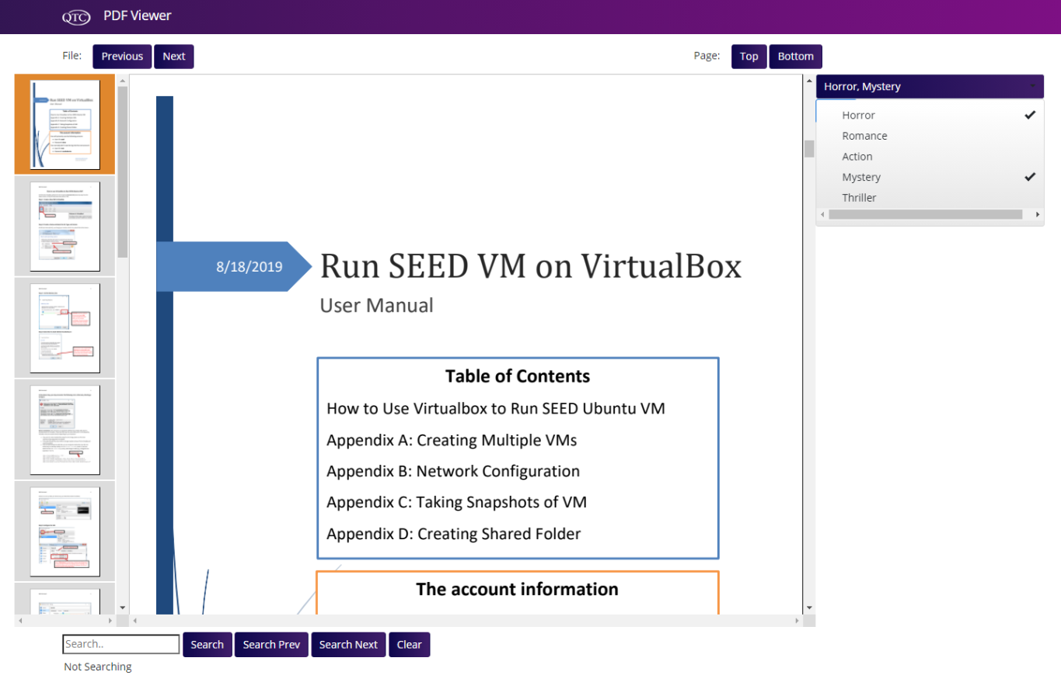
The interface will include buttons that will:
- Find previous / next file
- Scroll to bottom / top of page
- A Search bar to find keywords
- Search previous / next keywords
- Clear search
- A Drop-Down to filter through metadata
- Thumbnails to go to any page instantly

3.2 Hardware Interfaces
This software does not interact with any hardware device, therefore, the software does not have a hardware interface requirement.

3.3 Software Interfaces
- Atalasoft DotImage SDK, ver 11.2.0.7 found at https://www.atalasoft.com. This will be the overall user interface for the application
3.4 Communications Interfaces
The backend software will communicate with SQL Server Management Studio to retrieve information from the database. The program is also a web application, therefore it will communicate to the IIS web server manager using the .NET Framework

4. Requirements Specification
4.1 Functional Requirements
Requirement No. | Requirement Description
1.1.1 | The system shall implement an MVC ASP.NET web solution.
1.1.2 | The system shall place multiple pdf files in a queue to be displayed.
1.1.3 | The system shall let the user scroll onto the next file in the queue after viewing the current pdf file.
1.1.4 | The system shall allow the user to search for text specific keywords within the pdfs content.
1.1.5 | The system's search feature shall search through all of the pdfs that are in the display queue.
1.1.6 | The system's search feature shall allow the user to navigate back and forth through each occurrence of the searched text.
1.1.7 | The system shall update the display queue based off on the categories selected by the user.
1.1.8 | The system shall connect to an SQL database.
1.1.9 | The system shall use a stored procedure to retrieve the list of all categories.
1.1.10 | The system shall use a stored procedure to retrieve the PDF file locations of PDFs that must be displayed.

4.2 External Interface Requirements

Requirement No. | Requirement Description
1.2.1 | The interface shall be an online PDF viewer.
1.2.2 | The interface shall integrate Atalasoft's DotImage web viewer to display PDF files.
1.2.3 | The interface shall handle multiple pdf files in a single window as if dealing with one large pdf file.
1.2.4 | The interface shall have a filter by category feature that will allow the user to select specific categories.
1.2.5 | The interface shall prompt the user with a list of categories to choose from.
1.2.6 | The interface shall allow the user to select multiple categories.

4.3 Logical Database Requirements

Requirement No. | Requirement Description
1.3.1 | The database shall store the file locations of all PDFs within a table.
1.3.2 | The program's database shall store the file names of all PDFs within a table.
1.3.3 | The database shall store all possible categories within a table.
1.3.4 | The database shall have a table that displays the relation between a file and its category.
1.3.5 | The database shall have a table that displays the relationship between file names and its file group.
1.3.6 | The database shall have a stored procedure to retrieve all category names.
1.3.7 | The database shall have a stored procedure to retrieve all file paths.
1.3.8 | The database shall have a stored procedure to retrieve file paths by category.

4.4 Design Constraints
This program must implement Atalasoft’s DotImage software. Atalasoft’s DotImage software will be used to view files on the web. A SQL database must also be connected to the program. The program will make calls to the database to retrieve files and bring them into the view. The program will also query the database to sort the documents based on their metadata and bring them into the view.

5. Other Nonfunctional Requirements
5.1 Performance Requirements

Requirement No. | Requirement Description
1.4.1 | The program shall handle 1 to 1000 PDF files in a single viewer.
1.4.2 | The program shall handle all tasks with 100% accuracy.
1.4.3 | The program shall open up in less that 1 second.
1.4.4 | The program shall not take more than 2 seconds to display a pdf file
1.4.5 | The program shall not take more than 2 seconds to filter all pdf files.
5.2 Safety Requirements
There are no safety precautions that need to be taken when using this software
5.3 Security Requirements
This software will be used to view medical records and many of these records may contain sensitive information. Therefore, this software should only be used by authenticated employees of QTC. Precautions must be taken within the company to ensure that all personal information is kept secure and that only authorized personnel is allowed to use the application. QTC has assured the team that they will be in charge of implementing security measures within their in-house team.

5.4 Software Quality Attributes
Usability
- Inherited from the user friendly GUI that will allow the user to use the application.

Correctness
- The program will run specific queries that will retrieve very specific information, therefore, minimizing the error window.

Maintainability
- The team will be using QTC coding standards and conventions, ensuring that anyone familiarized with those standards will be able to modify the software to correct faults, improve performance, or adapt to a changed environment if needed.

At the time of writing, the application is hosted on a local host. However, QTC plans to move this to a web server allowing us to add attributes such as portability, availability, and reliability.
5.5 Business Rules
This will eventually be a tool that is incorporated within other portal applications. QTCs inhouse team will be responsible for the overall security and permissions of the overall implementation.

6. Legal and Ethical Considerations
This software does not pose any legal or ethical issues. QTC has maintained the safety and confidentiality of their client’s information for many years. All software licenses are legit and the program will only be used by QTC’s internal employees.

Appendix A: Glossary
A
ASP - Active Server Pages

I
IDE - Integrated development environment

P
PDF - Portable Document Format

Q
QTC - Quality, Timeliness, Customer Service: A Leidos Company

S
SQL - Structured Query Language
SDK - Software development kit

Appendix B: Analysis Models
Database ER Diagram
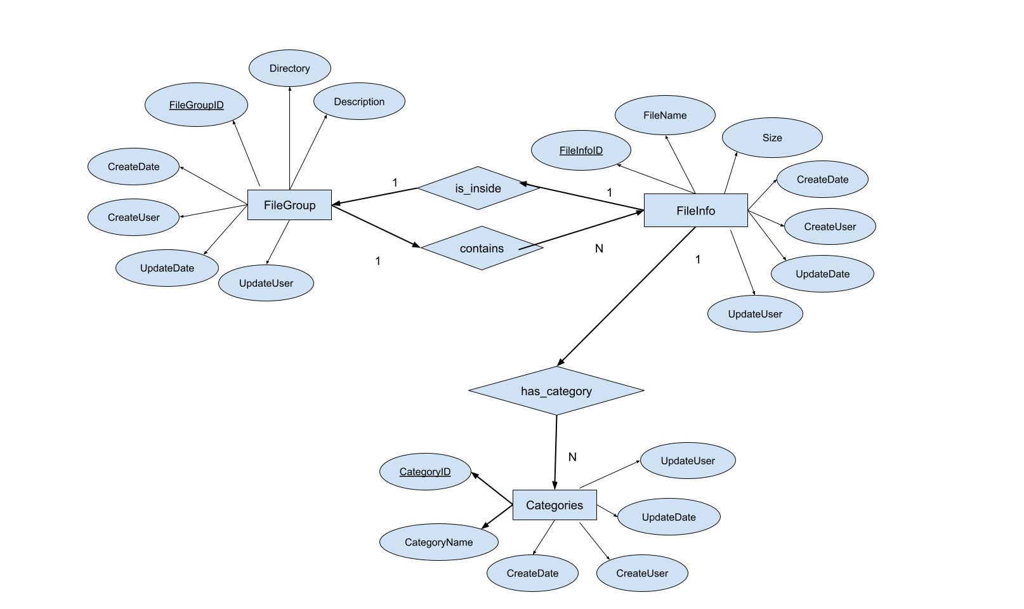

Data Flow Diagram
User
Server Side
Front End
Client Side
Database
Atalasoft Library
View Model

User viewer inputs
Linked
method/trigger calls
Viewer initialized and served to the interface
Redirects and serves database model information based on user inputs
Makes queries and receives appropriate data from database
Database tables linked to models class
QTC Web Viewer Application

PDF keyword Search
Loaded Document Viewer
Requirement C
Requirement 2
GUI
Requirement A
Requirement B

Appendix C: To Be Determined List
- Atalasoft: https://www.atalasoft.com/Products

