Software Design
Document
for
Capital Project Development Map

Version 1 approved

Prepared by Kevin Gamboa, Kevin Lam, Alvin Nguyen, Elizaveta Sokolova

LA City Data Science

April 10, 2018

Table of Contents................................................................................................................... <pg 1>
Revision History.................................................................................................................... <pg 2>
- Introduction................................................................................................................ <pg 3>
  - Purpose........................................................................................................... <pg 3>
  - Document Conventions……………………................................................. <pg 3>
  - Intended Audience and Reading Suggestions................................................ <pg 3>
  - System Overview........................................................................................... <pg 3>
- Design Considerations............................................................................................... <pg 4>
  - Assumptions and dependencies..................................................................... <pg 4>
  - General Constraints........................................................................................<pg 4>
  - Goals and Guidelines.....................................................................................<pg 4>
  - Development Methods................................................................................... <pg 4>
- Architectural Strategies.............................................................................................. <pg 5>
- System Architecture................................................................................................... <pg 6>
  - ....................................................................................................................... <pg 6>
  - ....................................................................................................................... <pg 6>
- Policies and Tactics.................................................................................................... <pg 7>
  - Specific Products Used.................................................................................. <pg 7>
  - Requirements traceability............................................................................... <pg 7>
  - Testing the software....................................................................................... <pg 7>
- Detailed System Design............................................................................................. <pg 8>
6.1 Administrative User Interface....................................................................... <pg 8>
6.1.1 Responsibilities...................................................................................... <pg 8>
6.1.2 Constraints............................................................................................. <pg 8>
6.1.3 Composition........................................................................................... <pg 8>
6.1.4 Uses/Interactions.................................................................................... <pg 8>
6.1.5 Resources............................................................................................... <pg 8>
6.1.6 Interface/Exports.................................................................................... <pg 8>
6.2 User Interface................................................................................................ <pg 8>
6.1.1 Responsibilities...................................................................................... <pg 8>
6.1.2 Constraints............................................................................................. <pg 8>
6.1.3 Composition........................................................................................... <pg 8>
6.1.4 Uses/Interactions.................................................................................... <pg 8>
6.1.5 Resources............................................................................................... <pg 8>
6.1.6 Interface/Exports.................................................................................... <pg 8>
- Database Design........................................................................................................ <pg 9>
- User Interface...........................................................................................................<pg 10>
  - Overview of User Interface.........................................................................<pg 10>
  - Screen Frameworks or Images....................................................................<pg 10>
  - User Interface Flow Model.........................................................................<pg 13>
- References................................................................................................................<pg 15>

Revision History

Name | Date | Reason For Changes | Version
Kevin Gamboa | 3/15/18 | Rough Draft | 1
Kevin Gamboa | 4/10/18 | Final Draft | 1

1. Introduction

1.1 Purpose
This document outlines in detail the software architecture and design for the Capital Project Development Map application. This document provides multiple views of the design of the application to better help understand the underlying architecture for this application. This document intends to be the sole source for reference while developing this application. This document describes only part of the system.

1.2 Document Conventions
The typographical conventions followed were given by our template. Each requirement statement within this document has its own set of priorities.

1.3 Intended Audience and Reading Suggestions
This document is intended for developers, project managers, users, testers, and documentation writers. Developers and project managers need to read the entire SRS to further understand the whole project.

This SRS begins with an introduction for the project and its system overview, which would give readers a basic understanding of the project. Following the introduction, readers would continue on to its design constraints which contains the projects assumptions and dependencies, all the way up to its development methods. Then the projects architectural strategies are listed next. The readers then would find a description of the project’s system architecture. This section will give the reader an easier understanding of the foundation of the project’s system. The next section would be the project’s policies and tactics, followed by the detailed system design section. The detailed system design section is the most important section of the document because it describes many important functionalities of the project. Database design section is next, which shows the description of how the database is worked throughout the project. The last section is the User Interface portion, which displays screenshots of how the user would interact with the project.

1.4 System Overview
The application used primarily Javascript (ArcGIS API) throughout the entire project.
The system is a web application where users may enter their login credentials, then access the web page where users may locate mobility investments within the city and use automated overlay
analysis to apply a weighted scoring model to the proposed projects, calculating how consistent
the investment is with the City’s mobility goals and policies.

2. Design Considerations

2.1 Assumptions and Dependencies
- Web Application needs to implement ESRI’s multipoint feature.

2.2 General Constraints
User will need administrative rights within the organization to update weights on the web application.

2.3 Goals and Guidelines
Our primary goal was to finish the web application by the end of Spring, 2018. The next goal for the team was to use data-driven approaches including machine learning algorithms to automatically design the best weights and scores rather than using pre-defined parameters.

2.4 Development Methods
The Capital Project Development Map was integrated with ESRI’s ArcGIS system that covered the front and backend of the web application. It was developed using the Water Fall Development method. As a team, we looked over the requirements for the project which would then help us design an approach to implement our ideas together. After verifying the constraints and solutions to our project, we developed the project then maintained it.

3. Architectural Strategies

3.1 Web Server
The web server for this project, is the main host for the entire web application. ESRI is the main web server which is implemented through ArcGIS. It should be responsible for handling the web-client interactions with the users. The frontend of the web application is completely dependent on ESRI’s servers. If ESRI’s servers are down, our web application would experience some technical difficulties.

3.2 Database Server
ESRI is responsible for dealing with the web application’s attributes and fields that are stored within the backend of the project. Those servers handle all reports and serve as a host to the data regarding location of the projects data.

4. System Architecture
The system’s responsibility is to provide the admin and user access to a web application that will enable LADOT staff to justify mobility investment using an automated web map. Each functionality has its own UI components.
DFD 0

An administrative user account may update or modify the scores and weights on all projects. They may also extract data to run an analysis on those projects. A basic user account can have similar functions as an administrative account, except the two functionalities just listed.
DFD 1

5. Policies and Tactics

5.1 Choice of which specific products used
We implemented ArcGIS's API for Javascript to develop the Web Map. Python, SciKit-Learn, Numpy, and Pandas were used as well. SciKit-Learn was applied for deep learning algorithms towards projecting reduction in collisions near city mobility projects in LA County.

5.2 Plans for ensuring requirements traceability
To ensure the requirements traceability within this software, comments are added onto the important lines of code in the project. There is also a readme.md file on github that shows developers how to create certain functionalities and features.
5.3 Plans for testing the software
When testing the software, we upload our code into our company’s github repository, which then automatically uploads our code onto the city of Los Angeles’s website for users to test the web map.
6. Detailed System Design
6.1 Administrative User Interface
6.1.1 Responsibilities
Users with administrative responsibilities will be able to handle the weights and scores of projects in the web map.
6.1.2 Constraints
No constraints with the administrative account
6.1.3 Composition
No composition in this account
6.1.4 Uses/Interactions
Administrator account may extract an analysis on data regarding certain projects and scores.
6.1.5 Resources
Data is stored and handled through ESRI’s cloud based system for ArcGIS.
6.1.6 Interface/Exports
6.2 User Interface
6.2.1 Responsibilities
Users will be able to create projects in the web map.
6.2.2 Constraints
User does not have administrative rights in the web map. User is not allowed to edit projects scores / weights, and they can’t extract data analysis.
6.2.3 Composition
No composition in this account
6.2.4 Uses/Interactions
User may create projects on web map
6.2.5 Resources
Data is stored and handled through ESRI’s cloud based system for ArcGIS.
6.2.6 Interface/Export

7. Database Design

Our web map is integrated with ESRI’s ArcGIS database system which is cloud based.
8. User Interface

8.1 Overview of User Interface
Describe the functionality of the system from the user’s perspective. Explain how the user
will be able to use your system to complete all the expected features and the feedback
Information that will be displayed for the user. This is an overview of the UI and its use. The user manual will contain extensive detail about the actual use of the software.

8.2 Screen Frameworks or Images

Opening Web Page:
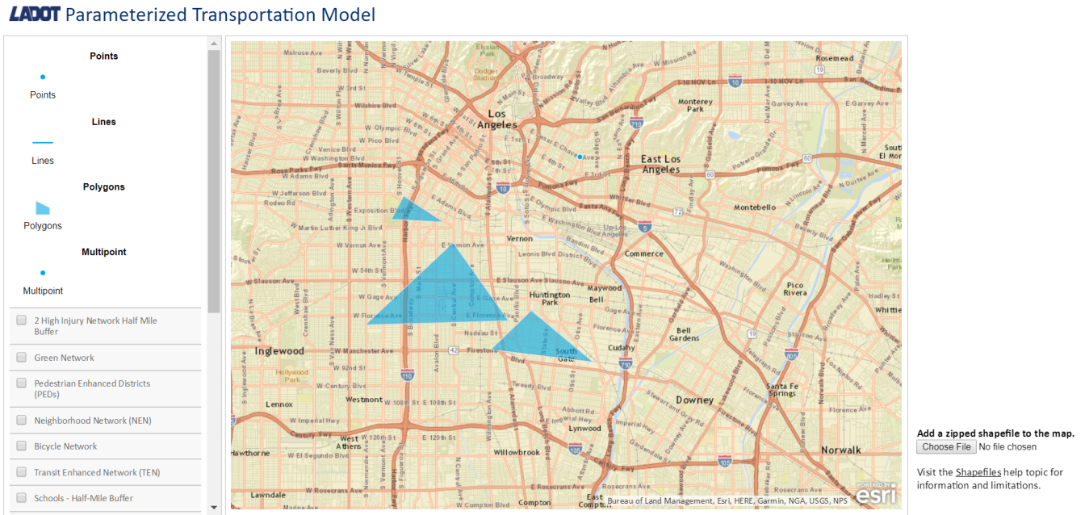

Scoring Feature located at the top right of the screen shot:
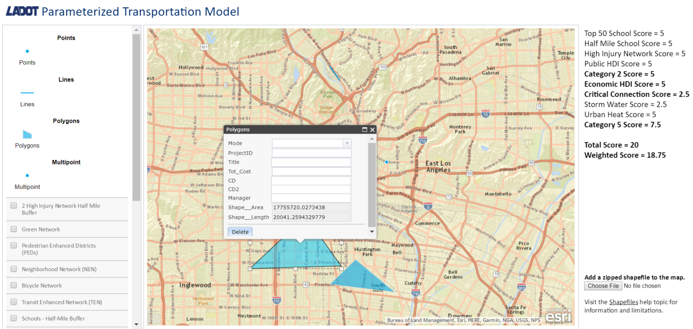

Point Feature:
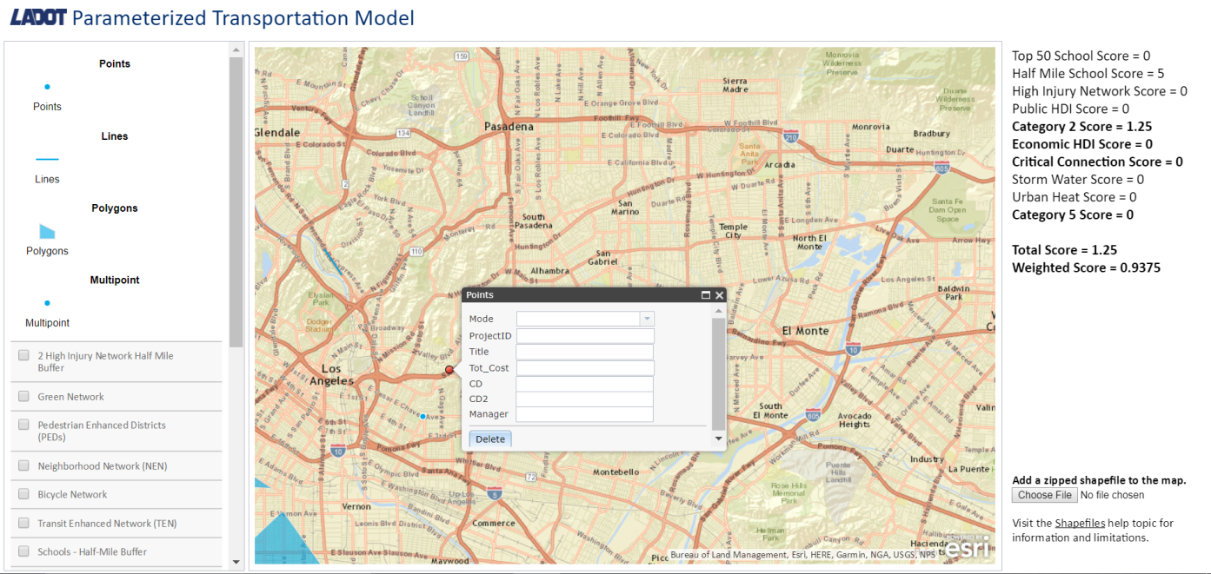

Line Feature:
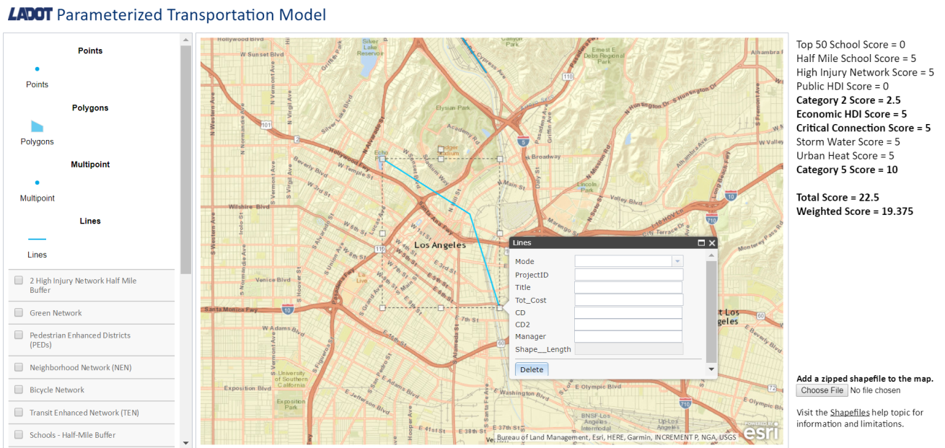

Polygon Feature:
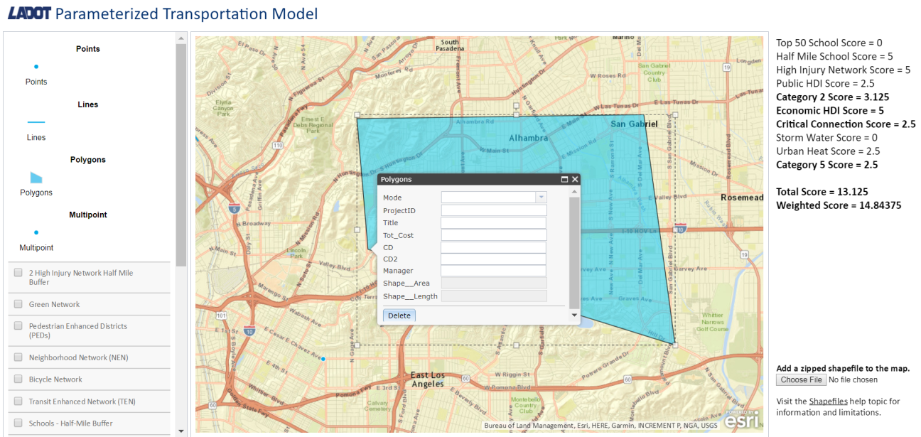

Layer Feature:
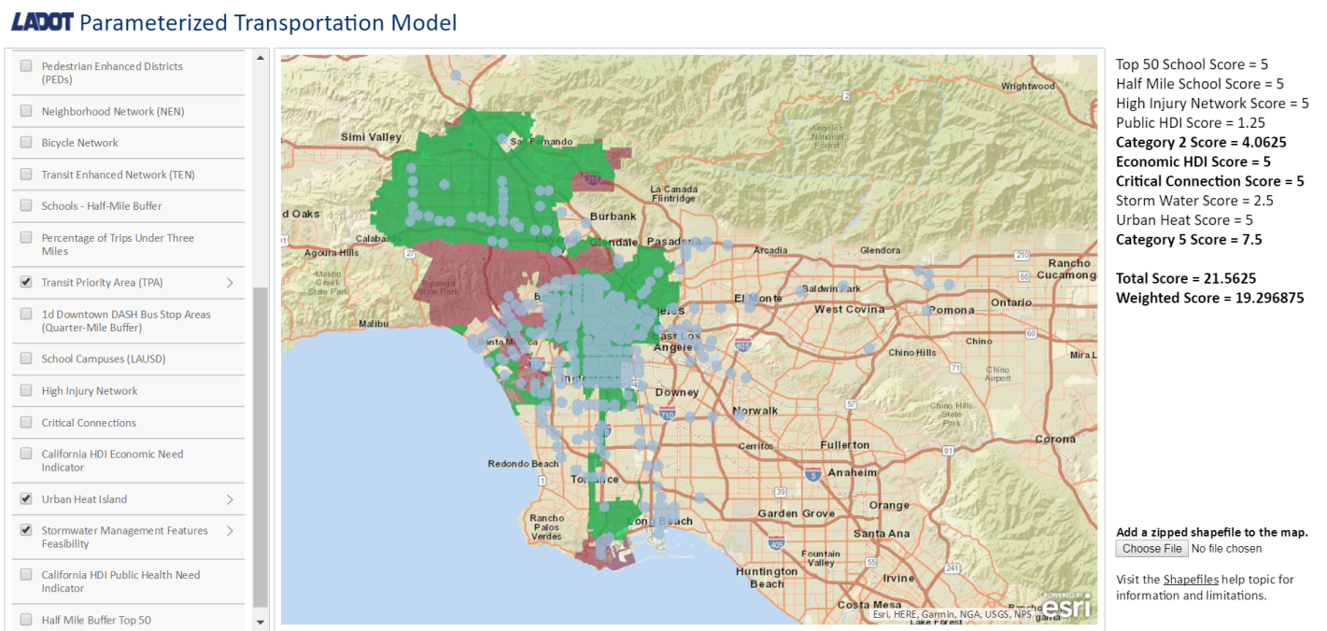
8.3 User Interface Flow Model

User is required to sign in once opening web page:
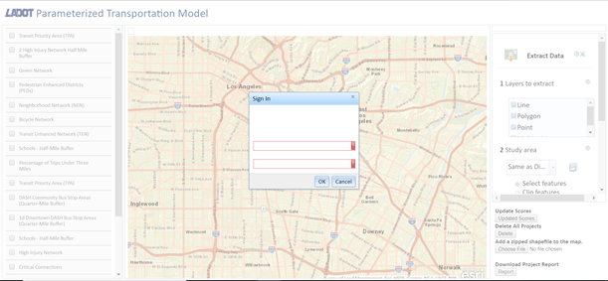

If the user has administrator credentials, they may change the weights / scores of the projects:
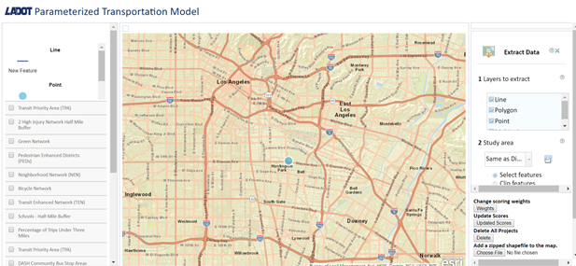

9. References

SRS:
https://csns.calstatela.edu/department/cs/project/resource/view?projectId=6059786&resourceId=6301334

