Software Design Document

for

Pelvic Image Analysis
and Geometry Reconstruction

Version <3.0> approved

Prepared by Nicol Barrios, Ralph Belleca, Ted Kim, Silvano Medina,
Robin Mok, Alejandra Olvera, Demetrius Parker, Sabino Ramirez,
Mary Semerdjian, Jason Tejada

Dr. Mathias Brieu (Biomedical)

May 13, 2022

Table of Contents...................................................................................................................<pg 2>
Revision History....................................................................................................................<pg 4>
- Introduction...............................................................................................................<pg 5>
  - Purpose..........................................................................................................<pg 5>
  - Document Conventions…………………….................................................<pg 5>
  - Intended Audience and Reading Suggestions...............................................<pg 5>
  - System Overview..........................................................................................<pg 5>
- Design Considerations..............................................................................................<pg 6>
  - Assumptions and dependencies....................................................................<pg 6>
  - General Constraints......................................................................................<pg 6>
  - Goals and Guidelines....................................................................................<pg 7>
  - Development Methods..................................................................................<pg 8>
- Architectural Strategies.............................................................................................<pg 9>
- System Architecture.................................................................................................<pg 10>
  - ......................................................................................................................<pg 10>
  - ......................................................................................................................<pg 11>
  - ......................................................................................................................<pg 12>
- Policies and Tactics..................................................................................................<pg 13>
  - Specific Products Used.................................................................................<pg 13>
  - Plans for ensuring requirements...................................................................<pg 13>
  - Testing the software.....................................................................................<pg 13>
  - Engineering trade-offs..................................................................................<pg 13>
  - Generate the system deliverables………………………………………… <pg 13>
- Detailed System Design...........................................................................................<pg 14>
6.1 AI-Assisted Annotation...................................................................................<pg 14>
6.1.1 Responsibilities................................................................................................<pg14>
6.1.2 Constraints.......................................................................................................<pg 14>
6.1.3 Composition....................................................................................................<pg 14>
6.1.4 Uses/Interactions.............................................................................................<pg 14>
6.1.5 Resources........................................................................................................<pg 14>
6.1.6 Interface/Exports.............................................................................................<pg 14>
6.2 Clara Train SDK..............................................................................................<pg 15>
6.2.1 Responsibilities................................................................................................<pg 15>
6.2.2 Constraints.......................................................................................................<pg 15>
6.2.3 Composition.....................................................................................................<pg 15>
6.2.4 User/Interactions..............................................................................................<pg 15>
6.2.5 Resources.........................................................................................................<pg 15>
6.2.6 Interface/Exports..............................................................................................<pg 16>
6.3 3D Slicer..........................................................................................................<pg 16>
6.3.1 Responsibilities................................................................................................<pg 16>
6.3.2 Constraints.......................................................................................................<pg 16>
6.3.3 Composition.....................................................................................................<pg 16>
6.3.4 User/Interactions..............................................................................................<pg 16>
6.3.5 Resources.........................................................................................................<pg 17>
6.3.6 Interface/Exports..............................................................................................<pg 17>

- Detailed Lower-level Component Design................................................................<pg 18>
- Database Design.......................................................................................................<pg 19>
- User Interface...........................................................................................................<pg 20>
- Requirements Validation and Verification...............................................................<pg 21>
- Glossary....................................................................................................................<pg 22>
- References.................................................................................................................<pg24

Revision History
Name | Date | Reason For Changes | Version
Silvano | 10/08/2021 | Update Document | 1.0
Silvano | 12/09/2021 | Update Document | 1.1
Mary | 12/09/2021 | Update Document | 1.1
Mary | 05/12/2022 | Revise Document | 2.0
Silvano | 05/13/2022 | Finalize Document | 3.0
1. Introduction
1.1 Purpose

The purpose of the Software Design Documentation (SDD) is to outline the design of our Image Analysis and Geometry Construction project, which is limited to the creation of 3D models of female pelvic organs. This document serves to expand the knowledge and understanding of our project’s functionalities, Level 0 DFD, Level 1 DFD, Level 2 DFD, user interface, and the libraries used in our software.

1.2 Document Conventions
The document contains headings, subheadings, and body text in Times New Roman. The headings are font size 20pt and bold, subheadings are 14pt and bold, and the body text is 12pt to make the document's layout more readable. Bullet points are used throughout the document to illustrate or outline specifications for the reader to read through quickly.
1.3 Intended Audience and Reading Suggestions
The document is mainly written for developers, medical doctors, and other healthcare professionals. It will include technical terminologies and diagrams, and tables that will be easy for the general public to comprehend. It is recommended to have a general understanding of cloud computing and physical computing.
1.4 System Overview

The project's goal is to streamline the process of converting MRI images of the pelvic organs into 3-D model objects. The project aimed to understand basic 3-D model construction – creating a high-quality 3D anatomical model from an MRI image through segmentation and smoothing tools. Lastly, creating an Artificial Intelligence (AI) model.

2. Design Considerations
This section describes many of the issues which need to be addressed or resolved before attempting to devise a complete design solution.
2.1 Assumptions and Dependencies
- Related software or hardware
- Operating systems
  - Windows
  - MacOS
  - Linux
- End-user characteristics
  - Understanding what the user wants when using the site
    - Make it as easy as possible for the user to use and understand in terms of human anatomy
    - Do not make it complicated; this will lead to confusion
- Possible and/or probable changes in functionality
2.2 General Constraints
- Hardware or software environment
  - Application software that has access to the internet or Wi-Fi
    - Runs on cloud web server provided by AWS
  - Linux
- End-user environment
  - Up-to-date web browser
    - Mozilla Firefox
    - Apple Safari
    - Internet Explorer
    - Google Chrome
    - Opera
    - Microsoft Edge
- Availability or volatility of resources
  - MRI scans for testing and Nvidia AIAA training
- Interface/protocol requirements
- Data repository and distribution requirements
  - Cost of using:
    - NVIDIA
    - Amazon Web Services (AWS)
- Security requirements (or other such regulations)
  - Anonymization of Personal Data (MRI Scans)
- Hardware requirements
  - Windows/Mac users with access to AWS
  - Linux Machine
  - NVIDIA GPU
- Memory and other capacity limitations
  - 8 GB RAM with 256 GB of space
  - 16 GB RAM with 500 GB or 1 TB of space
- Performance requirements
- Network communications
  - The user must have a stable internet connection
- Verification and validation requirements (testing)
- Other means of addressing quality goals
- Other requirements described in the requirements specification

2.3 Goals and Guidelines
While working on the project, we set many milestones and standards for ourselves in order to ensure that we get the best results we can possibly achieve. They ranged from setting up a virtual GPU to guides on how to successfully train a model.
Goals:
- Installation Videos NVIDIA Software
  - Give users a quick guide on how to set up their environment for training a model
- Emphasis on speed versus memory use
  - Two critical uses, the user should understand
- The product should work, look, or "feel" like an existing product
- The product should generate a competent result
- 3D Pelvic organ models made to be used for AIAA
  - Organs: Vagina, Rectum, Bladder
- The patient Data should be anonymized
  - MRIs (Magnetic Resonance Imagining) have extremely sensitive information on them; therefore, we must anonymize the data before we process it ourselves.
Guidelines:
- Follow an uncomplicated and straightforward guideline
- Make it easy to use for the user
- Make it simple to use NVIDIA AIAA (deep grow, boundary points)
2.4 Development Methods
The team decided to use AI Assistance to create a workspace for users to use the program with little-to-no training or practice. To create a near-accurate AI assistance tool, the team has shifted focus into developing a custom AI-trained model to fit the program's needs. The AI has been fed information about the pelvic regions, specifically the vagina, rectum, and bladder.

The team followed the female-pelvis-anatomical approach for this project. They hosted client bi-weekly meetings on Tuesdays and weekly meetings every Friday.

3. Architectural Strategies

3.1 Use of a particular type of product
To make 3D models from MRIs, we used a 3D slicer, a visualization software. Before we started with a 3D model, the team had to anonymize MRI data with a DICOM cleaner to protect each patients' privacy, which is very important in one's case. After anonymization, the team used 3D Slicer to make 3D models from anonymized patient data.
The team focused on three organs in the female pelvis: bladder, vagina, and rectum. We also used a 3D slicer to create binary masks for training and NVIDIA's Clara SDK to create our own AI model trained on the team's target data points. To do the training, Amazon Web Services was used.
3.2 Reuse of existing software components to implement the system
The team made extensive use of NVIDIA's AI-Assisted Annotation, a segmentation tool available in 3D slicer as a downloadable plugin, and NVIDIA AIAA, open-source medical image visualization, and analysis application.
Using the tool automates the 3D modeling process for the user. This plugin has three methods: fully automatic segmentation, DEXTR3D, and Deep Grow segmentation. Since DEXTR3D did not work well with the application of our AI model, we used Deep Grow to do the segmenting for the 3D model.
3.3 Future plans for extending or enhancing the software
Although there were no initial plans for extending the project, the team has made enough progress to warrant the continuation of this work. The group mainly used programming languages such as python, bash, and JSON to create configuration files and run Linux/Unix scripts to set up the training.

The team has thought of enhancing this work by getting more data points to train a more potent model, either through machine learning algorithms like GANs or by acquiring a large set of patient MRIs. The system is still in its early stages, so there is much room for improvement.

4. System Architecture
4.1 Level 0 DFD
The NVIDIA AIAA was used with a traditional approach in the system architecture. In Level 0 DFD, we have four methods; input the 3D model, anonymize the 3D model, create it and output it. Note that, in the inputting, the 3D model was in use with a DICOM-MRI as an input. And as an output, a 3D model output is shown as a result. The output can be either a rectum, vagina, or bladder. See Level 0 Data Flow Diagram below to see how Level 0 works best.
Level 0 Data Flow Diagram (DFD)
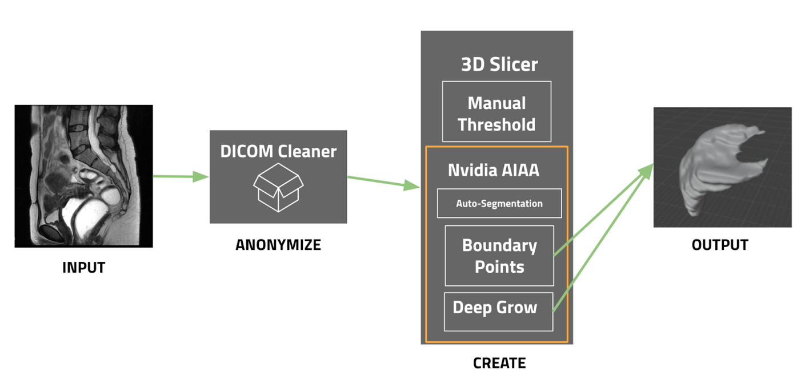

4.2 Level 1 DFD
Level 1 DFD Clara Train SDK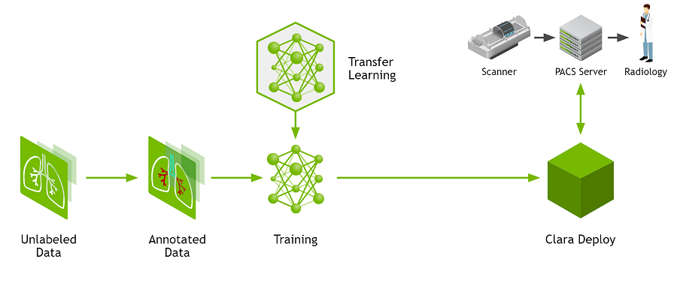
We have a Level 1 Diagram Flow Design of a Clara Train SDK above.
This Level 1 will show how Clara Train works with a physical GPU and how it may work with AWS cloud GPU dependency.

Unlabeled Data: data that has not been labeled or trained.
Annotated Data: data that has been labeled and is essential in training AI algorithms and Transfer Learning.
Transfer Learning: was used to speed up the creation of the AI model.
Clara Deploy: deploy the AI application.
Radiology: view the MRI DICOM data to see what treatment and diagnosis the patient needs.

4.3 Level 2 DFD
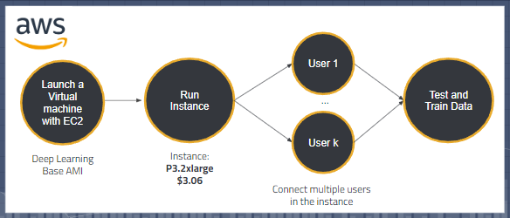
Level 2 DFD Amazon Web Services
Level 2 was the lowest design. The AWS uses Deep Learning Base AMI. The Deep Learning Base AMI provides a foundational platform for deep learning on AWS EC2 with NVIDIA CUDA, Docker, etc. Once an instance is running, multiple users can connect to the instance, and lastly, we test and train the data for accuracy and other various purposes.
5. Policies and Tactics
5.1 Choice of which specific products used
- IDE
  - PyCharm
- Software
  - 3D Slicer
  - Python
  - Jupyter Notebook
  - TensorBoard
  - JSON
- Programming Language
  - Python
  - JSON
  - Shell scripting
- Import/Export Files
  - DICOM files
  - NIFTI files
5.2 Plans for ensuring requirements traceability

We will be using GitHub because it's fast and accessible. Every time one of the group members makes an "update," the other group members will know and have access to it.

5.3 Plans for testing the software

The plan for testing the software is to aim for professionalism. The goal is to combine AI and human anatomy together basically; that way, we will have more extended accessibility to it.

5.3.1 Basic QA Testing
- Testing if generative MRI data passes through our AI and models as expected.
- Testing if models export as expected from our data.

5.4 Plans for maintaining software

The web application software will be maintained by additionally training the AI in pelvic model creation when needed to maintain efficiency.

5.5 How to generate the systems deliverables

The system will generate our pelvic model deliverable through identification from our AI and recreation of the anatomy.

6. Detailed System Design
6.1 AI-Assisted Annotation (Nvidia Plugin for 3D Slicer)
6.1.1 Responsibilities
Uses model reference to select region on interest with minimal user inputs. Specifically
will be focused on pelvic organs (bladder, rectum, vagina).
6.1.2 Constraints
Heavy reliance on model reference. Quality of model determines accuracy and success rates. Model has to be specifically tailored to get accurate result as mismatched model to organ selection can lead to imperfect model or no feasible results.
6.1.3 Composition
6.1.3.1 Deep Grow
Takes two inputs, background and foreground. Uses input and reference model
selected to create an expected pelvic 3D Model using information in MRI Scans.
6.1.3.2 Boundary Points (DExtr3D)
Select organ boundaries of interested organ and creates 3D model.
6.1.3.3 Auto-Segmentation
Segmentation of organ of interest without any user input.
6.1.3.4 Masking
Unused.
6.1.4 Uses/Interactions
Used to create 3D models of one of three pelvic organs in 3D Slicer. Sole purpose is to make overall skill needed to operate software easier with minimal time loss.
6.1.5 Resources
6.1.5.1 Reference Model
6.1.5.2 Server Connection
6.1.5.2.1 Internet
6.1.5.2.2 LAN
6.1.6 Interface/Exports
6.1.6.1 3D Model
Smooth 3D Model with acceptable accuracy outputted in file of interest, at the
moment STL.

6.2 Clara Train SDK
6.2.1 Responsibilities
Needed to create reference model of pelvic organs(bladder, rectum, vagina) using
reference MRI scans using AI machine learning.
6.2.2 Constraints
6.2.2.1 MRI Scans
Limited available numbers of scans can limit the accuracy of the 3D model.
Needed for creation and testing of the 3D model.
6.2.2.2 Software Requirement
Need of Linux environment.
6.2.2.3 Hardware Requirements
Need an Nvidia GPU with required specifications.
6.2.3 Composition
6.2.3.1 Tensor Board
6.2.3.2 Monai
6.2.3.3 Pytorch
6.2.4 Uses/Interactions
6.2.4.1 Training
Trains a model using annotated data.
6.2.5 Resources
6.2.5.1 Data
6.2.5.1.1 Annotated MRI Scans
6.2.5.2 Software
6.2.5.2.1 Linux Operating System
6.2.5.2.2 Docker
6.2.5.2.2.1 DGX-1
6.2.5.2.2.2 DGX-2
6.2.5.2.2.3 DGX Station
6.2.5.2.2.4 Pytorch
6.2.5.2.2.4.1 MONAI.io
6.2.5.2.2.4.2 Jupyter Notebook
6.2.5.2.2.4.3 TensorBoard
6.2.5.2.2.4.4 NVIDIA CUDA
6.2.5.2.3 NVIDIA Flare
6.2.5.3 Hardware
6.2.5.3.1 CUDA GPU
6.2.5.3.1.1 CUDA Core
6.2.5.3.1.2 Architecture
6.2.5.3.1.3 Memory
6.2.6 Interface/Exports
6.2.6.1 Visual Output
Visually see 3D trained model works in TensorBoard
6.2.6.2 File Output
3D trained Model
6.3 3D Slicer
6.3.1 Responsibilities
Medium used to create 3D model from MRI Scans.
6.3.2 Constraints
6.3.2.1 User Input
Requires complicated sets of instructions to select and create organ of interest.
6.3.2.2 Data Input
Requires MRI/CAT scans as data to create a model.
6.3.3 Composition
6.3.3.1 Drop Down Menu
6.3.3.1.1 Segment Editor
6.3.3.1.2 Data
6.3.3.2 Visualization
MRI scans visualized in 3D
6.3.4 Uses/Interactions
6.3.4.1 Segmentation
Select Region of interest and create 3D model visualization
6.3.4.2 3D Graphical view
Have Sagittal, Coronal, Axial views lined up with the XYZ planes and allow for
easy viewing
6.3.4.3 Plugins
Plugin library, allows us to use NVIDIA AIAA plugin
6.3.5 Resources
6.3.5.1 NVIDIA AIAA
Uses model reference to create segmentation of MRI Scan, assumably easier
than manual.
6.3.6 Interface/Exports
6.3.6.1 Visual Output
6.3.6.1.1 MRI Scans in 3D chart
6.3.6.1.2 3D model of Segmented section
6.3.6.2 File Output
Segmented section can be outputted as a save file in the following format: NIFTI,
STL, OBJ, NRRD

7. Detailed Lower-level Component Design
Does not apply.

8. Database Design

No Database was used in the project; therefore, this does not apply.
9. User Interface

Because of the approach we are giving the project, the group does not have a user interface set up as of right now. After exploring the project further and narrowing our priorities, it was decided to focus on working with NVIDIA’s software and train the AI to create masks of the pelvic organs we want to utilize. The user interface and its use should be prioritized for future groups to implement.

10. Requirements Validation and Verification

Since the project does not have a UI, then, no Requirements Validation and Verification was used in this project.

11. Glossary
3D Slicer - a free and open-source software package for image analysis and scientific visualization.
Amazon Web Services – the provider of cloud computing services that we used to host our machine learning model.
Anatomy - the study, classification, and description of structures and organs of the body.
API - stands for application programming interface—a set of definitions and protocols to build and integrate application software.
Artificial Intelligence (AI) - It is the science and engineering of making intelligent machines, especially intelligent computer programs.
Automate – to convert to automatic operation.
Bladder – a membranous sac serving as a receptacle for secretions, such as the gallbladder.
Biology – the scientific study of life.
Clara Train SDK – a software development kit that allows us to train a machine learning model to help us perform image analysis
DICOM (digital imaging and communications in medicine) - the standard used for the electronic transferring of digital image data.
Dimension - a measure of the width, length, or height of a space, usually described in units of a linear scale.
Female - pertaining to the sex that can become pregnant and bear children; feminine.
Geometry - a branch of mathematics that deals with the measurement, properties, and relationships of points, lines, angles, surfaces, and solids.
Image smoothing - a key technology of image enhancement, which can remove noise in images.
Image thresholding - the simplest method of image segmentation, which replaces each pixel in an image with a black pixel, if the image intensity is less than than some fixed constant, or a white pixel if image intensity is greater than the constant.
MRI (Magnetic Resonance Imagining) - medical imaging based on the resonance of atomic nuclei in a strong magnetic field and it has also become an important tool in musculo- skeletal and pelvic imaging. Page 1081 from Mosby Medical Dictionary
Nvidia - designs graphics processing units for the gaming and professional markets, as well as system on a chip units for the mobile computing and automotive market.
Nvidia AIAA - enables you to serve the models you trained to speed up annotation process.
Patient - a recipient of a health care service.
Pelvis – the lower part of the trunk of the body, composed of four bones, the two innominate bones laterally and ventrally and the sacrum and coccyx posteriorly.
Organ – a structural part of the system of the body that is composed of tissues and cells that enable it to perform a particular function.
Rectum – the lower part of the large intestine, about 12 cm long, continuous with the descending sigmoid colon, proximal to the anal canal.
Render - the process of generating a photorealistic or non-photorealistic image from a 2D or 3D model by means of a computer program.
Rendering - the process involved in the generation of a two-dimensional or three-dimensional image from a model by means of application programs.
Two Dimension (2D) – having only two dimensions, such as width, length, or height.
Three Dimension (3D) – having only three dimensions, such as width, length, or height.
Vagina – the part of the female genitalia that forms a canal from the orifice through the vestibule to the uterine cervix.

12. References
Kikinis R, Pieper SD, Vosburgh K (2014) 3D Slicer: a platform for subject-specific image analysis, visualization, and clinical support. Intraoperative Imaging Image-Guided Therapy, Ferenc A. Jolesz, Editor 3(19):277–289 ISBN: 978-1-4614-7656-6 (Print) 978-1-4614-7657-3 (Online)
Mosby’s Medical Dictionary. 9th ed. St. Louis, MO: Mosby Elsevier, 2013. Print.
NVIDIA Clara Imaging.
https://developer.nvidia.com/clara-medical-imaging (2022).

