Senior Design Final Report
Power BI Data Analytics Dashboard
Team Members:
Yara Ajjawi
Markniel Cruz
Jevon Fan
Suresh Ghimire
Jiajun Gu
DeQing Liang
Elton Lin
Edwin Lugo Bautista
Tommy Ly
Winston Pham
Alvin Truong

Faculty Advisor:
Dr. Chengyu Sun

Liaisons:
Deepak Budwani
Angella Stokke
Sarah Rothschild
Bryan Burzon
Aidan Bassett

Table of Contents

- Introduction 2
  - Background 2
  - Design Principles 2
  - Design Benefits 2
  - Achievements 2
- Related Technologies 3
  - Existing Solutions 3
  - Reused Products 3
- System Architecture 3
  - Overview 3
  - Data Flow 3
  - Implementation 3
- Conclusions 4
  - Results 4
  - Future 4
- References

1. Introduction:
1.1 Background:

Santa Barabara County Public Defender’s office deals with tons of data, and with that comes many questions. As of right now, their main source of creating static monthly reports is with an SQL server that exports raw data from their system Excel to run pivot tables, create summary reports, and present visualizations. With the help of California State University, Los Angeles, the Santa Barbara Public Defender’s Office hopes to build an interactive, real-time data dashboard that incorporates data from their content management system (eDefender) to increase data transparency, understand patterns and trends in our local criminal justice system, measure outcomes, and be better equipped to use evidence-base models to drive policy and system change. With the help of Microsoft Power BI, this is done along with automating manual processes and making the data reports accessible in real-time.

Power BI is a business analytics tool first introduced in July of 2011 as part of Microsoft’s Power Platform. Its main purpose was to allow businesses to analyze and shape data into meaningful insights that can help make more calculated decisions within a businesses work plan and also allowed users to get a brief and quicker insight on the underlying data their business has collected over time.
‘
1.2 Design Principles
The goal of these dashboards is to provide the user who is viewing them crucial information at a glance. The dashboards need to be simple, intuitive, and not cluttered, while at the same time display all information necessary to make crucial decisions. Because Power BI provides real-time data, shifting the emphasis from annual metrics to real-time reporting will be integral as they integrate data into their daily practices and operations.

1.3 Design Benefits
The visualizations and charts need to be customizable, because the Santa Barbara team deals with different populations along with different locations. Ensuring that the dashboards are customizable by the team will be a crucial aspect of getting the most out of the dashboard. The Santa Barbara team should be able to filter data by important client demographics such as race/ethnicity, gender and age, as well as additional filters such as indigency status, offense type, and severity.

1.4 Achievements
Our team has been able to develop two dashboards that provide detailed overviews of specific data to help management make better day-to-day decisions about resource allocation. The two dashboards consist of one internal and one external dashboard. The internal dashboard provides a detailed overview of information that provides feedback on whether the team has met their goals or not. These metrics and data fall under management metrics, client advocacy metrics, and data validation audits. For the external dashboard, the data and visualizations displayed organizational performance and criminal justice system metrics. The intended audience for the external dashboard is for the community, as it is important for the community to know what is currently being done in the office.

2. Related Technologies:
2.1. Existing Solutions:
Prior to looking into using Power Bi within their workflow, they would create their data visualizations by hand every month, cleaning data and doing each and every single data visual manually. In terms of existing solutions to the Santa Barbara Public Defender’s office goal, they have brought several different implementations of data visualizations and dashboards to us beforehand. On their own time, they have looked into other platforms to create these dashboards, but they felt that Microsoft’s Power BI was the best option to implement into their workflow as most of the applications they use are based on the Microsoft platform. So, incorporating and compatibility between Power BI and what they are already using is straightforward and seamless.

2.1. Reused Products:
Both Excel and a MySQL server will continue to be used by the Santa Barbara team. Excel will be used to preprocess and clean data before importing it all into their SQL server. The SQL server will then be the main source of data being pulled into the Power BI workspace. The visuals of the dashboards will then be updated automatically when the imported data is updated.

3. System Architecture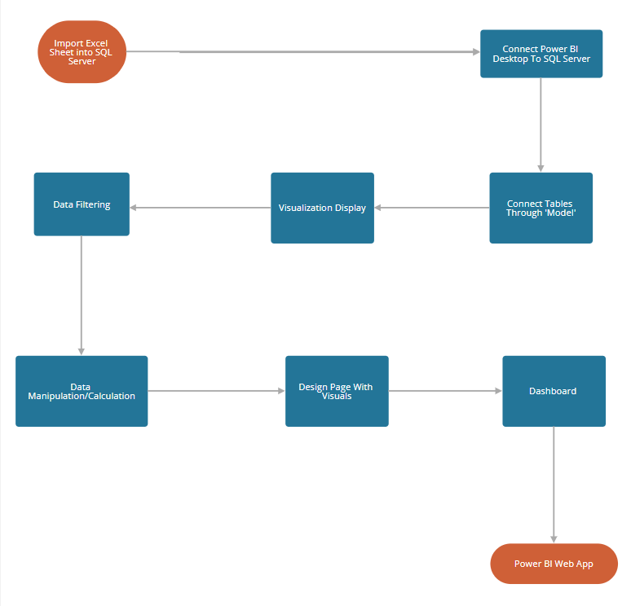

3.1.Overview:
We directly import our data as an excel sheet provided to us by the SB team into our SQL server using MSSQL client management tool, the relationships between the tables were then created within the Power BI 'model' where they directly affect our data calculations.
We then pick from a variety of visualizations that include charts, funnels, maps and cards to display the required data within the pages that we create based on the dashboard design that was initially provided to us by the SB team. The SB team provided us with the design template where in it we can find the description for the data that will be displayed, the description includes what data will be filtered and what the data will represent in terms of the story they are conveying.
Through selecting fields in the tables we can display data within the visuals, if we initially want to filter our data we can make use of 'Filters' feature which are independent of visuals, pages and all pages to decide how the data will be manipulated and displayed. Once we are required to calculate more complicated filtering we can make use of DAX functions which allows us to use the Power BI library functions that helps us to creatively filter, calculate, and ultimately entirely manipulate data to our liking to then be displayed regarding the dashboard design and story.
3.2. Implementation:
Early into the project development we were split into two groups to divide and conquer the tasks at hand. Database and PowerBI. Database was later dropped as it was no longer needed and we had everyone work on PowerBI and divide the different dashboards.
3.2.1 Office of the Public Defender, Santa Barbara County’s Data
The office of Santa Barbara had data stored in an excel sheet. This was sent through email to our team lead and later processed into MySQL
3.2.2 MySQL Database
Data was converted from excel spreadsheet to MySQL for PowerBI to directly pull data from.
3.2.3 PowerBI User Interface
Once the data was in the MySQL database we used PowerBI to create visualizations and dashboards. PowerBI has many tools such as DAX(data analysis expression) and charts generate dashboards.

4. Conclusions
4.1 Results

We have created multiple dashboards for the Santa Barbara Public Defender's Office for their attorneys to use. They are currently pulled directly from the SQL servers the California State University controls but the data can be pulled from Santa Barbara’s own eDefender database after the deliverables are transferred.
We have created multiple visualizations and DAX functions for each dashboard, each unique in its own information given and required. There are also specific filters for certain cards to show only what is wanted.

4.2 Future

In the future there are plans to fully implement all of the dashboards onto the Santa Barbara County’s website for the general population to view, including an internal dashboard designed specifically for attorneys to see. There are also future plans for PowerBI to be used via mobile application. One final step to fully finish our work is to make sure everything is fully automated by the software itself whenever new information is presented via eDefender.

