Software Requirements Specification

For

Improve the WiFi Coverage and Quality in Cal State LA
Version 1.1 approved

Prepared by Steven Castro, Daniel Xu, Jorge Lima, Paul French, Albert Ting

CSULA

4-13-2018

Table of Contents
Table of Contents................................................................................................................... <pg 2>
Revision History..................................................................................................................... <pg 3>
- Introduction................................................................................................................ <pg 1>
  - Purpose........................................................................................................... <pg 1>
  - Intended Audience and Reading Suggestions................................................ <pg 1>
  - Product Scope................................................................................................ <pg 1>
  - Definitions, Acronyms, and Abbreviations .................................................. <pg 2>
  - References......................................................................................................<pg 2>
- Overall Description.................................................................................................... <pg 3>
  - Product Perspective........................................................................................ <pg 4>
  - Product Functions...........................................................................................<pg 5>
  - User Classes and Characteristics....................................................................<pg 5>
  - Operating Environment.................................................................................. <pg 5>
  - Design and Implementation Constraints........................................................ <pg 5>
  - User Documentation...................................................................................... <pg 6>
  - Assumptions and Dependencies.................................................................... <pg 6>
  - Apportioning of Requirements...................................................................... <pg 6>
- External Interface Requirements............................................................................... <pg 7>
  - User Interfaces............................................................................................... <pg 7>
  - Hardware Interfaces....................................................................................... <pg 8>
  - Software Interfaces........................................................................................ <pg 8>
  - Communications Interfaces........................................................................... <pg 8>
- Requirements Specification....................................................................................... <pg 9>
  - Functional Requirements............................................................................... <pg 9>
  - External Interface Requirements..................................................................<pg 11>
  - Logical Database Requirements...................................................................<pg 12>
  - Design Constraints.......................................................................................<pg 12>
- Other Nonfunctional Requirements.........................................................................<pg 13>
  - Performance Requirements..........................................................................<pg 13>
  - Safety Requirements....................................................................................<pg 13>
  - Security Requirements.................................................................................<pg 13>
  - Software Quality Attributes..........................................................................<pg 14>
  - Business Rules..............................................................................................<pg 14>
- Other Requirements................................................................................................. <pg 15>
Appendix A: Glossary..........................................................................................................<pg 16>
Appendix B: Analysis Models..............................................................................................<pg 17>
Appendix C: To Be Determined List....................................................................................<pg 18>

Revision History

Name | Date | Reason For Changes | Version
Steven Castro | 12/7/2017 | Initial version completed | 1.0
Steven Castro | 4/13/2018 | Minor changes to requirements regarding UI and simultaneous users. | 1.1

1. Introduction

This document contains the Business Requirements for the Improve the WiFi Coverage and Quality in Cal State LA (IWCQCSLA) project. The software requirements for this project are stated in this document with the implementation for this project being in the Software Design Document.

1.1 Purpose

This document’s purpose is to be used as a reference for the Software Design Document for the IWCQCSLA project. This document states the software requirements for the architecture, design style, and coding platform.

1.2 Intended Audience and Reading Suggestions
This document’s intended audience is to be used by developers for creating the Software Design Document. Testers may use this document to verify that the requirements have been met in both the Software Design Document and in the developed application. This document states the software requirements for this project with the design being created separately. Reference this document when creating the software design document to fulfill all requirements specified in this document.

1.3 Product Scope

The IWCQCSLA project’s scope is to create a new app within the current CSULA GET mobile app (for both IOS/Android) to be used by people on the CSULA Wi-Fi network. Its purpose is to give users of the CSULA network a way to report Wi-Fi outages, bad signal strength, and to provide a heatmap that shows zones with many outage reports.

1.4 Definitions, Acronyms, and Abbreviations

IWCQCSLA - Improve the WiFi Coverage and Quality in Cal State LA (project title)
CSULA GET mobile app – Current official application for CSULA (for both IOS/Android)

1.5 References

2. Overall Description
The IWCQCSLA project’s purpose is to create a web based application that is mobile friendly. This web based application will be implemented into the CSULA GET mobile application after completion. The web app will display a heatmap of the campus that shows where Wi-Fi coverage is bad based on user reports generated through this app. This application shall have an option to report a Wi-Fi outage through a form from within the app. The report will utilize GPS location to help fill out the form for reporting a Wi-Fi outage. The web based application will use a backend database to store reports for Wi-Fi outages.
2.1 Product Perspective

This application will exist within the CSULA GET mobile application. The CSULA GET mobile application can acquire new weblinks to show on the main page. This project is designed to be a web-app to be featured on the main page in the CSULA GET mobile app.
This application will exist only within the CSULA GET mobile app.

Perspective of the project is shown below in respect to the already existing CSULA GET mobile app.

CSULA GET MOBILE APP

OTHER MODULES

IWCQCSLA

2.2 Product Functions

The functions of IWCQCSLA are as follows:
- Provide a link within the CSULA GET mobile app to access the IWCQCSLA module.
- Show a heatmap of reported Wi-Fi outages within the CSULA campus.
- Provide a form for a user to report a Wi-Fi outage within CSULA. The form will have been partially completed if location (via GPS) is given permission by the user.

2.3 User Classes and Characteristics
There will be one user class for the IWCQCSLA module.
All users will be able to access the module within the CSULA GET mobile app to report Wi-Fi outages and view the Wi-Fi outage heatmap.

2.4 Operating Environment

The frontend(web server) for the application will be hosted on a separate server from the backend server. The frontend server shall be able to host a webpage with PHP.
The backend server (database server) shall be able to host a SQL database.

2.5 Design and Implementation Constraints

- User’s Smartphone must be able to install and run the CSULA GET mobile application on Android / IOS.
- Two servers must be used for this project. A server to host the website and a server to host the backend database due to security constraints.

2.6 User Documentation
Two documents will be released along with the IWCQCSLA module.
- Release Notes (given through email and on patch notes through the app’s homepage on its respective app-store)
- Guide on how to utilize the new module. (through email)

2.7 Assumptions and Dependencies

The server must be able to host a webpage running PHP with another server being able to run PostGRE SQL.
The users for this module must have a smartphone with the CSULA GET mobile app installed.

2.8 Apportioning of Requirements
1. Develop a heatmap of areas with reported outages.
2. Automatically fill out partial information in the reporting form based on location.

3. External Interface Requirements
The External Interface of this module shall be ran on a server hosting a webpage on PHP.
The webpage shall function as a normal webpage optimized to scale to a mobile view.

3.1 User Interfaces
The user must be able to access all the features of this application through the home screen. The purpose of this is to make this application enhancement easy to use. The following are concept images of how the final product may look like for reporting an outage and may not reflect the final product.
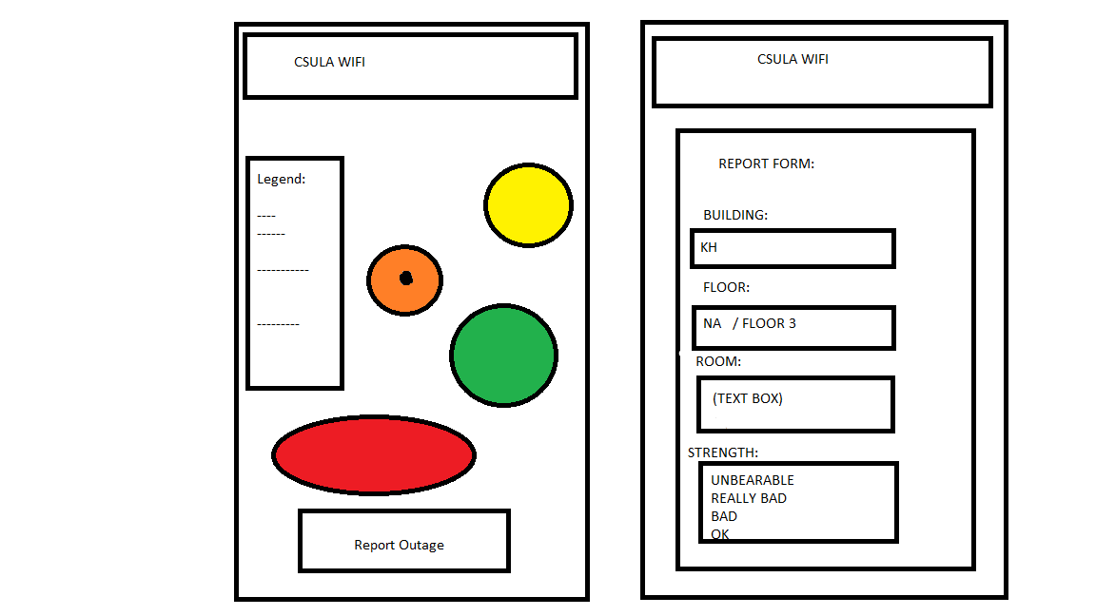
The application shall have a Report Outage button on the main page. The background for the application will be the heatmap of the reported Wi-Fi outages on the CSULA campus.
Once the ‘Report Outage’ button has been pushed it will lead into a form to complete reporting a Wi-Fi outage. Features of the form include drop down menus to help pinpoint where the outage is occurring.

3.2 Hardware Interfaces

This module shall be able to be ran on a mobile operating system that can run the CSULA GET mobile app.

3.3 Software Interfaces

The software that this application must utilize is as follows:
Ubuntu LTS 16.04
PostgreSQL 9.5
PHP 7

This application must be able to be ran in the CSULA GET mobile application.

3.4 Communications Interfaces
The communication requirements for this application is of the following:
- The web page shall be hosted on a server separate from the PostgreSQL database.
- The SQL database will have protection from SQL injection.
- The SQL database shall be updated through the use of a form with dropdown boxes.

4. Requirements Specification
This Section collects all the IWCQCSLA Functional Requirements. This section includes the complete set of functional requirements with explanation and rationale where the statement of the requirement was deemed insufficient or needing additional background/justification. An effort has been made to standardize the correlation between the design modules and the requirements to make their access and organization more consistent. For example, requirement number “n” affecting module 2.1 will be labeled 3.1-n.

4.1 Functional Requirements

Requirements Related to Web Server (WS) Module (4.1)
Requirement No. | Requirement Description
4.1-1 | WS shall be running PHP.
4.1-2 | WS shall support JavaScript.
4.1-3 | WS shall request the user’s location data.
4.1-4 | WS shall use Google Maps APIs.
4.1-5 | WS shall store and manage data by retrieving and updating tables in the database server.
4.1-7 | WS URL for the web page shall be accessible through the CSULAGET mobile app.
4.1-8 | WS’s generated webpage shall have a dropdown form menu that contains the ‘Report Outage’ Submodule.
4.1-9 | WS shall be running on a server separate from the database server.
4.1-10 | WS heatmap shall be based off of the data from the Database server.
4.1-11 | WS’s generated webpage shall be optimized to fit on mobile devices.
4.1-12 | WS’s generated webpage shall show your statistics on download speed ping and other network stats.
 | SUBMODULE 4.1.1 OUTAGE REPORT FORM (ORF)
4.1.1-2 | ORF shall have a form that allows the user to report the wifi quality
4.1.1-3 | ORF’s dropdown fields shall be filled with information regarding location from within CSULA.
4.1.1-4 | ORF’s dropdown fields shall be partially filled in depending if the user has their location services on. The partially filled in forms shall be but not limited to: the building they are in, download speeds, ping.
4.1.1-5 | ORF’s shall send the form’s contents to the separate server that hosts the database.
4.1.1-6 | ORF shall use prebuilt commands to update the SQL server.
4.1.1-7 | ORF shall have a text box for additional comments.
4.1.1-8 | ORF shall protect against SQL injection through parsing out the sent command to the SQL database.

Requirements Related to Database Server (DS) Module (4.2)
Requirement No. | Requirement Description
4.2-1 | DS shall be running postGRE SQL.
4.2-2 | DS shall be running on a Linux based OS.
4.2-3 | DS shall be on a separate server from the WS.
4.2-4 | DS shall have protection from SQL injection through commands sent from the WS.
4.2-5 | DS shall store and send out data from the SQL tables created.
4.2-6 | DS shall have a SQL table setup with locations from within CSULA as the main key.
4.2-7 | DS can only be updated from within the Report Outage form from within the WS module..
4.2-8 | DS shall be able to support multiple users updating the SQL database simultaneously.
4.2-9 | DS shall be able to send out data for generating a heatmap in the WS.
4.2-10 | DS shall only interact with the webserver with SQL commands and sending data.

4.2 External Interface Requirements
- The IWQCSLA module shall be able to be accessed through the CSULA GET mobile application home screen.
- The WS module shall be responsible for displaying the enhancement on the user’s devices.
- The WS module shall be responsible for handling all the inputs and outputs of this application.
  - List of Outputs:
    - Home Web page of application.
      - Contains:
        - Heatmap
    - Report Outage Form view.
      - Contains:
        - Form
        - Submit Form button.
  - List of Inputs:
    - Location
    - Report Outage Form
    - SQL commands.
- This application shall be able to be viewed on any mobile devices that can install and run the CSULA GET mobile application on IOS/Android.

4.3 Logical Database Requirements
The Database Server Requirements are as follows:
- Shall be able to host a SQL database.
- Shall be on a separate server from the Web server.
- Shall be running a Linux based OS.
- Shall be able to support simultaneous users updating the same SQL database.
- Shall be able to send out data to create a heatmap in the WS.
- Shall be able to prevent SQL injection.
- Shall be able to be accessed through the CSULA GET mobile application.
- Shall have tables that are related through location of buildings.
- Shall only store publicly reported outage data and no personal data of users.
The rest of the Database Requirements if not listed here are listed in section 4.1 of this document.

4.4 Design Constraints

This application must utilize two separate servers for maintaining the front end and back end separately. The front end shall host a website that will filter out bad commands to the SQL server. The back end shall be able to support many simultaneous users updating the same SQL database.
The application shall not add any new requirements to the CSULA GET mobile application as this will exist within that application.
The application shall be optimized for a mobile view and mobile interaction (touch screen).

5. Other Nonfunctional Requirements

5.1 Performance Requirements

This application shall be implemented into the CSULA GET mobile application. This application shall be supported on mobile devices that are able to run the CSULA GET mobile application in Android/IOS.
- The number of simultaneous users to be supported is 100 users sending queries at the same time.
- 90% of the transactions shall be processed within 10 seconds.
- 10% of the transactions might take longer than 10 seconds, wait duration will be dependent on the number of simultaneous users.
The information being sent over from the user’s side will be a SQL command to update an existing database.
The server shall support up to 100 simultaneous users accessing the application’s webpage link within the CSULA GET mobile application.

5.2 Safety Requirements
All reports from within the application will be anonymous to protect the user’s identity and personal information. By not holding the user’s information in the backend databases, it will protect the users from possible security breaches in the database.

5.3 Security Requirements
HTTPS certification will be sought after but is not required. The server for the database cannot be the same server that hosts the applications website, therefore a minimum of two servers will be used in this application.

5.4 Software Quality Attributes

The quality attributes that the product will strive to have the most of is having an ease of use for the application. By making the application easy to use, we hope that more users will utilize this application to report Wi-Fi out ages.

5.5 Business Rules

All users of this application will have a uniform level of access for reporting Wi-Fi outages. Users with specific permissions in IT will have access to a private website to view contents of Wi-Fi outages.

6. Other Requirements
None.

Appendix A: Glossary
IWCQCSLA - Improve the WiFi Coverage and Quality in Cal State LA (project title)
CSULA GET mobile app – Current official application for CSULA (for both IOS/Android)
WS – Web server
DS – Database Server
ORF – Outage Report Form
SQL – Database type used.

Appendix B: Analysis Models

The IWCQCSLA shall exist within the CSULA GET mobile application.
This shall be accessible from within the homepage of the CSULA GET mobile application.

CSULA GET MOBILE APP

OTHER MODULES

IWCQCSLA

This shows the relationship to the IWCQCSLA compared to the CSULA GET mobile application.

Appendix C: To Be Determined List

