Software Requirements Specification

for
Digitizing the Employee/Contractor Boarding Process

Version 1.3 approved

Prepared by Javier Garcia,
Adrian Palomares,
Rawad Moussa,
Marlito Refuerzo Jr,
Christopher Rodriguez,
Tabassuma Torosa,
Paul Ube,
Audelia Valdovinoz,
Pierce Wei

Office of Public Defender, LA County

14 May, 2021
Table of Contents
Table of Contents................................................................................................................. pg 2
Revision History................................................................................................................... pg 3
1. Introduction................................................................................................................ pg 4
1.1. Purpose........................................................................................................... pg 4
1.2. Intended Audience and Reading Suggestions................................................ pg 4
1.3. Product Scope................................................................................................ pg 4
1.4. Definitions, Acronyms, and Abbreviations .................................................. pg 4
1.5. References...................................................................................................... pg 5
2. Overall Description.................................................................................................... pg 6
2.1. System Analysis…......................................................................................... pg 6
2.2. Product Perspective........................................................................................... pg 6
2.3. Product Functions........................................................................................... pg 6
2.4. User Classes and Characteristics.................................................................... pg 6
2.5. Operating Environment.................................................................................. pg 7
2.6. Design and Implementation Constraints........................................................ pg 7
2.7. User Documentation...................................................................................... pg 7
2.8. Assumptions and Dependencies.................................................................... pg 7
2.9. Apportioning of Requirements...................................................................... pg 8
3. External Interface Requirements............................................................................... pg 9
3.1. User Interfaces............................................................................................... pg 9
3.2. Hardware Interfaces....................................................................................... pg 9
3.3. Software Interfaces........................................................................................ pg 9
3.4. Communications Interfaces........................................................................... pg 9
4. Requirements Specification....................................................................................... pg 10
4.1. Functional Requirements............................................................................... pg 10
4.2. External Interface Requirements................................................................... pg 11
4.3. Logical Database Requirements.................................................................... pg 12
4.4. Design Constraints......................................................................................... pg 12
5. Other Nonfunctional Requirements........................................................................... pg 13
5.1. Performance Requirements............................................................................ pg 13
5.2. Safety Requirements...................................................................................... pg 13
5.3. Security Requirements................................................................................... pg 13
5.4. Software Quality Attributes........................................................................... pg 13
5.5. Business Rules............................................................................................... pg 13
6. Legal and Ethical Considerations.….......................................................................... pg 14
Appendix A: Glossary........................................................................................................ pg 15
Appendix B: Analysis Models........................................................................................... pg 16

Revision History
Name | Date | Reason For Changes | Version
Documentation Subteam | 11/6/2020 | Initial creation/start of documentation process | 1.0
Pierce Wei | 12/5/2020 | Finalization of documentation | 1.1
Marlito Refuerzo | 03/13/2020 | Updating Project Requirements and Plans | 1.2
Pierce Wei | 05/09/2021 | Small updates and finalizing | 1.3

1. Introduction

1.1 Purpose
The purpose of this document is intended to give an overview on the project’s functionalities and nonfunctional requirements. It will go over aspects of the finalized version of the software and how it was designed.

1.2 Intended Audience and Reading Suggestions
This SRS is intended for the Office of Public Defender LA County officials, project managers, employees, contractors, and vendors. The Office of Public Defender LA County staff will also be maintaining the software into the future.

1.3 Product Scope
The software is designed to allow employees, contractors, and vendors to easily submit onboarding information that will be sent to one of two online templates via the back-end program. This will allow the users to submit a web form which allows the hosted templates to be pre-populated with the data. However, the user is required to enter all their information prior to having all the forms pre-populated so that the system will have their information ready. Once the software is released, it should provide an efficient method for contractors, employees, and various approvers to complete the onboarding process.

1.4 Definitions, Acronyms, and Abbreviations
AngularJS - JavaScript-based open-source front-end web framework used in developing single-page applications
ISD - Internal Services Department
PDF - Portable Document Format
SRS - Software Requirements Specification
BOX - Secure Content Management Software
Adobe API - Adobe Application Programming Interface
1.5 References
All PDF files will be hosted directly on the Adobe Sign platform when completed. Each PDF will also have attached the Board of Supervisors Policy No. 6.101 (Revised January 2019) at the end of each form.
- County of Los Angeles Internal Services Department: Active Directory/Hosted Registration Form For L.A. County Employees
  - Revised October 2017
- County of Los Angeles Internal Services Department: Active Directory/Hosted Registration Form For Contractor/Vendor
  - Revised October 2017
- County of Los Angeles Downey Data Center Registration For L.A. County Employees
  - Revised October 2015
- County of Los Angeles Downey Data Center Registration For Contractors/Vendors
  - Revised October 2015
- County of Los Angeles Internal Services Department Internet Registration Form For L.A. County Employees
  - Revised November 2011
- County of Los Angeles Downey Data Center Registration For L.A. Contractor/Vendor
  - Revised November 2011
- Employee/Contractor Enrollment Application

2. Overall Description
This section will provide background information about the specific requirements of the application service to be developed in brief. Everything will be explained in broad detail for simplified understanding for the customer/client’s benefit.

2.1 System Analysis
The goal of the project is to create an efficient approach for employees and contractors to complete the onboarding process. It also automates the approval workflow for efficiency. In order to implement this system, we established a front-end page where users can submit a web form, which will send the data to a back-end database which stores their information. For this to happen, we have to create an efficient front-end that can be able to communicate and manipulate data in the back-end. After the process, the information is then transferred to Adobe Sign, where all employee information is populated into the document; the user will then be able to electronically sign specific fields and forward the document to remaining approvers.

2.2 Product Perspective
This application applies the usage of the Adobe Sign API for documents to be auto-populated and signed prior to being stored online. Adobe API will be used to allow users to avoid manually filling out forms, aside from signatures. A structural example of this design is when users are able to sign these forms with their information prepopulated in it.

2.3 Product Functions
The functions of the product are:
- Submit user request form from Angular app.
- Request details are received on back-end and details are added to a database.
- Adobe API populates templates for requestor and approvers to sign.
- User signs forms then submits it via Adobe Sign platform.
- Upon completion from all users, finished template documents are saved on Adobe Sign.

2.4 User Classes and Characteristics
The people that would be designated to use this product would generally be new employees or contractors/vendors. There will be two categories in which users can choose their forms from, these being Employee and Contractor/Vendor forms. If the user is an employee, their given form(s) would be designed only for an employee to fill out whereas if the user were a contractor, their given form(s) would have all the information needed for a contractor.

2.5 Operating Environment
The main operating environment should be a web application that the software will be held on. Any sort of browser and operating system with minimum processing power should allow the program to work. The other applications working with the app include a Spring Boot server, Adobe API, and the Adobe Sign platform.

2.6 Design and Implementation Constraints
- A server is needed in order to host the application; early development was hosted on the developer's local machine.
- Understand how user’s information can be shared across all six PDF forms
- Needs to have a secure method of storing user’s information without others being able to access it.
- An Adobe Acrobat Pro DC Account is necessary in order to create documents and give users the ability to electronically sign it.

2.7 User Documentation
Informal “Installation Guide” document shall be hosted alongside finished project.

2.8 Assumptions and Dependencies
The application will be on an Angular application that would take service request data from the user and send the data back to a Spring Boot back-end application. Back-end will then store the data in a database and may be sent back to Angular for the user to revise. Once the user fills out the form(s), the data will be sent back into Spring Boot and into the database for record keeping.
When the user gets to the step where they will have to sign the documents, the document itself would not be considered “completed” until ALL specified users have electronically signed the document (Dept. Info Security Officer, Manager, Div. Chief, etc). With this in mind, other specific users will not be informed to sign the document until the order of signing is completed (ex. Dept. Info Security Officer will not be able to sign the document until the user signs and submits the form, the Manager will not be able to sign the form until the Dept. Info Security Officer signs and submits the form, etc.).

2.9 Apportioning of Requirements
Future implementations may elaborate on the use of the BOX platform and host the frontend and backend applications on a web server.

3. External Interface Requirements

3.1 User Interfaces
The interface that will be used is a website which has Custom Forms attached to it. Users are allowed to choose the form that they would like to fill out. Upon pressing a form, the user will be redirected to that specific Custom Form and will be able to input data into different data fields, which range from text, check boxes, and multiple choice. Upon pressing “submit” for the form, the Admin will be able to review the information and also be able to send to others before completing the form. Following review, all parties will be invited to an Adobe Sign Application where they will be able to go over all of their submitted information as well as electronically sign necessary fields.

3.2 Hardware Interfaces
N/A

3.3 Software Interfaces
Electronic Forms that will be saved by the user and officially submitted will make use of the Adobe Sign API. This in turn requires access to the account to obtain and review the files once again. Viewing all of the documents that have been completed or are in progress requires Adobe account permission.

3.4 Communications Interfaces
N/A

4. Requirements Specification

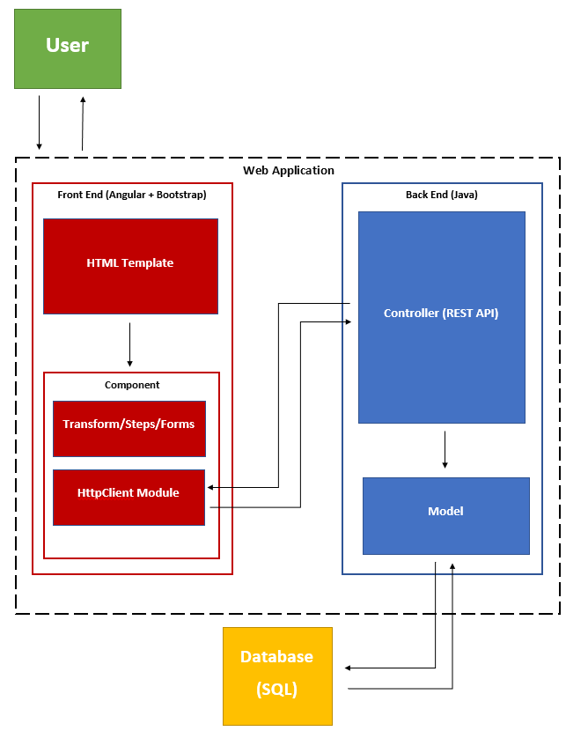

4.1 Functional Requirements
- The System will be creating a Custom Form using AngularJS to capture employee/contractor form-specific information
- Employee Form Key Fields
  - First Name
  - Last Name
  - Telephone
  - Address(Street, City, State, Zip Code)
  - Email ID
  - Employee Type (Defaults to Employee)
  - Employee ID
  - Submission Date (Default to Current Date)
  - Requestor Name
  - Requestor Email
  - Approvers
  - Department Number
  - Department Name
- Contractor Form Key Fields
  - First Name
  - Last Name
  - Contracting Company (Only available if Employee Type is set to Contractor)
  - Telephone
  - Address(Street, City, State, Zip Code)
  - Company Email ID
  - Employee Type (Defaults to Contractor)
  - Employee ID (Only available if Employee Type is set to Employee)
  - Submission Date (Default to Current Date)
  - Requestor Name
  - Requestor Email
  - Approvers
  - Department Number
  - Contract Work Order Number
  - Contract Expiration Date
  - Business Street Address
  - Department Name
- There should be a Request Status page within the AngularApp; the following fields will be searchable from the search page
  - Request ID
  - Employee ID
  - Contracting Company
  - First Name
  - Last Name
- Upon submission of a Form (Request is recorded and an entry is added in the database and status is sent to "Initial Request Sent" and “RequestID” is presented back to the requestor)

4.2 External Interface Requirements
As of the moment, the only input necessary would be the requestor’s input. Specific details regarding the amount that can be put within each field is still currently in the works.
The main input necessary would come from both the user and the necessary approvers. Examples of fields that the user would have to fill out is mentioned above in section 4.1. The main inputs the other approvers would have to fulfill is to sign the document as well as possibly edit their fields after the Admin user has done so.

4.3 Logical Database Requirements
N/A

4.4 Design Constraints
Can only be opened in a web browser on a computer; mobile browsers may work but are not the preferred access method. There also needs to be a web server for the application to be run on in order for the application to fully function. If there is no server to host the application, it will not run.

5. Other Nonfunctional Requirements
5.1 Performance Requirements
- Software should reduce the amount of time spent completing multiple forms.
- Software should eliminate manual forwarding of onboarding documents.
- User interface will be built using AngularJS.
- Form documents will be created as Adobe Sign templates.
- Forms will be edited using Adobe Sign.
5.2 Safety Requirements
N/A - no loss, damage, or harm should come from improving efficiency of form submissions.
5.3 Security Requirements
- Host server shall protect the integrity and privacy of data collected from Employee/Vendors.
5.4 Software Quality Attributes
- Web form shall adapt to multiple devices and operating systems.
- Data stored on Employee/Vendors shall easily be accessed for reference/updates.
- Software should follow a simple flow for users to access.
- Software will require little to no maintenance after finalization.

5.5 Business Rules
- New Employee/Vendors may only view the front-end of the application to submit field responses.
- Administrators will be able to access employee submitted fields as well as documents required for respective Employee/Vendor.
- Office of Public Defenders staff have access to the databases.

6. Legal and Ethical Considerations
No legal issues will come from the application as it will be used solely to ease the submission of employee/contractor onboarding information.

Appendix A: Glossary
Refer to section 1.4.

Appendix B: Analysis Models
