Lunar Image Processing - Feature Detection

(LIPFD)
CS496 Senior Design
Preliminary Functional Requirements, Design and Progress
Document Prepared by:
Natalie Gallegos
Tony Liang
Marvin Mendez
Raul Ornelas
Alberto Serrano

5 December 2014

CALIFORNIA STATE UNIVERSITY LOS ANGELES
Los Angeles, California

Document Change Log
Update | Date Released |  | Changes
First Draft | 11/24/2014 | Initial Drafting
List of TBD Items
Page | Item | Description | Status
 | Implementation
Table of Contents
1.0 INTRODUCTION
1.1 Purpose.........................................................................................
1.2 Scope…………………………………………………………………..
1.2.1 Relationship to Other Documents…………………………………
1.2.2 Hardware and Software Considerations…………………............
1.3 Documentation of the Development Process………………...........
1.4 References…………………………………………………………….
1.4.1 Controlling Documents……………………………………………..
1.4.2 Applicable Documents……………………………………………..
1.4.3 Standards……………………………………………………………
2.0 Implementation of Crater and Rock Detection
2.1.1 Ellipse Fitting……………………………………………………….
2.1.2 Circular Hough Transform…………………………………………
2.1.3 Crater Diameter and Depth Extraction…………………………..
2.2 Creating Test Cases and Producing Analysis Data………………
2.3. System Requirements
2.4 Rock Detection
3.0 Functional Description of the LIPFD
3.1 LIPFD Architecture…..……………………………………………...

3.2.1 Detailed Functional Description of LIPFD Major Sub­Units.…...

1.0 INTRODUCTION

1.1 Purpose
The purpose of this document is two-­fold:
- Define a full set of requirements for LIPFD. (These sections correspond to a Software Requirements Document, SRD).
- Define feasible modules for the requirements of LIPFD. (This section will be further developed during CS496b).
The complete definition of all LIPFD requirements provides the requirements to be used in the subsequent software subsystem documents

1.2 Scope
This is the documentation developed as part of this CS496A class. Full implementation will be completed in the following CS496B and CS496C classes.
The scope of this document includes the following:
All functional and nonfunctional requirements. These requirements are organized by key LIPFD functional units shown in the level 0 DFD.
A detailed description of algorithms being used for crater and rock detection.

1.2.1 Relationship to Other Documents
The LIPFD SRD/SDD/STP/SID is a complete self-contained document. Relationships to other documents in the literature are indicated below in sub­section 1.5.

1.2.2 Hardware and Software Considerations
The software being written requires the use of open source code. The software must also be executable in the Linux environment.

1.3 Documentation of the Development Process
Section 2 is a succinct software description document. Describing the implementation of the various crater detection and feature extraction algorithms.
Section 3 is a succinct software description document. The overall detailed functional description is based on higher level DFDs (above level 1). All major functional units are described in this part of the document. The requirements will be added in detail in this part of the document at a later date.

1.4 References
All references used in the creation of this document are listed below.

1.4.1 Controlling Documents
There is no document controlling this document.

1.4.2 Applicable Documents
There are no external documents applicable to our project thus far.

1.4.3 Standards
No Standard has been used in the creation of this document.

2.0 IMPLEMENTATION OF CRATER AND ROCK DETECTION

2.1.1 Ellipse Fitting
The crater detection algorithm using the ellipse fitting method takes lunar images with varying sun angles that produce distinct highlights and shadows. The image is sent through a two-step process; pre-processing and ellipse fitting. The pre-processing stage begins with a lunar image and converted using an RGB to HSV filter. The resulting image is then fed through a thresholding function, converting the image into a binary image. The process continues on to an erosion and dilation phase, removing any background noise. The image now moves on to the centroid detection and matching of light and dark patches, as well as calculation of distance and angles, and saved as crater candidates. This candidate list is then sent on to the ellipse fitting method, where an ellipse is fit to each candidate. The final image, with fitted ellipses, is then displayed and the detected craters are stored in a list.
2.1.2 Circular Hough Transform
The crater detection algorithm using the circular Hough transform takes in a lunar image and detects the crisp new craters within the image. Before the image is fed into the CHT (Circular Hough Transform) some pre-processing steps must be accomplished. First the image is enhanced by applying a retinex algorithm to the image. The retinex algorithm will reveal details normally hidden by shadows. Secondly, the image is passed through gaussian and median filters to reduce the noise within the image. Once pre-processing is done the image is ran under the canny edge detector. The user adjusts a slider to determine the hysteresis lower and upper thresholding values to be used in the canny edge detector. The canny edge detector will output an image of edges that will be feed into the circular Hough transform. The circular Hough transform will determine the centers and radii of craters. This data is stored and the centers and radii are overlaid on the lunar image. This algorithm runs the Hough transform with different radii ranges and thresholding values. The results are unioned, stored, and displayed.
2.1.3 Crater Diameter and Depth Extraction
After Crater detection, information for each crater will be used, for instance the bounding ellipse, as well as shadows and highlights for each crater to determine the depth and diameter of a crater, and the sun vector. Additional information such as sun angle, longitude and latitude of the crater or image location, and the distance between the moon and sun at specified times are needed for diameter and depth extraction. This additional information can be found using various tools on websites and the user will be prompted to provide this data. The results will be stored and displayed.

2.2 Creating Test Cases and Producing Analysis Data
Test cases are produced by downloading CDR(Calibrated Data Record) IMG files of LROC NAC (Narrow Angle Camera) images from http://lroc.sese.asu.edu/ and using the website’s quickMap function. The IMG files were converted to images in TIFF format using GDAL commands. These TIFF images are used to test our algorithms on. The algorithms will be tested across various images to check for accuracy of feature extraction. Each algorithm will run the same images through to compare results and compare accuracy and performance between different methodologies used. Results regarding depth and diameter will be compared to craters with known features to check for accuracy.
2.3 System Requirements
Algorithms must run on a Linux System. There is no preference as far as languages or libraries to be used. Algorithms shall be written in Java, and will use OpenCV library for image processing. Any additional libraries or languages to be implemented will be noted on later SDR drafts.
2.4 Rock Detection
Rock Detection might be implemented at a later date if time permits. The focus of this software will be crater detection and crater data extraction.

3.0 FUNCTIONAL DESCRIPTION OF THE LIPFD

3.1 LIPFD Architecture

3.1.1 Context Diagram (DFD Level 0)

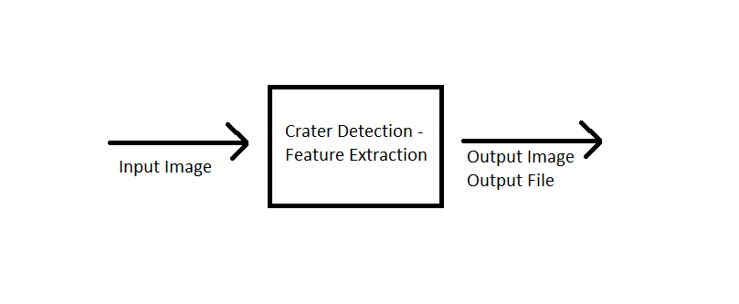

The main purpose of LIPFD project is to detect craters and extract crater data by combining different approaches and achieving a high accuracy percentage. Accuracy is prioritized over performance, per request by JPL. Detecting other features such as rocks and lava tubes will follow, if time permits.
3.2.1 Detailed Functional Description of the LIPFD Major Sub­Units.
The description of the function of the LIPFD major functional units shown in Figure 2.1 follows.

DATA DICTIONARY
None.
B. | ACRONYMS
DEM | Digital Elevation Model
GDAL | Geospatial Data Abstraction Library
LROC | Lunar Reconnaissance Orbiter Camera
IMG | Disk Image File
CDR | Calibrated Data Record
NAC | Narrow Angle Camera
LIPFD | Lunar Image Processing - Feature Detection
TIFF | Tagged Image File Format

