Senior Design Report
Fleet Management System
for
Los Angeles County Department of Parks and Recreation

5/1/2018

Team Members:
Patrick Flinner
Avik Ghazarian
Robert Karapetyan
Aaron Romero
Ken Shimauchi
Benjamin Valadez

Faculty Advisors:
Dr. Russ Abbott
Dr. Jungsoo Lim

Liaison:
Sammy Urbina

Table of Contents

- Introduction 2
  - Background 3
  - Existing Solutions 3
  - Accomplishments 3
  - Design Benefits 4
- Related Works 5
  - US Fleet Tracking 5
  - Fleet Genius 5
  - MasTrack 5
- System Architecture 6
  - Architecture Layout 6
  - Workflow 7
  - Implementation 7
  - Implementation Considerations 14
  - Algorithms and Calculations 14
- Results 16
- References 17

- Introduction

  - Background

The Fleet Management System was designed to replace Los Angeles County Department of Parks and Recreation’s current managerial implementation for recording vehicle usage. Whenever a county employee checks out a vehicle, the employee must fill out a form and state where they are going, who their supervisor is, why they are using the vehicle, and many more detailed fields. The form, called Los Angeles County Safety Check and Mileage Form, is time consuming and can delay an employee. By automating this system, employees may be more incentivized to use county vehicles.

  - Existing Solutions

The Fleet Management System is not a new idea in the world of business. Multiple devices exist within the market and all share roughly the same functionalities. The biggest similarity between them is that all existing solutions require a subscription fee, plus an adoption fee. The price per solution varies, but exists none the less. The average price appears to be around $60 per vehicle/per month + $150 for the initial purchase of the device. For a company that has a large fleet of vehicles, this price point is cost-prohibitive. On top of the price, a company is only able to gather data that is gathered by those solutions. Parks and Recreation wanted to find a cheap and customizable alternative.

  - Accomplishments

Over the course of this year, this project has been able to build a device to gather vehicle diagnostic information, route travelled information, employee vehicle use. A dataflow program that can gather data from the device and successfully place the information into a relational database. Finally, a web application was developed to allow for Employees to fill in any other pertinent information for their vehicle use and a web portal for managers to view their subordinates driving history.

  - Design Benefits

The benefits that this project brings to Los Angeles County Department of Parks and Recreation ranges from price to customization. The Fleet Management System is a simple one-time purchase for Parks and Recreation. The department will only need to buy the components for each Raspberry Pi and the ELM 327 OBD-II Reader. The estimated upward price is around $200 for fully setting up the device inside a vehicle. This is only $50 more expensive than the device purchase price for other solutions, and it does not have any subscription prices. The Fleet Management System also allows Parks and Recreation to fit the device to their needs. If they decide that they need more data points, it is easy to customize the device and add in these data points. With other devices, the department is limited to the information that the competing solutions provide.

- Related Works

  - US Fleet Tracking
US Fleet Tracking utilizes a proprietary plug-in OBD-II device as shown in that contains a GPS tracker inside to keep track of the vehicle. The system keeps track of the vehicles' location, diagnostics, and maintenance. However, the plug-in OBD-II device comes with a costly price tag of $249.00 excluding taxes. In addition, in order to use the plug-in device, one should pay a subscription fee to the services which start at $29.95 per month per device. As adding additional services or improving the network connectivity, the monthly subscription fee goes up to $79.95 per month per device.

  - Fleet Genius
Fleet Genius by Prova systems and Technologies Inc. provides packaged vehicle management service. Through the use of a proprietary plug-in device as shown in along with fleet management software, Fleet Genius provides a solution for small to large scale fleets wanting to keep track of and maintain their vehicles. Their software supports a range of functionalities, some of which include driver performance, vehicle trip tracking, vehicle diagnostics and maintenance. Data collection from their plug-in device to their cloud server is done via their proprietary wireless access points or available cellular network via Android mobile device. All of these is available for high costs. The Annual plan is $159 per device with a free plug-in device. The cost for the Pay as you go plan is priced at $14.95 per month per device with $69.95 for the Device.

  - MasTrack
MasTrack by Mobile Asset Solutions utilizes a proprietary plug-in OBD-II device as shown that contains a built in GPS tracker. The device sends out data in predefined intervals that are dependent on the service plan one has purchased from MasTrack. The plug-in device comes with a price tag of $78.00 excluding taxes, with services for data reporting ranging from $109 to $171 annually per device. They also offer monthly plans ranging from an average of $15.83 to $17.91 per month per device.

- System Architecture
  - Architecture Layout
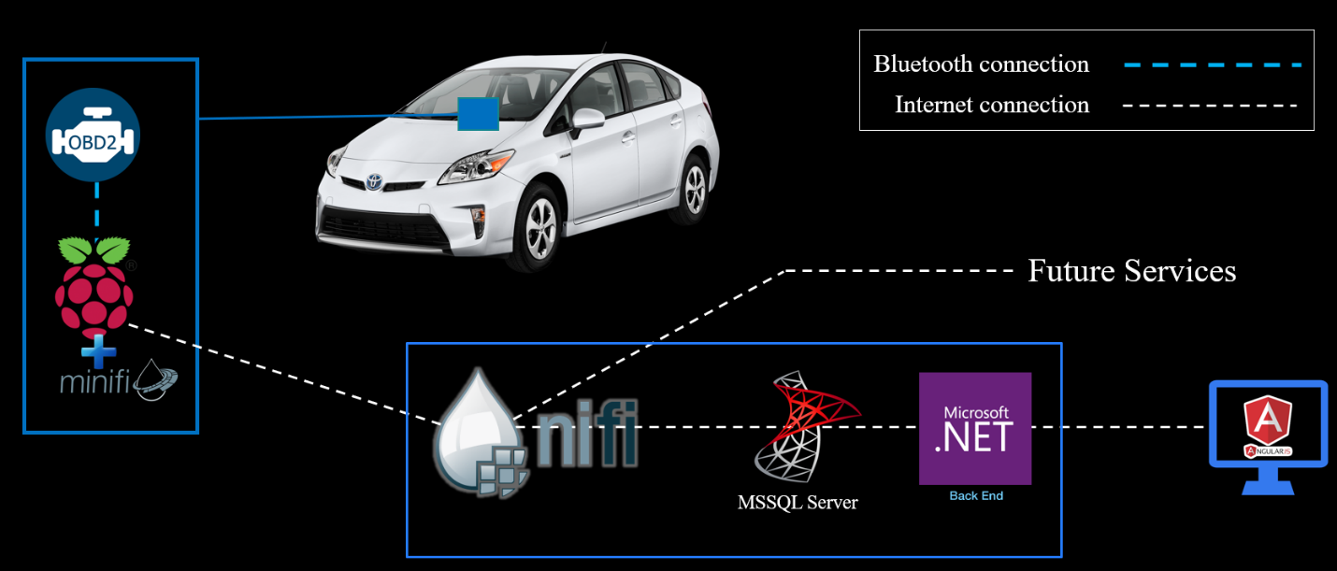

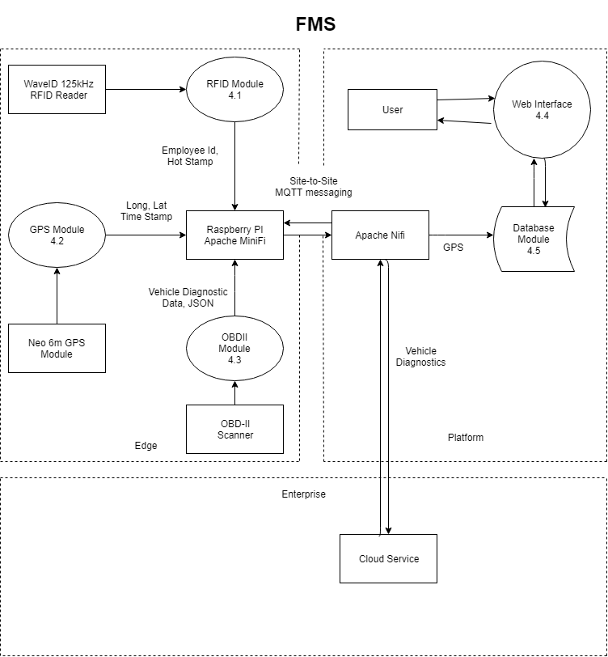

  - Workflow

Within every vehicle will be a Raspberry Pi that is connected to the OBD-II Port via a Bluetooth connection. The Raspberry Pi is connected to a GPS module and RFID Reader, which will record who is using the vehicle and where the vehicle goes. When the data is finished being created, the data is ingested by Apache MiNiFi and sent to Apache NiFi. The data is transformed from JSON to an SQL query and inserted into the MSSQL database. From there the data can be accessed from the web application, with data being passed back and forth between the back end and front end of the application.

  - Implementation

Raspberry Pi

The implementation of the Raspberry Pi required the need to plan out exactly what data was needed to be generated, how it could be generated, and how to send the information from the device. Two main pieces of information needed to be generated: Diagnostic Data and Trip Data. All the Diagnostic data comes from the OBD-II reader. A simple device was purchased to receive the information and then we utilized the open source library Python-OBD to transform the data from Binary to human readable information. Trip data required information from the Diagnostic data set and GPS data that was generated. We chose a well-reviewed GPS module to generate the trip route. It can retrieve multiple coordinates a second, so this allows for detailed trip routes. All this information is compiled within Objects that are transformed into JSON. The next part was to send the data from the device to county servers.

Apache NiFi

Apache NiFi and MiNiFi, a subproject of NiFi, allows for the mass sending of data from multiple devices to county servers. It is an open source data flow manager that received a 1.0 release a couple of years ago. This new piece of technology made the network portion of the project simple and easy to implement. NiFi is able to ingest all the json data and transform it into SQL queries to be inserted into the main database. Apache NiFi offers encryption, data management, data persistence, and many more solutions.

Web Application

Our web application allows for Park and Recreation Employees and
Managers to view the data that has been generated on the Raspberry Pi. A back end allows for two web portals to communicate with the SQL Database. The project uses .NET Core 2.0 and the Entity Framework for all connections. The Entity Framework allows for the use of Classes to generate SQL queries.

Employee Portal

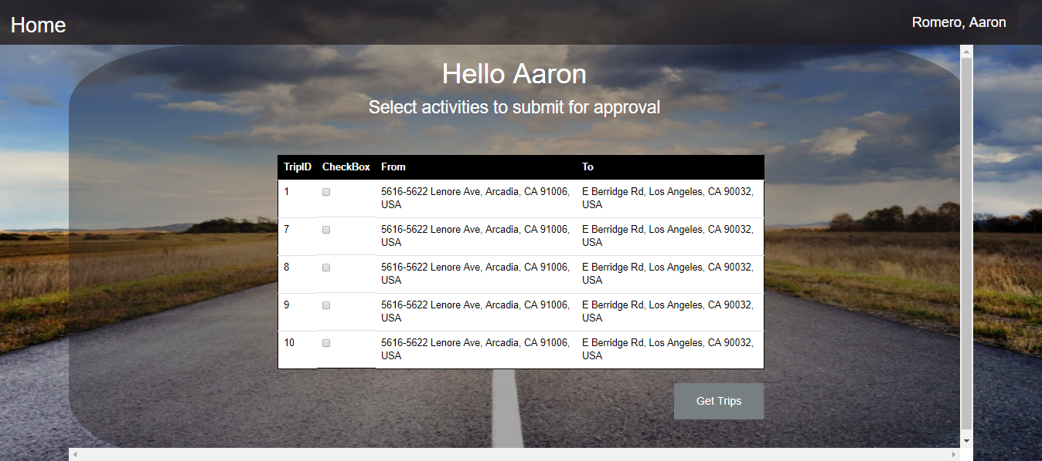

The employee can see any trips that they have not finished finalizing the information for. On this screen they can select the trip, or trip segments, to finalize.

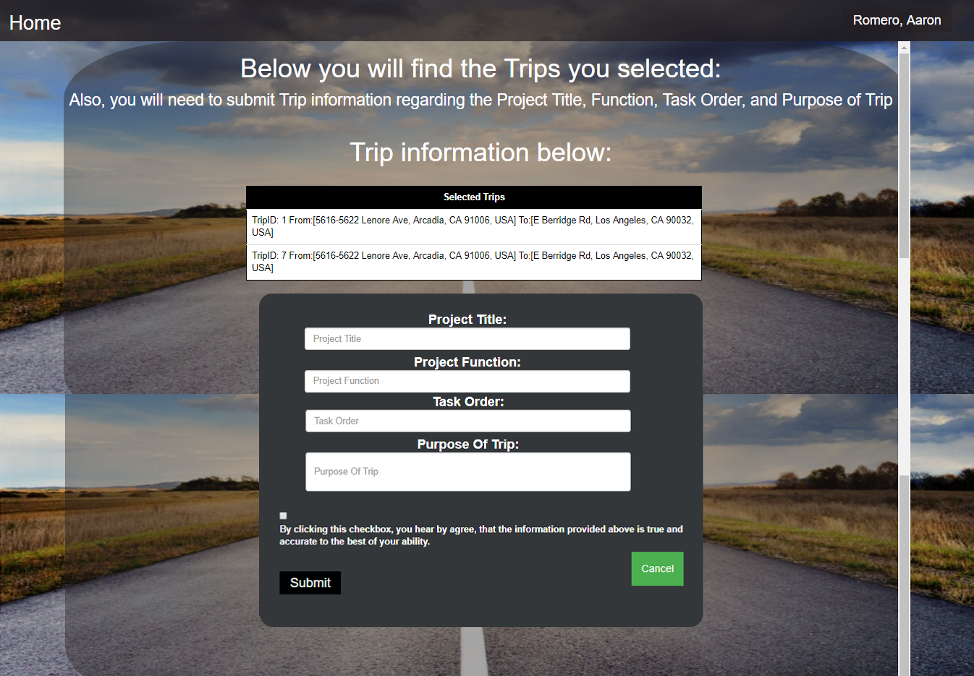
After selecting the trip segments, a user can fill in the four fields that cannot be automatically generated. The user must legally state that the trip information is complete to the best of their knowledge.

Manager Portal

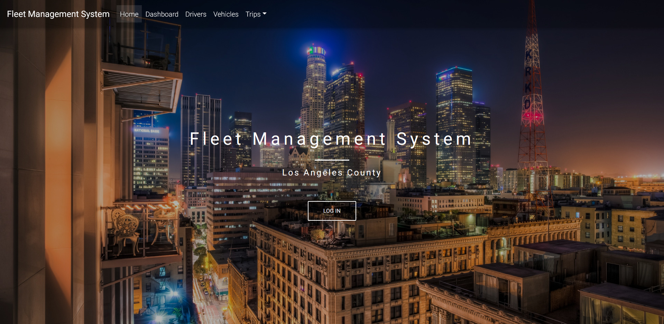

Managers can login to a portal that is specifically designed for them. Only managers and IT admins can login to this portal to prevent unauthorized data access.
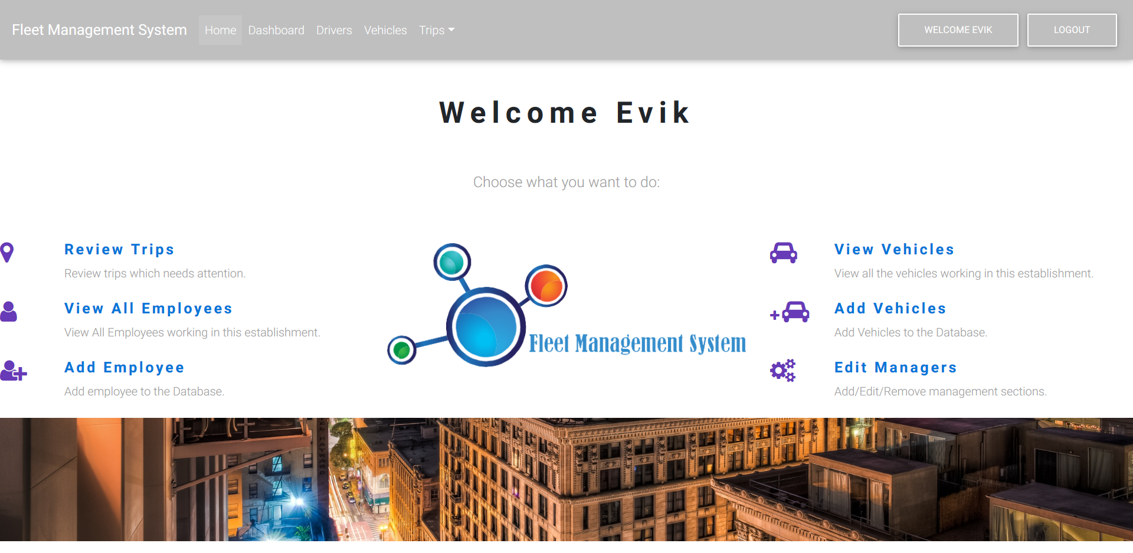
When a manager has finished logging in. They are met by a dashboard that enables them to complete various job functionalities. The main functionality is the ability to Review Trips of the employees that they manage.

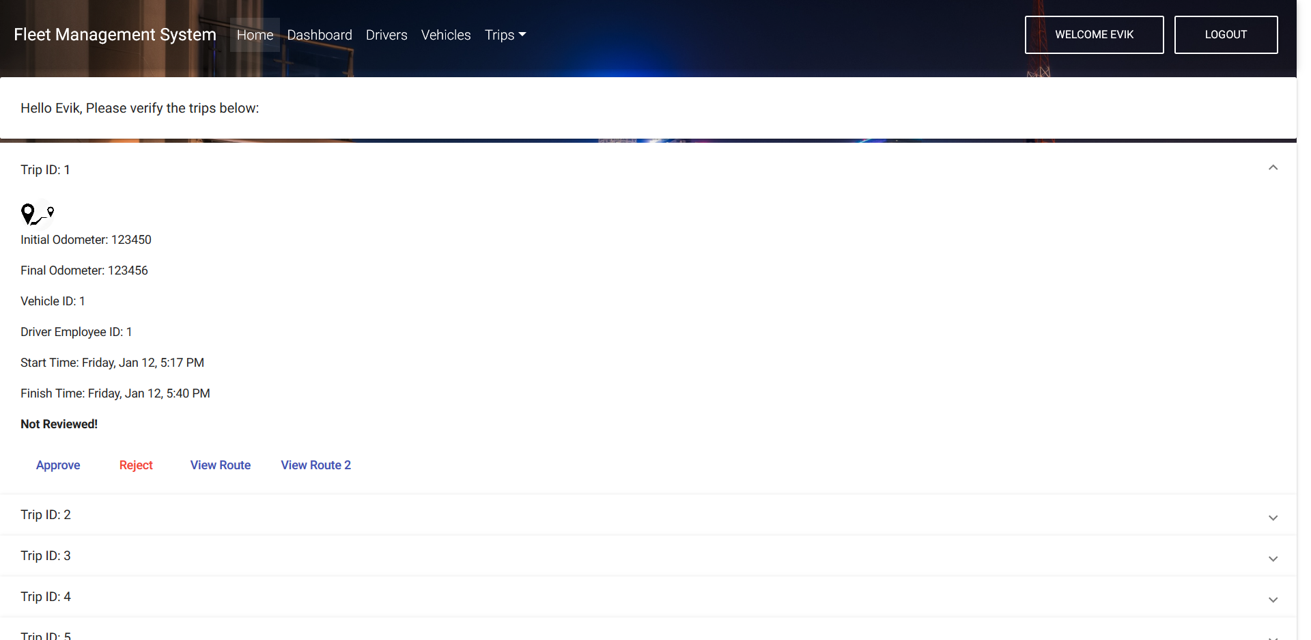
When they select a trip, they can approve or reject that the trip was authorized. A google map view allows them to view the route that an employee work to make sure no unnecessary detours were taken.
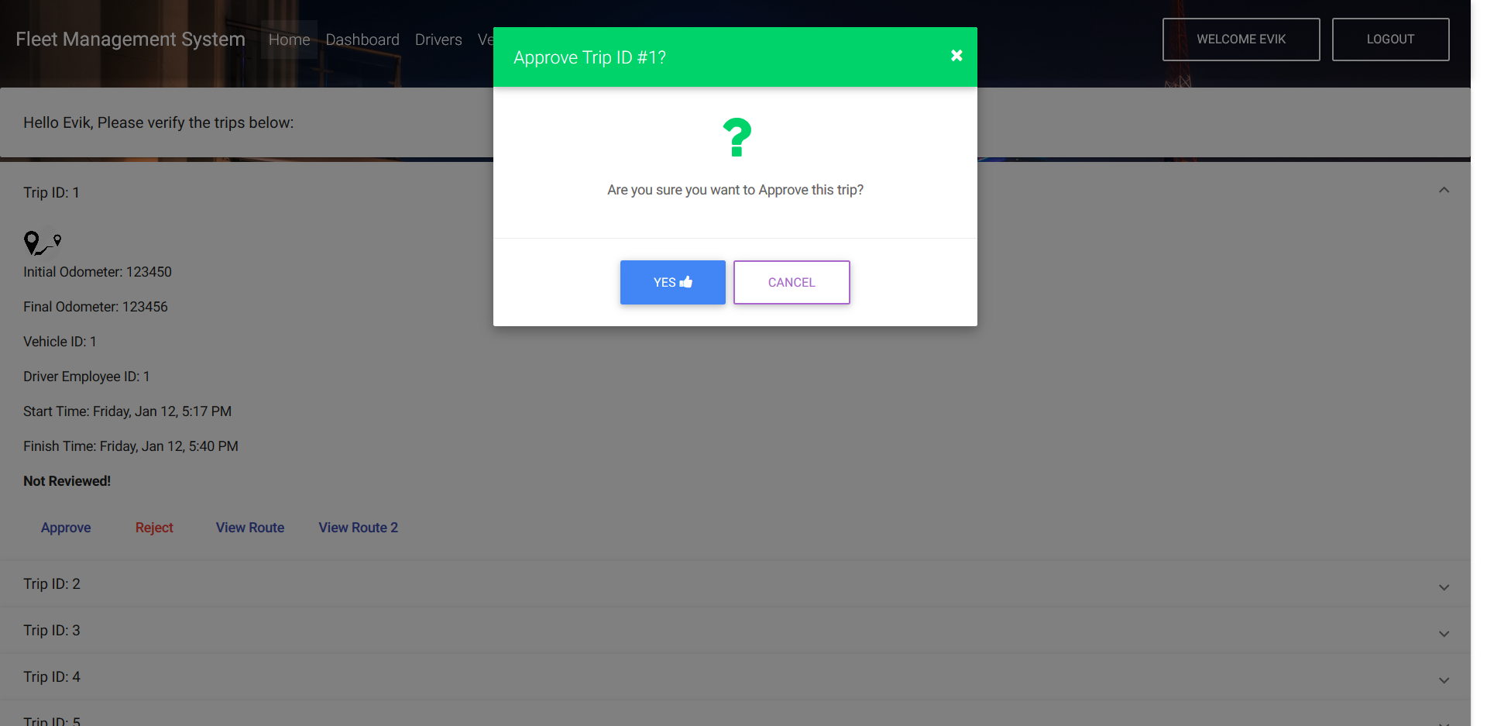

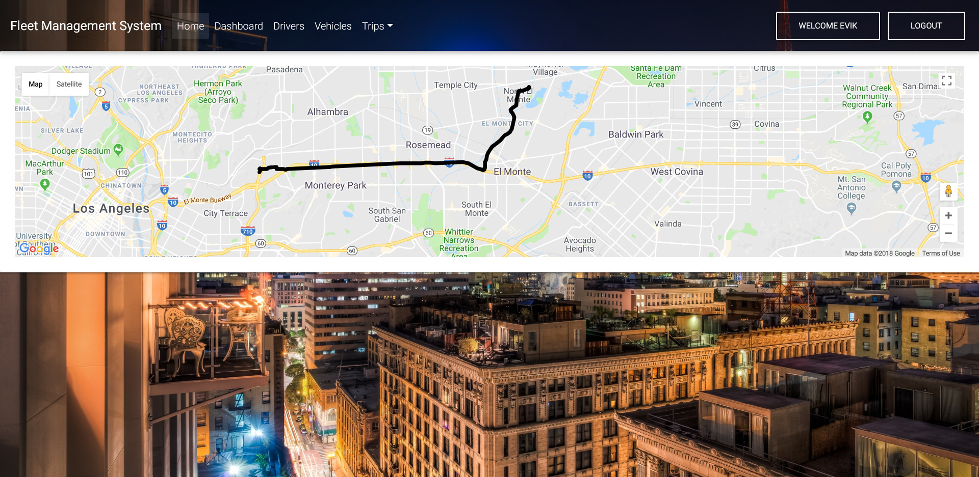

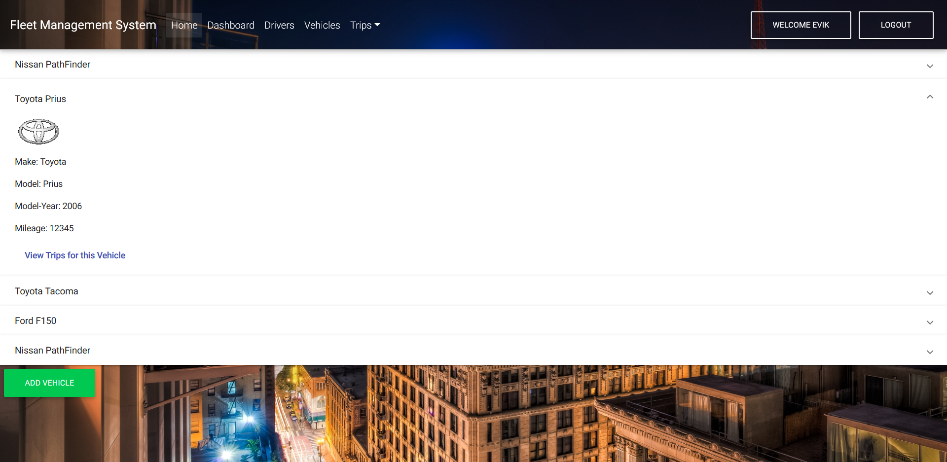 Other pieces of functionality for the web page include the ability to review trips for specific videos. They can see who took what vehicle on what day.

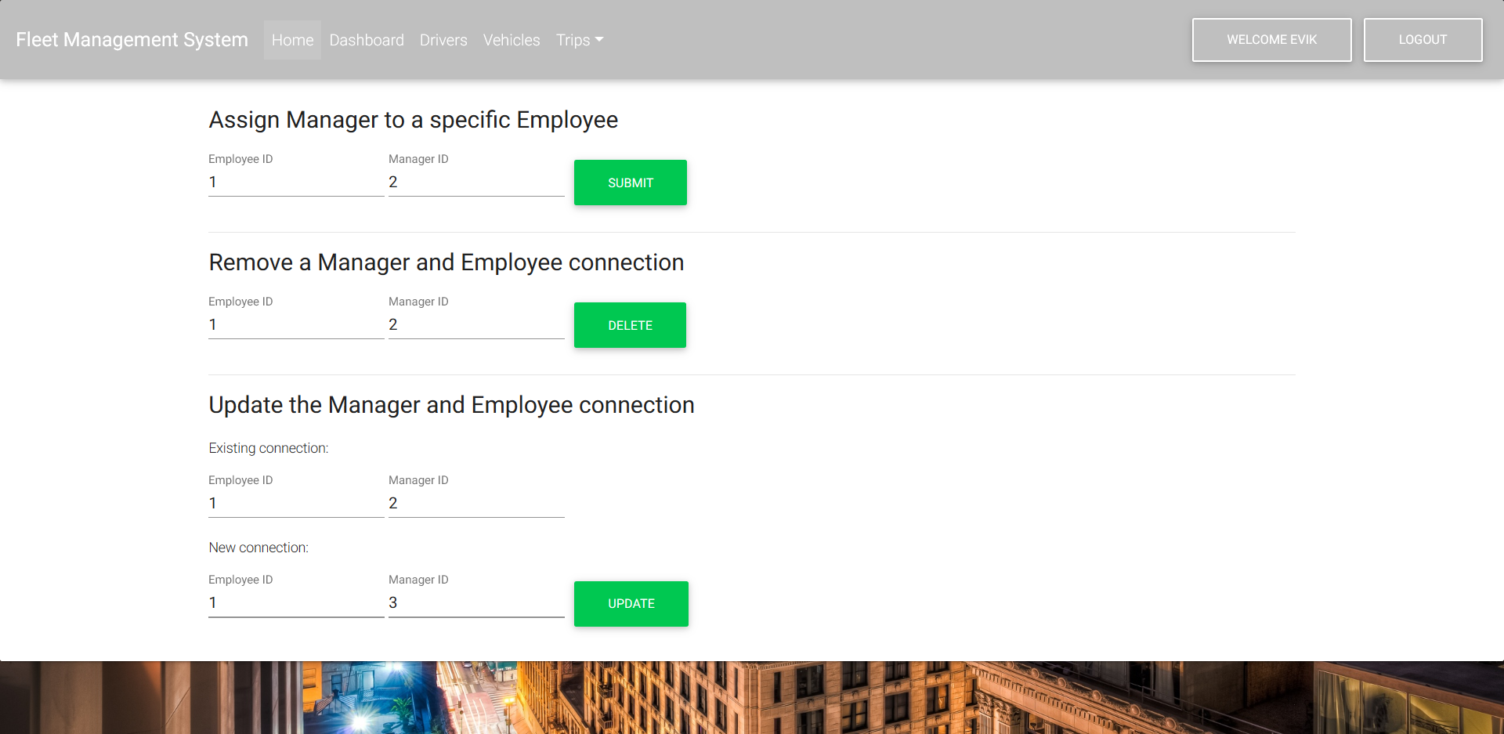 IT Admins can determine who manages who.

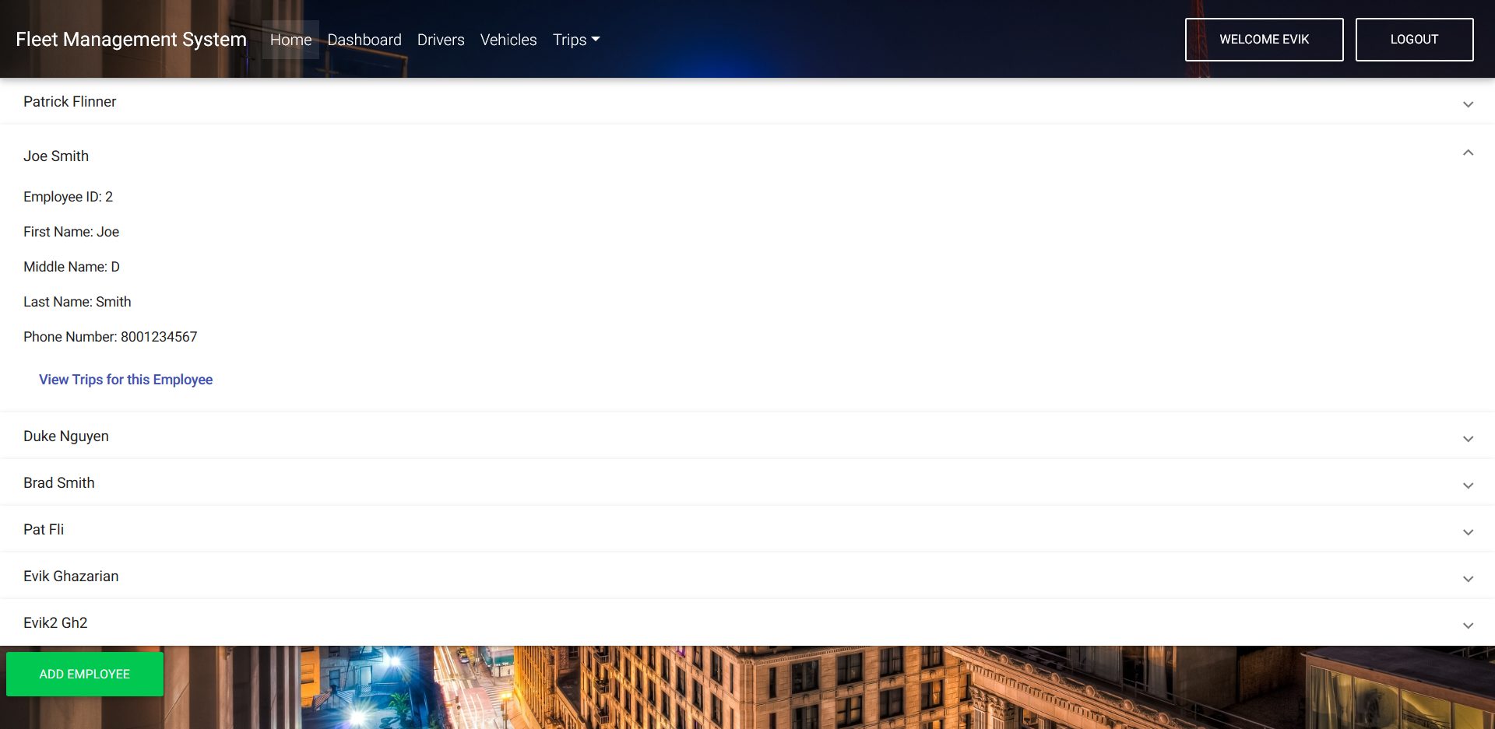
Finally, managers can view all employees that they manage and specifically look at the trips that a specific employee took.

  - Implementation Considerations

Special steps had to be taken to implement the system on a Raspberry Pi. To test changes without the need of a physical vehicle, the project needed an OBD-II simulator. Simulators are not cheap pieces of technology and the more functional simulators are outside of the project’s price range. The simulator that was purchased allowed for the easy testing of diagnostic gathering.

  - Algorithms and Calculations

Two sets of calculations are needed for the Fleet Management System to work optimally.

Distance Formula

To reduce the number of points gathered for the GPS route, the distance formula is utilized. Two GPS objects, containing Latitude and Longitude, are passed into a function where the result is calculated.

$\sqrt{{\left(x_{1}-x_{2}\right)}^{2}+{\left(y_{1}-y_{2}\right)}^{2}}$

Using this formula, the Fleet Management System can determine if two points are far enough apart to record a new point. X represents Latitude and Y represents Longitude. This formula helps prevent the recording of duplicate points, allowing Fleet Management System to save memory usage.

The second formula is the Haversine Formula. Fleet Management System uses it to calculate the distance between two points in miles. The project is unable to retrieve the odometer value from the OBD-II port, so the Haversine Formula circumvents this problem by calculating the distance between GPS points.

The Haversine Formula’s main use is to determine the distance on a great sphere. The calculations generated by this formula are added and can generate the vehicle’s distance travelled during use.

- Results
Over the course of this year, we were able to create a physical device that can generate trip and diagnostic data and a web application that can finalize and manage the generated data.

For the device, we created a power supply that would enable the Raspberry Pi to be connected directly to the car battery without harming the device. We hand picked the components that are used to generate pieces of information. Various scripts allow the Raspberry Pi to generate data with little employee input. An employee only needs to swipe their badge to signal that they are the ones using a county vehicle. The Raspberry Pi will generate the rest of the trip information through the use of the hardware components. A data flow manager was used to send data from the devices to country servers and infrastructure. The data is transformed into an SQL query that allows for easy data ingestion.

For the web application, we created two separate web portals. The first web portal is used by all employees to quickly complete the information that could not be automatically generated by the Raspberry Pi. Employees are able to login and select trip segments to complete and then submit those trips for approval. The second web portal is useable by managerial staff to determine if employees are using the vehicles for authorized trips. Managers can approve or not approve employee trips, add employees, add employees to managers, add vehicles and other managerial tasks.

- References
https://www.fleet-genius.com/
https://www.usfleettracking.com/
https://www.mastrack.com/
https://python-obd.readthedocs.io/en/latest/

