THE F.E.W.W. Concept & Design Document

Introduction

The F.E.W.W. is a single player RPG that will explore the theme of racial prejudice. We follow Chuma as she attempts to get stronger to help fight in the rebellion for her people.

Game Analysis

Game Description
Genre: | RPG
Player: | Single
Game Elements: | Two different game mechanics for each world. Faburkan is combat heavy and Whishinvey is stealth and strategy heavy.
Game Content: | Simulation, Narrative Game play, action rpg battle mechanics
Theme: | Sci-Fi, Fantasy
Style: | Dystopian Future corresponding with town’s element
Game Sequence: | Single Narrative with multiple endings that stagger to the next story
Player Immersion: | Tactical, Narrative, Emotional
Technical From: | 2D graphics
View: | Top down flat 2D and profile side scrolling
SW Platform: | C#
HW Platform: | PC/Mobile
Audience | General

Game Atmosphere
- Furburkan is a loud city due to the constant fire showers from the mighty volcanoes exploding on the background. Occasional sounds of rocks crashing on the roads add to the comotion.
- Furburkans are a warrior/tribal culture, thus drums are constantly present on the background music. Hymns smoothly complement the beats of the drums. Think of Native American music or African folk music.

Game Play
- Opening the Game Application Once the play plays the game the user is requested what day their birthday is. The game then assigns a role for the player to play and an opening scene is played about the history of the planet.

Once the scene is completed the planet turns to center whatever nation the players character is from and the game give the player a brief intro to their character’s country and people.

- Game Options Basic game settings such as mute mode, text speed, text size, save.

- Story Synopsis The game follows Chuma. A member of the Faburkan town who has had enough of the oppression brought on by the people of Enthral. This is her journey of joining with the rebellion and freeing her people.

- Modes Single player multi story game.

- Game Elements Mechanics based on race. Furburkan is heavy on combat and brute force.
- Game Levels A tutorial level and a city encounter for furburkan to explore towns such as Maazai.

- Player’s Control All protagonist can run, jump and climb. Action button can be used to talk, examine, and pick up items. Menu button can be used to see players inventory, switch weapons, heal, and view money or maps.

  - Faburkan Has the ability to manifest flames in their hands and send fireballs. This ability is developed slowly and when the character levels the fireball will be able to shoot faster and bigger fireballs.

- Winning The player has to defeat the the Enthral forces and drive them out of their homeland.
- Losing get killed by enforcers or failing a quest.

- End To end the game the player must defeat the the Enthral forces and drive them out of their homeland.

5. Key Features
- Number of Levels 1 storyline, follows Chuma through her days leading up to the trials
- Maximum Enemy Attacking / Playable Character There will be a maximum of 3 enemies attacking the player at once. While in battle, it is possible for more enemies to join the battle. The playable character for this game is one player, with one ability.
- Time of Game Play This game will have playable content equivalent to approximately 1 hour of non-repeating storyline walkthrough.
- Replayability High
- Audio Specifications Sound effects will change based on type of enemy the character attack. Background should change accordingly when enter/exit town and dungeon. Consumable, collectable, enemies detecting player would also have sound effects.
- Graphic Specification This graphic requirement for this game will be 2D images drawn on image processing software with color, exported with PNG (support alpha channel). Image assets will use dimensions as a power of 2 for best performance and scaling. Last but not least, the assets should not be less than 1920 by 1080, crop and scale down if necessary.
- Device Compatibility This game will be support on PC Windows Operating System, and mobile devices
- Number of Players This game is for single player, one playable character, and does not require internet connection
- Online Activities (high scores, etc.) no online activities
- Number/Type Modes Single Player only.

Details of Game Design
- Menu
  - Main menu will have four options: start, load, options, exit
  - Start will start a new game with default character and startup equipments.
  - Load will load a saved point previously saved by player after finishing a dungeon or after sleeping within hometown.
  - Options will either have dropdown or slider for graphics tuning [Low, Medium, High], audio tuning [0% - 100%], text speed [1, 2, 3, 4, 5], screen resolution [480p, 720p, 1080p] etc.
  - Exit will exit the program and return to Desktop, or Android Launcher home screen.
- Synopsis
  - The game follows Chuma. A member of the Faburkan town who has had enough of the oppression brought on by the people of Enthral. This is her journey of joining with the rebellion and freeing her people.
- Game Play
  - Side scroll will representing dungeon, fighting scene, and entrance dialogue. In this scroll view, there will only be able to moving forward and backward. Forcing player to encounter enemies and/or use strategies and obstacles to avoid enemies attack.
  - Top down view will representing hometown where there will be more path than just moving left and right. More realistic environment as well as more ways to interact with NPC.

- Player Control
  - Run - Character will be able to sprint forever, increase their movement speed.
  - Jump - Character will be able to make single jump, and landed before issue another jump action.
  - Climb - Character will be able to climb to a new terrains through ladder or vine, in order to avoid enemies, get buff, or claim loots.
  - Interaction Button -
  - Menu Button -
    - This will call the menu overlay and take up full screen.
    - This menu button will pause the game if in dungeon, however, player will not be able to save in dungeon.
    - In town, save button will be able to save current progress.
    - In town, menu button will also be able to read their journal, about their past encounters.
    - This menu will also have options to change resolution/volume/texture quality.
- Game Over (Winning & Losing)
  - Winning - when the character defeats the final boss, either by using physical attack, or by final boss question answering (different answer derives to different ending), the game will enter cutscene and prompting the player that they have complete the game.
  - Losing - when the character health bar reach 0, either killed by enforcers, environment effects, or high ground drop penalty, the player is consider lose the game, and will be spawn at last save point. Player’s inventory will be restored to last save point status.

Player Elements

Player Definition

- The player can run, walk, jump, attack, and cast fireballs.
- The player can see their health, inventory, and view enemy health.
- The player begins with a toy weapon and is only able to create a weak fireball. Player will progress the story to increment skills.
- Players quest is to prepare for the trials for her coming of age.
- The player wins when they successfully defeat the enthralian forces occupying their homeland.
- The player loses whenever all his/her life points are depleted.

Player Properties

Make a list that defines the properties that a player has. Player properties can be affected by player’s action or interaction with other game elements. Define the properties and how they affect the player’s current game.

A suggested list of player properties:
- Player starts off with one bar of health that allows them to take 3 hits
- Player will choose between a sword, axe, and a spear
- Player will be able to throw fireballs
Each property should mention a feedback as a result of the property changing

Player Rewards (Power-ups & Pick-ups)

Make a list of all objects that affect the player in a positive way. (i.e. health replenished). Define these objects by describing what affect they cause and how the player can use the object.

User Interface (UI)

Heads up Display (HUD)

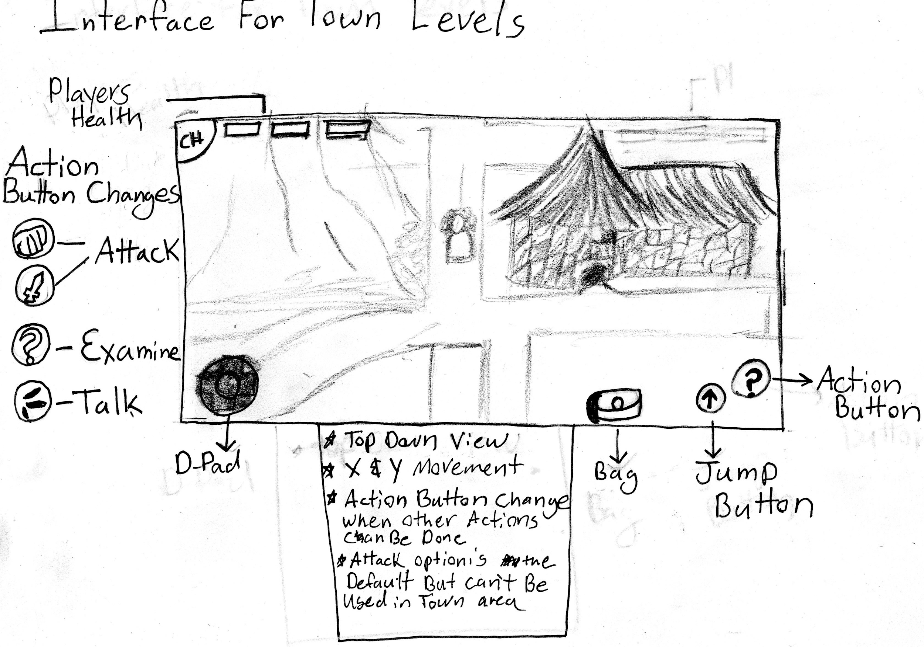
The action button can serve many purpose depending on its function. If the player goes to an npc the button image will change to an examine icon, if they player is fighting the button will be changed to a sword or fireball.
Fireballs are held presses while sword attacks are tap attacks.

Player View

Top down flat 2D and profile side scrolling.

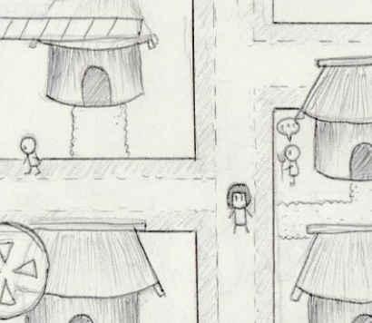
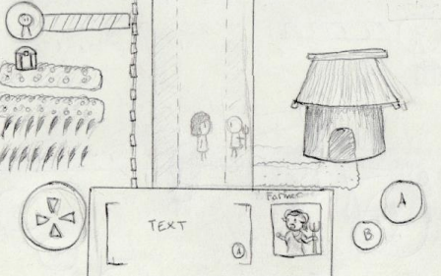

Key map or control table

Action | Control | Contex
Left | A or D-pad: left | all
Right | D or D-pad: right | all
Forward | W or D-pad: up | all
Backwards | S or D-pad: down | all
Action Button | J or Action Button | all
Jump Button | K or Jump Button | all
Settings | escape or Escape Button | all

Antagonistic Elements

This is where a list of antagonistic (enemies, opponent) objects should be listed with graphics (sketch) and written description.

Antagonistic Definitions

A description of what makes an antagonistic element.

Antagonistic Properties

A list of properties that antagonistic elements have in common.

Antagonistic List

- Enthral Enforcers
- Enforcer boss

Artificial Intelligence (AI)

Enthral Enforcer AI
- Normal State: they are patrolling back and forth in their area
- Detection State: Move toward the enemy and prepare to attack
- Reaction State: Attempt to attack Player
- End State: If the player’s attack lands first then the enforcer takes damage and hurt animation, otherwise if the enforcer’s attack lands then the player takes damage

An example describing the player/antagonistic element

Object | Properties
Unit type | Hit Points | Damage | Movement
Basic Enemies
Enforcer 1 | 3 | 1 | Medium
Enforcer 2 | 1 | 1 | Fast
Enforcer 3 | 3 | 1 | Slow
Boss | 10 | 2 | Slow

Global Game Elements

The Camera views will be top down in the town area and profile view during missions outside of the town. The towns will be surrounded by walls which will keep the player from venturing out of them. Buildings and other town elements will be Neutral game world objects.

The Story

Chuma is 3 days away from the trials which is a right of passage for her people. The story follows her as she prepares for the day. She must perform tasks that pits her against the enthral enforcers that oversee her land. dealing with their persecution she must work towards her goal to complete the trials so she can join the rebel forces to take back her homeland.

Concept Art

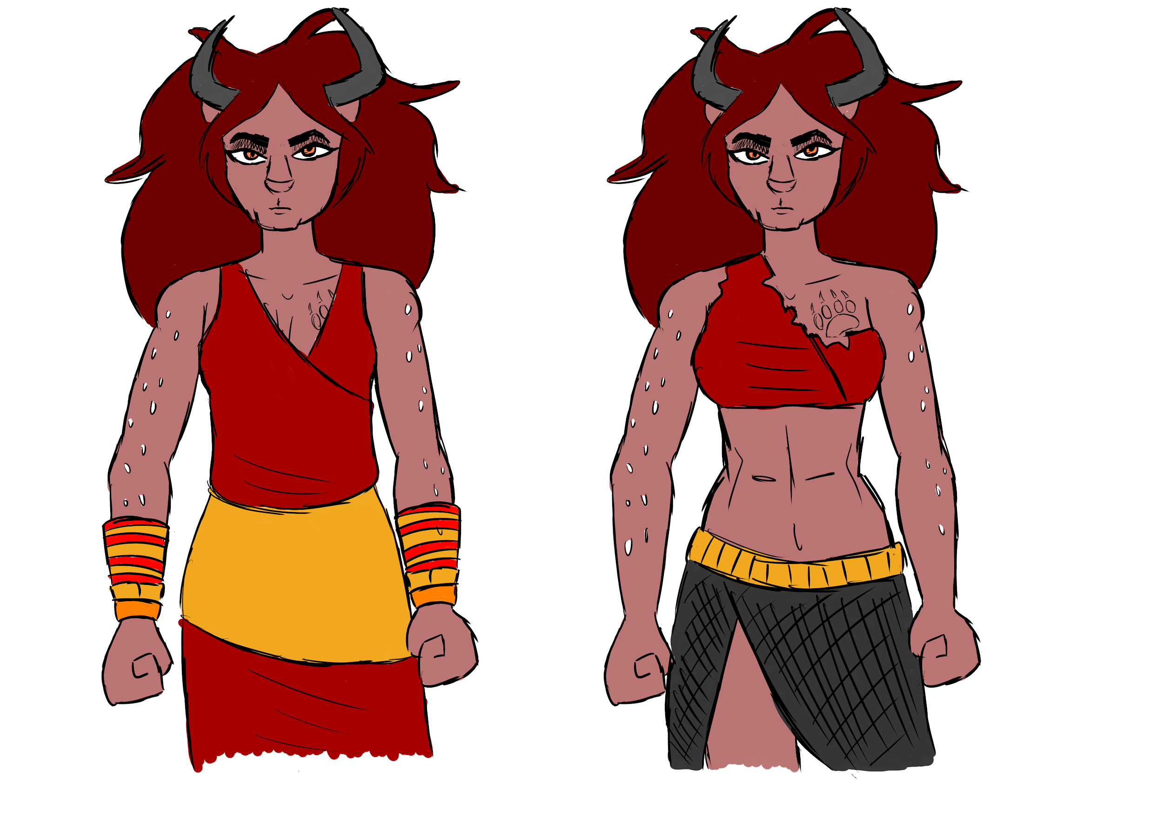
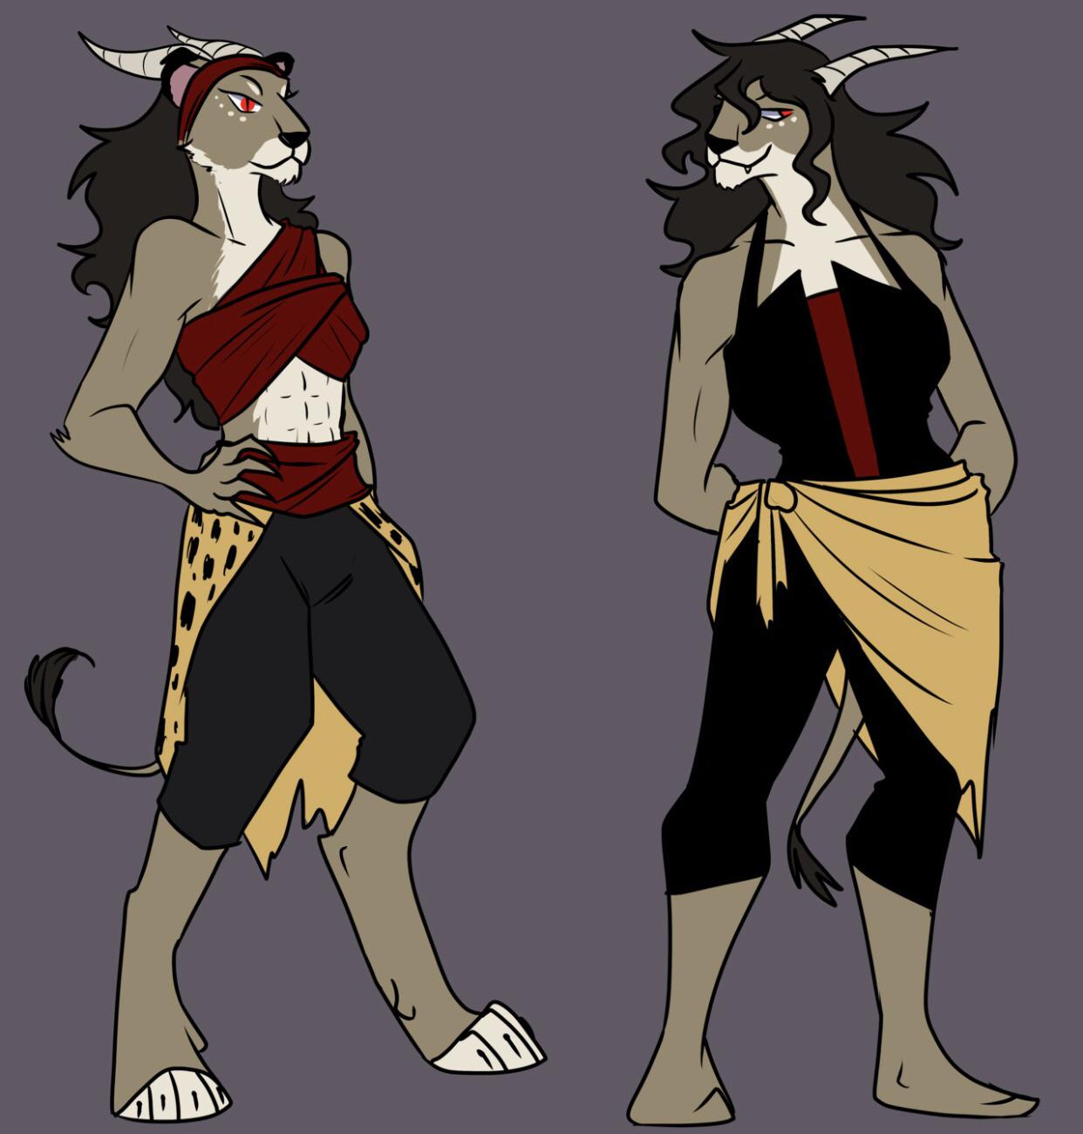
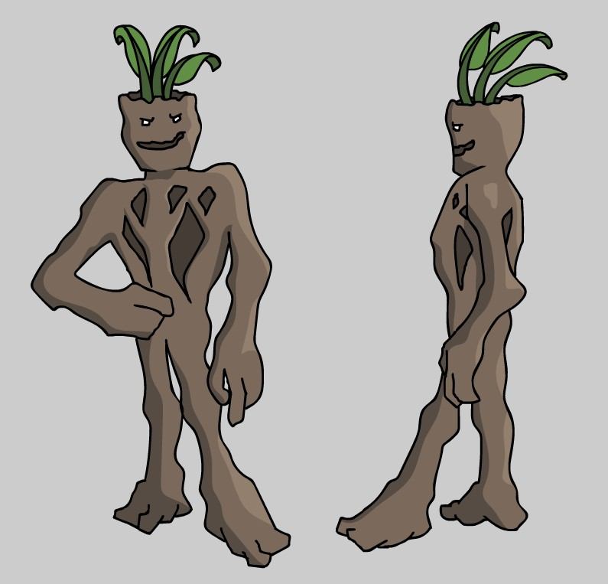

Level Design

This is where information pertaining to level design and visuals of the level design goes. Level design can best be shown as a flow chart.

Audio & Sound F/X

This is where game ambient and Sound F/X should be listed with generic names then described.

Game Architecture
Splash Screen
logo
Title Screen
<Start>
<options>
<Quit>
Intro Sequence
Animation
music <on>
soundfx<on>
End Sequence Animation
Game Start
Level 1

Technical Document

System Requirements

This is a list of system requirements that a device will have to meet to run the game. This also represents the restrictions that may apply to the end product.

Visual Content

A list of technical requirements from those in concerned with the visual aspects of the game. All objects should be listed with their generic names.

- General
  - 0 - 100Mb
  - SVG and PNG files
  - High Quality
  - Visual Scale

- Player Elements
  - Animation states
    - Walk
    - Idle
    - Run
    - Jump
    - Climb
    - Melee attack
    - Cast fireball

- Heads Up Display (HUD)
  - SVG, PNG
  - States
  - Font Type

- Antagonistic Elements
  - Animation States
    - Idle
    - Walk
    - Attack
    - Close Combat
    - Ranged
- Global Elements
  - Background/Texture/Tiles
  - Font Type

Audio Content

It is very important to communicate with the audio designer before and while the audio content is being developed.

- General
  - Size 1Mb - 100Mb
  - Format MP3, WAV, OGG
  - Audio quality Good sound quality
- Player Elements
  - Type of Sound FX: Weaponry, Running, Jumping, Special Abilities, etc.
  - Device Vibration: No physical feedback such as controller vibration.
- Antagonistic Elements
  - Type of Sound FX: Weaponry.
  - Device Vibration: No physical feedback.
- Global Elements
  - Ambient Music
- Splash Screens
  - Ambient Music
- Menus
  - No Sound FX

Programming Content

The objective here is to try to organize and modulate as much as possible.

- General
  - Requirements
    - PC running Windows Operating System
    - Android running Kitkat API level >=19
  - File Format Type
    - .exe for x86 architecture
    - .apk for ARM x86 architecture
  - Specify Coding Conventions
    - camelCase and PascalCase are the two coding conventions C# uses.
  - Language/Device Restrictions
    - The game will be written under Unity Engine using C# programming language.
    - Unity is a multiplatform and write once run everywhere engine that could be deploy to most platforms.
  - for small and large screens
    - We are capping the resolution to 1080p max, this resolution match most mainstream display device and will also be able to conserve lots of space when deploying to mobile.
- Player Elements
  - Inventory elements
  - Skill/Experience elements
  - Decision tree affecting narrative
- Antagonistic Elements
  - Attack speed/ movement speed elements
  - Health elements
- Global Elements
  - Environment elements
  - Singleton Saving elements
- Splash Screens
  - Unity Splash Screen (Made With Unity)
- Menus
  - Slider and dropdown elements
  - Resolution/Volume/Texture Quality

Development timeline

Timeline for the entire game

Complete the Faburkan story before spring 2019.

Task distribution

- Patrick Hanna: Enemy AI
- Erik Sorto: Player controls
- Adan Constanzo: UI and dialogue
- MingYang Liu: Environment and Scene Management

