Software Requirements Specification
for
Referral / ERRA Trending Analysis Tool (RE-TAT)

Version 2.0

Prepared by Wilson Thomas
Emanoel K.
Henry Liwag
Daniel Limas
Xiaoye Li
Philip Tran

QTC Management / Grace Pang-Truong
Last changed: April 14, 2018

Table of Contents
Table of Contents.....................................................................................................<pg 1>
Revision History.......................................................................................................<pg 2>

- Introduction..............................................................................................<pg 3 - 4>
  - Purpose..............................................................................................<pg 3>
  - Intended Audience and Reading Suggestions...................................<pg 3>
  - Product Scope...................................................................................<pg 3>
  - Definitions, Acronyms, and Abbreviations ........................................<pg 3>
  - References.........................................................................................<pg 4>

- Overall Description..................................................................................<pg 5 - 7>
  - Product Perspective...........................................................................<pg 5>
  - Product Functions.........................................................................<pg 5 - 6>
  - Assumptions and Dependencies.......................................................<pg 7>

- External Interface Requirements..................................................................<pg 8>
  - User Interfaces...................................................................................<pg 8>
  - Software Interfaces............................................................................<pg 8>

- Requirements Specification...................................................................<pg 9 - 11>
  - Functional Requirements............................................................<pg 9 - 10>
  - Design Constraints...........................................................................<pg 11>

- Other Nonfunctional Requirements............................................................<pg 12>
  - Safety Requirements.......................................................................<pg 12>
  - Software Quality Attributes..............................................................<pg 12>

Appendix A: Glossary............................................................................................<pg 13>
Appendix B: Analysis Models.........................................................................<pg 14 - 15>

Revision History

Name | Date | Reason For Changes | Version
Philip Tran | 12/08/17 | Last editing and proofreading checks | 1.0
Philip Tran | 4/12/18 | Updates | 2.0

1. Introduction

1.1 Purpose
  - This document will outline in detail the Referral / ERRA Trending Analysis Tool (RE-TAT)’s software architecture and design. This document will display the system’s design from several viewpoints to provide a guide on how the system works and communicate what the system does. It intends to get an insight into the architectural and design decisions that were made for RE-TAT.

1.2 Intended Audience and Reading Suggestions

This document is written on a technical level to address the QTC Management team and Cal State LA computer science department.

1.3 Product Scope

This document provides the architecture and design of RE-TAT. Given several sets of data, RE-TAT will create a trending analysis tool that will validate appointments assigned to QTC and determine if an area has enough providers within a given distance. This software will allow the QTC management team to effectively balance how their workload will be allocated across the provider areas.

1.4 Definitions, Acronyms, and Abbreviations

- RE-TAT - Referral / ERRA Trending Analysis Tool
- ERRA - Exam Request Routing Assistant
- VARO - VA Regional Office
- DOR - Date of Referral
- SQL – Structured Query Language
- JSP - Java Server Page
- VA - Veteran Affairs
- IDE – Integrated Development Environment
- QTC - Quality Timeliness Customer Service
- MVC - Model View Controller
- UI - User Interface

1.5 References
Referral / ERRA Treading Analysis Tool (RE-TAT)
Functional Requirements and Design (FRD) Document

2. Overall Description

2.1 Product Perspective

The Data Flow Diagram, DFD, is going to be a major tool to utilize for the design of the RE-TAT architecture. Because of its simplicity and versatility, the DFD is the preferred design tool for modeling this system.

2.1.1 Level 1 DFD

RE-TAT’s major functional sub-units are shown in the DFD Level 1 below:

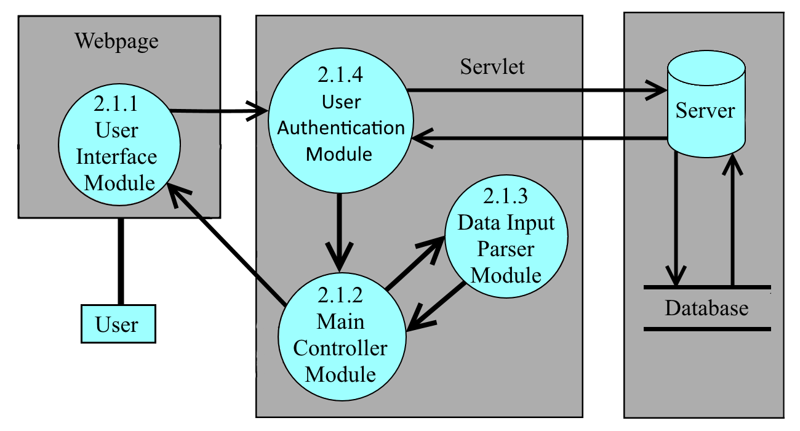

2.2 Product Functions
User interface - Module 2.1.1

The User Interface Module(UIM) provides a web-base GUI and functionality for the user-friendly interface. It organizes and visualizes the data-set based on user geolocation input, defined categories’ input, and distance input. The UIM contains tools such as searching geo-location based on user location input and time of date and pinpointing geo-location. The UIM also contains feature that identifies specialty availability within a region and determine how many claimants are in the area, validate appointment assigned to QTC, and determine if an area has enough providers within a given distance. For security, the user will to enter their login information on the UIM to gain access to the system. The UIM is also responsible for receiving the QTC’s excel file information and sending it to the UIM.

Main Controller - Module 2.1.2

The Main Controller Module(MCM) is the Model View Controller(MVC) of the RE-TAT. It contains the central system of the server side implementation on the RE-TAT. The MVC will serve as the main controller for the User Interface Module(UIM), Data Input Parser Module(DIPM), User Module(UM) and the server. The MCM is responsible for the implementation of the features. Based on the user’s input of date, geolocation, medical specialty for a given feature from the UIM, the MCM will search through the dataset for a list of information the user wants to view and sends it to the UIM. The MCM is also responsible for transferring Excel files to the DIPM and receiving the content of the Excel files' data from the DIPM.

Data Input Parser - Module 2.1.3

The Data Input Parser Module(DIPM) is a excel file reader of the RE-TAT. Given an Excel file from the MCM, the DIPM will extract the contents of the Excel file's data and sent it information back to the MCM. There are four Excel files formats that the DIPM uses to extract the files' data.

User Authentication - Module 2.1.4

This module should allow administrators to create usernames and passwords. Regular users or administrators should be able to access the features in our program. They have low level access that can only read information but not change anything in the database. There should also be one admin that controls the database. The admin should be able to update the database and control the lower level user when needed.

2.3 Assumptions and Dependencies

The DIPM depends on QTC Excel file formatting structure. That formatting helps parse the files’ data into the RE-TAT system. Any changes on the formatting can affect how the DIPM parses the Excel file and how the UIM displays the information back to the user.

3. External Interface Requirements

3.1 User Interfaces

The standard buttons that will be displayed on the screen are the tab buttons. The tab buttons are considered to be the menus of our system. It lets the user choose between different features that the RE-TAT tool provides. The tabs will be created so that the users can click on it to navigate different feature options. Each tab will display different UI layouts. One of the tabs will be labeled Erra and Provider Cross Check and another will be Referral and Provider Check, Those two pages will generally have a UI layout that allows the users to filter the data. Filters are considered to be the input from the user. The filters consists of a drop-down list of states, a text field to enter zip codes, and a calendar to select dates for different date range intervals.

3.2 Software Interfaces

The APIs that are going to be use in the RE-TAT system is the Apache's POI-HSSF and POI-XSSF Java API. This API will interact with the client’s Excel files and extract the content of the files’ data into the system. Also we will be using Bcrypt API to hash password and compare passwords. As well as Apache file upload API to store files on the web-server.

4. Requirements Specification

4.1 Functional Requirements

This section is the collection of RE-TAT’s functional requirements. This section includes the complete set of functional requirements, along with explanations for cases in which the statement of the requirement was deemed insufficient or requires additional clarification. All requirements relate to the design modules described in Section 2. An effort has been made to standardize the correlation between the design modules and the requirements to make access and organization more consistent. For example, requirement number “n” affecting module 2.1 will be labeled 4.1.n.

Requirements Related to Module 2.1.1: User Interface Module (UIM)
Requirement No.# | Requirement Description
4.1.1.1 | UIM shall display a Graphical User Interface.
4.1.1.2 | UIM shall provide feature inputs to the User Module (UM).
4.1.1.3 | UIM shall display feature information sent by the MCM.
4.1.1.4 | UIM shall display drop-down menus.
4.1.1.5 | UIM shall display text fields.
4.1.1.6 | UIM shall display a calendar for specified data ranges as input.
4.1.1.7 | UIM shall display a tab menu for functionality navigation.
4.1.1.8 | UIM shall display a search input and button for zip codes and cities.
4.1.1.9 | UIM shall display checkboxes for search filters.
4.1.1.10 | UIM shall display radio buttons for search filters.
4.1.1.11 | UIM shall display scroll-over text fields and tables once search results are obtained by the user.
4.1.1.12 | UIM shall display file input buttons, where the user could upload files needed for the application.

Requirements Related to Module 2.1.2: Main Control Module (MCM)
Requirement No.# | Requirement Description
4.1.2.1 | Given the feature type and user input from the UIM, the MCM shall organize the dataset for those feature information.
4.1.2.2 | Determine by Requirement 4.1.2.1, MCM shall output the feature’s information to the UIM.
4.1.2.3 | Given the Excel file from the UAM, the MCM shall pass that file to the DIPM.
4.1.2.4 | MCM shall receive the Excel files and store them within the main memory.
4.1.2.5 | MCM shall delete or select different excel files.

Requirements Related to Module 2.1.3: Data Input Parser Module (DIPM)
Requirement No.# | Requirement Description
4.1.3.1 | DIPM shall read .xlsx excel file formats
4.1.3.2 | DIPM shall parse excel file
4.1.3.3 | DIPM shall output to the MCM from the content of the Excel file’s data.
4.1.3.4 | DIPM shall format the Excel data into a RE-TAT data formatting
4.1.3.5 | DIPM shall verify whether the file is an Excel file exist.

Requirements Related to Module 2.1.4: User Authentication Module (UAM)
Requirement No.# | Requirement Description
4.1.4.1 | UAM shall allow admin to create an account.
4.1.4.2 | UAM shall let user login in with the correct username and password.
4.1.4.3 | UAM shall allow admin to change a specific user’s password.
4.1.4.4 | UAM shall allow admin to delete a user.
4.1.4.5 | UAM shall check if a user account already exists.

4.2 Design Constraints

The formatting of the QTC Excel files can affect the data output of the tool. There are four Excel file formats that are required in order to use RE-TAT: QTC’s ERRA historical data, QTC’s VA providers list, QTC’s referral data, and QTC's Specialty and Mileage range. If QTC were to add any new attributes into these Excel files, changes how the Excel file was format, and/or add a new Excel file that was not listed above, RE-TAT will not be able to handle those changes. Careful design has to be taken in the DIPM in order for the tool to work correctly.

5. Other Nonfunctional Requirements

5.1 Security Requirements
There is going to be a login page for the user to fill out. The user has to provide a username and password to gain access to the RE-TAT tool. The admin is responsible for adding user accounts to the website/database. HTTPS request will be direct to SSL which help user to identify the server’s credential. All excel files, which contain our data, will be encrypted so only admin user can make the change.

5.2 Software Quality Attributes

Some quality attributes to were consider with our RE-TAT software is to be reusable, robust, and available.

Appendix A: Glossary

A. ACRONYMS

RE-TAT - Referral / ERRA Trending Analysis Tool
ERRA - Exam Request Routing Assistant
VARO - VA Regional Office
DOR - Date of Referral
SQL – Structured Query Language
JSP - Java Server Page
VA - Veteran Affairs
IDE – Integrated Development Environment
QTC - Quality Timeliness Customer Service
MVC - Model View Controller
UI - User Interface

Appendix B: Analysis Models
