Senior Design Final Report
Walking A Mile In My Shoes

Team Members:
Joseph Chong
Jimmy Hernandez
Edwin Hernandez
Jaquan Jones
Alberto Landeros
Tony Lee
Jennelle Maximo
Eduardo Meza
Dean Nguyen
Anthony Viramontes

Faculty Advisor:
Dr. Krum

Liaisons:
InART
(Institute for Interactive Arts, Research, and Technology)
Table of Contents

1. Introduction 3
1.1. Background 3
1.2. Design Principles 3
1.3. Design Benefits 3
1.4. Achievements 4
2. Related Technologies 4
2.1. Existing Solutions 4
2.2. Reused Products 4
3. System architecture 4
3.1. Overview 4
3.2. Data Flow: 5
3.3. Implementation 6
3.3.1. Introductory Level/Start Menu 6
3.3.2. Farm Level 6
3.3.3. Kitchen Level 6
4. Conclusions 6
4.1. Results 6
4.2. Future 6
5. References 7

1. Introduction

1.1. Background
Virtual Reality is a relatively new technology that allows users to place themselves in an immersive world with endless possibilities. The most well-known company that is associated with virtual reality is Oculus. The Oculus Rift was the first commercial product for VR back in 2016. It had to be tethered to a powerful PC, and the resolution was fairly low. There have been many advances in this technology since then. Oculus’ most recent product, which our team utilized for this project, is the Oculus Quest 2. This VR headset boasts a higher resolution and is completely stand-alone, forgoing the need for a PC and cables, allowing completely free movement.
Unity is a game engine with many applications and can be used to make games for various platforms, including virtual reality headsets. We implemented our game using Unity due to the ease of use and compatibility with the Oculus Quest 2.
Virtual reality offers a new medium for storytelling. Previously, one can play a game in the third or first person, but you are still only controlling another character. You are not playing as yourself. With virtual reality, since you get to see the virtual world with your very own eyes, and get to move your arms and hands around with the controllers, it is more immersive, thus making the stories told in virtual reality be more connected and impactful. That is what our game and overall project aims to accomplish; to make an impactful, immersive, story-driven game that anyone can play.

1.2. Design Principles
Our virtual reality game is the main deliverable of our project. As previously mentioned, it is based on Unity and is being developed for the Oculus Quest 2. The game will include two levels, each based on a different ethnic group. It will also utilize the two Oculus touch controllers for movement and interaction within the game.

1.3. Design Benefits
The game will cater for people of all ages. The game will be easy to follow and easy to get through for it to be playable by anyone, even those who have never touched a VR headset before. The game's simplicity is also for the sake of it being able to run on the hardware and because of time constraints.

1.4. Achievements
Throughout the two semesters spent working on the project, our team has been able to plan, design, and program a working virtual reality game with no previous experience in game development or working with Unity. The game is fully working and includes most of what we had originally planned.

2. Related Technologies

2.1. Existing Solutions
There are many virtual reality games available on storefronts such as the Oculus Store and Steam. Like regular console or pc games, virtual reality games come in many genres and playing styles. There are sports games, first person shooters, platformers, etc. What there seems to be a lack of is games that have a focus on storytelling. That is where we and InART come into play. We looked into the games available for the Oculus Quest 2 for inspiration for the levels we have in our game. We also looked at real life experiences to help tell the story we wanted to tell with our game. We hope that we can bring awareness to the fact that virtual reality is a great medium for storytelling.

2.2. Reused Products
Our game was developed using the Unity game engine. One of the pros of Unity is the wide platform support, supporting all the major virtual reality headsets. Unity was a great game engine for us to use due to the relative ease of use. Furthermore, the game engine is free to download and use for personal projects such as ours.

3. System architecture

3.1. Overview
DFD* diagrams have been prepared to help illustrate the system specifications. The first level of the modules is the user interface, and it will accept every input from the user. The user interface is bounded between the user and their input, so they can call any module with their input. We broke down each major component into modules, and each module will represent a specific feature.
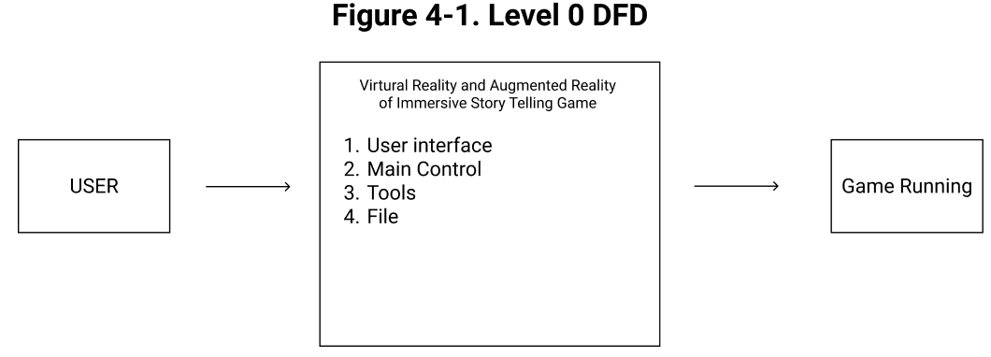

3.2. Data Flow:

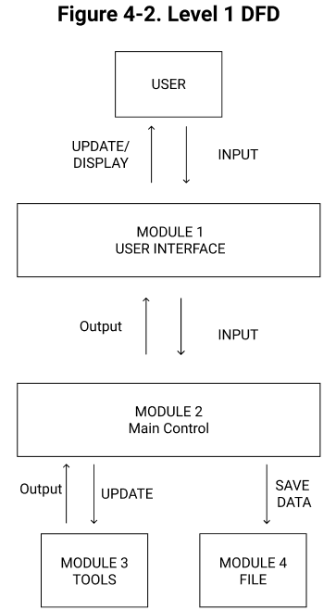

3.3. Implementation
The initial plan was for our game to have one central hub that acts as the introduction level. From there, the user can teleport to any of the three levels. This also helped to split the workload and be easier to develop the game, as opposed to having just one big level to work on.

3.3.1. Introductory Level/Start Menu
The start menu utilizes scene transitions in Unity for the user to go to any of the three levels.

3.3.2. Farm Level
The farm level includes being able to grab interactable items and harvesting crops. The audio was added to immerse the user into the world of a farmer, which includes hearing steps on soil and hearing cows moo when you walk near them.

3.3.3. Kitchen Level
The kitchen level includes being able to grab interactable kitchen items. This level also includes spawning items in order to be able to cook various dishes.

4. Conclusions

4.1. Results
We were able to successfully develop a virtual reality game for the Oculus Quest 2. We were able to split the workload in a reasonable manner by implementing various “bite-sized” levels.​​ This also helped develop more efficiently, thus, in the end, bringing the parts together to make a whole game.

4.2. Future
The game is far from perfect, and we could not add everything we had initially planned. Therefore, suggested improvements to the game include the following:
- Adding the third level we had in mind
- Include more gestures and actions within the game
- Adding an introductory level that ties all the other levels together and allows to switch between levels seamlessly
- Include better, high-quality textures and detailed environments
- Implement more unique gestures a user can perform in the game
- Include voice acting for NPCs
- Implement different language options other than just English to appeal to a broader audience

5. References

Unity website: https://unity.com

Unity Documentation: https://docs.unity3d.com/Manual/index.html

Blender website (for game assets): https://www.blender.org

Oculus website: https://www.oculus.com

