Software Design
Document
for
Sidewalk Slope Monitoring System

Version 1 approved

Prepared by Jan Bautista, Hua Chen, Abigail Garcia, Ana Guardado, Cristina Munteanu, Pabasara Navaratne, Alexis Pena, Beatriz Ruiz, Aoqian Wang

Department of Public Works and Bureau of Engineering, LA City

CSULA Senior Design 2020-2021 / LA City Bureau of Engineering

Table of Contents

1.0 Introduction 5

1.1 Purpose 5

1.2 Document Conventions 5

1.3 Intended Audience and Reading Suggestions 5

1.4 System Overview 5

2.0 Design Considerations 7

2.1 Assumptions and Dependencies 7

2.2 General Constraints 7

2.3 Goals and Guidelines 8

2.4 Development Methods 9

3.0 Architectural Strategies 11

3.1 Task 1 11

4.0 System Architecture 13

4.1 Task 1 13

4.2 Task 2 14

4.3 Task 3 15

4.4 Task 4 15

4.4.1 Database Data Diagram 15

5.0 Policies and Tactics 17

5.1 Choice of which specific products used 17

5.2 Plans for ensuring requirements traceability 18

5.3 Plans for testing the software 18

6.0 Detailed System Design 19

6.1 Raspberry Pi 3 19

6.1.1 Responsibilities 19

6.1.2 Constraints 19

6.1.3 Composition 19

6.1.4 Resources 19

6.1.5 Interface/Exports 19

6.2 Rover User Interface 19

6.2.1 Responsibilities 19

6.2.2 Constraints 19

6.2.3 Composition 19

6.2.4 Uses/Interactions 19

6.2.5 Resources 19

6.2.6 Interface/Exports 20

6.3 Image Processing 20

6.3.1 Responsibilities 20

6.3.2 Constraints 20

6.3.3 Composition 20

6.3.4 Uses/Interactions 20

6.3.5 Resources 20

6.3.6 Interface/Exports 20

6.4 Web application and mapping files 20

6.4.1 Responsibilities 20

6.4.2 Constraints 20

6.4.3 Composition 21

6.4.4 Uses/Interactions 21

6.4.5 Resources 21

6.4.6 Interface/Exports 21

7.0 Detailed Lower level Component Design 22

8.0 Database Design 23

8.1 Relational Schema 23

8.2 Diagram Description 23

8.3 Azure blob Storage implementation 24

8.4 Data Collection 24

8.5 Future Implementation 24

9.0 User Interface 25

9.1 Overview of User Interface 25

9.1.1 Task 1, Web Application 25

9.2 Screen Frameworks or Images 25

9.2.1 Task 1, Web Application 25

9.2.2 Task 3, Rover UI 27

9.3 User Interface Flow Model 27

9.3.1 Task 1, Web Application 27

10.0 Requirements Validation and Verification 28

11.0 Glossary 29

12.0 References 29

Revision History

Name | Date | Reason For Changes | Version
Abigail G. + Alex P. | 12/8/2020 | Fall 2020 Draft | 1
Pabasara N. | 12/9/2020 | Added basic descriptions to sections 1 and 2 | 1
Ana G. | 12/10/2020 | Fixed formatting for headers, changed table of contents for automatic updates. Updated descriptions, contents, explanations for Section 1, Introduction. Changes pending approval of SDD lead, Pabasara | .2
Pabasara N. + Jan B. | 12/10/20 | Added to section 2.3,2.4, 4, 5.1, 6.3, and update the table of contents. Fixed headers. | .2
Cristina M. + Beatriz R. | 12/10/20 | Fall 2020 Draft | 1
Ana G. | 12/11/2020 | Added to sections 2, 3, 4, 5, 6 from a task 1 perspective. | .2

Introduction

Purpose
The Sidewalk Slope Monitoring System project is an effort to develop the necessary databases, user interfaces, and automation scripts to aid the City of Los Angeles, Bureau of Engineering (BOE) in maintaining over 11,000 miles of sidewalk. Based on their prioritization and scoring system, BOE can assign a numerical score to each sidewalk segment to determine which segments require immediate attention or repair for their Sidewalk Repair Program.

The system developed by our team is designed to help BOE in their data collection by building a robot user interface to control the robot BOE uses during their field analysis, image processing scripts to extract image information, a web application to display and map image data, and a database to hold the data collected and extracted by the system.

This document will outline the design the system explained above. See System Overview for an exact breakdown of the system into tasks.

Document Conventions
This Software Design Document (SDD) uses a standard documentation template provided by the California State University, Los Angeles Computer Science department. The template follows the format:
- Main sections are identified by size 20, bold Times New Roman font
- Sub-sections are identified by size 14, bold Times New Roman font

Intended Audience and Reading Suggestions
This document is intended to aid the team members listed in the first page in scoping and developing their initial software design requirements that will later be refined in the Software Requirements Specification (SRS) document. This document is intended to breakdown BOE’s initial project requirements into tasks to aid the team in planning work. The entire document should be read by the team. Although team members are ultimately held responsible for their specific tasks, team members should be aware of the entire team’s efforts.

This document is intended to provide BOE and the project advisor an overview of the expected work to be completed by the team. Sections 2, 6, and 10 should be read by BOE and the project advisor.

This document is intended to provide a high-level overview of design planning and concepts for Computer Science students involved in future years’ efforts. Sections 2, 3, 4, 6, 9, and 10 should be read by Computer Science students who will continue this project beyond Spring 2021.

System Overview
BOE requires sidewalk data to evaluate sidewalk segments for their Sidewalk Repair Program. Because there are over 11,000 miles of sidewalk, it is valuable to BOE to leverage a process that minimizes overhead by automating image and data processing.

To collect the necessary data to assign scores, BOE plans to utilize a Leo Rover robot, with a GoPro camera mounted on it, to collect images of sidewalk segments in the city of Los Angeles. The system as a whole is broken down into four major components or tasks. The process for BOE to use our system is as follows:
- The robot will be accompanied by a field worker that will control it using a user interface developed by the team. The user interface is hereby referenced to as Task 3.
- Once the images are collected, scripts produced during previous years’ efforts will be used to parse out Exchangeable Image File (EXIF) data from the GoPro images. Image processing scripts will be applied to the images to extract additional data necessary for BOE’s prioritization and scoring system. The image processing scripts will hereby be referenced to as Task 2.
- A web application will display the collected images, one at a time, with its related EXIF and image processing data. In addition, Task 1 will develop scripts to create mapping files that can be hosted on BOE’s mapping application, NavigateLA. The web application and the mapping files will hereby be referenced to Task 1.
- A database developed by the team will contain the parsed EXIF data and the image processing scripts’ output. The database is hereby referenced to as Task 4.

Design Considerations

Assumptions and Dependencies
- Rover expectations
  - Cracks and holes on sidewalk shall be minimal.
  - Battery 4hrs of nominal driving or 8hrs of video streaming.
  - Hardware is reliable.
  - User will protect hardware from damage.
  - System is waterproof.
  - Operator will clear sidewalk before measurement.
- Task 1
  - Web application
    - Web application will be used to view specific or individual sidewalk segment images.
    - Web application will be used to view damage and assign numerical score to sidewalk segment.
  - Mapping files
    - Mapping files will be viewed by user by importing them to NavigateLA, if and only if, mapping files are not hosted on NavigateLA.
    - Mapping files will contain data for many sidewalk segments.
    - Mapping files will be viewed by user by selecting a layer hosted on NavigateLA, if and only if, mapping files are kept on a database managed by BOE.
- Task 2
  - System will be used during the day to take optimal photos.
  - Sidewalk will always be captured as the center of the image
  - Rendered images requires user-input before processing measurements
- Task 4
  - Rover
    - User will use GoPro provided app to render 360 Degree Images
    - User will keep an eye on the rover at all times.
    - User will manually extract data from rover's memory cards
  - Database
    - User will manually input data into Azure DB
    - User will manually input sidewalk asset ID after every rover scan.
    - User will manually input location data fields after every use.

General Constraints
- Task 1
  - Web application
    - Web application can use a local instance for development and testing purposes.
    - Web application must have access to the database containing sidewalk data.
    - Web application must use database when displaying sidewalk data and cannot store or use data locally.
    - Web application must use a BOE web server for production.
    - Web application must be accessible to BOE, either using Internet or Intranet access.
    - Web application must be accessible to BOE regardless of their preferred browser.
    - BOE must provision a web server for web application production use.
    - BOE must maintain the web server hosting the web application.
    - Web application backend will be done using Python.
    - Web application frontend will be done using HTML/CSS and Bootstrap.
  - Mapping files
    - 3rd party application must have a command language to develop automation scripts.
    - Mapping files must be generated by scripts using the 3rd party application’s command language.
    - Mapping files must be importable in NavigateLA, if and only if, mapping files will not be hosted on a database managed by BOE.
    - Mapping files must maintain all design features, such as color schemes, annotations, polygons, lines, shapes, when hosted in NavigateLA.
    - Mapping files must be hosted on NavigateLA when a substantial amount of mapping files is available for viewing.
    - A request for a database to host the mapping files can only be placed after discussing and receiving approval from advisor and BOE.

Goals and Guidelines
- Task 1
  - Web application
    - Web application will be hosted on a web server when the frontend and major components of the backend are completed.
    - Web application’s web server will be discussed with BOE to determine what languages and web server applications are available to us.
  - Mapping files
    - Mapping files will be hosted on NavigateLA after receiving approval from advisor and BOE to request database. Database will host files that NavigateLA will reference. Users can select the files as a layer on NavigateLA.
    - Mapping files will be available to uses to import to NavigateLA if a database is not available or if only a limited section of the city is mapped by the mapping files.
    - Meeting with advisor and BOE will be required to determine how users can best view mapping files.
- Task 2
  - Image Processing
    - Implement image segmentation and texture processing methods on images to easily help find the x and y displacement of a sidewalk.
    - Count pixels between two points.
    - Convert pixel distance to centimeters.
- Task 3
  - Image reading structure for the image processing.
  - Utilize sidewalk measurements
  - Conjoin the four tasks
  - Redesign Rover Ui control buttons for easier recognition
  - Test Ui functionality on Rover
- Task 4
  - Rover
    - Build Leo Rover
    - Implement last year's project onto the Leo Rover.
    - Implement this year's tasks on the Leo Rover
  - Database
    - Design a database schema which will include all aspects of the project. Including but not limited it too, rover, UI’s, and NavLA.
    - Create a way to bridge rover data with NavLa data. This might require the team to map sidewalk coordinates into their own table and use that to correlate with the existing tables. An algorithm will then be needed to loop through all the coordinates and make that correlation.
    - Create the necessary SQL statements to create said database in an Azure environment provided by the BOE to begin storing important data.
    - Gain access to Azures Blob storage within the BOE’s environment to be able to store JPG’s.
    - Implement Azure tools to help with data manipulation.

Development Methods
Components to build a slope monitoring system have been divided into four applicable tasks for early stages of the system. Development methods are yet to be discussed.

- Task 1
  - Web application
    - Use prior knowledge from web development courses to build frontend and backend of site.
    - Refer to Mozilla and Django’s documentation for best practices and setting up environment.
  - Mapping files
    - Leverage existing automation efforts to create DWG files
    - Reference AutoCAD’s forums to explore other user’s methods and processes when developing scripts using AutoCAD’s command language
    - Run through manual steps in developing DWG files, to narrow down what is required for the automation scripts
- Task 2
  - Use the Grabcut Algorithm from the OpenCV library to easily remove background noise and segment sidewalks from captured GoPro images.
  - Use Euclidean distance method when calculating the distance between two points to find x and y displacement in pixels.
- Task 3
- Rover User Interface allows field users to control the rover and collect sidewalk data.
- Task 4
  - Database allows for access to storage from all aspects of the project.
  - Sources of data are the rover with numerical data as well as the GoPro with image and EXIF data collected upon testing; incorporated with the corresponding sidewalk data provided by BOE.
  - Organized in Azure Data Studio to efficiently manipulate and connect data from all sources including the rover as well as other image data.
  - With the large number of images involved, Azure Blob storage is implemented for easy access from other tasks.

Architectural Strategies

Task 1
- Web application
  - Used Django to use HTML, CSS, Bootstrap for frontend and Python for backend.
    - Python libraries are heavily used in parsing and processing image data both in task1 and in other tasks.
    - Enables team to utilize each other’s scripts and combine efforts without being concerned with language compatibility.
    - Django also uses templates that make it easier in developing the backend.
    - Django testing environment can easily be created. Existing environment can easily be replicated following Django and Mozilla’s documentation.
    - Django, Mozilla, and Python have an extensive set of documentation that we have heavily depended on to ensure our product is created with best practices.
  - Utilizing existing scripts to parse EXIF data from GoPro images
    - Scripts were created during previous years efforts. Scripts will be reused.
  - Depending on availability of web server from liaison, the Django environment will be recreated for a production environment. Dependencies on liaison’s web server application may also cause us to change our use from Django to another widely supported web server.
- Mapping files
  - Used AutoCAD to automate the creation of DWG files that will be mapped on NavigateLA.
    - AutoCAD’s forums have many posts, notices, explanations, and pages regarding automation and how to use AutoCAD’s command language.
    - AutoCAD is widely used and available to students for free from the university.
    - AutoCAD supports location and GPS coordinates, which allows us to use EXIF GPS data and map it easily on NavigateLA.
    - AutoCAD DWG files are supported by NavigateLA.
  - Other mapping applications such as ArcGIS are available and their file types are supported by NavigateLA, but ultimately AutoCAD was the best option.
    - ArcGIS is also available to students for free from the university, but is only accessible via Parallels Client, a remote desktop application that allows users to access campus servers containing the application. Because we are remotely accessing the server from our personal machines, performance is limited and requires an internet connection.
    - AutoCAD is also used by BOE.
  - Once many mapping files are created to cover a large portion of the city of Los Angeles, the mapping files can be hosted on NavigateLA.
    - Users would be able to select our layer on NavigateLA.
    - Otherwise, users would need to import the mapping files and apply color schemes. When imported to NavigateLA, color schemes are not maintained. Any colors or annotations applied to the mapping file is forgotten.
    - However, in order for the layer to be hosted on NavigateLA, large amounts of sidewalk data and fully functioning automation scripts are required. This would develop many, or perhaps a large DWG file, that covers a large portion of the city of Los Angeles. We can then request a database from the liaison to host our data so that NavigateLA users can select the layer.

System Architecture
The main functionalities of the system are divided into four tasks, then brought together at the end. The four tasks; create a web application for rover data, implement image processing, creates a user interface for rover controls, and create a backend database.

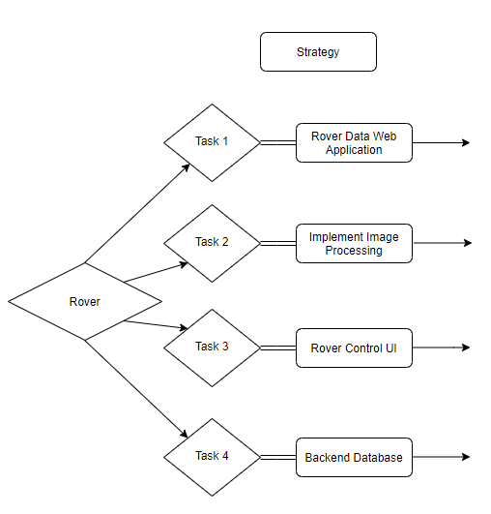

Task 1
- Web Application
  - The web application will display a GoPro image and all of its related data on the console. Users can switch back and forth between images, use the auto feature so that the position in the sidewalk moves forward showing many images, or search for specific images based on GPS coordinates and image name.
  - The web application is intended to show one instance of a sidewalk segment at a time. It will not provide an overview of the entire city of Los Angeles.
  - Data shown on the web console is obtained from the Azure database. The console contains data from the image processing team, too.
- Mapping files
  - Mapping files will pull data from the Azure database. It will map the GPS coordinates and the sidewalk to a DWG file in AutoCAD using automation scripts leveraging AutoCAD’s command language.
  - The DWG file can then either be imported or hosted on NavigateLA.
  - The DWG file can provide an overview of the entire city of Los Angeles. Users can also zoom in to a section of the map and view annotations or additional notes creating during the automation scripts.

Task 2
Implements the functionalities to process the images rendered and stored by the rover camera. Currently, the program reads an image and applies image processing algorithms using the OpenCV library.

Algorithms in use:
Image Thresholding and Canny Edge Detection
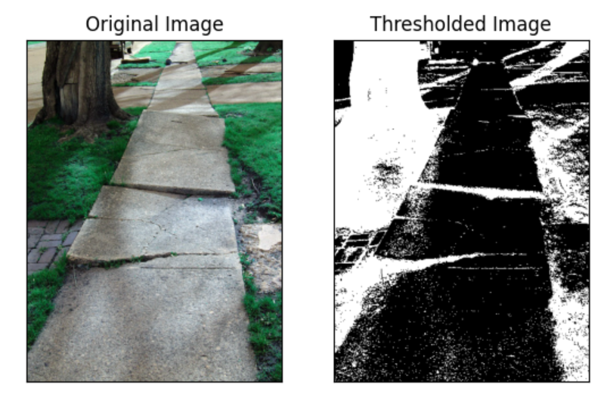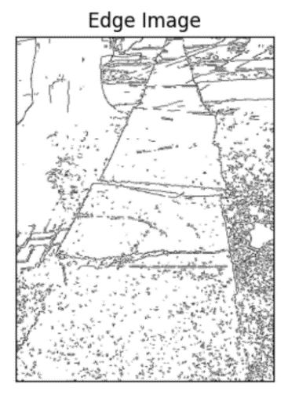

Image Segmentation and Grabcut Algorithm

Current goal of this task is to count the pixels so it can be scaled onto real unit measurement, specifically in centimeters. The above images can easily help find the edges of the sidewalk to precisely locate the starting and ending points for each of the x and y displacements. Then we can calculate the distance between those two points to find the pixel distance.
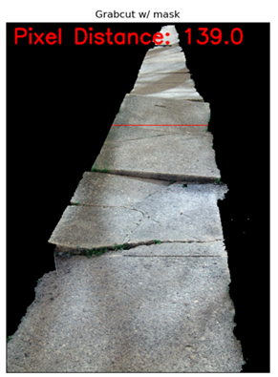

The ultimate goal is to get the measurements of the horizontal and vertical displacements on the sidewalk. Once we find the pixel distance for the x and y displacements, we convert it to centimeters. Those measurements will be used as part of the parameters in labeling the priority of the sidewalk images.

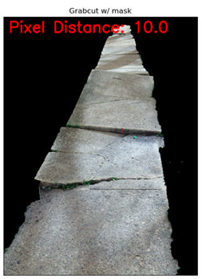

Task 3
Rover Ui

Task 4

Database Data Diagram

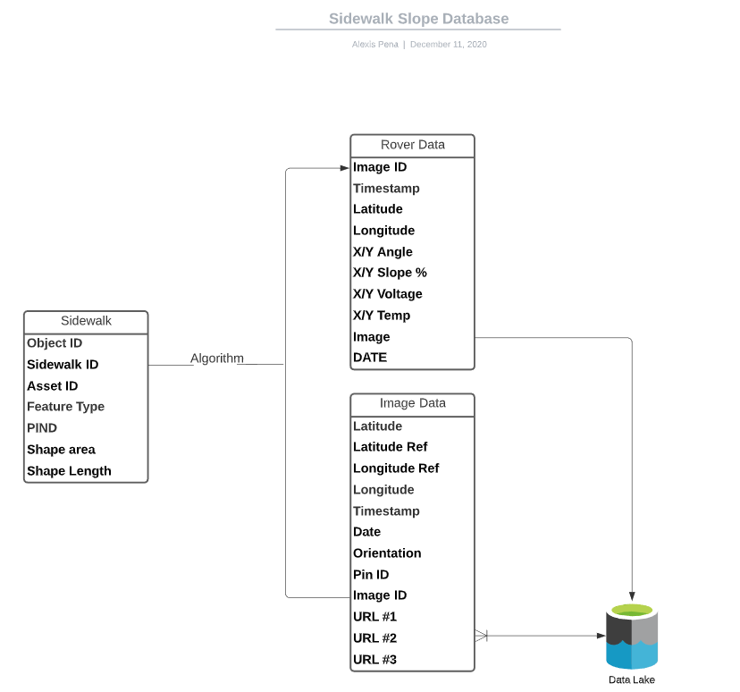

Policies and Tactics

Choice of which specific products used

- Task 1
  - Web application
    - Django
      - Django uses Python for its backend. See Python under the mapping files bullet point to view why we select Python.
  - Mapping files
    - AutoCAD
      - Command language available to automate mapping file creation. Forums and documentation thoroughly explains how command language may be used and provides sample use cases.
    - Python
      - Existing scripts from previous years efforts use this language. Python has an extensive library that can provide parsing and data processing abilities that is not readily available in other languages.
- Task 2
  - OpenCV Library
    - OpenCV library was chosen for image processing because it provides many functions that helps with image segmentation.
    - Our advisor recommended using OpenCV.
- Task 3
  - We choose to use a Python IDE due to the Rover we acquired, Leo Rover, uses a Raspberry Pi microprocessor. The database we choose is the Azure database based on our liaison, the city of los Angeles, using the same database. This is so we can transfer our data freely between the liaison and our project.
- Task 4
  - Rover
    - Leo Rover was chosen as a replacement for our previous rover “Robecca” because its more versatile, price friendly, and is a good platform a base a fleet of rovers on.
    - GoPro Fusion was chosen as our camera because it offers a 360-degree view of the rovers surrounding with only one product.

  - Database
    - Azure SQL database was chosen by our corresponding liaisons because it’s what they currently using themselves.
    - Azure Blob storage was chosen as a solution for image storage because it integrates to Azure DB nicely and it’s the most cost-effective method available to the BOE.

Plans for ensuring requirements traceability

- Task 1
  - Web application
    - Backend is actively pulling data from the Azure database and is not storing or using local data.
  - Mapping files
    - Automation scripts create DWG files that meet the design requirements. Design requirements include color schemes based on BOE’s prioritization and scoring system, annotations for slope, etc.

Plans for testing the software
- Task 1
  - Web application
    - Users can view an image. The administrators can confirm that the image shown, and its pulled data are related.
    - Users can flip through the images and its related data is shown. See the first bullet point.
    - Users can auto flip through the images and all related data is shown. See the first bullet point.
  - Mapping files
    - When running the automation scripts, the automation scripts pull data from the Azure database and create DWG files.
    - The DWG files must display the shape of a sidewalk with annotations and any needed color schemes (applying color schemes based on BOE’s prioritization and scoring system).
- Quality Control

Detailed System Design

Raspberry Pi 3

Responsibilities
The role of this module will be to compute and store data captured by the rover modules such as Camera and Accelerometer.

Constraints
Possible constraint of this module would be the memory size of MicroSd Card attached to the rover.

Composition
A description of the use and meaning of the subcomponents that are a part of this component.
Uses/Interactions
User interaction to power the Raspberry Pi 3

Resources
This is the main module that will power the accelerometer and camera.
They are dependent on Raspberry Pi 3

Interface/Exports
CSV file will export data from MicroSd card into the database.
Interface Linux.

Rover User Interface

Responsibilities
The primary responsibility of the rover interface is to allow the user to access, move, and to automate data collection using the rover.

Constraints
Constraints of this component would be based on the sidewalk condition, any debris would give inaccurate results.

Composition
Extra camera added on the rover is a GoPro. It is responsible for capturing photos of the sidewalk where data was recorded.

Uses/Interactions
The rover user interface will be used to control the rover movements and ability to collect data. The rover user interface will interact with the Bureau Of Engineering field workers.

Resources
Rover UI

Interface/Exports
The interface has been coded with python tkinter toolkit. The exports available will be a data CSV file.

Image Processing

Responsibilities
Image processing functionalities will be implemented for the images taken from the GoPro camera attached to the Rover. The functionalities include measuring the XY (vertical and horizontal) displacements on the sidewalk and eventually categorize the images according to their condition.

Constraints
Measuring the vertical displacement is the close to impossible. The angle of the images being take from the camera doesn’t show the distance from an overhead view.

Composition
We use OpenCV or Open-Source Computer Vision library that is compatible with Python for image processing functionality. We currently use Pycharm IDE to utilize those components.

Uses/Interactions
If the strokes for Grabcut technique mentioned earlier cannot be implemented automatically, user strokes are a requirement to isolate the sidewalk, when measurements are made.

Resources
Beginning stages don’t require any resources other than the images used to learn and test OpenCV algorithms.

Interface/Exports
OpenCV library built in GUI with input and processed image.

Web application and mapping files

Responsibilities
The web application is a console for users to view a single instance of a GoPro image and its related data. The mapping files script will create DWG files automatically that can either be imported or hosted on NavigateLA. The DWG files will contain data from the GoPro image, too.

Constraints
Web application will be developed in a test environment locally. If the liaison provides a web server, the web application will be moved to a production environment. The mapping files will be imported to NavigateLA. If many mapping files are creating using sidewalk data, the mapping files can be hosted on NavigateLA. This depends on the amount of sidewalk data collected, GoPro images available, and a database to host the mapping files.

Composition
The web application is the web console that users interact with. The mapping files are automation scripts the create DWG files.

Uses/Interactions
The web application and the mapping files scripts use the image processing scripts and the Azure database.

Resources
Azure database, image processing scripts

Interface/Exports
Web application is the web console and the mapping files scripts create DWG files.

Detailed Lower level Component Design

To be determined in Spring

Database Design
The database is utilized by all aspects of the project, linking the existing data from NavLA to new data collected by the rover--providing access web server which displays the data in real-time. In addition, it provides access and stores the images from the GoPro which can then be directly implemented with the image processing side of things.

Relational Schema

Diagram Description
The relational schema as seen in the diagram is organized by the various sources of data in mind.

The left most part, being the existing data provided by BOE:sidewalk, and property tables. It also includes PIN ID’s and asset ID’s which are essential in pinpointing specific properties and sidewalk locations. Navigate LA data will serve as geographical reference points for the Image data and the rover data listed.

The rightmost data, the Rover Data Table and Image Data Table would be extracted from the rover itself--using the timestamps and PIN ID columns to link it to the Image data Table.

The algorithm portion will make the correlation between the location (longitude and latitude) points provided by both the rover/ GoPro and the NavLA data.

Azure blob Storage implementation
Azure Blob Storage is required in order to store a large amount of JPG’s--such as the front, rear, and rendered Images. Image IDs from the GoPro picture data will serve as a link for the images stored in the blob storage. This method allows us to create a much more efficient method of storing images and sharing them across different platforms, such as our UI and web applications.

Data Collection
Data sources include:
- Rover
  - The main focus as it holds key information that will be used by BOE to prioritize the locations in need of repairs.
  - GPS Coordinates (Precise Lat and Longitude)
  - Timestamps
  - Leveler - Vertical and Horizontal displacement of the sidewalk
- GoPro Fusion
  - Forward and Rear facing camera to create a 360 Degree image on the rovers surroundings
  - Rendered Images
  - Python code to exfiltrate the EXIF/METADATA from each image which provides another DB table to populate
- Existing data - Mapped by the BOE on NavLA

Future Implementation
Future implementations consist of things such as
- Data Manipulation
  - The way data is correlated, either by location or specific timestamps
  - Automation of data uploads
- Data Visualization
  - Azure offers Tools which help visualize our data, which offers a unique perspective that could be implemented into our applications.
- Image processing
  - Azure AI will be utilized to introduce severity levels into our dataset and help reduce the manual labor and reach our goal faster and more productively.

User Interface
The user interface tasks are Task 1 for the web application and Task 3 for the rover UI.

Overview of User Interface

Task 1, Web Application
The web interface will receive image data from Leo Rover’s camera to be transferred to the website. BOE uses an Azure database for their backend, which we will integrate into our web application.

Our web application will include a page to display our data. The data to be displayed includes images received from the rover, longitude and longitude slope data, Global Positioning System (GPS) data as well as the image name and date when what image was taken. The web application will have the ability to iterate through the image with a previous button, next button, and an auto button. The auto button will literate through the images automatically, with each image showing for 2 seconds. The user will be able to pan the image and zoom in and out of the image. The web application will have a function to search through the database of pictures by the images name or coordinate which the image was taken from.

The web application will have additional pages which will describe the purpose of our project, the overall description, the environment where our project was worked on, and the algorithms used in this project.

Screen Frameworks or Images

Task 1, Web Application
The following are wireframes and actual frontend images:
- 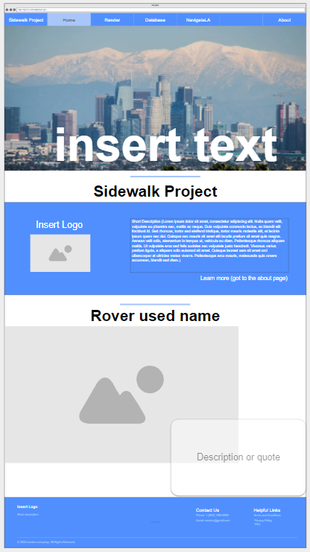

- 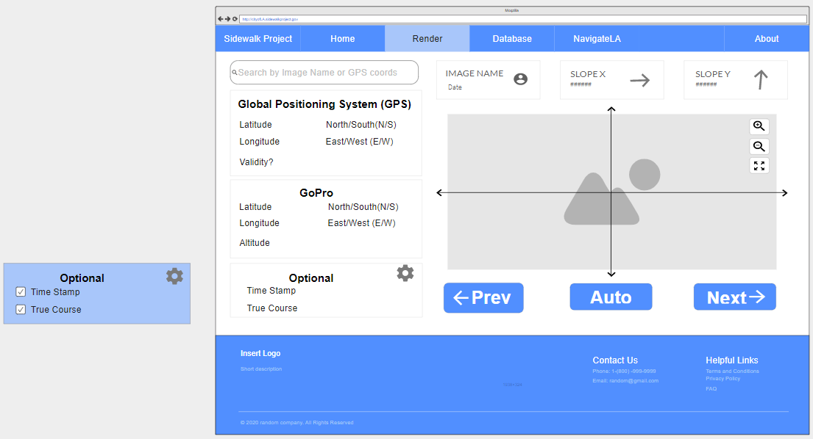

- 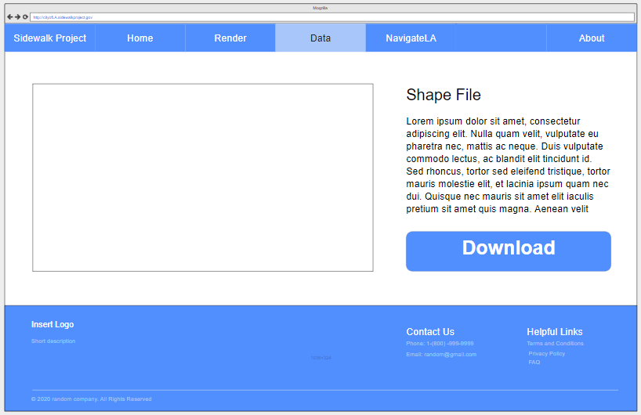

- 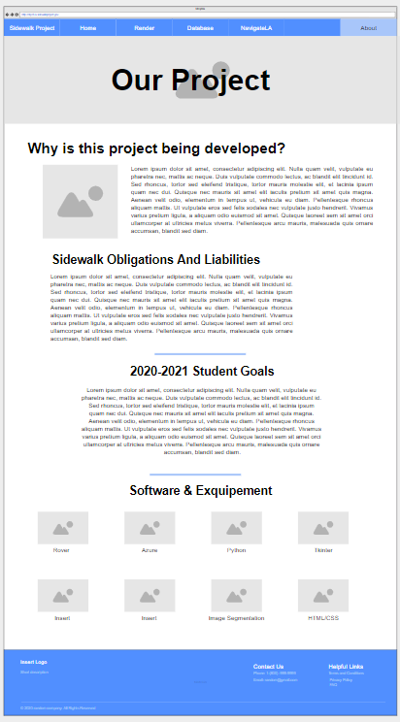

Task 3, Rover UI
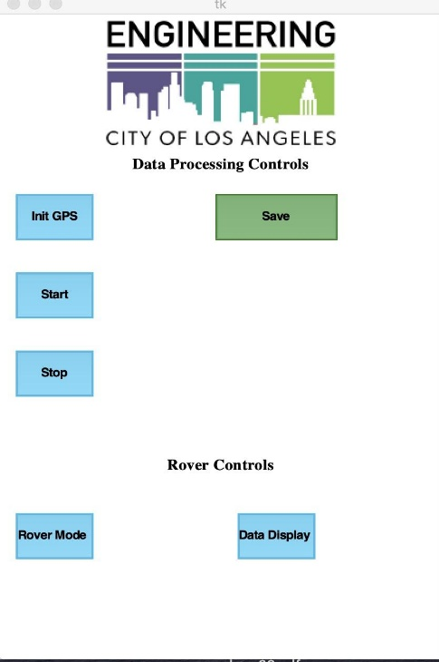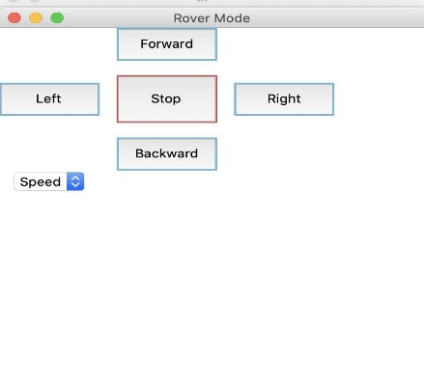

User Interface Flow Model

Task 1, Web Application
The Home, Render, Database and About page can freely navigate between each other. However, the NavigateLA tab is different. It takes the user to a different webpage, https://navigatela.lacity.org/. Once at NavigateLA, the user cannot navigate back to the web application.

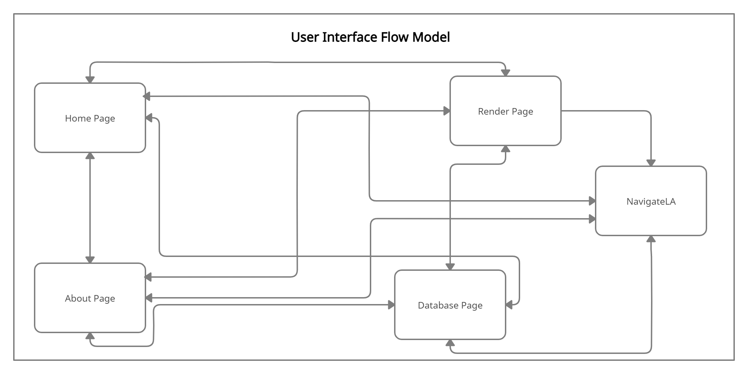

Requirements Validation and Verification

Requirement | Component | Test
 | Module
Raspberry Pi 3 shall collect data from modules and store the data. | Raspberry Pi 3 | To be determined in Spring
Accelerometer shall measure the grade of sidewalk and send the raw data to Raspberry Pi 3. | Accelerometer | To be determined in Spring
Camera shall be responsible for taking pictures. | Camera | To be determined in Spring

Glossary
For the purposes of this project, the following terms are defined as follows:
BOE | City of Los Angeles, Bureau of Engineering
SDD | Software Design Document
SRS | Software Requirements Specification
Rover | Device with wheels that will display the GUI software.
IMU | Inertial Measurement Unit
DB | Database
NavLA | NavigateLA (Site)
EXIF | Exchangeable Image File
IDE | Integrated Development Environment
GUI | Graphical User Interface
Task 1 | Web application and mapping files
Task 2 | Image processing
Task 3 | Rover UI
Task 4 | Database

References
- NavigateLA, https://navigatela.lacity.org/navigatela/
- Sidewalk Repair Program Prioritization and Scoring System Council File 14-0163-S3, from the City of Los Angeles, Bureau of Engineering
- Azure SQL database - https://docs.microsoft.com/en-us/azure/azure-sql/
- Azure Blob - https://docs.microsoft.com/en-us/azure/storage/blobs/
- Leo Rover - https://www.leorover.tech/
- GoPro Fusion - https://gopro.com/content/dam/help/fusion/manuals/Fusion_UM_ENG_REVC.pdf

