Software Requirements Specification

for

Aquila
Process Management System

Version 1 approved
Prepared by Bryan Bravo
Barry Boayes
Jurelly Tello
Sasha Nicole Cisneros
Jessica Palacios

Aquila

10/03/17

Table of Contents
- Introduction
  - Purpose
  - Intended Audience and Reading Suggestions
  - Product Scope
  - Definitions, Acronyms, and Abbreviations
  - References
- Overall Description
  - Product Perspective
  - Product Function
  - User Classes and Characteristics
  - Operating Environment
  - Design and Implementation Constraints
  - User Documentation
  - Assumptions and Dependencies
  - Apportioning of Requirements
- External Interface Requirements
  - User Interfaces
  - Hardware Interfaces
  - Software Interfaces
  - Communications Interfaces
- Requirements Specification
  - Functional Requirements
  - External Interface Requirements
  - Logical Database Requirements
  - Design Constraints
- Other Nonfunctional Requirements
  - Performance Requirements
  - Safety Requirements
  - Security Requirements
  - Software Quality Attributes
  - Business Rules
- Other Requirements

Revision History

Name | Date | Reason For Changes | Version
Initial Draft | 12/01/17 | Initial Changes | 1
Final Draft | 4/10/18 | Final Changes | 2

1. Introduction

1.1 Purpose
The purpose of this document is to give a detailed description of these requirement for UAS. It will explain the purpose and features of Aquila, along with its system constraints, its user interface, and its interactions with users. This document is intended for the developers of the system and will be proposed to the UAS for its approval.
1.2 Intended Audience and Reading Suggestions
This document is to be read by the development team, the project managers, testers, and documentations writers. California State University, Los Angeles ECST Department, and UAS, may review the document to learn about the project and to understand the detailed list of requirements. The SRS has been organized approximately in order of increasing specificity. Developers and project managers need to become intimately familiar with the SRS.
1.3 Product Scope

Aquila is a process management tool for UAS.Our web application will allow for UAS to manage and oversee their current projects and past projects. Aquila will also make the applicant’s application process more efficient. The forms will be filled out online. Submissions will be online so there will be no need to print out forms. The applicant will also be able to view their past projects in an archive. UAS analyst and the applicant will be able to communicate through the software in the form of messages.

Our software will improve efficiency for UAS and the applicant. The web application allows for better workflow. Our application will have a form of communication built in so that it is easier for an applicant and UAS analyst to communicate. The application process time will be much shorter using our system because the user can will get feedback. Our software will replace their current process of printing and using paper documents. Removing the paper work allows for our system to be solely online which in turn makes it easier to go back and view entire projects.

.1.4 Definitions, Acronyms, and Abbreviations
UAS - University Auxiliary Services
SAML - Security Assertion Markup Language
UI- User Interface Module
PR - Pre Award Module
PO - Post award Module
SEC - Security Module
PA - Proposal Archive Module
UM - User Management Module
PI - Principal Investigator
ECST - College of Engineering, Computer Science, and Technology
HTTP​ ​-​ ​HyperText​ ​Transfer​ ​Protocol HTTPS​ ​-​ ​HyperText​ ​Transfer​ ​Protocol​ ​over​ ​TLS
FE- Front End
BE-Back End
COI - Conflict Of Interest

1.5 References
// angular
Angular Documentation - https://angular.io/docs
Angular Documentation was used to comprehensively understand the Angular API. It provides many useful tutorials and there is an open source GitHub that provides many useful examples for using Angular.

NodeJS Documentation - https://nodejs.org/dist/latest-v8.x/docs/api
The NodeJS Documentation was used to reference to the Node.js API.

PrimeNG Documentation - https://www.primefaces.org/primeng
Animate.css demos - https://daneden.github.io/animate.css/
// spring
//cs5220
Dr. Sun Github on hibernate- https://github.com/cysun/cs5220-hibernate
Dr. Sun

5

2. Overall Description
We will develop a system that manages various types of workflows for UAS. The plan is to focus on two processes, Post Award and Pre Award. At the time of this document being written we have not started development on the Post Award Process. The current process for the Pre Award section starts with the applicant downloading the forms off UAS’s existing site. They have to fill out an intake and budget forms then turn them into a UAS analyst through email. The Intake form discloses what college is applying for the award,their need for extra space, students or other faculty members ,etc. The applicant will turn in a budget form which will have draft budgets.The people applying will also need to email the analyst the link to the announcement of the award they are applying to. Afterwards UAS requires a face to face meeting between UAS, the applicant and academic affairs: to go over important scheduling aspects of the project. Once all the deadlines are met and everyone's in agreement. Then an approval excel sheet is generated using the sheets that are submitted by the applicant.This sheet will also need approval signatures from other departments, for example if the project uses hazardous materials they need to be approved to use these materials.then everything is put into an application which is sent to the funding agency. After submitting all the paperwork to apply for this grant, it takes 6 months to a year to get approved or denied for the grant. Which in turn starts the Post Award Process
We will be making a web application where applicants will be able to go through the entire current process online. They will begin by making an account, then they will be able to fill out all the forms online. Once finished they submit to a UAS analyst, a face to face meeting is scheduled. In this meeting, they will agree to dates for submission of the all finalized forms. This web application will allow the applicant to get signatures from their superiors digitally. On the administrative side, our application will allow administrators to view all of their projects. They will be able to access past project through an archive. Our application will have a comment section allowing the applicant and administrator to have an easy means of communication and avoids making emails.
This web application’s main goal is to help UAS make their current process more efficient. With the use of our application, the applicant will avoid traveling to people’s office for signatures. This task will be faster and easier with the use of the digital signatures. The digital timeline will help keep the applicant on schedule. There will also have an email notifications that will warn applicants of upcoming deadlines. Aquila will have a status bar that will show the current progress of the application. Our application will have all the documents easily accessible, this makes it easy for UAS to review projects. This will also allows the applicant to easily make any revisions to their applications. Aquila is going to help the current process become faster and easier for each of the applicants.

2.1 Product Perspective
Our product is a web application and it will require us to interface with a CSULA administered external authentication server.

Our product is unique to any other software we have encountered because it will be made specifically for the needs of UAS. Some parts of the software will resemble other systems, for example the workflow will be similar to the workflow management features in software products like Microsoft SharePoint. Other than that the software is specifically made to aide in the services provided by UAS.
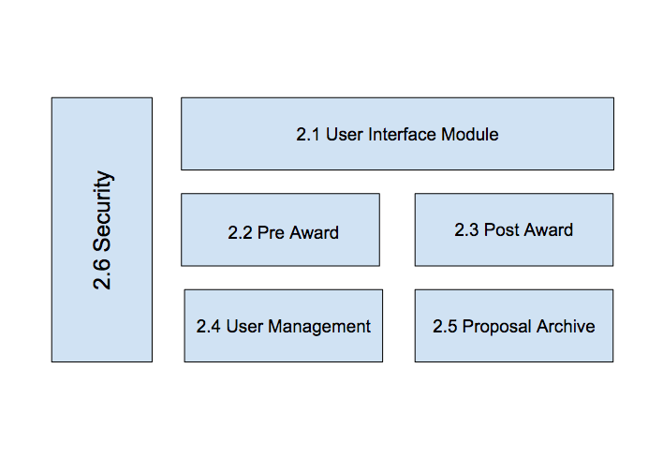
Diagram 1
2.2 Product Functions
The following list summarizes the major functions of the system.
2.1 User Interface
- Display a login page
- UAS users can view a list of proposals along with date and status
- UAS user will be able to schedule a meeting with PI user
- Display a timeline for PI user to be able to view their deadlines
- Provide notification emphasizing nearby deadlines
- Display notification of completed forms
2.2 Pre Award
- Applicants can create/manage proposals
- Applicants will be able to upload files to fulfill requirements
- PI users will be able to fill out the following forms
  - Intake
  - Approval
  - Equipment
  - Statement Of Economic Interest
  - COI PI Personnel NON PHS
  - COI PI Personnel PHS
  - COI OI Non PHS
  - COI OI PHS
2.3 Post Award
- Unsure
2.4 User Management
- Users will be created automatically upon verification of valid CSULA email and password
- Users can edit most of their own information
- There will be a system admin
- System admin will be able create users/ change user privileges
- UAS Analysts will be able to monitor proposals
- UAS Analysts will be able to approve/decline stages of a proposal
2.5 Proposal Archive
- Store completed proposals
- Show status of a proposal (draft, pending, completed….etc)
- Store completed proposals as immutable
2.6 Security
- Authenticates user
- Prevent Users from modifying proposals at certain stages
- Only UAS Analyst and Proposal applicants will be able to view/modify proposals
All features are detailed in the functional requirements in section 4.1 of this document

2.3 User Classes and Characteristics
2.3.1 UAS Analyst: UAS analyst will use the software to view the information the applicant has input forms and files. UAS analyst will be able to view the completion of the forms. When UAS user meets with the Applicant user they will be able to fill out a Timeline Form. Once the Timeline Form is completed both the UAS and Applicant users will be able to view the form through the software. UAS analyst will have the ability control to edit, add, or delete any information. UAS will also have the ability to send notifications to Applicants through the software
2.3.2 Investigator User: Applicant user will be able to apply through the software by filling out the Intake and Budget form. Once UAS user and Applicant have the meeting and complete the Timeline form, the applicant will have deadlines for the rest the forms. The Applicants have to complete the forms through the software. Applicants will be able to view the process of their forms getting completed.
2.3.3 UAS System Administrator
Will be able to create UAS analysts and create System Administrators. Will all have all access privileges.
2.4 Operating Environment
This software is currently being hosted on a Linux server virtual machine that is running Java and Tomcat. For the backend, we are using a mySQL database server.
2.5 Design and Implementation Constraints
DocuSign for digital signatures.
2.6 User Documentation
At this time, we don’t have plans on creating user documentation to go along with the software.
2.7 Assumptions and Dependencies
Currently, we do not have any other factors that may affect the requirements stated in this document.

List any third-party or commercial components that you plan to use.
- We plan on using commercial digital signature software.
- The SAML Database

2.8 Apportioning of Requirements
There are no requirements that will be delayed until further versions of the system.
3. External Interface Requirements
3.1 User Interfaces
The user interface is hosted in the user’s web browser with internet access. The browser is used through navigate through system and communicate with database.

Common features that will be found in our website will be installed to help users interact with our application. We will have a process bar that will show the status of the applicant’s proposal. We will have a comment section that allows easy communication between the PI and UAS analyst. There will be navigation buttons for the user to go through the pages of the forms. For the archive, the user will have a search bar that allow user to search by name, date, etc.

Everything in the UI will be displayed in an organized fashion, that is easy to use for the user to understand and use.
3.2 Hardware Interfaces
Hardware devices are not required due to the software being a web-based system.
3.3 Software Interfaces
The software interface that the software shall interact with university authentication service, Shibboleth Identity Provider which requires the use of SAML. The application shall authenticate users through the university system, Shibboleth Identity Provider.
3.4 Communications Interfaces
The software shall run on a server that will communicate through HTTP requests by a user’s web browser. HTTP request will send a message that will be valid HTML that shall be parsed by a user’s web browser. The communication with the Shibboleth Identity Provider require the use of SAML in order to authenticate users using university-issued credentials.

4. Requirements Specification
4.1 Functional Requirements

These requirements are based off of Diagram 1

4.1 | User Interface Module (UI) Requirements
Requirement No. | Requirement Description
4.1.1 | UI shall provide a login page
4.1.2 | UI shall display a current status bar
4.1.3 | UI shall allow the PI to upload documents
4.1.4 | UI shall allow the PI to access their archive
4.1.5 | UI shall allow UAS oversee all projects
4.1.6 | UI shall allow the applicant to logout

4.2 | Pre Award (PR) Requirements
Requirement No. | Requirement Description
4.2.1 | PR shall allow PI to create a new project
4.2.2 | PR shall allow the PI to fill out the Intake Form
4.2.3 | PR shall allow the PI to fill out the Budget Form
4.2.4 | PR shall allow the PI to fill out the Approval Form
4.2.5 | PR shall allow the PI to fill out optional Equipment Form
4.2.6 | PR shall allow the PI to fill out optional Conflict of Interest Forms
4.2.7 | PR shall have access to a Timeline
4.2.8 | PR shall allow the PI to communicate with a UAS staff
4.2.9 | PR shall allow the PI to terminate the project at any moment
4.2.10 | PR shall allow the PI to save a project at any moment
4.2.11 | PR shall allow user to edit information in the forms
4.2.12 | PR shall allow UAS to oversee any current projects
4.2.13 | PR shall allow UAS to approve a proposal
4.2.14 | PR shall allow UAS to submit a proposal

Post Award Requirements are in progress.
4.3 | Post Award (PO) Requirements
Requirement No. | Requirement Description

4.4 | User Management (UM) Requirements
Requirement No. | Requirement Description
4.4.1 | UM shall put user information into database
4.4.2 | UM shall allow only one account per applicant
4.4.3 | UM shall require a distinct username
4.4.4 | UM shall require a phone number
4.4.5 | UM shall require an email address

4.5 | Proposal Archive (PA) Requirements
Requirement No. | Requirement Description
4.5.1 | PA shall save all completed projects from a PI
4.5.2 | PA shall allow PI to search through their previous projects
4.5.3 | PA shall allow UAS to view all projects
4.5.4 | PA shall save different versions of the same project

4.6 | Security (SEC) Requirements
Requirement No. | Requirement Description
4.6.1 | SEC shall verify the user
4.6.2 | SEC shall verify a UAS faculty
4.6.3 | SEC shall only allow the PI to view their projects
4.6.4 | SEC shall allow UAS to view project
4.6.5 | SEC shall not allow UAS to revise completed projects
4.6.6 | SEC shall allow UAS to download any project
4.6.7 | SEC shall allow the applicant to logout of their account
4.6.8 | SEC shall allow the UAS faculty to logout of their account

4.2 External Interface Requirements
There is no External Interface Requirements at this time.
4.3 Logical Database Requirements

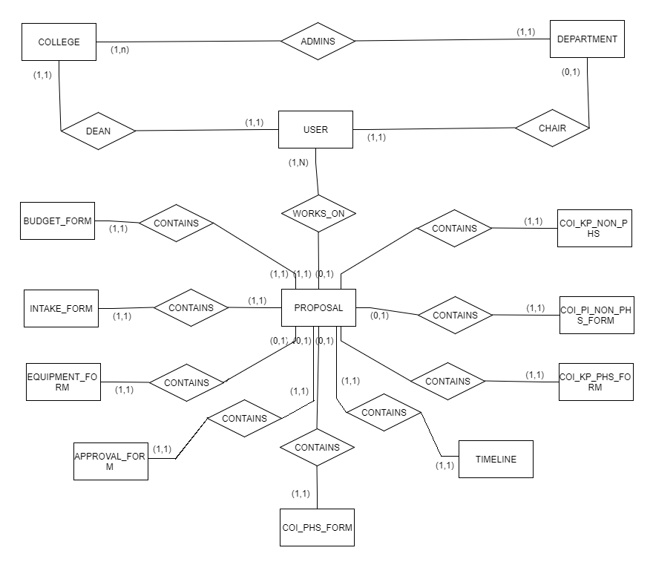

There will be two different accessing capabilities. The user and admin will have a login with different capabilities. Users will only have the capability of completing and viewing their own projects. While the admin has the ability to view all the applicant’s projects. There are many entities that are important for this application. The most important entity is the user. The user’s information will be important as it will be used throughout the entire project. We use the username and password to gain access into the application , which will have all the users information including the past and current proposals. There will be a College entity and Department entity that work together to find the college of the applicant and also returns the dean and chair. Together they will keep track of the applicant’s hierarchy. Next is the the proposal entity because it has a relationship to every form in the database. Most of this information will just be data from forms. The first form that will be filled out by the applicant will be the Intake Form, which is a brief introduction of the project’s needs. The budget entity will have the quantity of need for the entire project. After these initial forms are completed, then Timeline entity will hold the due dates of the final versions of the forms. There are optional entities that will have to be filled out if the projects requires additional supplies or faculty, the Equipment Forms and the Conflict of Interest Forms; Key Personnel Statement of Financial Interests NSF and other Non-PHS Governmental Agencies, Principal Investigator’s Statement of Financial Interests NSF and Other Non-PHS Governmental Agencies, and Other Investigators/ Key Personnel Statement of Financial Interests/PHS. The Approval entity will be receiving information from mosts of the previous forms and will require signatures.

Since our project has a very complex diagram, all the entities and their attributes will be listed below:

USER
User Id
Username
Password
Last Name
First Name
Email

DEPARTMENT
Department ID
Name
Department Chair
College

COLLEGE
Id
Name
Dean

PROPOSAL
Proposal ID
Proposal Name
Date Created
Status
User
Timeline
Intake Form
Approval Form
Coi Kp Non Phs
Coi Pi Non Phs
Coi Kp Phs
Coi Phs
Equipment Form
Budget Form

APPROVAL
Approval ID
Project Title
PI Name
Email
College
Department
Deadline Date
Prepared Date
Prepared By
Additional Space
Vertebrate Animal
Biological Hazards
Coi Statement
Human Subjects
Radiological Hazards
Computer Equipment
Recombinant Dna
Additional Space Approved
Vertebrate Animal Approved
Biological Hazards Approved
Coi Statement Approved
Human Subjects Approved
Radiological Hazards Approved
Computer Equipment Approved
Recombinant Dna Approved
Pi Signature
Chair Signature
College Dean Signature
Pi Signature Date
Chair Signature Date
College Dean Signature Date

INTAKE
Id
Principal Investigator
Department
College
Project Title
Proposed Funding Amount
Start Date
End Date
Personnel
Stipends
Faculty Student Research Creative Activities
Students In Research
Number of Undergraduate Students
Number of Graduate Students
Laboratory Assistance
Data Collection
Report Writing
Literature Review
Coding Or Data Entry
Presentation
Archival Research
Data Analysis
Other Activities
Subgrants or Sub Contracts
Project Locations
Additional Involved Parties
Agency Cost Rate Percentage
Agency Cost SHaring
PI Cost Sharing
Computer Requested
Requested Equipment
Spaces
Hazardous Substances
Human Subjects
Vertebrate Animals
Questionnaire Fields
Category Title
Assistance with Proposal Development
Technical Assistance
Letter of Support President
Letter of Support Provost
Letter of Support Associate VP of Research
Duplication of Final Document Package
Number of Copies
Summary

TIMELINE
Timeline ID
PI
CoPi
Proposal
Funding Agency
Shipping Deadline
UAS Deadline
Sponsor Due Date
Final Sign
Shipping Date
PI Due Dates
Pi Initial
Analyst Initial
PI Sign
Analyst Sign
Add Comments

Conflict Of Interest_KP_NON_PHS
Conflict Of Interest KP NON PHS Id
Pi name
Proposal Number
Proposal Title
Sponsor
Subaward
Subaward Sponsor
Subaward Agency
Disclosure Reasons
Budget Period Start
Budget Period End
Project Period Start
Project Period End
Amount Requested
IRB/IACUC/IBC No(s)
Significant Financial Interest
Key Personnel Signature
Key Personnel Date
ARI Official
ARI Date

Conflict Of Interest_PI_NON_PHS
Conflict Of Interest PI Non PHS Id
Subaward With Federal Agency Pass Through
Disclosure Reason
Proposal Title
Budget Period Start
Budget Period End
Project Period Start
Project Period End
Amount Requested
IRB/IACUC/IBC No(s)
Significant Financial Interest
Significant Financial Interest Reason
Significant Financial Interest Doesn’t Include
Other Personnel Contribution
Names Of Other Investigators
PI Signature
Pi Signature Date
Pi Name
ARI Official Approved
ARI Official
ARI Date

Conflict Of Interest_PHS
Conflict Of Interest PHS Id
PI
Proposal Number
Proposal Title
Sponsors
Disclosure Reasons
Budget Period Start
Budget Period End
Project Period Start
Project Period End
Amount Requested
IRB/IACUC/IBC No(s)
Significant Financial Interest
Key Personnel Signature
Key Personnel Date
ARI Official
ARI Date

Conflict Of Interest_KP_PHS
Conflict Of Interest Kp PHS Id
PI
Proposal Number
Proposal Title
Sponsors
Disclosure Reasons
Budget Period Start
Budget Period End
Project Period Start
Project Period End
Amount Requested
IRB/IACUC/IBC No(s)
Significant Financial Interest
Key Personnel Signature
Key Personnel Date
ARI Official
ARI Date

EQUIPMENT
Equipment Id
Faculty Name
Department
Proposal Title
Extension
Extension Value
Cost Share
Donation
New Equipment
Type Of Equipment
Building Location
Room Location
Is Donation
Company Donating
Previous Use
Space Modification Requirement
Electrical Modification
Volts
Amps
Phase
Dedicated Power
Circuit Breaker Specification
Motor Compressor Specification
Special News
FWR
Special Needs String
FWR Paid By
Hvac
Air Chilled Water Flow
Temperature
Humidity Control
Supply Pressure
Central Package Unit
Special Work
Noise Requirement
Plumbing
Fluid
Flow Rate
Pressure
Fluid Temperature
Pump Compressor Motor
Maintenance
License Requirements
Hardware
Hazardous Material
Chemicals
Radiation Use
Maintenance Requirement
List Of Requirements
Size Of Equipment
Height
Width
Length
Director Of Research Development Signature
Director Of Research Development Signature Date
Director Of Facilities Services Signature
Director Of Facilities Services Signature Date

BUDGET
Budget Id
Name Of Uploader
Name Of File
File Type
File Path
Date Of Upload

4.4 Design Constraints
There are no design constraints at this time.

5. Other Nonfunctional Requirements
5.1 Performance Requirements
There are no Performance Requirements for this system.
5.2 Safety Requirements
There are no Safety Requirements for this system.
5.3 Security Requirements
The software must verify the user’s information using their username and password, if so, they will have access to the software. If user is a PI they shall only have access to their project only, they will not have to any other information but theirs. If user is analyst they will have access to all projects in the database but if the projects are completed they shall have access to the information. Although analyst can still view the information they shall not have access to revise the projects once completed. UAS user shall have access to view any information within the Pre-Awards database. Operations of modifying proposals will be done at certain proposal status and locked at others.
5.4 Software Quality Attributes
There are no Software Quality Attributes for this system.
5.5 Business Rules
There are no Business Rules we have to oblige by for this system.

6. Other Requirements
The system does not have any other requirements

