Software Requirements Specification
for
Document Tag Parser

Version 2.4 approved

Prepared by Joshua Cabrera, Marco De La Torre, Raul Gallegos, Daniel Guevara-Dominguez, Chuang Huang, Dang Le, Jesica Lopez De Leon, Shaocheng Shi, Sergio Tapia, Luke Williams.

Advisor: Jungsoo (Soo) Lim
Santa Barbara Public Defender Office

May 8, 2022

Table of Contents

Revision History 3
1. Introduction 4
1.1 Purpose 4
1.2 Intended Audience and Reading Suggestions 4
1.3 Product Scope 5
1.4 Definitions, Acronyms, and Abbreviations 5
1.5 References 5
2. Overall Description 5
2.1 System Analysis 5
2.2 Product Perspective 5
2.3 Product Functions 6
2.4 User Classes and Characteristics 6
2.2 Operating Environment 6
2.6 Design and Implementation Constraints 6
2.7 User Documentation 6
2.8 Assumptions and Dependencies 6
2.9 Apportioning of Requirements 6
3. External Interface Requirements 7
3.1 User Interfaces 7
3.2 Hardware Interfaces 8
3.3 Software Interfaces 8
3.4 Communications Interfaces 8
4. Requirements Specification 9
4.1 Functional Requirements 10
4.2 External Interface Requirements 11
4.3 Logical Database Requirements 11
4.4 Design Constraints 11
5. Other Nonfunctional Requirements 11
5.1 Performance Requirements 11
5.2 Safety Requirements 11
5.3 Security Requirements 11
5.4 Software Quality Attributes 11
5.5 Business Rules 12
6. Legal and Ethical Considerations 13
Appendix A: Glossary 14
Appendix B: Analysis Models 14
Appendix C: To Be Determined List 14

Revision History
Name | Date | Reason For Changes | Version
Team | 3/8/22 | Update requirements, DTP | 2.1
Team | 5/7/22 | Updated DTP for sections 1,2,3 | 2.2
Team | 5/8/22 | Updated DTP sections 4,5,6 & Appendix A-C | 2.3
Team | 5/9/22 | Revised and Final Draft | 2.4

1. Introduction
Document Tag Parser
The document tag parser app purpose is to extract pdf files tag number and then rename the file with the tag number included. The document tag parser is also able to transcribe text from image files. This application can handle multiple files and will greatly speed up the process compared to doing it manually one by one.

1.1 Purpose
The purpose of this document is the following:
- Identify the requirements for the Document Tag Parser application.
- Identify the needed software and how it is being used.
- State how the user is meant to interact and use the product.
- How the product will interact with any external service.
- Define and describe concepts that will clarify the functions of the product.

Document Tag Parser
The Document Tag Parser Module is coded in Python and implements Pytesseract and a Text Parsing Module.

1.2 Intended Audience and Reading Suggestions
This document is intended for developers, testers, project managers, and users to understand the purpose, function, and requirements of the product. Suggested reading sequence for each is the following:

Document Tag Parser
- Developers - Understand the purpose and functions of the product to help during development; Recommended Reading: Recommended Reading: pytesseract documentation, pdf2image documentation, python documentation, tkinter documentation.
- Testers - Understand the purpose of the document tag parser and what it does during testing to guarantee intended function; Recommended Reading: pytesseract documentation, pdf2image documentation, python documentation
- Users - Understand the purpose of the product and its functions; Recommended reading: Sections 1-5

1.3 Product Scope

Document Tag Parser
The document tag parser app will help speed up the process for public defenders by eliminating the process of manually renaming each file one by one, saving a lot of time.

1.4 Definitions, Acronyms, and Abbreviations
- See Appendix A: Glossary

1.5 References

Document Tag Parser
- pytesseract documentation
- tkinter documentation
- pdf2image library documentation
- Python Documentation

2. Overall Description

Document Tag Parser
Document Tag Parser retrieves bate stamps from court documents and creates copies of the court documents in pdf. When it creates the copy the new name of the file will contain the bate stamp that was retrieved. Users also have the option to have the program generate extra strings to the file name.

2.1 System Analysis
Document Tag Parser
- PDF files will contain tag numbers that will be extracted from the pdf and added to the name of the pdf file.
- The goal is to speed up the process of renaming files from court PDF documents. Previously SBPD would manually open up each PDF file and manually retrieve the bate stamps in order to rename the PDF files.

2.2 Product Perspective
Document Tag Parser
Document Tag parser app is created with python. It requires the use of three libraries; pytesseract OCR that extracts printed text from images, pdf2image converts pdf2s to images, and tkinter GUI toolkit to create a GUI.

2.3 Product Functions
Document Tag Parser
- Read text transcribed from text images in pdfs.
- Retrieve bate stamps from text transcribed text images.
- Transcription of pdf tag and renaming of pdf files based on tag.

2.4 User Classes and Characteristics
Document Tag Parser
This software is designed with Public Defenders as the main users/recipients.

2.2 Operating Environment
Document Tag Parser
Currently this software will operate only on windows.

2.6 Design and Implementation Constraints
Document Tag Parser
Not a common occurrence but bate stamps sometimes come with extra symbols that don't match a description of a bate stamp. The DTP app will not be able to read the bate stamps and will say there are no bate stamps on the pdf form.

2.7 User Documentation
Document Tag Parser
- DTP user manual.pdf

2.8 Assumptions and Dependencies
Document Tag Parser
- DTP retrieves bate stamps with two attempts. First attempt is getting the text from the pdf, second attempt is converting the pdf two an image and then transcribing the text from the images with pytesseract. The user interface will use the tkinter python library.
- DTP will need to use pdf2image library, pytesseract, and tkinter python libraries.

2.9 Apportioning of Requirements

Document Tag Parser
N/A

3. External Interface Requirements
Document Tag Parser
The document tag parser app will be a desktop program installed on the machine of the user and the GUI will be built with the tkinter library.

3.1 User Interfaces
Document Tag Parser App
The user will interact with a desktop program that is installed on the user's machine. The program lets the user choose the file directory they would like to read from, and the directory to place the text file into. 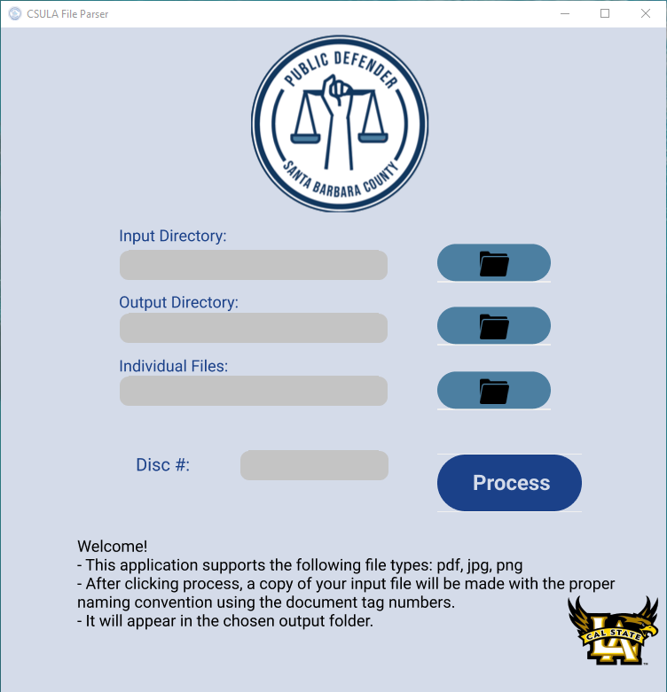

3.2 Hardware Interfaces
Document Tag Parser App
N/A

3.3 Software Interfaces
Document Tag Parser App
DTP uses a Graphical User Interface that is built with the tkinter python library.

3.4 Communications Interfaces
Document Tag Parser App
N/A

4. Requirements Specification
Document Tag Parser App
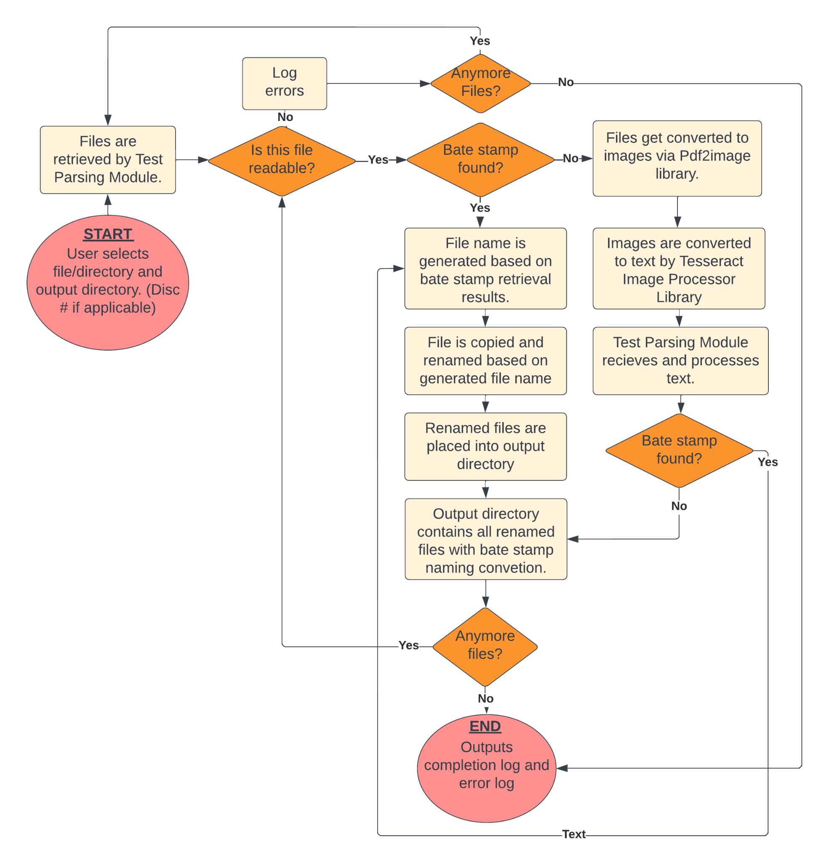
This is an installer program which allows users to parse any pdf and image files with specific requirements set by SBPD. Furthermore, the program will be able to process multiple files at once and give users the flexibility of processing by folder or by files. The program will accept a disc number from the user and locate the starting and ending bate stamps within each file and combine all information to rename and make a copy of the files using SBPD’s naming convention. For better user experience, the program will stay responsive while processing files and a loading bar lets the user know it is processing files. To speed up the process, we utilize multi threads to process files in parallel sessions with four threads running concurrently. At the end, the program will provide a completion log indicating the files that potentially need user attention, and all the original files will remain unchanged.

4.1 Functional Requirements
Document Tag Parser App
1.1:Document Tag Parser(DTP)
4.2-1.1-1 | DTP shall convert pdfs and images into text files for parsing
4.2-1.1-2 | DTP shall read the tag numbers on the first and last page of each document
4.2-1.1-3 | DTP shall rename the file based on the SBPD’S naming convention
4.2-1.1-4 | DTP shall add the disc number based on the user’s choice within the application
4.2-1.1-5 | DTP shall not modify the original file
4.2-1.1-6 | DTP shall create new copies with the appropriate file naming convention
4.2-1.1-7 | DTP shall allow input by files and/or by folder
4.2-1.1-8 | DTP shall display processing messages
4.2-1.1-9 | DTP shall give a completion log indicating files need user attention
4.2-1.1-10 | DTP shall be responsive while processing the files
4.2-1.1-11 | DPT shall optimize processing speed with multithreading
4.2-1.1-12 | DPT shall display loading bar while processing

4.2 External Interface Requirements
Document Tag Parser
- Processing files must be pdf, png, or jpg
- Currently only compatible with windows system computers.

4.3 Logical Database Requirements
N/A

4.4 Design Constraints
Document Tag Parser App
- The program can only pick up 6 digit bate stamp numbers, edge cases with extra symbols next to bate stamp numbers will not work.
- The program has a considerably long processing time with big image files
- When input by folder, sub folders will not be processed.

5. Other Nonfunctional Requirements

5.1 Performance Requirements
Document Tag Parser
- Currently only compatible with windows system computers.
- Large image files can cause longer processing/execution time
- Supports multithreading

5.2 Safety Requirements
N/A

5.3 Security Requirements
N/A

5.4 Software Quality Attributes
Document Tag Parser App
Document Tag Parser is a standalone application that runs after installation. It can be installed as necessary and requires no external resources other than the Python modules listed above. See appendix for more information.

5.5 Business Rules
N/A

6. Legal and Ethical Considerations
N/A

Appendix A: Glossary

- SRS: Software Requirements Specification
- AI/ML: Artificial Intelligence/Machine Learning
- DTP: Document Tag Parser
- SBPD: Santa Barbara Public Defender

Appendix B: Analysis Models
- Refer to flow diagram in Section 4

Appendix C: To Be Determined List
- Document parser app to extract tags from documents and append it to file names

Software Requirements Specification
for
Box.com/eDefender Integration

Version 2.1 approved

Prepared by Joshua Cabrera, Marco De La Torre, Raul Gallegos, Daniel Guevara-Dominguez, Chuang Huang, Dang Le, Jesica Lopez De Leon, Shaocheng Shi, Sergio Tapia, Luke Williams.

Advisor: Jungsoo (Soo) Lim
Santa Barbara Public Defender Office

May 10, 2022

Table of Contents

Revision History 18
1. Introduction 19
1.1 Purpose 19
1.2 Intended Audience and Reading Suggestions 19
1.3 Product Scope 20
1.4 Definitions, Acronyms, and Abbreviations 20
1.5 References 20
2. Overall Description 20
2.1 System Analysis 20
2.2 Product Perspective 20
2.3 Product Functions 21
2.4 User Classes and Characteristics 21
2.2 Operating Environment 21
2.6 Design and Implementation Constraints 21
2.7 User Documentation 21
2.8 Assumptions and Dependencies 21
2.9 Apportioning of Requirements 22
3. External Interface Requirements 22
3.1 User Interfaces 22
3.2 Hardware Interfaces 22
3.3 Software Interfaces 23
3.4 Communications Interfaces 23
4. Requirements Specification 24
4.1 Functional Requirements 25
4.2 External Interface Requirements 26
4.3 Logical Database Requirements 26
4.4 Design Constraints 26
5. Other Nonfunctional Requirements 27
5.1 Performance Requirements 27
5.2 Safety Requirements 27
5.3 Security Requirements 27
5.4 Software Quality Attributes 27
5.5 Business Rules 27
6. Legal and Ethical Considerations 28
Appendix A: Glossary 29
Appendix B: Analysis Models 29
Appendix C: To Be Determined List 29

Revision History
Name | Date | Reason For Changes | Version
Team | 10/7/21 | First Draft | 1.0
Team | 12/7/21 | Update Requirements, Project Scope | 1.1
Team | 5/10/22 | Revised and Final Draft | 2.1

1. Introduction
Box.com/eDefender Integration
The purpose of this Box.com and eDefender integration software is to serve as an intermediary between Box.com and E-Defender in order to provide automatic transcription services and other advanced machine learning functionality.

1.1 Purpose
The purpose of this document is the following:
- Identify the requirements for Box.com and eDefender integration (Version
- Identify the needed software and how it is being used.
- State how the user is meant to interact and use the product.
- How the product will interact with any external service.
- Define and describe concepts that will clarify the functions of the product.

Box.com/eDefender Integration
This Box.com and eDefender integration borrows heavily from previous implementations that provided similar functionality for the City of Los Angeles. This document covers the features that were implemented on behalf of the City of Santa Barbara by California State University, Los Angeles which includes facial recognition, voice transcription, pdf text transcription and tagging, and translation for supported languages.

1.2 Intended Audience and Reading Suggestions
This document is intended for developers, testers, project managers, and users to understand the purpose, function, and requirements of the product. Suggested reading sequence for each is the following:
Box.com/eDefender Integration
- Developers - Understand the purpose and functions of the product to help during development; Recommended Reading: REST + API Documentation.
- Testers - Understand the purpose and requirements of the product to help during testing to guarantee intended function; Recommended Reading: REST + API Documentation
- Users - Understand the purpose of the product and its functions; Recommended Reading: Sections 1 - 5

1.3 Product Scope

Box.com/eDefender Integration
Box.com and E-Defender integration will allow for reduced workloads on lawyers and public defenders by providing transcription services for digital audio and/or video evidence. The transcription will include timestamps for the dialogue as well as faces of parties involved.

1.4 Definitions, Acronyms, and Abbreviations
- See Appendix A: Glossary

1.5 References
Box.com/Edefender integration
- REST+API.doc
- user_manual_box_indexer.pdf
- https://journaltech.com/
- https://box.com
- https://aws.amazon.com/lambda/

2. Overall Description
Box.com/eDefender Integration
Box Skills makes use of third-party AI/ML to get metadata within media files, it is not a product on its own and requires the use of other APIs. Box skills node is a middleware and needs to be hosted on a serverless function.

2.1 System Analysis
Box.com/eDefender Integration
- The goal is to provide automatic transcription services for audio and/or video files through Box.
- File extension support may vary, and errors or debugging is not covered.
- Our design right now is to have AWS Lambda as our serverless function and Azure Video Analyzer to analyze .

2.2 Product Perspective
Box.com/eDefender Integration
Box Skills acts as middleware between third-party AI/ML services and other API technologies. As a result, Box Skills needs to be hosted on a serverless function. Many other solutions exist, including but not limited to, Google and Microsoft transcription services. Prices will differ and Box was chosen by sponsor for their skills technology.

2.3 Product Functions

Box.com/eDefender Integration
- Transcription of audio and/or video files into English, Spanish.
- Facial recognition and indexing, providing timestamps
- Transcription of pdf tag and renaming of pdf files based on tag.

2.4 User Classes and Characteristics
Box.com/eDefender Integration
This software is designed with Public Defenders as the main users/recipients.

2.2 Operating Environment
Box.com/eDefender Integration
This software will operate on serverless technologies and cloud-based networks.

2.6 Design and Implementation Constraints
Box.com/eDefender Integration
There are associated costs for each video being transcribed of $0.0000166667 per GB-s as of December 2021. Additionally, not all languages are as readily transcribable. For languages that are supported, accuracy of transcription services is not guaranteed to be 100% accurate. Access to an internet connection is required for accessing Box and E-Defender.

2.7 User Documentation
Box.com/eDefender Integration
- REST+API.doc
- user_manual_box_indexer.pdf

2.8 Assumptions and Dependencies
Box.com/eDefender Integration
- AWS Lambda retrieves a file from Box and analyzes it before the metadata is sent back to Box from AWS.
- The Box Skill Application will need to be hosted on the Serverless Function AWS Lambda.

2.9 Apportioning of Requirements
Box.com/eDefender Integration
- Transcribing multiple languages
- Sending a notification of completion to desired parties involved after transcription

3. External Interface Requirements
Box.com/eDefender Integration
All aspects of the Box skill will be running and controlled through the cloud and webapps. Once deployed, the Box skill will run automatically once a file is uploaded to Box.

3.1 User Interfaces
Box.com/eDefender Integration
The user must have a Box account given to them by the Santa Barbara County Public Defender Office. With the account, the user may login and upload a video to its respective skill enabled folder. The user will receive an eDefender notification of the action, and now only has to wait for a confirmation of the file being successfully uploaded and transcribed. Once the confirmation is given, the metadata will be displayed on the side as a skill.
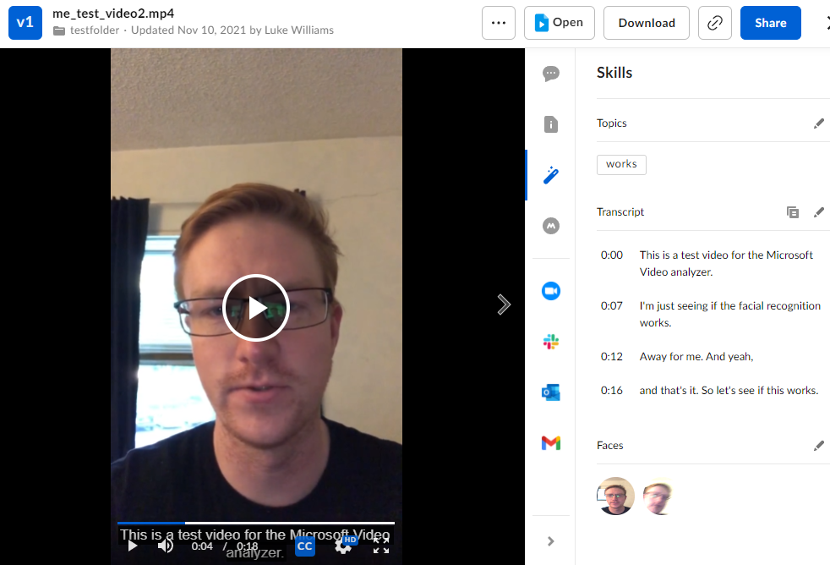

3.2 Hardware Interfaces
Box.com/eDefender Integration
N/A

3.3 Software Interfaces
Box.com/eDefender Integration
N/A

3.4 Communications Interfaces
Box.com/eDefender Integration
Box invokes AWS, which then invokes the lambda function and then finally the rest of the program. For this to happen, these portions of the program will need to be interconnected via security keys, invocation URLs, and access tokens.

4. Requirements Specification
Box.com/eDefender Integration
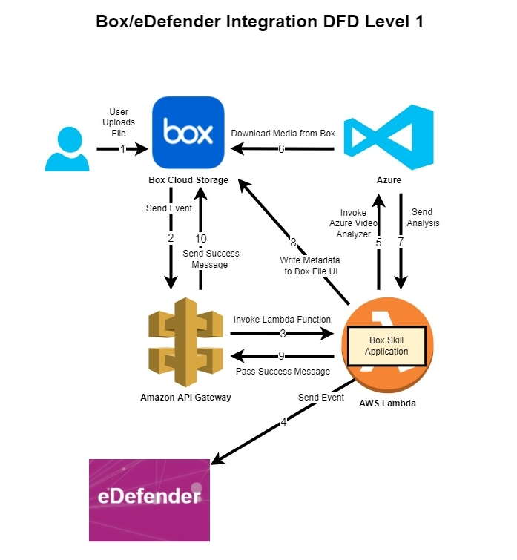
Users should be able to upload video and audio to Box and Box custom skill should trigger upon uploading files. Box skill should send access tokens to serverless hosting sites(AWS), and later pass to ML service(Azure Video Indexer) for file retrieval. ML service should produce metadata including transcription, facial recognition, and topic detection and the hosting site should write that metadata back to the video in Box. A notification should be sent to e-Defender once the video is ready to view with all the metadata embedded to it.

4.1 Functional Requirements
Box.com/e-Defender Integration
1.1:Box
4.2-1.1-1 | Box shall allow users upload and download files
4.2-1.1-2 | Box shall trigger BCS upon file upload to pre-configured folder
4.2-1.1-3 | Box shall send access token to hosting site(AWS)
4.2-1.1-4 | Box shall embed metadata to original video/audio
4.2-1.1-5 | Box shall visualize metadata as transcript, face, and topic card

1.2:AWS
4.2-1.2-1 | AWS shall host the Box skill application
4.2-1.2-2 | AWS shall capture and parse all information of an event send by Box
4.2-1.2-3 | AWS shall send an event to ML service(Azure Video Analyzer)
4.2-1.2-4 | AWS shall send access token to ML service
4.2-1.2-5 | AWS shall receive response from ML service
4.2-1.2-6 | AWS shall retrieve metadata from ML service
4.2-1.2-7 | AWS shall write metadata back to Box

1.3:ML service(AVA)
4.2-1.3-1 | ML service shall listen for AWS call to process video/audio
4.2-1.3-2 | ML service shall use access token to retrieve file from Box
4.2-1.3-3 | ML service shall produce transcription of a file
4.2-1.3-4 | ML service shall perform language auto detection
4.2-1.3-5 | ML service shall recognize faces and keywords
4.2-1.3-6 | ML service shall provide timestamp for analyzed result

4.2 External Interface Requirements
Box.com/eDefender Integration
- Files upload to Box restricted to video or audio only
  - Acceptable video formats: aac, aif, aifc, aiff, amr, au, flac, m4a, mp3, ogg, ra, wav, wma.
  - Acceptable audio format: 3g2, 3gp, avi, m2v, m2ts, m4v, mkv, mov, mp4, mpeg, mpg, ogg, mts, qt, ts, wmv.

4.3 Logical Database Requirements
N/A

4.4 Design Constraints
Box.com/eDefender Integration
- ML services do not provide 100% accurate transcription.
- Inaccuracy increases with multiple languages, voices, and background noises.
- Language auto detection happens when language is not specified, thus increasing inaccuracy and wrong language when generating transcripts.
- Faces recognition not 100% working in picking up faces.
- Topic detection could be irrelevant.

5. Other Nonfunctional Requirements

5.1 Performance Requirements
- Media metadata extraction time should be at least 1:1 with video length.
- Accuracy should be up to standard with current transcription services.
- Media file will be handled box skills enterprise plan uploaded and handled can be up to 150 gb.

5.2 Safety Requirements
N/A

5.3 Security Requirements
Files distributed outside of Box should be deleted after metadata is extracted, as they are often important evidence of ongoing cases.

5.4 Software Quality Attributes
Box Skill Application is flexible and can be hosted in a number of ways. On a server, on serverless functions, or on a cloud server. AI/ML services can also be replaced. This process is simple as it only needs to be directed by AWS Lambda to make its call to a specific AI/ML.

5.5 Business Rules
N/A

6. Legal and Ethical Considerations
N/A

Appendix A: Glossary

- SRS: Software Requirements Specification
- AI/ML: Artificial Intelligence/Machine Learning
- Box: Cloud Storage provider
- Box Skills: A framework used to provide customization for folder/files on Box.
- AWS: Amazon Web Services
- AWS Lambda: A serverless, event-driven compute service
- E-Defender: supplies case management software to courts, prosecutors, public defenders, probation and other justice agencies.
- BCS: Box Custom Skill
- AVA: Azure Video Indexer
- SBPD: Santa Barbara Public Defender

Appendix B: Analysis Models
- Refer to flow diagram in Section 4

Appendix C: To Be Determined List
- Document parser app to extract tags from documents and append it to file names

