Software Requirements Specification

for

Sidewalk Slope Monitoring System

Version 1.1 approved

Prepared by Alexis Pena, Aoqian Wang, Beatriz Ruiz, Jan Bautista, Hua Chen, Abigail Garcia, Ana Guardado, Pabasara Navaratne, Cristina Munteanu

Sponsored by Department of Public Works and Bureau of Engineering LA City.

CSULA Senior Design 2020-2021
Table of Contents
Table of Contents................................................................................................................. pg #2
Revision History................................................................................................................... pg #3
1. Introduction................................................................................................................ pg #4
1.1. Purpose........................................................................................................... pg #4
1.2. Intended Audience and Reading Suggestions................................................ pg #4
1.3. Product Scope................................................................................................ pg #4
1.4. Definitions, Acronyms, and Abbreviations .................................................. pg #4
1.5. References...................................................................................................... pg #4
2. Overall Description.................................................................................................... pg #5
2.1. System Analysis…......................................................................................... pg #5
2.2. Product Perspective........................................................................................... pg #5
2.3. Product Functions........................................................................................... pg #6
2.4. User Classes and Characteristics.................................................................... pg #6
2.5. Operating Environment.................................................................................. pg #6
2.6. Design and Implementation Constraints........................................................ pg #6
2.7. Assumptions and Dependencies.................................................................... pg #7
2.8. Apportioning of Requirements...................................................................... pg #7
3. External Interface Requirements............................................................................... pg #8
3.1. User Interfaces............................................................................................... pg #8
3.2. Hardware Interfaces....................................................................................... pg #8
3.3. Software Interfaces........................................................................................ pg #8
3.4. Communications Interfaces........................................................................... pg #8
4. Requirements Specification....................................................................................... pg #9
4.1. Functional Requirements............................................................................... pg #10
4.2. External Interface Requirements................................................................... pg #10
4.3. Logical Database Requirements.................................................................... pg #11
4.4. Design Constraints......................................................................................... pg #11
5. Other Nonfunctional Requirements........................................................................... pg #11
5.1. Performance Requirements............................................................................ pg #11
5.2. Safety Requirements...................................................................................... pg #11
5.3. Security Requirements................................................................................... pg #12
5.4. Software Quality Attributes........................................................................... pg #12
5.5. Business Rules............................................................................................... pg #13
6. Legal and Ethical Considerations.….......................................................................... pg #14
Appendix A: Glossary........................................................................................................ pg #15
Appendix B: Analysis Models........................................................................................... pg #16
Appendix C: To Be Determined List................................................................................. pg #17

Revision History
Name | Date | Reason for Changes | Version
Cristina Munteanu /Beatriz Task 3 | 12/04/2020 | Initial Draft for presentation | 1.0
Task 2 Team | 12/6/2020 | Adding task 2 perspective to draft | 1.0
Task 4 Alex/Abigail | 12/8/2020 | Adding Task 4 Perspective | 1.0
Task 1 Team | 12/11/2020 | Added Task 1 perspective | 1.0

1. Introduction
The Sidewalk Slope Monitoring System project is an effort to develop the necessary databases, user interfaces, and automation scripts to aid the City of Los Angeles, Bureau of Engineering (BOE) in maintaining over 11,000 miles of sidewalk. Based on their prioritization and scoring system, BOE can assign a numerical score to each sidewalk segment to determine which segments require immediate attention or repair for their Sidewalk Repair Program.

The system developed by our team is designed to help BOE in their data collection by building a robot user interface to control the robot BOE uses during their field analysis, image processing scripts to extract image information, a web application to display and map image data, and a database to hold the data collected and extracted by the system.

1.1 Purpose
The document will define all software and hardware requirements for the rover. It will also cover all the modules and their purposes. The modules and their functionalities will be described in this document.
1.2 Intended Audience and Reading Suggestions
The intended audience of this document is for the developers of this project, City of Los Angeles Bureau of Engineering and members of the sidewalk repair team. Reading this document will give a better understanding of how to operate the rover and its data collection.
1.3 Product Scope
The rover will provide a simple approach for the field user(s) when assessing sidewalks. The rover will collect data longitudinal and latitudinal slope data as well as capture images of the sidewalk.
The data will be transferred to an application that will give a visual representation of the findings. This will allow the user to collect a list of sidewalks that needs repairing.
A library of scripts will be developed to create files and layers of data that will be used alongside the Bureau of Engineering’s mapping application, NavigateLA. The scripts will obtain data from the database and automatically generate mapping files. These mapping files will be hosted on NavigateLA as a layer of sidewalk data for the Bureau of Engineering to view.
1.4 Definitions, Acronyms, and Abbreviations
For the purposes of this project, the following terms are defined as follows:

Rover | Device with wheels that will display the GUI software.
IMU | Inertial Measurement Unit
DB | Database
NavLA | Navigate Los Angeles (Site)
BOE | Bureau of Engineering
GUI | Graphical User Interface

1.5 References
Python Documentation - https://docs.python.org/3/
This document was used to comprehensively understand Python Tk language. The bulk of the code will be written in Python Tk therefore this will provide tutorials on how the environment is set up.

Leo Rover Documentation - https://www.leorover.tech/the-rover
This document was used to comprehend and understand the Leo rover software and hardware.

Python Tutorials - https://opencv-python-tutroals.readthedocs.io/en/latest/py_tutorials/py_tutorials.html
OpenCV - Python Tutorials were used to familiarize with the OpenCV library. OpenCV library is used for the Image Processing portion of the project.

Azure Documentation https://docs.microsoft.com/en-us/azure/azure-sql/
Microsoft documentation used as reference when learning Azure SQL database.

AutoCAD Forums: https://forums.autodesk.com/
AutoCAD Documentation: https://knowledge.autodesk.com/
AutoCAD documentation used to explore how other users utilize AutoCAD’s command language, learn about possible use cases, and apply best practices to our automation scripts.

Django Documentation: https://docs.djangoproject.com/en/3.1/
Mozilla’s Django Documentation: https://developer.mozilla.org/en-US/docs/Learn/Server-side/Django
Django and Mozilla’s Django documentation were used to set-up a testing environment. The documentation was also used to understand how to get started developing the frontend and backend, as Django uses Python and templates for the backend.

2. Overall Description
The rover will provide a faster approach for the user(s) when they go out to assess sidewalks. As the user controls the rover down a block, it will collect data about the longitudinal and latitudinal slope as well as capture images of the sidewalk.

This data will later be saved in the Azure SQL database where it can be accessed on our website which will have a visual representation of our findings. Collecting the data will allow the user to run analytics and determine the severity of each sidewalk--providing a list of which sidewalks have priority when it comes to fixing them.

2.1 System Analysis
The system is designed to solve the manual collection of data by providing field workers with a semi-automated rover to assist in collecting sidewalk data. The goal is to provide field workers with simple yet effective designs for the user interface that will assist in collecting and exporting sidewalk data.
Furthermore, the software will provide functionality to process the images of sidewalks rendered by the rover camera. This functionality will allow users to distinguish the horizontal and vertical (X and Y) displacement of the sidewalk.

2.2 Product Perspective
The Leo Rover will serve to replace manual methods of collecting sidewalk assessment information. It will reduce the level of training the user will need in order to gather data from the sidewalk. The rover’s ability to take images and associate them to a specific location will help the user(s) to correlate a specific location to a visual representation.

2.3 Product Functions
Raspberry PI 3 and Rover
- Initialize GPS
- Display rover controls
- Output data collected results to CSV file
- Collect photographs using a GoPro Fusion
- Rover will traverse sidewalk

Graph/Front-end
- Read data from CSV file and produce graph
- Display pictures taken and associate them to specific readings on graph

Image Processing
- Read/write image data
- Allow user input functionality to draw on images
- Calculate xy displacement
Database
- Store Rover Data (Latitude, Longitude, slope, GPS)
- Store Image files (GoPro Fusion)
- Store data pulled from NavigateLA

Web application and mapping files
- A web application will display the collected images, one at a time, with its related EXIF and image processing data.
- In addition, Task 1 will develop scripts to create mapping files that can be hosted on BOE’s mapping application, NavigateLA.

2.4 User Classes and Characteristics
2.4.1 Operator: refers to any user who will physically operate the rover and will collect the data.
2.4.2 Administrator: refers to any user who will have direct access to the system to modify or change functions of the system. As well as access, input, remove, and my changes to the database.

2.5 Operating Environment
The Raspberry Pi 3 operates in the open-source ecosystem runs on Linux, and its main supported operating system, Raspbian is open source and runs a suite of open-source software. The application that will be responsible for visualizing the data will most likely be on a web application. For testing purposes, we will be running this application locally on our computers (MacBook laptop/ iPad and Windows laptop /tablet). The azure database can be reached using Windows, Mac, and Linux.

2.6 Design and Implementation Constraints
Possible constraints:
● Accuracy of rover controls
● Accurately calculating the cross slope of the sidewalk
● Analyzing various types of surfaces
● Supplying enough power for all components
● Rover should be operated by someone with minimal training.
● Measuring the vertical displacement
● Accuracy of correlating data from Rover and NavLA (Mainly GPS Coordinates)
● Limited to 1 terabyte of accessible database storage

  - Web application
    - Web application can use a local instance for development and testing purposes.
    - Web application must have access to the database containing sidewalk data.
    - Web application must use database when displaying sidewalk data and cannot store or use data locally.
    - Web application must use a BOE web server for production.
    - Web application must be accessible to BOE, either using Internet or Intranet access.
    - Web application must be accessible to BOE regardless of their preferred browser.
    - BOE must provision a web server for web application production use.
    - BOE must maintain the web server hosting the web application.
    - Web application backend will be done using Python.
    - Web application frontend will be done using HTML/CSS and Bootstrap.
  - Mapping files
    - 3rd party application must have a command language to develop automation scripts.
    - Mapping files must be generated by scripts using the 3rd party application’s command language.
    - Mapping files must be importable in NavigateLA, if and only if, mapping files will not be hosted on a database managed by BOE.
    - Mapping files must maintain all design features, such as color schemes, annotations, polygons, lines, shapes, when hosted in NavigateLA.
    - Mapping files must be hosted on NavigateLA when a substantial amount of mapping files is available for viewing.
    - A request for a database to host the mapping files can only be placed after discussing and receiving approval from advisor and BOE.
2.7 Assumptions and Dependencies
● Assumptions:
o Cracks and holes on sidewalk shall be minimal.
o Battery 4hrs of nominal driving or 8hrs of video streaming.
o Hardware is reliable.
o User will protect hardware from damage.
o System is waterproof.
o Operator will clear sidewalk before measurement.
o System will be used during the day to take optimal photos.
o Sidewalk will always be captured as the center of the image
o Rendered images requires user-input before processing measurements
o User will manually input location data fields after every use.
o User will use GoPro Provided app to render 360 Degree Images
o User will manually input data into Azure DB

- Web application and mapping files
  - Web application
    - Web application will be used to view specific or individual sidewalk segment images.
    - Web application will be used to view damage and assign numerical score to sidewalk segment.
  - Mapping files
    - Mapping files will be viewed by user by importing them to NavigateLA, if and only if, mapping files are not hosted on NavigateLA.
    - Mapping files will contain data for many sidewalk segments.
    - Mapping files will be viewed by user by selecting a layer hosted on NavigateLA, if and only if, mapping files are kept on a database managed by BOE.

2.8 Apportioning of Requirements
Machine Learning and Image Classification will be implemented in future versions of the project because image collections and storage are required to train and test image data. Image collection and storage are currently not available, as the project is in its beginning stages. The rover that is used to render images has not been set up for image rendering. Once the camera starts rendering images, they will be stored and trained under an image classification model. The software will ultimately be able to classify images according to the sidewalks condition.
Regarding the data storage side of things, the azure blob storage will be implemented in the future, once the BOE allocates the necessary space for it. The automation of data entries and image rendering will be delayed until we have the capability to pull and read from the azure blob storage.

3. External Interface Requirements

3.1 User Interfaces
The system will use a web application that receives the slope data and photos recorded by the rover, The web application will have a graphical interface to visualize the system’s Time stamps(in seconds) and slope data will be the labels for the X and Y axis.
3.1.1 Web application
The web interface will receive image data from Leo Rover’s camera to be transferred to the website. BOE uses an Azure database for their backend, which we will integrate into our web application.
Our web application will include a page to display our data. The data to be displayed includes images received from the rover, longitude and longitude slope data, Global Positioning System (GPS) data as well as the image name and date when what image was taken. The web application will have the ability to iterate through the image with a previous button, next button, and an auto button. The auto button will literate through the images automatically, with each image showing for 2 seconds. The user will be able to pan the image and zoom in and out of the image. The web application will have a function to search through the database of pictures by the images name or coordinate which the image was taken from.
The web application will have additional pages which will describe the purpose of our project, the overall description, the environment where our project was worked on, and the algorithms used in this project.

3.2 Hardware Interfaces
The web interface will receive image data from Leo Rover’s camera to be transferred to the website. The Leo recovery is equipped with a fisheye lens with a 170-degree view. The images the rover capture will transfer to our database side.
Power input to power the sensor board and Raspberry Pi 70 / 3000mA current consumption, depends on external modules standard 5.5/2.1 mm DC plug (center-positive)
I/O ports 3.3V/5V tolerant GPIOs series resistance is 330Ω, 2.4 GHz Wi-Fi modem, 12V battery.

3.3 Software Interfaces
Our customer, the city of Los Angeles, uses an Azure database for their backend, which we will integrate into our web application. Our web application will include a page to display our data. The data to be displayed includes images received from the rover, longitude and longitude slope data, Global Positioning System (GPS) data as well as the image name and date when what image was taken. The web application will have the ability to iterate through the image with a previous button, next button and an auto button. The auto button will literate through the image’s automation with each image showing for 2 seconds. The user will be able to pan the image and zoom in and out of the image. The web application will have a function to search through the database of pictures by the images name or coordinate which the image was taken from. The web application will have additional pages which will describe the purpose of our project, the overall description, the environment where our project was worked on and the algorithms used in this project.
The software products we will be using include:
- Python
- HTML/CSS
- Azure Database
- AutoCAD

3.4 Communications Interfaces
One of our user interfaces is a web application which will use HTTP to communicate between our web application pages. The web application also redirects the user to https://navigatela.lacity.org/navigatela/.

4. Requirements Specification

4.1 Functional Requirements
4.1.1. User Control (UC):
● The system shall initialize GPS
● The system shall capture a photo using the attached camera Go Pro module.
● The system shall display the data captured in CSV file.
● The system shall control desired speed.
● The system shall move forward backward left and right.

4.1.2. Data Transfer Control (DTC)
● The system shall store the data in MicroSD card.

4.1.5 Traversal
● The rover max linear speed ca. 0.4 m/s
● Estimated maximum obstacle size: 70 mm
4.1.6. Image Processing (IP):
● The system shall calculate xy displacement.
● The system shall read/write image data.
● The user shall draw on images as input for image segmentation.

4.2 External Interface Requirements
Raspberry Pi 3
The Raspberry Pi 3 will operate as the main module of the system. The Raspberry Pi will receive the data from the digital level, and Camera to perform the calculation and/or store this data into the Raspberry Pi’s MicroSD card. The system’s data will be transferred manually from MicroSD card to a database.

The digital level, accelerometer data (imu/accel topic) represents linear acceleration along the sensor's axes.
This module will capture the raw data of the sidewalk’s measurements. The data obtained is the values of the three-axis acceleration sensor(m/s^2) and three-axis gyroscope(°/s). Using this data, the Raspberry Pi 3 performs the slope calculations, and the data will be saved into the microSD 00+card as a CSV file.

4.3 Logical Database Requirements
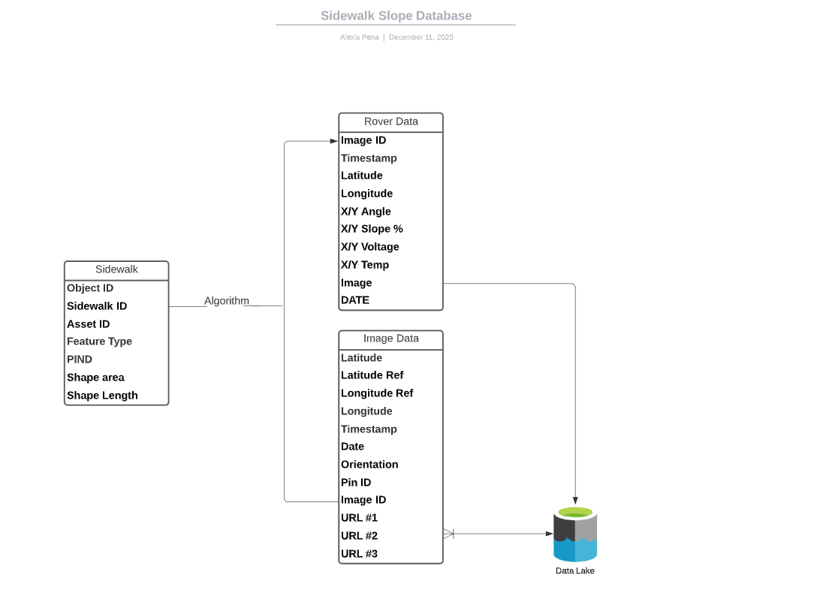

Data which is currently being stored in the Azure DB is coming from three sources. NavigateLA offers map data which provides asset and pin ID’s which help us ID property lines. The majority of the data comes from the rover which provides the data it analyzes from the sidewalks it scans. Lastly, the GoPro not only provides images but a complete table of EXIF Data which we extract using a python code.

The rover data is our main source of information. It mainly consists of numeric data which the rover creates by calculating the sidewalk's slope. This data includes GPS coordinates, slope percentages, accelerometer reads, date, angle, and a Pin ID used to associate the data to a certain property. This will be the information that will be constantly displayed and used to calculate whether a sidewalk is in need of repair. This data will also be used to piece together the Navigate LA and GoPro tables. The Pin ID will be used to link the Rover table to the NavLA table, and a unique ID will be used to link the images from the GoPro to its corresponding data on the rover. At the moment, all data will be retained until the DB is full--steps to prevent hitting the DB cap are in the works. All data added to the Azure DB is currently being imputed manually after each rover session.

4.4 Design Constraints
- The Rover processing equipment is dependent on battery use.
- Maximum linear speed: ca. 0.4m/s
- Maximum angular speed: ca 60deg/s
- Wheel diameter: 130 mm
- Tire material: rubber with foam insert (non - pneumatic)
- Database and Web server

5. Other Nonfunctional Requirements
5.1 Performance Requirements
- The camera shall be able to take photos on at least a one second interval
- The digital level shall be able to collect data on at least a one second interval
- The estimated maximum obstacle size is 70 mm while running circa 4 hrs of nominal driving.
- Connection range: Up to 100m (with live video stream)
- Azure database is limited to three types of users: Admin (Full Access), Regular user (Read/Write), guest (Read Only)
- The system shall be charged on a standard outlet
- The system shall run on a rechargeable battery
- The system shall be calibrated before use.

5.2 Safety Requirements
There is no concern for possible loss, damage, or harm that could result from using the system.
5.3 Security Requirements
The system shall only be developed and accessed by CSULA and BoE teams.
The system shall only take pictures of the sidewalks.

5.4 Software Quality Attributes
Python scripts in the system shall follow the PEP 8 standard.

5.5 Business Rules
Only staff assigned by the City of Los Angeles Bureau of Engineering shall operate and access the robot, web interface, and database system.

6. Legal and Ethical Considerations
Our project is focused on redesigning the robot, web interface, and database system that will be used by the City of Los Angeles Bureau of Engineering. Our redesigned robot, web interface, and database system will assist in collecting and displaying sidewalk slope monitoring data in order to help the City of Los Angeles to get their sidewalks to reach American’s with Disabilities Act Compliance standards. To fulfill the new design of the project we had a couple of items we had to take into consideration such as privacy and public safety concerns.
Since our project is sponsored by the City of Los Angeles Bureau of Engineering, which is a part of a government agency we must take into consideration the privacy of their data. This means that any data that we will be collecting and storing using the robot, web interface and database systems we have designed must be kept secure and private. Some of the information such as the GPS coordinates and photos taken by the rover is a privacy concern. Some examples of GPS coordinate data and photos that could be a privacy threat are those of private or residential locations and if not protected could lead to personal data being stolen or disclosed. We also had to take into consideration the privacy and security of our database system in order to keep all data safe. Our solution to combat this issue is that we are currently working with the BOE team to research the best database security structure.
Furthermore, since our developed software for the City of Los Angeles focuses on fixing sidewalks that do not meet ADA compliance, we must take into consideration the legal and ethical implications of public safety when it comes to the rover. We have to take necessary precautions to ensure that our rover user interface is efficiently designed so that rover movements will be precise. We took this into consideration since a malfunction of the rover can cause physical harm to the field worker operating the rover or to any pedestrian that is on the street. To combat this issue our user interface has ensured that all buttons are big enough so that there are no discrepancies in controlling the rover and we will conduct extensive testing once the rover has been completely built.
In conclusion, when developing our software, we took into consideration the privacy and public safety concerns that surround our project. We took into account that privacy is crucial for the City of Los Angeles Bureau of Engineering and we are currently collaborating with BOE to choose the most secure platform. Also, since data collection will be done by field workers who will be navigating the rover, we made sure to make our interfaces as simple to navigate as to prevent any accidents from causing bodily harm to any pedestrians or field workers. Our software will be compliant with all legal and ethical standards to ensure the success of the project.

Appendix A: Glossary
BOE | City of Los Angeles, Bureau of Engineering
SDD | Software Design Document
SRS | Software Requirements Specification
Rover | Device with wheels that will display the GUI software.
IMU | Inertial Measurement Unit
DB | Database
NavLA | NavigateLA (Site)
EXIF | Exchangeable Image File
IDE | Integrated Development Environment
GUI | Graphical User Interface

Appendix B: Analysis Models

Azure SQL database Data Schema

Appendix C: To Be Determined List
Not Applicable.

