Senior Design Final Report

City Pave

Version 1.0 – 5/14/2021

Team Members
Allen Atienza
Bryan Chu
Christian Esqueda
Adrian Flores
Andrew Gonzalez
Omar Juarez
Mark Kalaiji
Justin Nim
Christopher Ortega
Kayleen Ponce
Liaison
Dr. Mehran Mazari
Advisor
Dr. Negin Forouzesh

Table of Contents
Table of Contents 2
Introduction 3
Background 3
Design Principles 4
Design Benefits 4
Achievements 4
Related Works and Technologies 4
2.1 Existing Solutions 4
2.2 Reused Products 4
System Architecture 5
3.1 Overview 5
3.2 Data Flow 5
3.3 Implementation 6
3.3.1 User Interface 6
3.3.2 Database Design 7
Results and Conclusions 7
4.1 Results 7
4.2 Future 7
References 7

Introduction

Background
This project is sponsored by the Civil Engineering Department at CSULA. Civil Engineering is a field that is responsible for much if not all of the construction in our world. So naturally, aiding them in their work can be a huge improvement to productivity and efficiency. We set out to design a pavement construction/design website for them. Pavement is everywhere, whether it be streets, roads, highways, etc. and construction/design of it is a lengthy process. Most notably, the process requires a lot of math and equations. Our website simplifies this by having the user/civil engineer just plug in values and the website does all the heavy lifting for them. The motivation for us when building this website is the fact that by simplifying the civil engineer’s workload, it will lead to better results in their production of pavement. Less time spent stressing over calculations or making accidental mistakes from human error will be a huge benefit. Our website is unique in that there are many places that can do these equations online for you, but none have them all in one like ours, while also having a good user interface and being easy to use as well. Below are the contributions for each team member:

Allen Atienza: Back-End
Bryan Chu: Front-End
Christian Esqueda: Back-End
Adrian Flores: Front-End
Andrew Gonzalez: Front-End
Omar Juarez: Back-End
Mark Kalaiji: Customer Liaison
Justin Nim: QA & Documentation Lead
Christopher Ortega: Back-End
Kayleen Ponce: Project Lead

Our project lead is responsible for overseeing the entire team and giving us directions where seen fit. The customer liaison is in charge of working with both the back-end and front-end teams and providing feedback on their work as well as jumping in and editing things as they see fit. The QA & Documentation lead is responsible for all the documentation that our project requires. Back-end works behind the scenes of the website with things like databases for all our user logins as well as making sure all the equations work. Front-end is responsible for the user experience of the website and making sure it is clean and easy to navigate for the user. As stated earlier, our website is unique in that there are many places that can do these equations online for you, but none have them all in one like ours while also having a good user interface and being easy to use as well. Some key design principles in our website include many user friendly decisions. One example of this is a tool-tip section in each user input form. Tool-tips help the user decide what to put in the form if they are unsure of what to put for that section or the format for how the data should be entered. The main benefit of this is that it inevitably helps the user have a pleasant experience when navigating the website and making it easier to enter data. The experiment/testing results are displayed in a very clean fashion at the end of each pavement scenario form giving the user all the data requested.

Design Principles
Our goal with our web application was simplicity and ease of use. We focused on designing our app to be used as a tool instead of just a luxury, thus our application gives the user access to complex formulas without the need for manually implementing them. We focused on creating an application that was intuitive in order to alleviate any potential difficulties which may arise from learning new software. We implemented tool tips, built-in calculators and intentional design styling to help the user. The web application should serve as both a tool in its current state and as a template for future implementation and development, and with this in mind, we designed our application with the frameworks Express, Node.js and Vue. Through the use of these frameworks, we designed our UI and backend to be scalable by any future development team.

Design Benefits
We designed our web application with the understanding that this would be a long-term project, and our deliverable would become a template for future development by another team of engineers. With this being considered, our team ensured the future implementation and use of our project by using proper programming strategies, frameworks and design principles. Our web applications ease of use allows users to easily navigate the site, which is stored on Heroku. Our web applications core framework has been implemented, our models are set, any further implementation would only build upon the foundation we have laid and create more tools and interactive features for the user, thereby increasing navigation and ease of use.

Achievements
During our academic year, our team has been able to create a full stack web application that provides a user with calculation for pavement design. Our web application is currently built using a Front-End and a Back-End. Our Front-End is built with Javascript, more specifically with Node.js, Vue.js and Buefy. Our Back-End is built with MySQL. All these frameworks allow us to build City Pave from the ground up.

Related Works and Technologies

2.1 Existing Solutions
From the start of this project our Liaison always mentioned a website called PavXpress as our reference point when starting this project from the beginning. The problem with this website is that it has horrible outdated UI/UX components and is generally very buggy when navigating through the website. City Pave solves all these problems and adds even more to the table.

2.2 Reused Products
No products were reused in the construction of this website. Only basic frameworks like Javascript and SQL were used.

System Architecture

3.1 Overview
The architecture for our project is separated into three important parts: Client(user), Server (Process Input) and the Result (Display for User)
Here is a diagram (DFD level 0) that shows how this architecture works at a high level:

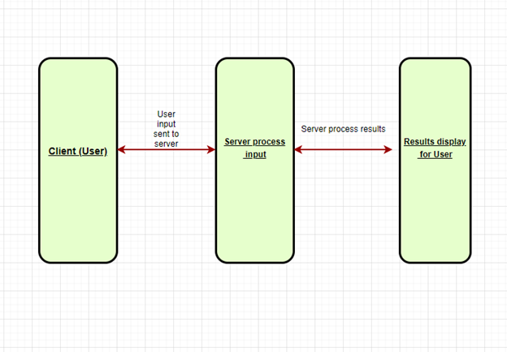
- Client (User): This aspect of the project is extremely important because it gives the user input and collects the data to send it to the Server.
- Server (Process Input): This aspect is important because this is where the input given by a user is processed.
- Result (Display for User): This aspect is important because this is where the server takes what it has processed and displays it for the user to see.

3.2 Data Flow
Here is an overview of our project based on a Model-view-controller pattern. The reason is that our group focused on making different models, views and controllers for different parts of our program. The reason we chose this is because this model works well with web application and since we are creating a web application we believed that this was a perfect fit for us. The programs we used were node.js, sequelize, html, css, javascript, and heroku for web hosting. The diagram belows shows our simple version architectural design.
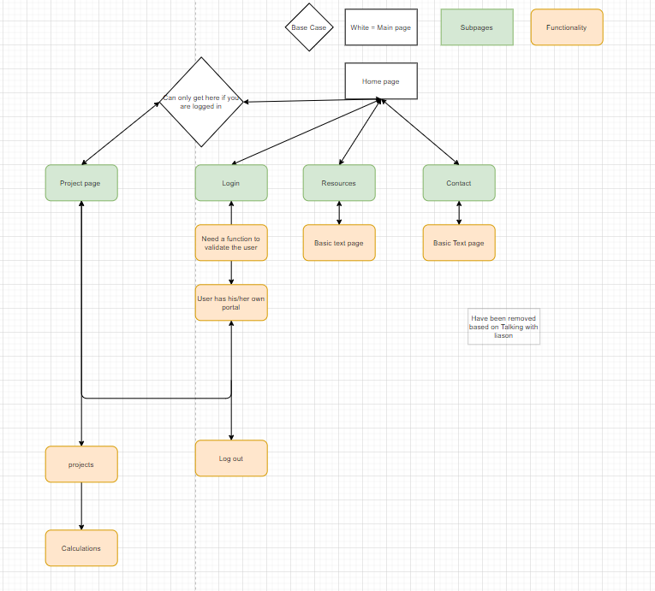

3.3 Implementation
The project was split up into two sections to allow more efficient development: User Interface, Database Design.

3.3.1 User Interface
The User interface revolves around the use of the navbar to navigate the site and the various important pages it offers. The navbar itself presents few logical processes that need to occur in order to access elements of the UI. These logical processes are the use of the login functionality, which is presented on both the homepage and it’s own dedicated page. Logging in then allows the user to look at the projects that have been created by the account they logged into, and of course to log out (all of which are presented on the navbar). If the user hasn’t logged in the option to register is also on the Navbar.
The projects page then allows users to select any of the variety of projects they have created to modify them, delete them, or even create new ones. The projects are presented in the form of cards. Clicking on them will take them to the forms which to fill out. Each one of these forms has fields for the user to fill out, which can be traversed with the tabs seen at the top. There are a multitude of restrictions imposed on this area of the UI as some of the fields have ranges that they can accept, and selecting different options for certain fields will also change the tabs that they can access and must fill out.

3.3.2 Database Design
MySQL was used for this project largely due to the relational structure between the users who will use the website and the project tables that will be saved under their accounts.
The object-relational mapper Sequelize was used as well to provide the code to build the tables using JavaScript conventional syntax without the need to write SQL style coding to minimize potential bugs. Sequelize was very useful in creating the “models” for which the tables represent such as “users” or “projects”.
Controllers were used to help create the tuples in the tables when users interact with the CityPave application. When the users fill out the forms and create a new account or start a new project, the website collects the information and stores them in the appropriate tables.

Results and Conclusions

4.1 Results

We have created CityPave, an easy to use website for individuals who require the need to complete pavement designs. CityPave offers plug and play fields which calculates information for the individuals in an easy to use manner by allowing only the necessary values they need to insert while the actual calculations are handled in the background out of the user's sight and mind. Aside from the calculations CityPave provides the ability to create, edit, delete, and save projects and allows for easy accessibility to the projects through the user's created account.

4.2 Future
Although the name CityPave and the overall design and implementation of the website are new, the calculations and ideas behind the website are not. The predecessor to CityPave, PaveXpress has been around for some time. However, as stated by the liaison CityPave was built out and launched much faster than PaveXpress which took 4 years to complete. We also believe CityPave to have a much easier and simpler user interface while offering all of that which it’s predecessor offers. CityPave can continue to be used far into the future. The calculations implemented are standardized and proven to be accurate and effective. There is still much to do and we as a group are happy to know that our project will be fully completed by the following senior design group at California State University, Los Angeles.
Below we have some suggested improvements for the next year’s team to work on:
- Continue finishing the calculations portion of the pavement design types
- Finishing the Analyze Pavement Structure and touch up on the Determine Pavement Structure sections
- Ask the user for the address/location of where the project will take place and insert a map image within the project element for better visual appearance

References

Name of Reference | Reasons for Using
Jungsoo Soo Lim Smart Pavement Project program | For Smart Pavement Project(used to create formula for calculations)
Vue.js | Creating the front end of the website
MySQL | Database for the website
Heroku | The web service provider for host our website and database
CSULA style guide lines | Used to design correctly colored theme

