Location Based Intelligent Forwarding Strategy
(NDNWiFi)
CS4962 Senior Design

Project Report

Faculty Advisor(s):
Zilong Ye

Team Leader:
Antonio Garcia

Team Member(s):
Michael Oceguera
Saba Mahbub
Kevin Tong
Hieu Tran

May 11th, 2018

CALIFORNIA STATE UNIVERSITY
LOS ANGELES

Los Angeles, California

Table of Content

Section 1: Introduction
Section 2: Related Works and Technologies
Section 3: System Architecture
Section 4: Results and Conclusion

1.0 Introduction

Architecture and Signal Work flow
NDNWiFi consists of four main functional components, which are Consumer, NDN router, Relay and Internet. Consumer sends Interests to obtain certain data content from Internet that serves as the Producer. NDN Router is a key infrastructure in NDNWiFi and it runs extended NDN protocol that caches not only returned Data but also unsatisfied Interests. It is also responsible for maintaining a list of NDNWiFi users in the local range. Given these NDN routers locate in different places, relay serves as a fine-grained “data mule” to carry data and provide intermittent links between NDN routers. The signaling workflow lies in the connection between (1) Consumer and ICN router, (2) ICN router and Relay and (3) ICN router and Producer, which is shown in Fig. 1.1.
Consumer and NDN router workflow: As shown in Fig. 1.1, the Consumer initiates the communication by sending an Interest to the closest NDN router nearby. If the requested Data can be satisfied in the NDN router’s Content Store (CS), it will be returned to the Consumer directly; otherwise, the NDN router will cache the Interest by either aggregating the Interest with previous identical Interests in the Pending Interest Table (PIT) or creating a new entry for the given Interest in the PIT. For all the pending Interests in PIT, they will be broadcasted to nearby relay users. If the nearby relay users can satisfy the Interest, the requested Data will be returned to the NDN router and then be forwarded back to the Consumer; otherwise, the NDN router will cache the Interest and re-broadcast it after a time setting and the relay user will also cache the Interest and forward it to the next NDN router that it encounters. Compared to the existing NDN, rather than dropping the unsatisfied Interests, NDNWiFi allows both the NDN router and relay users to cache the Interests until it encounters someone that can provide the requested Data. Such a design can improve the chance of data delivery under the unreliable and intermittent wireless signal in the challenged communication environment as in national parks.
NDN router and Relay workflow: As shown there are three main signaling workflows between NDN router and relay users. First, the NDN Router periodically broadcasts a Hello message to its neighboring users in order to maintain a list of nearby users in its local range. Secondly, the NDN router broadcasts all the pending Interests in its PIT to the nearby users, and the nearby users may return the requested Data if they can find a match in their local CS or they will cache the Interests and forward them to the next NDN routers upon receiving the Notification message (to be introduced next). Thirdly, the NDN router issues a Notification message to the nearby relay users to fetch all the pending Interests carried/relayed by them. If the NDN router can satisfy any of those Interests, it will return the requested Data to the relay users and the relay users can thus carry the Data and disseminate it in the network.
NDN router and Producer: There are some NDN routers or NDNWiFi smart phone users that comes from the entrance of the national park, which can access the Internet via the roadside network infrastructure. If the outside world uses NDN protocol, then the Interests will be sent out directly; otherwise, if the outside world uses IP protocol, a Gateway is needed to convert NDN messages to the IP messages before sending out to the Internet.
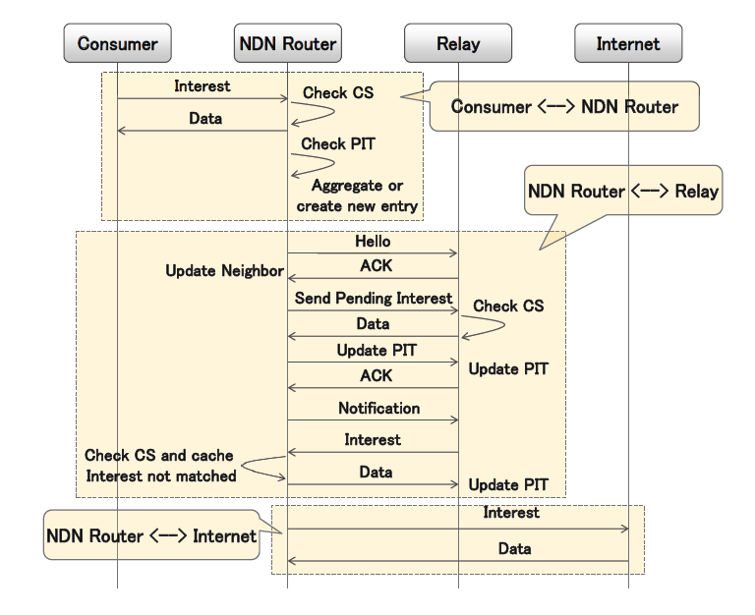
Fig. 1.1: NDNWiFi Signal Workflow

Software Architecture
NDNWiFi consists of several software modules, and the architecture is shown in Fig. 1.2. Among these modules, there are input and output sockets that enables wireless communications (e.g., send/receive Interest/Data/Notification) between NDN routers and smart phone users. When NDN routers or smart phone users receive an given Interest, they will first check their local content store to check if they can return the requested Data. If the given Interest cannot be satisfied, it will be cached and wait for the timer to expire to trigger another round of Interest dissemination, rather than simply being dropped as the existing NDN does. In addition, the NDN router can leverage the Discovery module to maintain and interact with a number of nearby smart phone users. Furthermore, a hit count map is developed to work with the forwarding information base to enable an intelligent forwarding strategy, which makes the forwarding decision based on historical hit rate on each interface.

Input Socket
NDNWiFi
Orchestrator
Content Store
Pending Interest
Table
Forwarding
Information Base
Discovery
Hit Count Map
Timer
Output Socket
Fig. 1.2. Software Architecture of NDNWiFi

2.0 Related works and Technologies
In NDNWiFi, the NDN router plays an important role in conveying Interest and Data between the Consumer, Producer and Relay. Hence, it is critical to design an effective forwarding strategy that can minimize the network resources (e.g., bandwidth) consumption and the file transmission latency (e.g., file download time). In order to achieve this objective, we propose the following three forwarding strategies, which are first-fit, flooding and hit-aware-multicast. The detailed description of the three forwarding strategies is presented in the rest of this section.

First-fit
A simple yet efficient forwarding strategy is the first-fit approach, which works as follows. Step 1:
When a Consumer requests a content (e.g., the image map of a national park) from Internet, he/she can send the Interest to the nearby NDN router. Once the NDN router receives an Interest, it will first check its local content store. If the Interest can be satisfied in the local content store, the NDN router will return the requested Data to the Consumer immediately; otherwise, the Interest will be cached in the NDN router’s pending interest table. Step 2: the NDN router attempts to obtain the requested Data from a list of registered user in its local range, through sending Interest to each of the interfaces/links one-by-one. Such a process is iteratively performed until the NDN router finds the first registered user that can return the requested Data. Then, the NDN router can return the requested Data to the corresponding Consumer(s) and clear the record(s) in the pending interest table. Step 3: if none of the nearby registered users has the requested Data, the NDN router continues to cache the Interest in its pending interest table rather than dropping the Interest. This is a unique extension of the existing NDN protocol in our NDNWiFi prototype, which considers the characteristics of intermittent and unreliable wireless communication in outdoor areas such as national park. It is worth noting that the frequency of resending the Interest and the number of re-try should be tuned depending on the application’s requirement and the real-world network conditions in a case by case manner.

Flooding
In NDNWiFi, we also develop a second forwarding strategy namely flooding. Flooding has the same procedures of Step 1 and Step 3 as in first-fit. However, in Step 2, if an Interest cannot be satisfied in the NDN router’s local content store, the Interest will first be cached in the pending interest table and then be flooded to all the remaining available interfaces/links (except the one that connects to the Consumer), rather than being sent to each interface one-by-one as in first-fit. Intuitively, flooding can obtain the requested Data in a faster way because of the adoption of the breadth-first-search method, compared to first-fit which is based on the idea of depth-first search. However, this is at a cost of consuming more network resources (e.g., bandwidth) since multiple requested Data may be returned. For example, one original Data can be returned by the Producer and multiple replicated or cached Data can be returned as well by other NDN devices that own the requested Data in their local content store. When multiple identical Data returns, only the first one will be cached and traced back to the Consumer(s) and the rest will be dropped at the NDN router, thus resulting in wasting a large amount of network resources. Hence, we can see that first-fit and flooding have their own pros and cons in terms of different application requirements.

Hit-aware-multicast
In order to balance the tradeoff between network resource (e.g., bandwidth) consumption and the response time to fetch the requested Data (e.g., the file download time), we propose the hit-aware-multicast strategy. In this approach, the NDN router contains a hit rate table that counts the number of “hit” and “missed” Interests at each interface/link. In the hit-aware-multicast approach, Step 1 and Step 3 remain the same as that of first-fit and flooding. However, in Step 2, rather than simply flooding the Interest to all the interfaces (flooding) or sequentially attempting each interface one-by-one (first-fit), hit-aware-multicast will selectively broadcast the Interest to interfaces/links that have a high hit-rate based on the historical counts in the hit-rate table. The intuition behind hit-aware-multicast is that an interface that has a higher hit count is more likely to connect to (1) a user that owns/caches a rich set of contents or (2) a Relay that locates/commutes on the shortest path between the NDN router and the user that has the access to Internet. For example, in Fig., 1, at NDN router R1, interface 1 may have a higher hit rate than interface 2, because interface 1 connects to car C2 that is on the shortest path to NDN router R4 which has access to the Internet. Compared to first-fit, hit-aware-multicast can potentially reduce the file download time because it can send Interests to interfaces that have a high chance to be able to return the requested Data, given the historical hit count information. Compared to flooding, hit-aware-multicast may achieve a smaller network resource consumption because it may return only one or a limited number of requested Data, because the Interest is only selectively broadcasted to a subset of Interfaces. As a result, hit-aware-multicast is a promising forwarding strategy that well balances the tradeoff or combines the benefits of first-fit and flooding.

3.0 System Architecture

We developed the software components as presented in Section II, and prototyped NDNWiFi on
Android smart phones. In addition, we implemented the proposed forwarding strategies in Section III, which are first-fit, flooding and hit-aware-multicast. We conducted a set of experiments to evaluate their performance in terms of bandwidth consumption and file download time.
In the experiments, we used four Samsung Galaxy 5 smart phones, in which one of them acts as the NDN router and the rest of them work as users, which can be either Consumer, Producer or Relay. The three users all connected to the NDN router and formed a star topology. Note that we focus on the small-scale experiments in this work, and we will conduct large-scale experiments with more NDN routers and users and explores several advanced topics in our future work (see Section V for more details). In the experiments, we randomly generated ten original images with the file size ranging from 0.57MB to 4.67MB. Each original image has a duplicated copy, and the image files and their duplications are randomly distributed among the smart phones. We conducted experiments to download each of the ten images using three different forwarding strategies. In each round of experiment, we let one of the users to issue an Interest for an image and obtain the file from another user. The numerical results shown in the following subsections are the average value of five rounds of experiments for each image. Subsection A shows the bandwidth consumption performance, and subsection B shows the file download time performance.

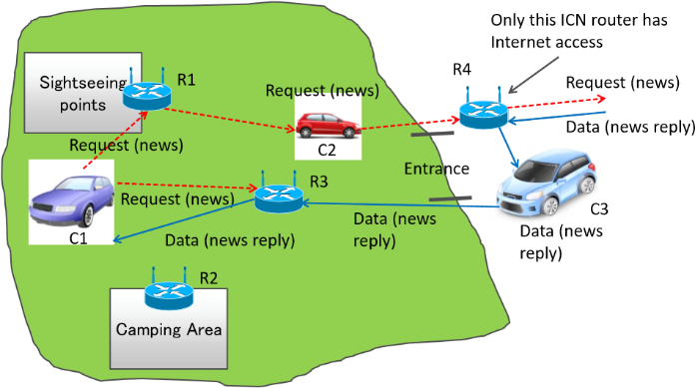

Fig. 3.1. User scenario of NDNWiFi in national park

The NDNWiFi major functional design components are shown in the DFD Level 1 depicted below:
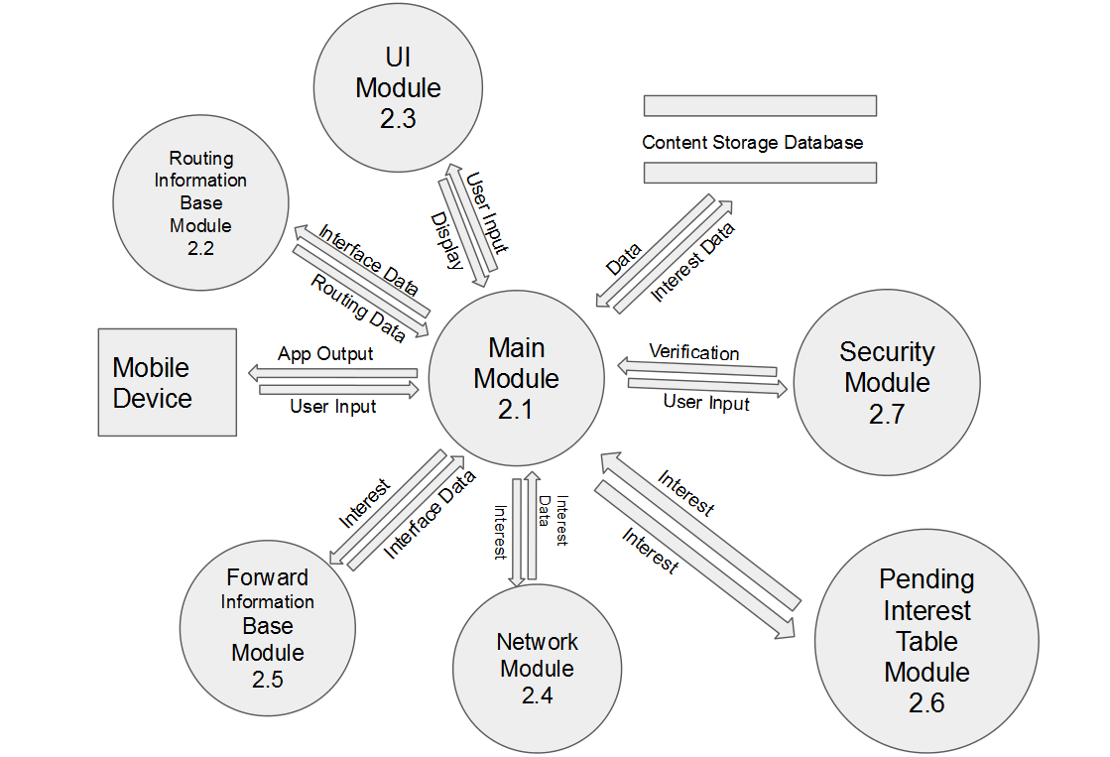

Figure 2-1. Context Diagram (Level 1 Data Flow Diagram)

The description of NDNWiFi major functional units show in level 1 DFD follows.
Most of NDNWiFi operations depends on the Main module to use the rest of the other modules.
Main- Module 2.1
The Main Module(MM) will provide linkability of data and other interactions between all other modules in the diagram
Routing Information Base- Module 2.2
The Routing Information Base Module(RM) is responsible for obtaining the Interest data, and process it to find the next hops for routing data. It is to receive the data from the (MM) and send back routing data back to the (MM).
UI-Module 2.3
The User Interface Module (UIM) is responsible for receiving user input and then displaying any of the information given in an easy to look at interface. The (UIM) is to develop the display that the user will be seeing and sending it back to the (MM).

Network-Module 2.4
The Network Module (NM) is responsible for sending the Interest with the correct Routing Information to the Network or Internet, then receive data back from the interest sent. Then send it back to the MM.

Forward Information Base-Module 2.5
The Forward Information Base Module (FIB) is responsible for storing a list of all routers it is connected too. Also (FIB) has to obtain the interest from the MM and return the list of routers it is connected to as data to the MM.

Pending Interest Table-Module 2.6
The Pending Interest Table (PIT) is responsible for storing all interest that the router has received but has not received data for. Also the PIT will send back the list of faces as data back to the MM.

Security-Module 2.7
The Security Module(SM) is responsible decrypting and encrypting data requested by the Users. Data sent to it will be decrypted and/or encrypted, then it will be sent back to the MM.

4.0 Results and Conclusions

Bandwidth Performance

For each of the three forwarding strategies, we measure the bandwidth consumption on the links between the NDN router and the users. The total bandwidth consumption (i.e., the bandwidth consumption of downloading ten different images, each of which process is replicated by five times) of each forwarding strategy is shown in Fig. 4.1. We can see that first-fit achieves the best performance, followed by hit-aware-multicast and flooding. This is because first-fit attempts each interface one-by-one and only one Data (either the original or the duplicated image) is returned, which leads to a small amount of bandwidth consumption. While, flooding broadcasts the Interest to all the interfaces and multiple duplicated Data can be obtained (both the original and duplicated images), thus resulting in a large amount of bandwidth consumption. Hit-aware-multicast consumes more bandwidth than first-fit, but much less than that of flooding. This indicates that it is more cost-efficient to selectively broadcast the Interest based on the hit rate, rather than flooding the Interest.
0
50
100
150
200
250
Bandwidth consumption (MB)
First-fit Flood Hit-aware-mcast
Fig. 4.1. Bandwidth consumption performance

Download Time Performance
In addition to the bandwidth consumption, we also evaluate the file download time performance of the three proposed forwarding strategies as shown in Fig. 4.2 and Fig. 4.3. As shown in Fig. 4.2, in most of the cases, flooding achieves the best performance, followed by hit-aware-multicast and first-fit. The reason behind this is that flooding is a breadth-first-search strategy which can returned the requested Data in a faster way at the cost of a higher bandwidth consumption, while first-fit adopts a depth-first-search strategy which more often takes a longer time to obtain the requested Data but with a relatively smaller bandwidth consumption. Hit-aware-multicast achieves a performance that is better than first-fit while a little worse than flooding, thanks to the use of selectively broadcast.
To take a more general analysis of the download time of the three proposed forwarding strategies, we show their mean, min, max, 1st quartile and 3rd quartile values in Fig. 4.3. We can observe that hit-aware-multicast achieves a better performance than first-fit in terms of mean, 1st quartile and 3rd quartile values, which follows the same observation as we can see in Fig. 4.2. We can also find out that such an observation may not be true in the two extreme cases at the min and max download time plots due to the reasons of actual file distribution condition or wireless communication conditions.

0
100
200
300
400
500
600
700
800
900
57.6
240.4
534.1
617.4
784.4
859.7
908.6
1262.1
4383.2
4673.7
Download time (ms)
File size (KB)
First-fit
Flooding
Hit-aware-mcast
Fig.4.2. Download time performance 1

0
200
400
600
800
1000
1200
1400
1600
mean
min
max
1
st Quartile
3
rd Quartile
Download
Time(
ms
)
First-fit
Flooding
Hit-aware-mcast
Fig. 4.3. Download time performance 2
From the experimental performance evaluation in the above two subsections, we can find out that hit-aware-multicast is a relatively good forwarding strategy that can balance the tradeoff between bandwidth consumption and file download time, compared to first-fit and flooding. Rather than attempts each interface one-by-one or simply flooding the Interest to all the interface, selectively broadcast the Interest based on historical hit rate can be an efficient way to fetch the requested Data in NDNWiFi.

