Senior Design Project Report

Referral ERRA Trending Analysis Tool (RE-TAT)

Documented Prepared by:

Philip Tran
Emanoel Khachadorian
Xiaoye Li,
Daniel Limas
Henry Liwag
Wilson E Thomas

Advisor:
Yuquing Zhu

May 2nd, 2018

Table of Contents

- Introduction

- Technologies

- System Architecture

- Results and Conclusions

- References

- Introduction

QTC is the largest provider of government-outsource disability and occupational health examination services in the nation. Their network consists of more than 1,000 clinical, corporate and operational associates. And more than 70 clinic locations that include physicians, registered nurses, and support personnel. Our tool RE-TAT was created by using data from ERRA, weekly provider zip code report, and historical referral data to identify:
- Areas that are missing providers and display the nearest provider.
- Track referrals assigned to QTC.

- Related works and technologies

In the development of RE-TAT, development tools included the following:
  - Java Oracle
  - Eclipse IDE
  - Tomcat Apache 7
  - MySQL
  - phpMyAdmin
  - Bootstrap
  - Apache POI Library.

- System Architecture

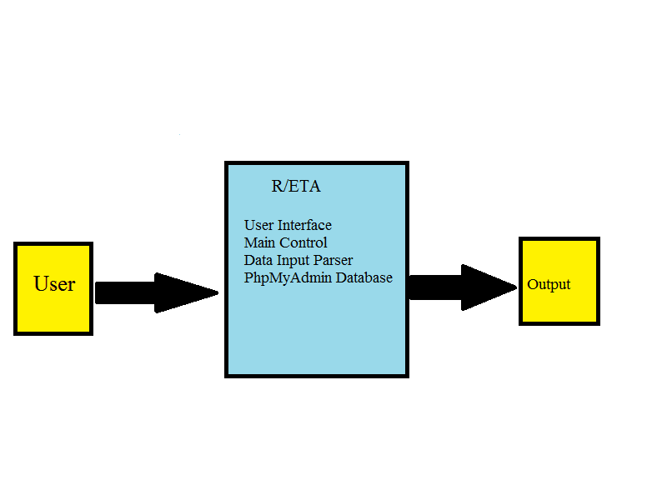
Figure 4.0 displays the Level 0 stage of the data flow diagram (DFD). Before using the tool, the user must interact with it by inputting data. The arrow indicates input to the system of modules. Each element of the list is a module. When the user enters an input, the modules interact with the input data.
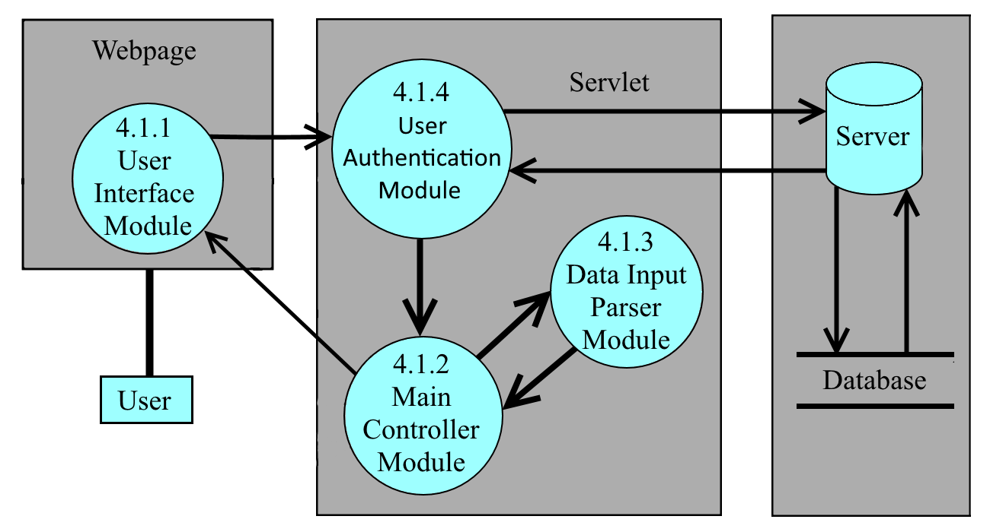
4.1.1 User Interface Module
The User Interface Module(UIM) provides a web-base GUI and functionality for the user-friendly interface. It organizes and visualizes the data-set based on user geolocation input, defined categories’ input, and distance input. The UIM contains tools such as searching geo-location based on user location input and time of date and pinpointing geo-location. The UIM also contains feature that identifies specialty availability within a region and determine how many claimants are in the area, validate appointment assigned to QTC, and determine if an area has enough providers within a given distance. For security, the user will to enter their login information on the UIM to gain access to the system. The UIM is also responsible for receiving the QTC’s excel file information and sending it to the UIM.

4.1.2 Main Controller Module
The Main Controller Module(MCM) is the Model View Controller(MVC) of the RE-TAT. M stands for models. Which when the data is parsed it creates model’s so the main controller module can manipulate the data. V stands for View, and the User Interface Module is that part of the system’s design pattern. View is will in charge of display and having a way to send input to the Main Controller Module. C stands for controller and the Main Controller Module is the controller for the view. It contains the central system of the server side implementation on the RE-TAT. The MVC will serve as the main controller for the User Interface Module(UIM), Data Input Parser Module(DIPM), User Module(UM) and the server. The MCM is responsible for the implementation of the features. Based on the user’s input of date, geolocation, medical specialty for a given feature from the UIM, the MCM will search through the dataset for a list of information the user wants to view and sends it to the UIM. The MCM is also responsible for transferring Excel files to the DIPM and receiving the content of the Excel files' data from the DIPM.

4.1.3 Data Input Parser Module.
The Data Input Parser Module receives input files and parses the data from the Main Controller Module and creates data models for the parsed information. After the files have been parsed, the module will that data to the Main Controller module. The higher-level components work together as whole and follow the MVC design pattern.

4.1.3 User Authentication Module
User Authentication Module connects to a database which store all username and password information. General users will use their unique username and password to access this program, but they will not have access to admin level privilege. There is only one Admin user in our system. Admin user have the same abilities as the general user as well as add and remove users, and change the users’ password.

- Results and Conclusions

The formatting of the QTC Excel files can affect the data output of the tool. There are four Excel file formats that are required in order to use RE-TAT: QTC’s ERRA historical data, QTC’s VA providers list, QTC’s referral data, and QTC's Specialty and Mileage range. If QTC were to add any new attributes into these Excel files, changes how the Excel file was format, and/or add a new Excel file that was not listed above, RE-TAT will not be able to handle those changes. Careful design has to be taken in the DIPM in order for the tool to work correctly.
The first feature REFERRAL AND PROVIDER CHECK achieves the following objectives:
- Find providers where referrals are assigned.
- If no providers are available, mark the region being searched.
- Ensure coverage in all required areas.
The second feature ERRA AND REFERRAL CROSS-CHECK achieves the following objectives:
- Check between referrals assigned with referrals QTC received.
- Provide comparison data from referrals.
Writing the Data Input Parser Module was essential to the success for this project from a technical and organizational standpoint. Our project (RE-TAT) will substantially improve QTC Management team’s decision-making process in future operations.
- References

https://commons.apache.org/proper/commons-fileupload/using.html
https://www.mindrot.org/projects/jBCrypt/
https://github.com/Twipped/Kalendae
https://poi.apache.org/apidocs/index.html

