Senior Design Final Report
Project Athena: Log & Infrastructure
Monitoring

Version 1.0 - 05/01/20

Team Members:
Misael Corvera Alfaro
Jateni Dida
Alexander Horejsi
Yi Wang
Zac You

Faculty Advisor:
Dr. Chengyu Sun

Liaisons:
Mahan Hajianpour
Table of Contents

- Introduction 2
  - Background 2
  - Design Principles 2
  - Design Benefits 2
  - Achievements 3
- Related Technologies 4
  - Existing Solutions 4
  - Reused Products 4
- System Architecture 5
  - Overview ?
  - Data Flow ?
  - Implementation ?
- Conclusions 6
  - Results ?
  - Future ?
- References 7

1. Introduction:
1.1. Background:

Commonwealth casualty company (CCC) is an insurance company based in Arizona and was founded in 2010 with a mission to provide affordable insurance for homeowners, renters, auto insurance seekers and much more. The company is driven to improve it’s services and products constantly to be able to provide customized and innovative solutions to serve the unique needs of every client. In order to provide the best tailored services, the company consumes and works with a huge amount of data and project Athena is intended to assist the administration, the technical stuff and the general employee with a user-friendly and custom dashboard that would display the real-time status of the servers and virtual private clouds (VPCs) the company is using to run the business.

1.2. Design Principles:

Project Athena utilizes the latest web development tools such as React, Chart.js, and SpringBoot topped with AWS Lambda functions for notification services. In this project, we intended to build a robust and scalable system health monitoring dashboard that can be used to track the overall system performance of the resources the company is using. By implementing a real-time system health status reporting bar, charts that depict raw data into meaningful and consumable information, notification and alarm system that would trigger when a certain threshold has been exceeded are some of the core designs and architectures we have implemented in this project.

1.3. Design Benefits:
By having an architecture that allows the Framework to expand with the demands of the company, we essentially ensure its usefulness for future expansion of the company. The architecture itself is a very complicated structure that connects different resources and technologies to provide information for the users on different components of the dashboard. This type of framework will provide a simple interface that can be used easily by developers.
The dashboard interface, on the other hand, is designed with simplicity in mind. Due to Reactjs nature, the app was divided into different components for each of the functions needed on the dashboard. They are all broad together on simple pages structured to display the information in a useful way for the user. By doing this, we allow the application to be scalabled based on the needs of the company and the new technologies that Amazon Web Services may come up with in the future.

1.4. Achievements:
Over the course of the academic year, our team has been able to develop a dashboard that can provide log and metric notifications to any endpoint allowed by AWS SNS, like emails. In addition, the user is able to create 3 different types of graphs, for example line, bar, or mix, from any resource metrics available in AWS CloudWath. Another important feature implemented in the dashboard is the ability to search logs stored on AWS CLoudWatch, which are then displayed in a useful way for the developer.
A backend that utilizes Spring Boot has also been successfully developed, and it can currently retrieve data from AWS RDS or any other MySql data server. The structure of the Restful API has been kept as simple as possible, by developing only the necessary endpoints needed for specific actions required from the dashboard interface. On the other hand, the database structure contains a simple table structure that is connected with foreign keys.
Lastly, a lambda function was developed using Java and deployed using AWS Lambda services. The lambda function is a serverless computer that gets activated only when specific parameters or filter events are met from any of the subscription endpoints. In our particular case, those endpoints are each of the AWS CloudWatch Log Groups that are manually subscribed to the Lambda Function. Additionally, the Lambda function retrieves data from the database in order to send notifications based on the log information obtained from the subscription.

2. Related Technologies:
2.1. Existing Solutions:
Our team has considered a full-fledged, pre built system health monitoring dashboard called Adminto that consists of graphs, tables, user profiles, navigation tools, back-end system and notification system. Even though these features provided by Adminto were a good resource to get started and see what the big picture would look like, they also had their own limitations and constraints.
The graphs provided by Adminto are only historic graphs. The platform does not support a real time graph that shows how a certain metric behaves in real time. One of the requirements in our project was to build a real time graph that shows the data flow in real time, therefore we completely discarded the resource provided by Adminto and built our own custom real time graph with Chart.js.
Tables and Lists are also one of the many features provided by Adminto. The tables Adminto provides were built with a react-table framework, which is a great framework but has its own limitations. For instance, it is difficult to contain a table in a specific card. Cards are used to display contents in an elegant and organized way and react-table doesn’t support a Card feature in the framework.
Hard coded and pre-built user profiles are provided by Adminto. These user profiles include an Avatar with a picture or last name, first name initials. They also include name, settings, the option of locking the screen and log out features. Our dashboard was not designed to have all these features, but instead to have the option of subscription, Avatar, name and logout.
Adminto also provides a left side navigation tool to add graphs, mail and calendar. We have kept the feature of adding graphs and extended the option to add historic or real time graphs. We have also implemented the log search, alerts, full screen mode and settings. The pre-built in dashboard also provides a back-end system that is built with node.js and is not connected to the database. On the other hand, our dashboard needs to store information about log events and record the activity of the user.
Notification system is also implemented in AWS Lambda. The notification system is designed to notify the user of others' interaction with that user. Our platform has a different idea of using the notification system. We planned and implemented the dashboard to notify the user upon the Simple Notification Service (SNS) they have subscribed to sends an alert.

2.2. Reused Products:

We have built our platform on top of the pre-built dashboard, Adminto. We have used react.js as our main programming language, Chart.js for our graphs, materialUI for tables and cards. These were our front end frameworks. We have also used AWS Lambda to trigger the Simple Notification Service (SNS). We have set up a MySQL database to store and track the user activity related to the dashboard.

3. System architecture:
3.1. Overview:
Our application primarily serves as an intermediary between our end-users and all AWS services. The Dashboard will make tracking the data used by various services easy to do and understand by allowing Users to create graphs that display how certain data is being used by specific AWS services. The Notification System will keep track of alarms that Users have set to monitor certain metrics and logs and will send messages when any such metric or alarm meets certain criteria. Both the graphs on the Dashboard and alarms monitored by the Notification System will be set by Users. AWS CloudWatch is where all metrics and logs for AWS are stored. The Database stores all information related to Users, metric alarms and log alarms
Here is a diagram (DFD level 0) that shows how this architecture works at a high level:
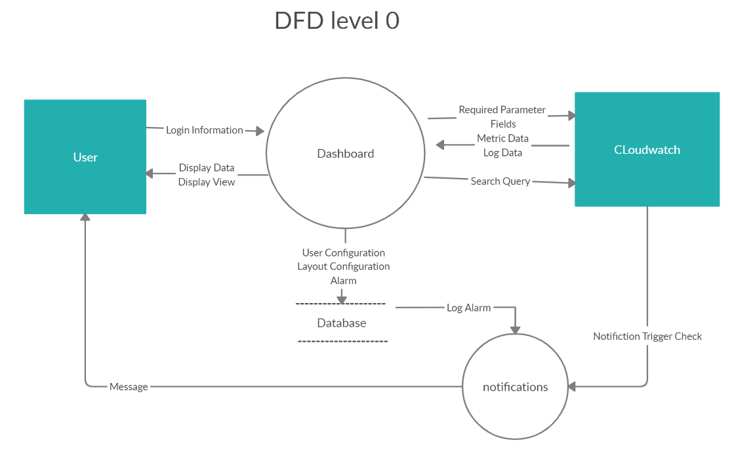
- User: The User wants to track what certain AWS services are doing. They are able to interact with both the Dashboard and the Notification System. With the Dashboard, they are able to create graphs that display what data was being used at a specific time as well as track data that is being used in real time. With the Notification System, they are able to set alarms that will send them messages letting them know that a given metric or log has met a certain set of criteria. All User information is stored on the Database.
- Dashboard: The Dashboard contains all of the graphs that show a given User what metrics they want to track in real time and what metrics were recorded at a specific time. What metrics are tracked and whether or not the metrics are tracked in real time or not is configured by the User. The type, color, size and position of the graph on the Dashboard are all configurable by the User. The configuration details of a User’s Dashboard is stored on the Database.
- Notification System: The Notification System monitors both metrics and logs and sends messages to specific Users when they meet certain criteria. The criteria for triggering a metric alarm of log alarm is specified by Users and stored on the Database. For log alarms, it makes use of AWS Lambda to process logs sent to AWS CloudWatch and to check if any of the logs in question should trigger any log alarms. For metric alarms, it makes use of functionality built into AWS CloudWatch to specify what criteria needs to be met and what users to send messages to. Messages will be either emails or text messages.
- CloudWatch: AWS CloudWatch is where all logs and AWS metrics are stored and tracked. CloudWatch already has a built in feature for setting metric alarms. Users can choose a service to monitor, what metrics on that service to monitor, what criteria that metric must meet for an alarm to be triggered and what endpoint to send a message to should an alarm be triggered. For log alarms, a custom AWS Lambda function monitors logs sent to AWS CloudWatch and processes them to check if any given log should trigger any log alarms that were set by Users.
- Database: The Database stores all information pertaining to Users and their Dashboards, log alarms and metric alarms. Whenever a User logs in, their information must be verified with the information on the Database. Whenever a User makes any changes to their Dashboard, their Dashboard configuration on the Database must be updated. Whenever, a log or metric alarm is created, changed or deleted, the Database must be updated to accommodate the change.

3.2. Data Flow:
Here is a diagram (DFD level 1):
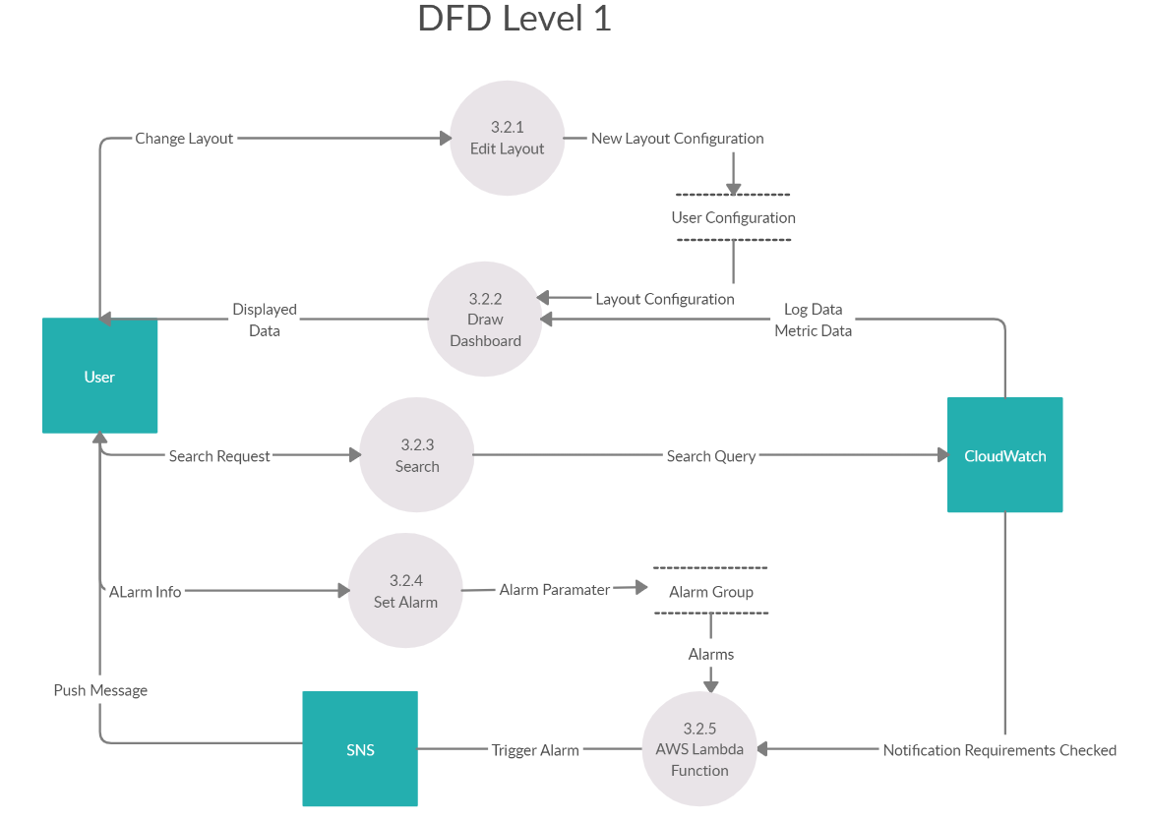
There are five major modules in this system. They are described in more details in section 6. Here is a brief overview of them:
3.2.1. Edit Layout: This is the module used to edit the layout of the Dashboard. Each dashboard under different users has its own set of contents and layout. This module would allow the user to change the position of each graph, adding new graphs or deleting old graphs. Once the edit is complete, it will store all the layout information into the database.
3.2.2. Draw Dashboard: This module generates the dashboard which is the main interface the user is going to interact with. It will access the database for the user configuration parameter to know what kind of graph it is going to display. Then it will get the log and metric data to generate the log table and graphs. It will also generate the health bar by using the data from Cloudwatch to tell the general status of the system.
3.2.3. Search: This model would make an API call to the Cloudwatch log function, and return the logs that match the keywords.
3.2.4. Set Alarm: This model is used to set the event flag for Lambda function to trigger flag. It will display the list of existing alarms for users to subscribe to, or let the user add more alarms by putting into a new parameter.
3.2.5. AWS Lambda Function: AWS Lambda Function is mainly responsible for notification service. AWS Lambda Function is an event driven serverless function, here it is used to detect whether there are metric data or logs that trigger the flag user set inside the Alarm group database. Once the event is triggered, it will call the AWS SNS to push the message to the user.

3.3. Implementation:
This project consisted of three apps: a frontend app, a backend app, and an AWS Lambda function. The frontend app exists to provide an intuitive user interface for modifying the dashboard and configuring alarms. The backend app exists to interact with the database. The AWS Lambda function exists to process logs sent to AWS CloudWatch and to send out notifications if a given log should trigger a given log alarm.

3.3.1. Frontend App
This app provides an easy-to-use user interface for customizing a dashboard and managing alarms. Users must log in before using the app and their credentials must be verified. The dashboard shows all of a user’s graphs that display the metrics they are tracking. The dashboard is highly configurable. It allows users to change the size, color, type and position of the graphs. There are forms that allow users to create and subscribe to any alarms they want. If any major changes are made to a user’s dashboard or if they change any alarms, the backend app must be called to make the appropriate changes to the database. There is also a search feature that gives users the option to search logs that contain certain keywords. The system health bar tells users how well their systems are doing and if there are any major concerns. The frontend app is written in JavaScript 6 and uses Node.js for project and dependency management, React as its UI framework, Adminto to create the dashboard, Chart.js to create the graphs and the AWS SDK to interact with AWS services.
3.3.2. Backend App
This app is responsible for interacting with the database. Whenever a user logs in to the frontend app, their username and password must match an user entry on the database. Whenever a user updates their dashboard, the configuration details of their dashboard must be updated on the database. Whenever a user creates, modifies or deletes an alarm, the database must be updated to accommodate the change. All of this functionality is implemented on the backend. If there is any operation that requires the database to be changed or read at all, it is done through the backend. The only exception to that is one query that is regularly done in the AWS Lambda function. The backend app is written in Java 8 and uses Spring Boot as its web framework, Maven for project and dependency management and the AWS SDK to interact with AWS services.
3.3.3. AWS Lambda Function
This app primarily exists to implement the log alarm system. The function monitors logs sent to AWS CloudWatch. The log messages must be in JSON format for the function to work at all. Whenever a log is sent to a log group that the function is monitoring, the function will be triggered. When invoked, all log alarms pertaining to a given log group will be retrieved from the database. Then, if any of the logs being processed meet the criteria for triggering any of the log alarms that were pulled from the database, messages containing the log will be sent to specified AWS SNS topics. The AWS Lambda function is written in Java 8 and uses Maven for project and dependency management and JSON Jackson for reading JSON data.
4. Conclusions:

4.1. Results:

So far we have created a dashboard application that can monitor overall system health across all the resources our client has on AWS. By means of overall system health, we are referring mostly to the status of the log as well as the status of the metrics data that have been published to CloudWatch. The dashboard is able to display the numbers of errors and warnings from the log in a real-time system health status reporting bar that we implemented. It also allows our clients to add charts to depict raw metric data into meaningful information by just entering a few necessary fields. The most important functionality of the application is that it allows our client to search log based on key words that they enter. These features give our client easy access to monitor their infrastructure.
We have created components that can query data from AWS by utilizing the API modules it provides.
The database module of our web application stores the overall layout of the dashboard that user customizes, the user credentials, as well as the notification settings.

4.2. Future:

As our liaison stated in the beginning that they need a dashboard application that can help them analyze and monitor their infrastructure which currently lies on AWS better, we tried our best learning how to use AWS in order to build up the features that they wanted. Despite the fact that the time frame we have is limited, we completed the modules that we can do. There is still much to improve on our project , but it is a good start for the following design groups at California State University, Los Angeles. Following are the suggested improvements we can give to the next year’s team to build:
- Responsiveness of the web application. Even though we have implemented several major functionalities, we have not worked on the responsiveness of the widgets and layouts when window size changes.
- Adding nightly script feature to the system bar. The nightly scripts are tests that are run to monitor that all the applications are running properly every night.
- Implementing Redux, which is a state management for Reactjs.
- Validating graph form inputs. When a user creates the graph, they have to enter several fields. Even though we checked for empty inputs, we have not managed to check for proper inputs. For example, the namespace ‘AWS/EC2’ has to be all uppercased, an ‘aws/ec2’ input is not proper.
- Make the mix graph more dynamic. So far we only allow for two graph inputs to the mix graph. Maybe you can work on adding more graph inputs to the mix graph.
- No information on the database is encrypted. Any information that is stored on the database that is considered sensitive should be encrypted. This could be accomplished through MySQL’s own encryption functions or through the backend with Spring Security.
- While the backend does configure any triggers on the database when configuring a log alarm on our database, it does not set the filter on AWS Lambda itself. AWS Lambda must be configured separately so that it knows what log groups to monitor and what logs to filter out using the filter pattern. This can be done through the AWS CloudWatch client on the backend.
- Note that some optimizations were made on the “alex” branch of the backend GitHub repository. Feel free to use them if you wish.

5. References:

