Software Design
Document
for
Project Athena: Log & Infrastructure Monitoring

Version 2.0
Prepared by Misael Corvera, Alexander Horejsi,
Yi Wang, Jateni Dida, Zac You

Sponsored by Commonwealth Casualty Company
March 22nd, 2020

Table of Contents
Table of Contents................................................................................................................................ <pg 2>
Revision History.................................................................................................................................. <pg 4>
1. Introduction.......................................................................................................................... <pg 5>
1.1. Purpose............................................................................................................................. <pg 5>
1.2. Document Conventions……………………..................................................................... <pg 5>
1.3. Intended Audience and Reading Suggestions................................................................... <pg 5>
1.4. System Overview............................................................................................................... <pg 5>
2. Design Considerations........................................................................................................... <pg 6>
2.1. Assumptions and dependencies........................................................................................ <pg 6>
2.2. General Constraints........................................................................................................... <pg 6>
2.3. Goals and Guidelines......................................................................................................... <pg 6>
2.4. Development Methods...................................................................................................... <pg 6>
3. Architectural Strategies......................................................................................................... <pg 7>
4. System Architecture.............................................................................................................. <pg 8>
4.1 DFD 0.................................................................................................................................... <pg 8>
4.2 DFD 1 …………………....................................................................................................... <pg 9>
5. Policies and Tactics.............................................................................................................. <pg 10>
5.1. Specific Products Used.................................................................................................... <pg 10>
5.2. Requirements traceability................................................................................................ <pg 10>
5.3. Testing the software......................................................................................................... <pg 10>
6 Detailed System Design....................................................................................................... <pg 10>
6.x Name of Module.................................................................................................................. <pg 11>
6.x.1 Responsibilities.................................................................................................................... <pg 11>
6.x.2 Constraints..................................................................................................................... <pg 11>
6.x.3 Composition................................................................................................................... <pg 11>
6.x.4 Uses/Interactions........................................................................................................... <pg 11>
6.x.5 Resources....................................................................................................................... <pg 11>
6.x.6 Interface/Exports............................................................................................................ <pg 11>
7 Detailed Lower level Component Design………………………………………………………………….……. <pg 14>
7.x Name of Class or File...................................................................................................... <pg 14>
7.x.1 Classification.................................................................................................................. <pg 14>
7.x.2 Processing Narrative(PSPEC).......................................................................................... <pg 14>
7.x.3 Interface Description...................................................................................................... <pg 14>
7.x.4 Processing Detail............................................................................................................ <pg 14>
7.x.4.1 Design Class Hierarchy................................................................................................... <pg 14>
7.x.4.2 Restrictions/Limitations..................................................................................................... <pg 14>
7.x.4.3 Performance Issues............................................................................................................ <pg 14>
7.x.4.4 Design Constraints............................................................................................................. <pg 14>
7.x.4.5 Processing Detail for Each Operation............................................................................... <pg 14>
8 Database Design……………………………………………………………………………………………… <pg 18>
9 User Interface...…………………………………………………………………………….…… <pg 19>
10 Requirements Validation and Verification.................................................................................... <pg 26>
11 Glossary....................................................................................................................................... <pg 28>
12 References.................................................................................................................................. <pg 29>

Revision History

Name | Date | Reason for Changes | Version
First Revision | 11/28/19 | Initial Document Write Up | 1.0
Second Revision | 03/22/20 | Updated new information | 2.0

1. Introduction

Commonwealth Casualty Company (CCC) was founded in 2010, and its mission is to provide affordable insurance to everyone in the community. Nearly 100 percent of the company’s dedicated employees volunteer their time with community service organizations. CCC partners with several charitable organizations that help the community in need, and these include Habitat for Humanity, the Special Olympics, and so on. The company offers a full suit of affordable products and services which includes homeowners, renters, auto insurance, and roadside assistance. Most importantly, the company provides a variety of discounts to help people save more on insurance.

1.1 Purpose
The purpose of this document is to inform future developers about the tools used to create this software.

1.2 Document Conventions
Each requirement statement has its own priority.

1.3 Intended Audience and Reading Suggestions
This document is mainly for future developers that will work on this project to inform them about what went into making this software.

1.4 System Overview

The system shall save dashboard layout for each individual user when they logout. Depending on the error level, the user shall be notified by the system with the error logs and error metrics. A user shall have the ability to add/delete/modify graph panels as well as configure notification settings for both logs and metrics.

2. Design Considerations

2.1 Assumptions and Dependencies

The users of the CCC dashboard should be able to navigate through the system as the system’s functionalities are fairly clear.

2.2 General Constraints
The website design is used to lower hardware limitations. Anyone with IOS, Windows, Android, Linux, or any operating system that has a browser will be able to gain access to the website.

● Programming languages, frameworks, and paradigms are limited to: React, Springboot, MySQL
● Database Servers are required in the process. As the data increase performance speed also increases.
● Cost constraints are encountered as the project requires AWS resources
● Time constraints are encountered as the project must be completed in time
● Real time update of the metric data

2.3 Goals and Guidelines

Goals designs for this system software:
- An administrative dashboard that provides a snapshot report of overall system health
- A friendly user interface that provides drill-down features that are easy to navigate

2.4 Development Methods

Requirements: First step of our development is to understand what needs to be designed as well as the overall functionality requirements for the objectives of this project.
Design: System design is the second phase of our development. It is to design the system architecture that help us understand the flow of each functionality that we will be implementing.
Implementation: In the implementation stage, we divide the project into smaller modules and distribute each module to individual member accordingly to make progress.
Testing: After implementation stage, we will get to testing phase where we combine all the modules and test them to make sure that there won’t be any errors or flaws.
Deployment of System: After the testing phase, the software, or the product will be integrated into the customer environment and will be ready to use.
Maintenance: The maintenance phase will occur after delivery of the final product, which it will require regular use of the system and make changes to the system once the error is detected.
3. Architectural Strategies
● Java Spring boot will be used for the backend of this software since that is what the CCC system can support.
● MySQL will be used to retrieve all the stored information from the RDS server.
● React.js will be used for building the frontend UI(User Interface)

4. System Architecture
Frontend: React.js, React-boot-strap, Chart.js
Backend: Java Spring boot

4.1 Level 0 DFD
This DFD describes a rough view of how the system will handle requests from the user and its response.
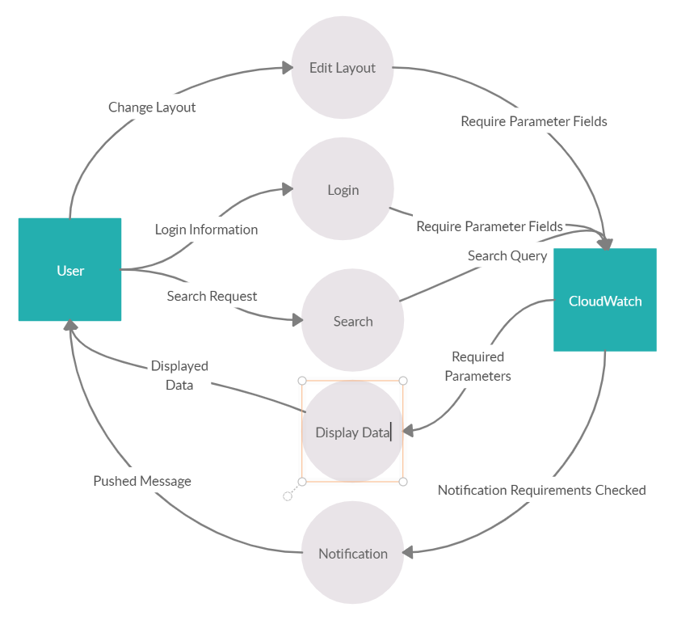

4.2 Level 1 DFD

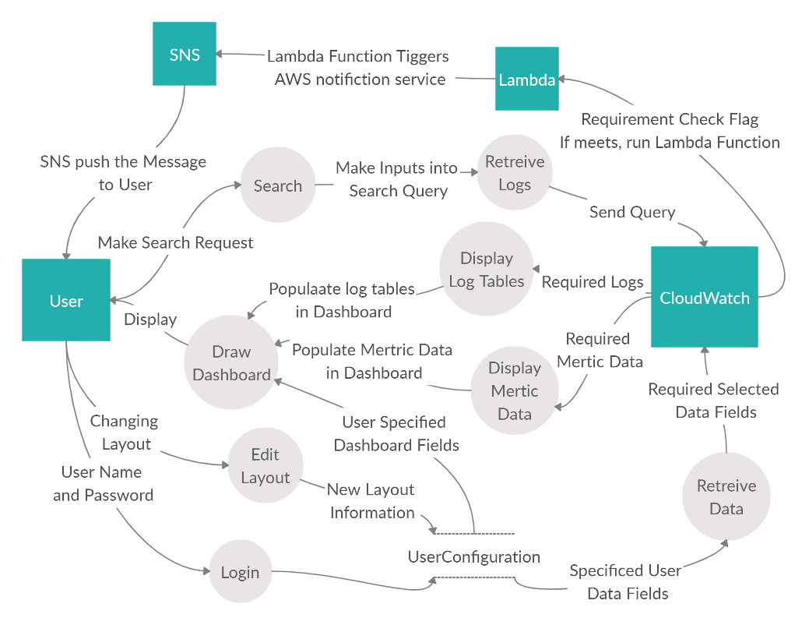

5. Policies and Tactics

5.1 Choice of which specific products used
Multiple code editors and IDEs (integrated development environments) such as Microsoft Visual Studio, Sublime and Atom text editors were used in the development process. Javascript’s framework, React was used as a primary front end development language with multiple libraries integrated in the development process. Chart.js, React-strap, and MaterialUI were the main libraries we used to display the contents in the front end. Elegance and simplicity were the reason why we chose those two libraries and also they were easy to integrate with the way we grab data from the API calls.
We implemented a custom search feature that takes a filter pattern keyword and searches through the available log groups in EC2 instance. In the prior documentation, we planned to use AWS cloudwatch insight but when we compare the performances and the scope of data that is available when working with these two different approaches, we chose to implement custom features.
AWS EC2 instances to run a live server on cloud. AWS Lambda to trigger AWS SNS (Simple Notification Services) service whenever a change a user wants to know happens.

5.2 Plans for ensuring requirements traceability
Section 10 has a table which describes all of the requirements and which modules satisfy them

5.3 Plans for testing the software
We plan to test the product with sample data we are going to receive from the company. Sample data includes: log files, virtual private clouds (VPC) and EC2 instances and cloud servers. After the trial, we intend to clean up and fix any issues that might occur and have it ready for production.

6. Detailed System Design

6.1 Add new historic/real-time Graph
6.1.1 Responsibilities | This module is responsible for adding new graph types in the dashboard.
6.1.2 Constraints
6.1.3 Composition
6.1.4 Uses/Interactions | This module is meant to interact with the Display module.
6.1.4 Resources
6.1.5 Interface/Exports

6.2 Display real time system status bar
6.2.1 Responsibilities | This module is responsible for displaying real time percentage of the aggregated log errors, log warnings and EC2 instance status. Each module expands to display the percentage of event(s) occurring per group.
6.2.2 Constraints
6.2.3 Composition
6.2.4 Uses/Interactions | This module is meant to interact with the Display module.
6.2.4 Resources
6.2.5 Interface/Exports

6.3 Edit Graph
6.3.1 Responsibilities | This module is responsible for editing the newly added graph.
6.3.2 Constraints
6.3.3 Composition
6.3.4 Uses/Interactions | This module is meant to interact with the Display module.
6.3.4 Resources
6.3.5 Interface/Exports

6.4 Delete Graph
6.4.1 Responsibilities | This module is responsible for deleting unwanted graph in the dashboard
6.4.2 Constraints
6.4.3 Composition
6.4.4 Uses/Interactions | This module is meant to interact with the Display module.
6.4.4 Resources
6.4.5 Interface/Exports

6.5 Subscribe to notification
6.5.1 Responsibilities | This module is responsible for subscribing users to a specific topic they choose or be alerted of a specific event.
6.5.2 Constraints
6.5.3 Composition
6.5.4 Uses/Interactions | This module is meant to interact with the Display module.
6.5.4 Resources
6.5.5 Interface/Exports

6.6 Search feature
6.6.1 Responsibilities | This module is responsible for searching a keyword and displaying the result with a table.
6.6.2 Constraints
6.6.3 Composition
6.6.4 Uses/Interactions | This module is meant to interact with the Display module.
6.6.4 Resources
6.6.5 Interface/Exports

7. Detailed Lower level Component Design

7.1 Update
7.1.1 Class
7.1.2 Used to change a user’s dashboard via adding, removing and modifying
7.2 Add
7.2.1 Class
7.2.2 Used to add graphs to a user’s dashboard
7.3 Remove
7.3.1 Class
7.3.2 Used to delete a graph from the dashboard
7.4 Modify
7.4.1 Class
7.4.2 Used to change the content of one of a user’s graphs
7.4.3 No interface.
7.5 UpdateController.java
7.5.1 Class
7.5.2 Performs updating of dashboard
7.5.3 No interface.
7.6 AddController.java
7.6.1 Class
7.6.2 Adds graph to dashboard
7.6.3 No interface
7.7 RemoveController.java
7.7.1 Class
7.7.2 Removes graph from user’s dashboard
7.7.3 No interface
7.8 ModifyController.java
7.8.1 Class
7.8.2 Modifies graph in dashboard
7.8.3 No interface
7.9 Bootstrap, React and Chart.js
7.9.1 Package
7.9.2 Provides all the necessary components that make up the application’s UI.

8. Database Design

8.1 Users Table
UserId | Int
Username | Varchar(50)
Password | Text
Email | Varchar(255)
Dashboard | Longtext

8.2 SNSTopics Table
SNSTopicId | Int
UserId | Int
TopicName | Varchar(50)
TopicArn | Varchar(255)

8.3 LogGroups Table
LogGroupId | Int
Name | Varchar(255)

8.4 Keywords Table
KeywordId | Int
Word | Varchar(70)
8.5 LogLevelCriteria Table
LogLevelCriteriaId | Int
LogLevel | Varchar(5)
Criteria | Varchar(2)

8.6 LogAlarms Table
LogAlarmId | Int
LogLevelCriteriaId | Int
AlarmName | Varchar(255)

8.7 XRefLogAlarmLogGroup Table
LogAlarmLogGroupId | Int
LogAlarmId | Int
LogGroupId | Int

8.8 XRefLogAlarmKeyword Table
LogAlarmKeywordId | Int
LogAlarmId | Int
KeywordId | Int
Criteria | Varchar(3)

8.9 XRefLogAlarmSNSTopic
LogAlarmSNSTopicId | Int
LogAlarmId | Int
SNSTopicId | Int

8.10 XRefUserLogAlarm Table
UserLogAlarmId | Int
UserId | Int
LogAlarmId | Int

9. User Interface

9.1 Overview of User Interface

When the application is booted up, the first thing the user will see is the login page. After successfully logging in the user will be redirected to the dashboard page. If the user is logging in for the first time, the dashboard will be empty and only the system health bar will be visible. Additionally, the menu icon can be found at the top left corner of the page which brings the left side menu. In the menu bar, the user can find icons and links that will open specific functionalities of the dashboard. For example, add new graphs, search logs, and configure email notification.

9.2 Screen Frameworks or Images

9.2.1 Login Page

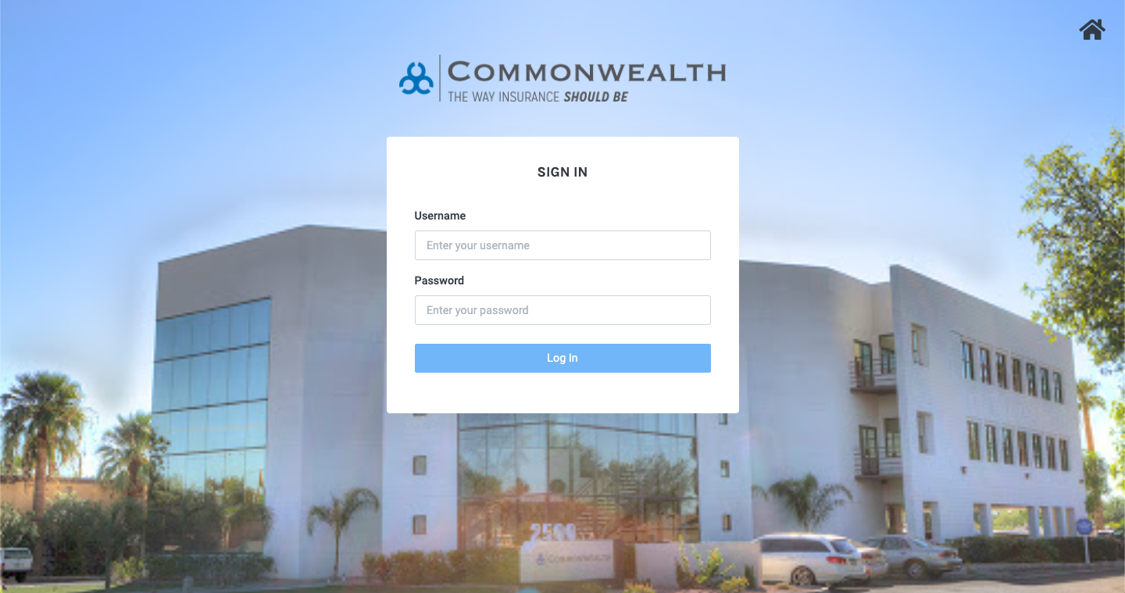

9.2.2 Home Page

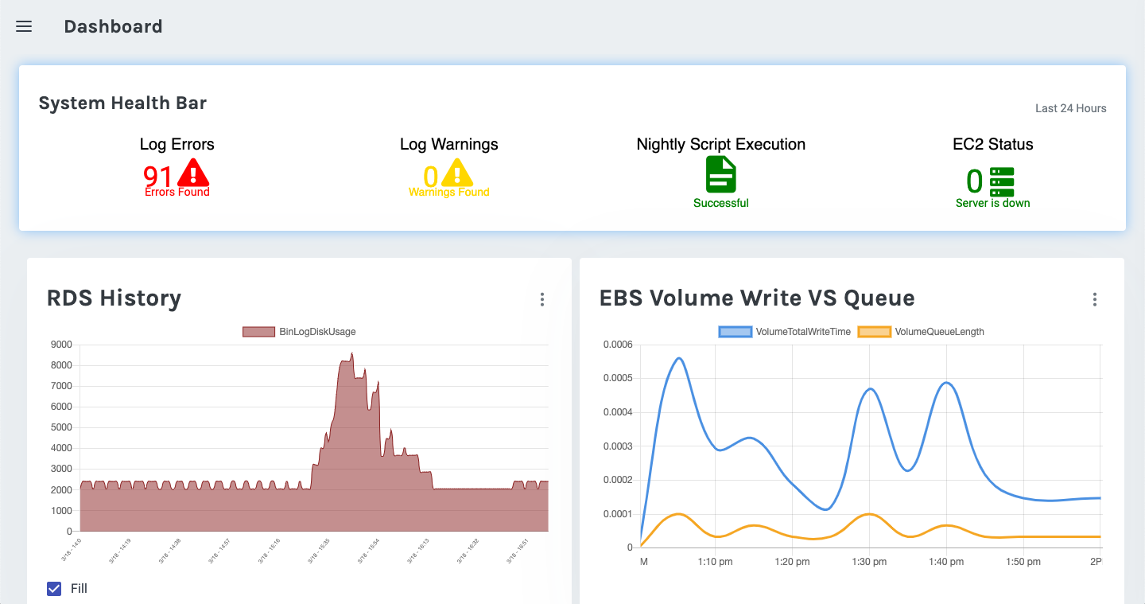

9.2.3 Side Menu

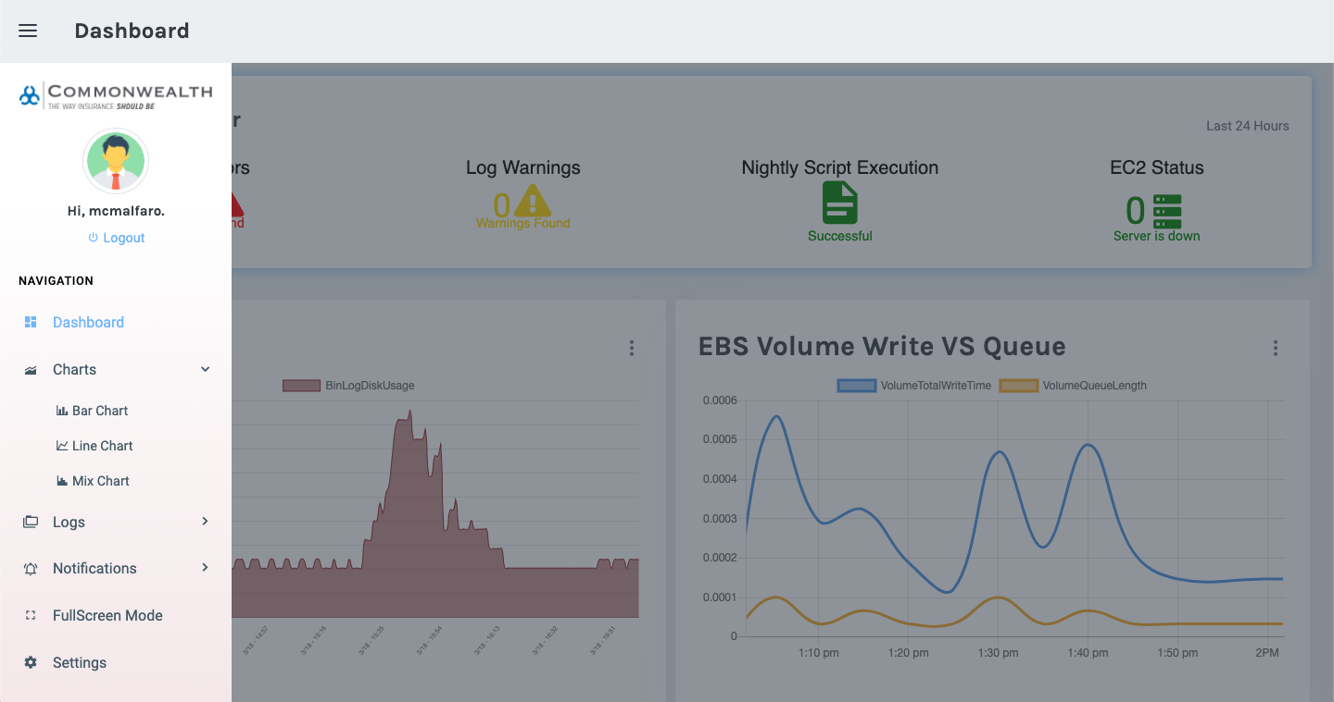

9.2.4 Form Component

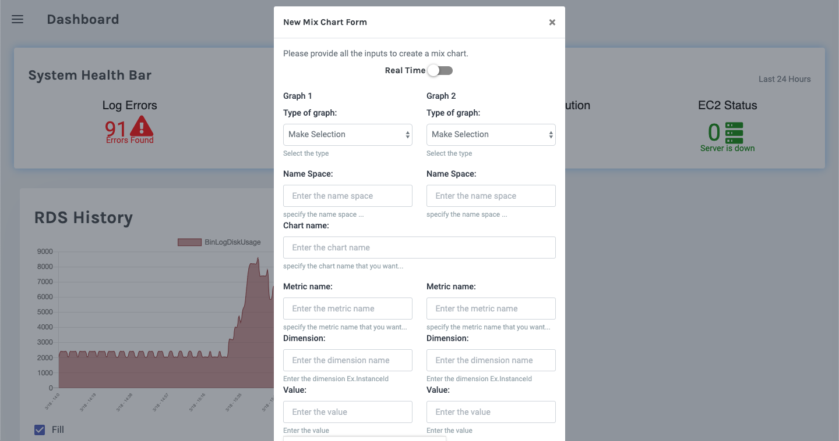

9.2.5 Log Search Form

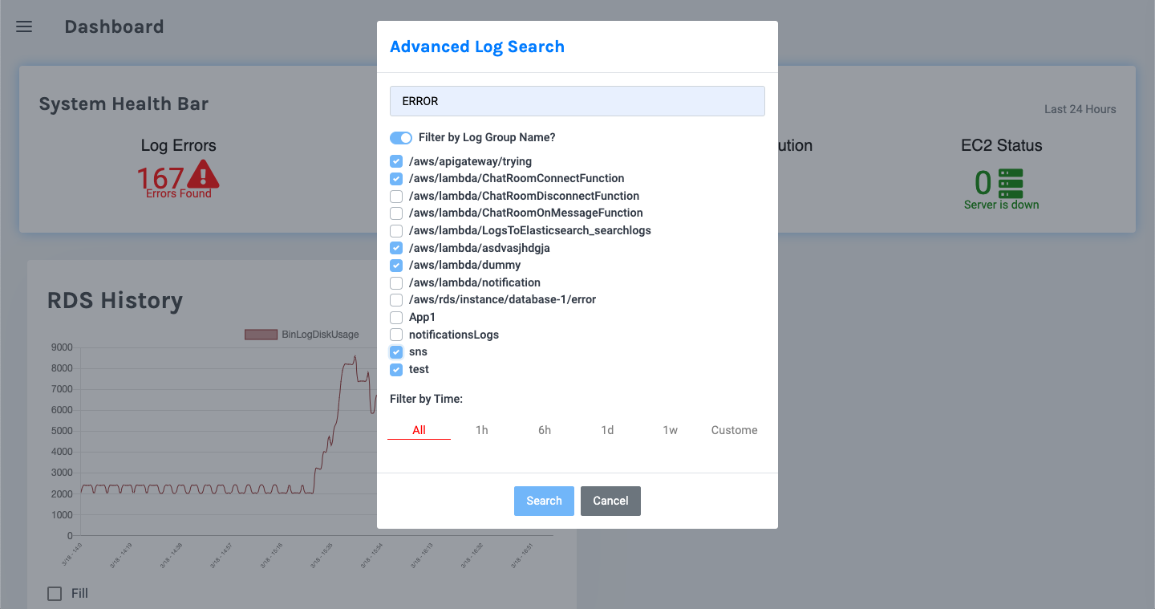

9.2.6 Search Result Page

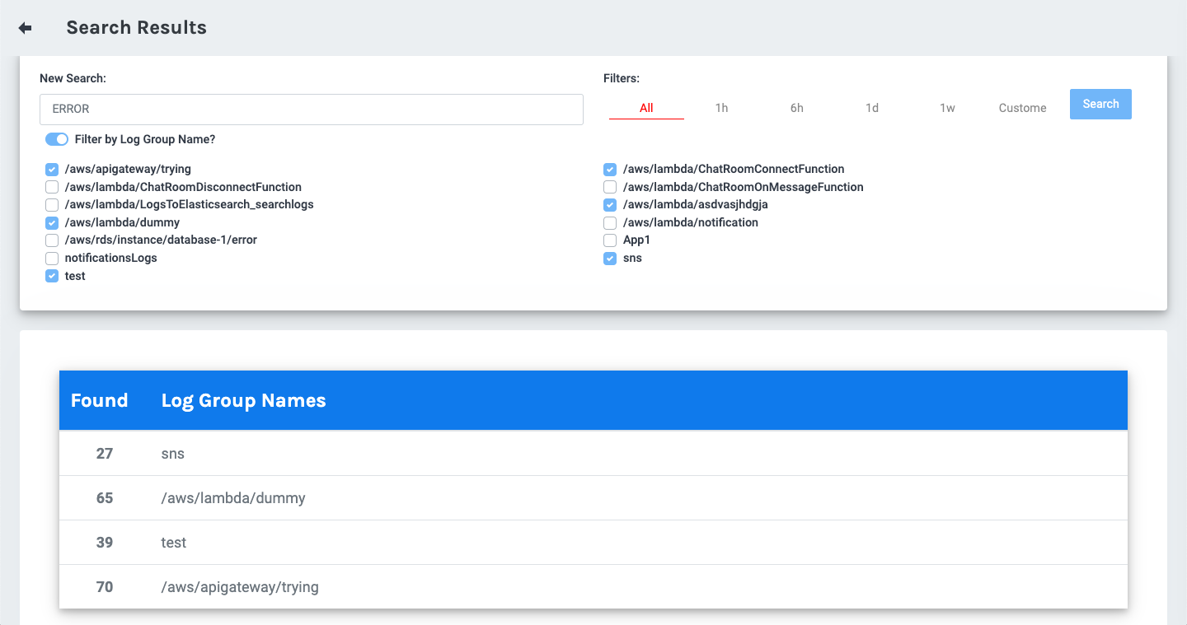

9.2.7 Log Details Component

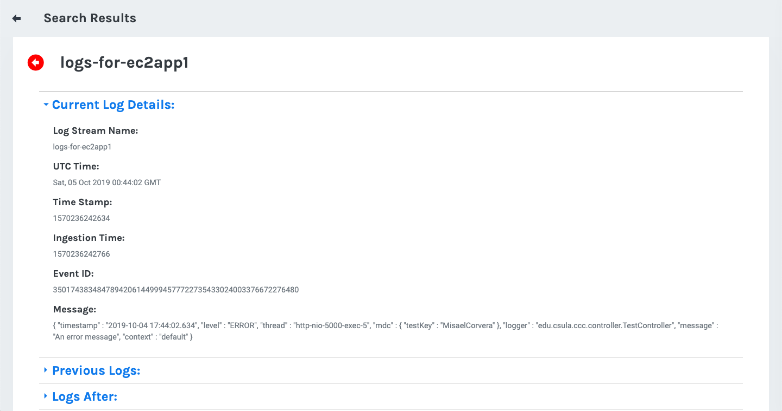

9.2.8 Metric Alerts Page

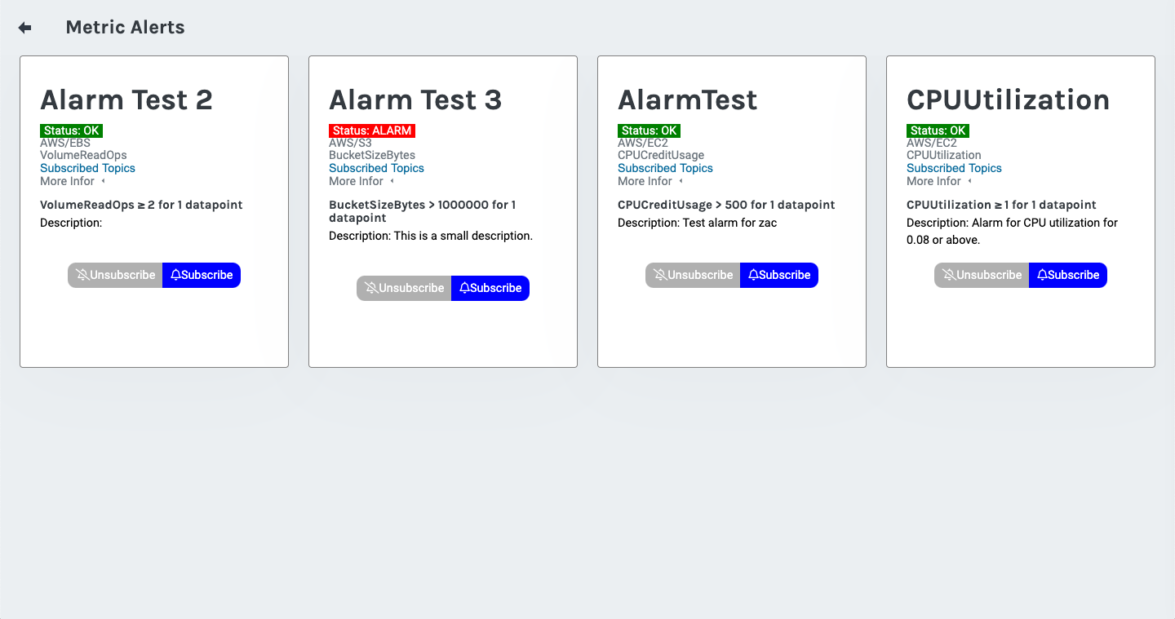

9.3 User Interface Flow Model

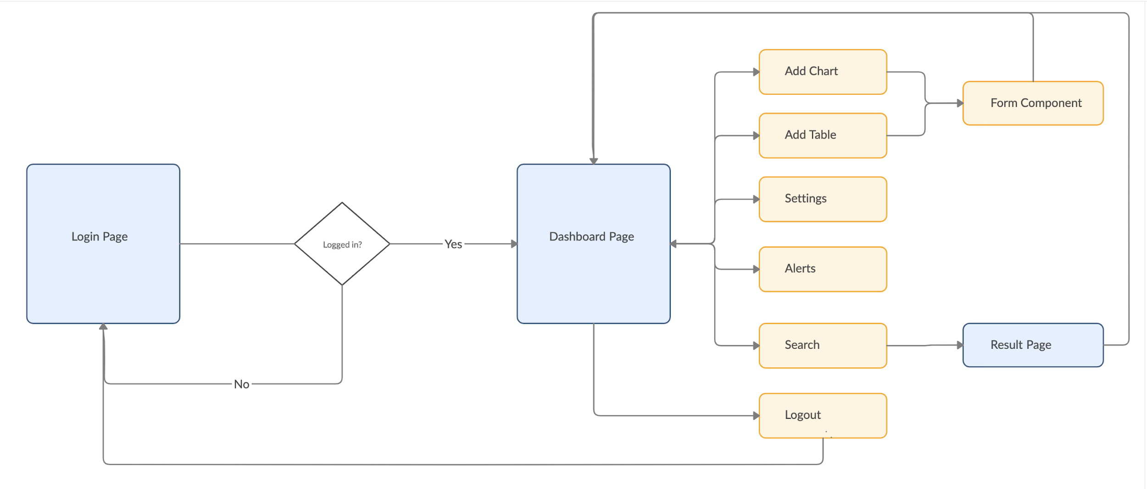

10. Requirements Validation and Verification

Requirement | Component/Module | Test
10.1.1 Application Requirements
10.1.1.1 Check user input for login: | Login.js | Observation of Code and Manual Testing
10.1.1.2 Check database for role credentials: | HomeController.java and MySQL | Observation of Code and Manual Testing
10.1.1.3 Redirect to home page and create user’s dashboard. | AutLayout.js and dashboard.js | Observation of Code and Manual Testing
10.1.4 From dashboard page user has access to navigation bar and dashboard. | AutLayout.js and dashboard.js | Observation of Code and Manual Testing
10.1.5 From navigation bar user can do the following actions::  Add real time chart.  Add charts.  Modify Alerts.  Access Fullscreen  Access Settings. | AutLayout.js and sidebar.js (uses BarGraph.js, LineGraph.js, SearchResult.js, MetricAlert.js, LogAlerts.js, and RightSidebar.js) | Observation of Code and Manual Testing
10.2 Logout | Logout.js | Observation of Code and Manual Testing

11. Glossary

AWS: Amazon Web Services.

AWS EC2: Elastic Compute Cloud

AWS SNS: Simple Notification Service

AWS Lambda: Serverless Computer

CCC: Commonwealth Casualty Company

MySQL: an open source relational database management system.

RESTful API: an application program interface (API) that uses HTTP requests to GET, PUT, POST and DELETE data.

RDS: Amazon Relational Database Service

VPC: Virtual private cloud

12. References

