Senior Design Final Report
Medical Records Queueing System



Version 1.0 - 05/06/2020

Team Members:
Alex Dang
Julie Kasparian
Alex Navarrete
Kevin Flores
Dinh Thai

Faculty Advisor:
Dr. Jiang Guo

Liaisons:
Francisco Guzman
Fleshika Ashley
Table of Contents

- Introduction 2
  - Background 2
  - Design Principles 2
  - Design Benefits 2
  - Achievements 3
- Related Technologies 4
  - Existing Solutions 4
  - Reused Products 4
- System Architecture 5
  - Overview 5
  - Data Flow 5
  - Implementation 6
- Conclusions 8
  - Results 8
  - Future 8
- References 10

1. Introduction:
1.1. Background:
QTC is the largest provider of government-outsourced occupational health and disability examination services in the nation. They identify existing and forecast program needs for their clients and deliver medical examination and diagnostic testing services. They are part of Leidos company who is a $10 billion technology solution provider. The company processes over more than 4 million pages of medical records daily, and to do this in a timely manner, they need a more automated workflow application.

1.2. Design Principles:

The software is identified as MRQS and will be used to manage workflow for QTC. Users will be able to log onto the application to clock in and they will see a list of tasks relative to their role and can filter what tasks they see. The application will keep track of when a user is active from when they start to when they clock out. A user may also take a break, causing the application to pause all tasks and keep track of their break time. Once a user completes an assignment, there will be a log to show who completed the assignment, when the assignment was started, and when it was completed. An assignment is given at random, depending when a user clicks on the “Get Next Task” button. There will be two queues in this software: download and index. A report will come in and move from download to index once they have been marked as complete in each queue. After index, the report will go into a history database.

1.3. Design Benefits:

This software is built to replace QTC’s current workflow application to enhance automation and to reduce a manager’s workload. The software application is similar to some workflow applications. QTC will create or link existing accounts to the application so that it can be accessed on their web portal. Currently managers manually assign documents daily and employees have to directly request more work when they complete their assigned work. The motivation for this application is to reduce the managers workload and have an automated method of assigning work.

1.4. Achievements:
Over the course of the academic year, our team was able to create a generic functional web application from scratch written in C# with Microsoft Visual Studio 2017. The application contains several tables that use stored procedures to update created in Microsoft SQL Server Management Studio.
We created a manager’s view and a user’s view for the application based on user credentials. A manager has more capabilities than a regular user. A manager has access to the user’s view and they can assign and unassign any task to a user. They can work on tasks themselves and they can see all active users. Users can work on tasks and get another task once they have completed all assigned tasks. We implemented a counter to show how many tasks a user has completed for that day. Tasks consist of workflow steps, where a task will move to the next step once it completes its current step. After completing all steps, a task will move into a history database, showing all steps and history of user completion. We also implemented a search and sorting feature to make it easier to manage thousands of records.

2. Related Technologies:
2.1. Existing Solutions:
There was no software solution for the medical records. All records were manually assigned by a manager to an appropriate employee to process. After a record from the previous step was completed it would be forwarded to the manager to send to an employee that handles the next step (ie. After the download step is completed it is forwarded to the manager to send to the index step). This process works but it takes too long and managers are unable to keep track of who made corrections or errors.

2.2. Reused Products:

Coding architecture and framework made by QTC were used in this project. The project was broken into multiple layers each handling a part of the Model-View-Controller (MVC) pattern. Styles for page elements and scripts that handle Document Object Model (DOM) were also reused. Coding environments, Visual Studio 2017 and SQL Server Management Studio are reused to build the application.

3. System architecture:
3.1. Overview:
Here is a diagram (DFD level 0) that shows how this architecture works at a high level:
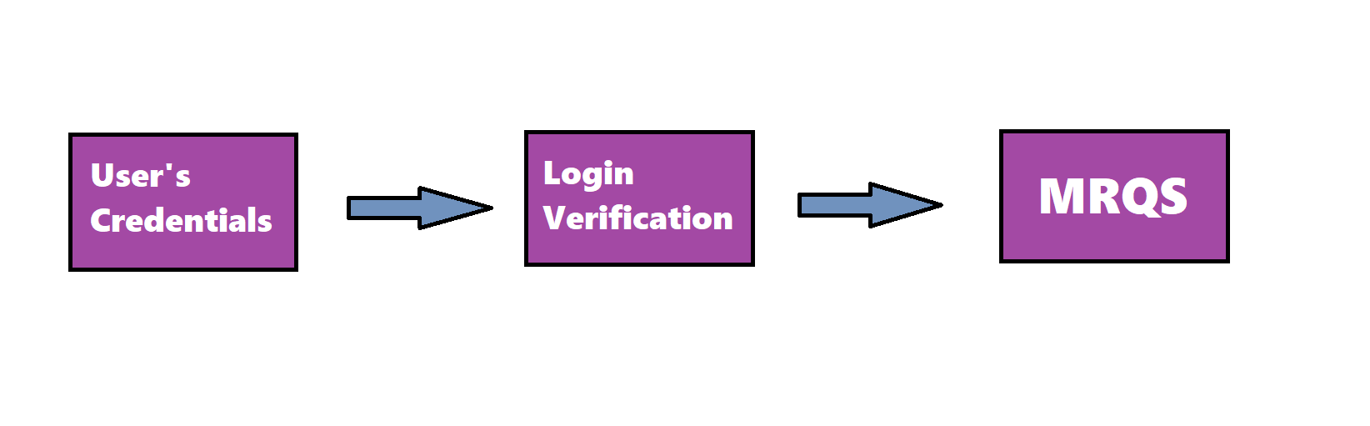
- User’s Credentials: Based on credentials, a user will either be a manager or normal user. This will determine how much access they have on the application with views and tasks.
- Login Verification: Once a user starts the application, they will automatically be logged in based on their credentials.
- MRQS: Through the use of a web application, more interfaces are available that allows for direct use and access with the application. Here, users will be able to work on tasks, go on breaks, and clock out.

3.2. Data Flow:
Here is an overview of the system, and how it connects to the application, incidentally, this is also our DFD level 1:
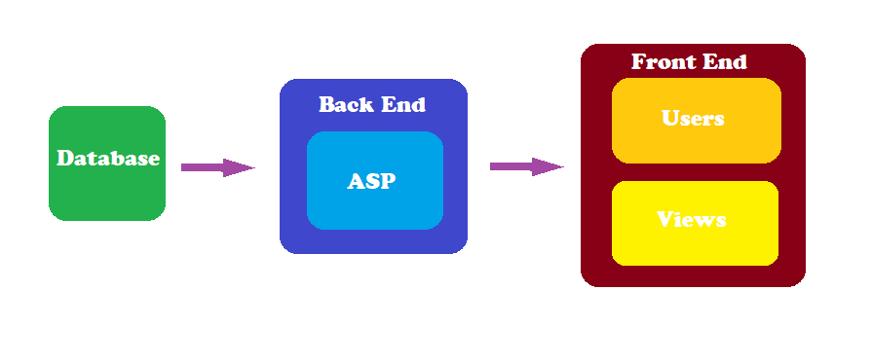
3.2.1 Database: The database is in charge of updating table information whenever a change is made.
3.2.2 Back End: The back end consists of ASP which handles the application and information that comes from the database.
3.2.3 Front End: The front end consists of users and views.This is where information from the database is displayed and users can access this through the views. Any changes made from the application will be updated in the database.

3.3. Implementation:
- MRQS will run using C# as a web application implementing the Entity Framework, ASP.Net, and MVC frameworks.
- The web application will allow authorized users //display which sorted medical records they are working on to their managers// \\to work on medical records sorted by the \\ //Sorting is handled by the // queuing system.
- Medical records will be retrieved from the SFTP server using the API provided to allow connectivity.

3.3.1 Requirements Relating to Users
1 | MRQS shall keep track of each user break, idle time, clock in time, and clock out time
2 | MRQS shall allow users to retrieve and complete tasks
3 | MRQS shall allow managers to assign tasks to users

3.3.2 Requirements Relating to Download Queue
1 | MRQS shall have the download queue retrieve reports from stored procedure
2 | MRQS shall assign a user whatever task is first in Download Queue
3 | MRQS shall provide links for users to download reports
4 | MRQS shall provide users with a download status
5 | MRQS shall notify users of download completion
6 | MRQS shall move the downloaded report to the Index Queue once a user verifies download completion

3.3.3 Requirements Relating to Index Queue
1 | MRQS shall assign a user whatever task is first in Index Queue
2 | MRQS shall allow indexers to create a special assignment(i.e. splitting a report if it is too large for one person) that will go back into the Index Queue with priority
3 | MRQS shall provide users with links to index reports

3.3.4 Requirements Relating to Activity Log
1 | MRQS shall keep track of each assignment using a log
2 | MRQS shall have the log keep track of user’s name, time started, and time completed for each task

3.3.5 Requirements Relating to History Database
1 | MRQS shall have a history database that shows the full details of each task
2 | MRQS shall allow a manager pull from the history database back into one of the queues if changes need to be made

4. Conclusions:

4.1. Results:

We have created a web application that places all existing tasks into a workflow queue and allows users to interact with the queue with actions based on their credentials. Managers can see all active tasks and are able to assign and unassign tasks. Users are able to click a button that retrieves the next task and have their page display their assigned tasks. The web application is also able to filter through the queue on the manager end, allowing search based on dates, user names, and queue steps.
We have created classes and methods that allow for easy plugging in of code for new commands based on database retrieval. The architecture of the program is split up following MVC Architecture allowing for efficient modularity. The front end design of the web application also allows for easy backend communication based on Javascript.
The database module of our app stores the downloaded data locally, and allows efficient processing of the data as needed by the application.
Finally, these parts have been brought together with an aesthetically pleasing and well designed user interface to showcase the developed technology.

4.2. Future:

While this program was created with the idea to increase productivity in QTC, the application for this project can be increased by making the design into a generic queue. The efficiency of multiple companies and workplaces can be increased by following this design that has been developed over the course of these 2 semesters. This has become a project that can reach the spans outside of QTC. However, even though there is great potential for this project, it needs to be further worked on as much time was spent on the architecture and design phase. Some of the future implementations could be:
- Real-time queues. Right now the system fetches the database and displays it as a static page. What if 10,000 workers log onto the system at the same time and all click the same task? Constant hard refreshes on a webpage would clog the network with requests and responses from the database, which is something that could be avoided with something like SignalR, also compatible with ASP.NET.
- Adding full functionality for every role and their respective webpage view for QTC. As a team we did not have enough time to fully implement the workflow queue frontend with every user view.
- Creating general purpose components for use in the Network and Database subsystems. Perhaps more stored procedures or triggers, or a more efficient way to deal with the database payloads.
- Expanding to a fully generic queue for different types of workflows.

5. References:

Visual Studio Documentation: https://docs.microsoft.com/en-us/visualstudio/?view=vs-2019

SQL Server Management Studio Documentation:
https://docs.microsoft.com/en-us/sql/ssms/sql-server-management-studio-ssms?view=sql-server-ver15

