Software Requirements Specification

For

EcoCAR2 Center Stack System
(ECSS)
Version 1.0 approved
Prepared by
Timothy Myung
Jay Chen
Richard Vu
Suren Abrahamyan
Leora Juster

CSULA EcoCAR 2
Table of Contents
Table of Contents ii
Revision History iii
1. Introduction 1
1.1 Purpose 1
1.2 Document Conventions 1
1.3 Intended Audience and Reading Suggestions 1
1.4 Product Scope 1
1.5 References 1
2. Overall Description 1
2.1 Product Perspective 1
2.2 Product Functions 2
2.3 Operating Environment 2
2.4 Design and Implementation Constraints 3
2.5 User Documentation 3
3. External Interface Requirements 3
3.1 User Interfaces 3
3.2 Hardware Interfaces 4
3.3 Software Interfaces 4
4. ECSS Requirements 5
5. Other Requirements 6
Appendix A: ACRONYMS 7

Revision History
Name | Date | Reason For Changes | Version
Leora Juster | 11/21/13 | Updated for year 3 | 1.0

Introduction

Purpose
The CSULA EcoCAR2 Team is developing a hybrid electric vehicle and will be replacing the center stack controls of the vehicle with a touch screen. For all associate Rules see the EcoCAR 2 None Year Specific (NYS) rules. The Computer Science department team will be responsible for the development of this system of the vehicle and will deliver a functional prototype version by May of 2014. This prototype will maintain all of the functions of the controls that they are replacing as well as also displaying several required diagnostic live data signals.

Document Conventions
This document follows the IEEE standard.

Intended Audience and Reading Suggestions
This document is intended for the CSULA EcoCAR 2 team management and the Senior Design Faculty associated with the project. All team members are to use the document to help keep track of the requirements developed for the project.

Product Scope
The software of this system is intended to be using the production prototype EcoCAR 2 that CSULA is developing. The system should be user friendly and work seamlessly with the existing systems that the vehicle has. By the end of this year’s work, the software should be fully functional with respect to the basic requirements stated by the NYS rules of EcoCAR 2. All of the previous functions of the Radio and Air Conditioning must be maintained. Additionally there will be a diagnostic display for the users testing the vehicle.

References
EcoCAR 2 None Year Specific Rules
EcoCAR 2 Year One Rules
EcoCAR 2 Year Two Rules

Overall Description

Product Perspective
The system will replace radio and A/C controllers from the car dashboard with a touch screen interface connected to the center stack. Also, it shall add GPS, temperature, current, and state of charge (SOC) diagnostic functions to the car display.

Product Functions
- A/C Controller buttons and functions
- Radio buttons and functions
- Diagnostic buttons and functions
- GPS buttons and functions

Operating Environment
The environment on which the software shall operate on is the QNX CAR2 platform, atop the Freescale i.MX 6 Sabre ARD board hardware.

Design and Implementation Constraints
The ECSS is designed as a direct replacement for the current center stack control buttons for the EcoCAR2 tournament car: a Chevrolet Malibu Hybrid. Also, the ECSS is charged with displaying diagnostic information of the car per the rules of the EcoCAR 2 Competition. ECSS is to run on a touch screen.
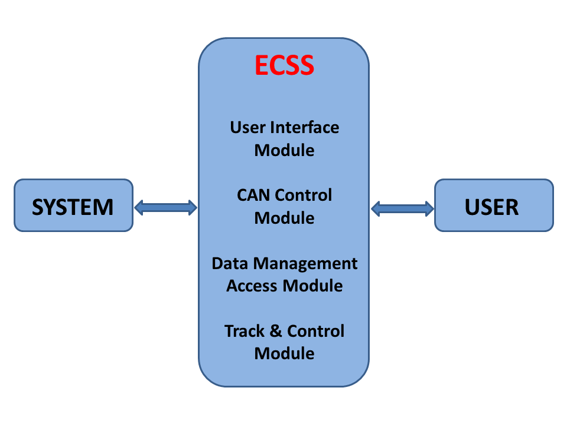

Figure - 1. DFD Level 0 for ECSS
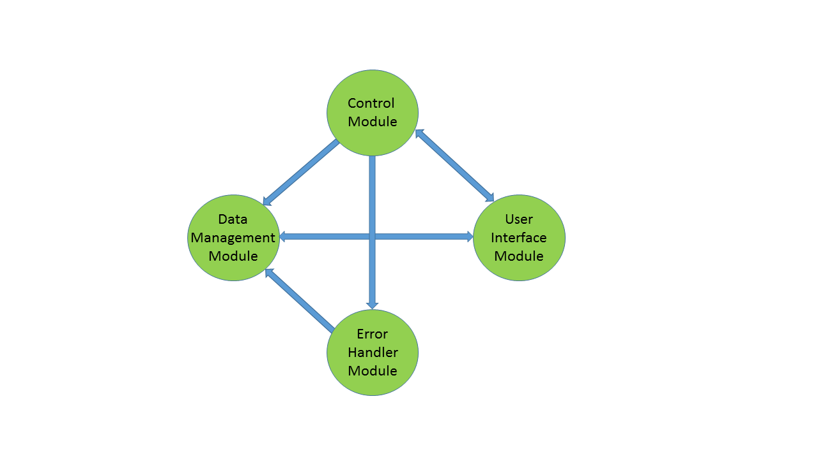
Figure - 2. DFD Level 1 for ECSS

User Documentation
On completion of the ECSS project, a quick starter guide booklet will be provided along with this report to explain basic functions to the user.

External Interface Requirements

User Interfaces

- Radio Control Screen:
  - Shall have a Radio/Band button to cycle available bands (AM, and FM)
  - Shall have a Volume +/- button so it will increase / decrease the volume
  - Shall have a Tuner/Menu button.
  - Shall have a two Seek buttons so it will seek forward and backwards.
  - Shall have a Favorite button to replace all six existing favorite station buttons.
- The climate Control Screen:
  - Shall have a Recirculation button.
  - Shall have a Fan Control button.
  - Shall have a Front/Rear Window Defogger button.
  - Shall have a SYNC function.
  - Shall have a Temperature Controls (driver/passenger) button
  - Shall have a Comfort/Eco Air Conditioning button
  - Shall have an Air Delivery Modes buttons

- Diagnostic Screen:
  - Shall have a Temperature functions
  - Shall have a Current functions
  - Shall have a state of charge or (SOC) functions

Hardware Interfaces
- System Shall have a minimum of two CAN Chanel interfaces
  - Shall have a Low Speed (250kbs) CAN Chanel interface
  - Shall have a High Speed (500kbs) CAN Chanel interface
- LCD touch screen interface for the user
- Freescale i.MX 6 boards Sabre ARD.

Software Interfaces
Using the touch screen, the user will be able to access the system via widgets or apps including diagnostics information, Radio, and Climate Control.

ECSS Requirements

Table 1. Requirements Related to Design Module 2.2: User Interface Module (UIM)
Requirement No. | Requirement Description
4.1-1 | UIM shall be a multi touch screen interface.
4.1-2 | UIM shall provide the necessary controls for Radio control via Radio Sub Module (RSM)
4.1-3 | UIM shall provide the necessary controls for Climate control via the Climate Control Sub Module (CCSM)
4.1-4 | UIM shall provide a means of displaying the RSM.
4.1-5 | UIM shall provide a means of displaying the Diagnostic Sub Module (DSM)
4.1-6 | UIM shall provide a means of displaying the CCSM
4.1-7 | UIM shall provide a means of displaying any other sub module.
4.1-8 | UIM shall display the current time.
4.1-9 | UIM shall display the current date.
4.1-10 | UIM shall provide a means of increase volume.
4.1-11 | UIM shall provide a means of decrease volume.
4.1-12 | UIM shall provide a means of muting volume.
4.1-13 | UIM shall display error messages received from Tracking & Control Module (TCM)
4.1-14 | UIM shall throw all exceptions to TCM
 | Radio Sub Module (RSM)
4.1-15 | RSM shall provide a means of increase volume.
4.1-16 | RSM shall provide a means of decrease volume.
4.1-17 | RSM shall provide a means of cycle through AM/FM.
4.1-18 | RSM shall provide a means of switching to AUX mode via an AUX button
4.1-19 | RSM shall provide a means of increasing volume.
4.1-20 | RSM shall provide a means of decreasing volume.
4.1-21 | RSM shall provide a means of cycling through Tuner/Menu
4.1-22 | RSM shall provide a means of displaying radio information via an info button
4.1-23 | RSM shall provide a means of seeking forward and backwards via two Seek buttons
4.1-24 | RSM shall provide a means of cycling through 6 preselected favorite stations via a favorite’s button.
 | Diagnostic Sub module (DSM)
4.1-25 | DSM shall display the temperature
4.1-26 | DSM shall display the state of charge
4.1-27 | DSM shall state the current
4.1-28 | DSM shall send commands to the control module in order to receive the temperature
4.1-29 | DSM shall send commands to the control module in order to receive the state of charge
4.1-30 | DSM shall send commands to the control module in order to receive the current
 | Climate Control Sub Module (CCSM)
4.1-31 | CCSM shall provide a means of adjusting Driver-side heated seats.
4.1-32 | CCSM shall provide a means of adjusting Passenger-side heated seats.
4.1-33 | CCSM shall provide a means of toggling Recirculation.
4.1-34 | CCSM shall provide a method for user Fan Control.
4.1-35 | CCSM shall provide a means of toggling the Front Window Defogger function
4.1-36 | CCSM shall provide a means of toggling the Rear Window Defogger function
4.1-37 | CCSM shall provide a means to synchronize climate settings on both Driver’s and Passenger side.
4.1-38 | CCSM shall provide a means of adjusting Driver side temperature
4.1-39 | CCSM shall provide a means of adjusting Passenger side temperature
4.1-40 | CCSM shall provide a means of toggling Comfort/Eco Air Conditioning mode
4.1-41 | CCSM shall provide all the necessary controls for the different Air Delivery Modes functions

Table 2. Requirements Related to Design Module 2.4: Data Management Access (DMA)
Requirement No. | Requirement Description
4.2-1 | DMA shall query database for activity log storage and retrieval.
4.2-2 | DMA shall receive Can signal data from the control module for storage in the CAN Signal Log (CSL).
4.2-3 | DMA shall receive requests from the UIM to consult the requested database and forward the results back.
4.2-4 | DMA shall receive requests from the UIM to query the requested database and forward the results back.
4.2-5 | DMA shall receive errors from the TCM to store into Error Log Database (ELDB).
Table 3. Requirements Related to Design Module 2.3: CAN Control Module (CCM)
Requirement No. | Requirement Description
4.3-1 | CCM shall receive all necessary CAN signals from the CAN Bus.
4.3-2 | CCM shall send all necessary CAN signals to the CAN Bus.
4.3-3 | CCM shall convert all necessary incoming CAN Bus binary data into decimal.
4.3-4 | CCM shall convert all necessary incoming CAN Bus binary data into hexadecimal
4.3-5 | CCM shall process incoming commands from UIM in order to emit the appropriate CAN signal.
4.3-6 | CCM shall receive command from the UIM.
4.3-7 | CCM shall throw all exceptions to the Tracking & Control module.
4.3-8 | CCM shall send converted CAN signal data the UIM.

Table 4. Requirements Related to Design Module 2.5: Tracking & Control Module (TCM)
Requirement No. | Requirement Description
4.4-1 | TCM shall handle all exceptions and errors from CCM.
4.4-2 | TCM shall handle all exceptions and errors from UIM.
4.4-3 | TCM shall handle all exceptions and errors from DMA.
4.4-4 | TCM shall report high priority errors to the UIM to alarm the user.

Other Requirements
No additional requirements are given to the team until the year 2013.

Appendix A: Glossary

CAN | Controller Area Network
CCM | CAN Control Module
CCSM | Climate Control Sub Module
CSL | CAN Signal Log. Logs of important CAN signal activity.
DMA | Data Management Access
DSM | Diagnostics Sub Module
ECSS | EcoCAR2 Center Stack System
ELDB | Error Log Database. Database for storing errors encountered in run-time
IEEE | Institute of Electrical and Electronics Engineers
NYS | None-Year-Specific
QR
RSM | Radio Sub Module
SOC | State of Charge
TCM | Tracking & Control Module
UIM | User Interface Sub Module

