Automated Test Framework
For the Boeing 702SP Satellite
(ATF)

CS496 Senior Design
Report

Prepared by
Bryan Pham
Loran Briggs
Guillermo Cervantes
Carlos Manzano
Mark Sargent

May 30, 2014

Table of Contents

Section 1: Executive Summary
Section 2: Introduction
Section 3: User Guide
3.1 Prerequisites
3.2 Installation
3.3 Using ATF
Section 4: Architecture and Design
Figure 4.1 ATF Architecture
4.2 User Interface
Section 5: Conclusion

Section 1: Executive Summary
Our client is Boeing Corporation, the world's largest aerospace company and leading manufacturer of commercial jetliners and military aircraft combined. The Automated Test Framework is a software designed for the Boeing 702SP Satellite that aims to save the company’s time and resources spent on system testing.
Currently, a large portion of the time and resources are spent on software testing for the 702Sp Satellite and could be allocated for better use. The current test procedures involves manually running the software which has limited user interaction over the course of hours to days. The large amount of idle time that requires an engineer to be present is costly. The goal of this project is to remedy this lengthy idle situation is to automate wherever possible, which will allow for integration testing concurrent to ongoing development.
The software will allow engineers to send Tcl (Tool Command Language) Scripts to the Test Developer (TD). The TD is a specialized function of the software that handles the input of Tcl Scripts, parses the Tcl Scripts into a set of commands that will be translated into a Parse Tree. This will allow the operator/engineer to manually select any number of paths from within the Parse Tree, in order to create test cases for the second function of the software known as the Test Executive (TE). The TE will ingest the test cases from the TD which are saved as JSON Files. The TE will allow the operator/engineer to decide the different scenarios and test cases from a user interface which would then be executed on an automation software known as Sikuli. The Sikuli will interact both satellite simulators known as the ASCS (Advanced Satellite Control System) and the DSS (Dynamic Satellite Simulator).
Our team has been able to complete all the functional requirements of the TD side of the project. The functional requirement includes everything that is listed above.
On the TD, our team was able to take development to another level by implementing the high-level functions, offering the operator/engineer the option to breakdown the test cases, creating the option to print all the test cases as individual test cases, printing out a PDF version of the test cases and providing scalability functionality to allow the operator/engineer to zoom in and out of the image.
As for the Test Executive side of our project, we were able to create a program that parses JSON and can set up the ASCS into its testing environment. The TE also logs errors and take screenshots of such errors. Because of some setbacks: limited access to a functional test lab, hardware changes, and limited documentation of Sikuli, our team was unable to complete the TE. But were able to research and plan for future development.
Our customer still needs our development team to reach a finite state in which the Test Developer will be able to ingest any TCL Scripts, and define all the grammar within the scripts without a single error. Another need is to add more functionality to the Test Developer’s User interface to give the operator/engineer more tools to allow them to customize the test cases to better analyzed the paths in which they want to execute on the Test Developer. The Boeing Corporationn would want our Test Executive to be able to automate the test cases on the ASCS/DSS virtual environments, record any errors that might have occurred during the execution, and reach their ultimate goal of creating a fully automated software.

Section 2: Introduction
The Automated Test Framework Report begins with the scope of the project, which will give the user an insight of the project’s goals and what the development strives to achieve.
The report provides the architecture of the Automated Test Framework Project to help the reader understand how data is being manipulated throughout the software, the information that needs to be extracted and the expected output of the project. The report also lists the functional requirements of both the Test Developer and Test Executive to illustrate a detail flow process of all the activities within the software.
Towards the end of the report, the user can view what was accomplished and tested during the team’s software development process and the report provides all the abbreviated acronyms listed throughout the report. This report aims to give the user a clear idea of all the ideas, thoughts, and functions during the development process.

Section 3: User Guide

3.1 Prerequisites
The host machine should have the following software installed:
- Java Running Environment (JRE) version 6 and above which is cross-platform. The location of the library must be added to the system PATH variable.
- PDF reader.
- Image viewer

3.2 Installation
The ATF software is a Java Project that is delivered packaged as a Java Archive (JAR) file which is based on ZIP file format. This format is cross-platform compatible.
- On Microsoft Windows systems, the Java 2 Run-time Environment's installation program will register a default association for JAR files so that double-clicking a JAR file will automatically run it with the executable "javaw.exe" that comes bundled with the JRE. In case it does not run all you need to do is set the default program to open it.
- On Linux/UNIX/Solaris based systems the JAR file should be executed via command line by invoking java -jar TestDeveloper.jar.

3.3 Using ATF
ATF has a Graphical User Interface (GUI). The entry point is a tabbed pane (Fig 1) window containing three tabs, the first two are part of the Test Developer module and the last is part of the Test Executive module: using the software includes the following steps
- Parse Script
- Build Batch Case
- Test Executive
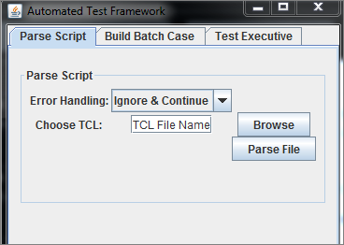
Fig 1: Tabbed Pane

Test Developer (TD)
In the Parse Script tab the test engineer chooses a TCL procedure (Figure 2) to generate an interactive graphical representation of the different test cases.
Click on and choose your file. Then click on

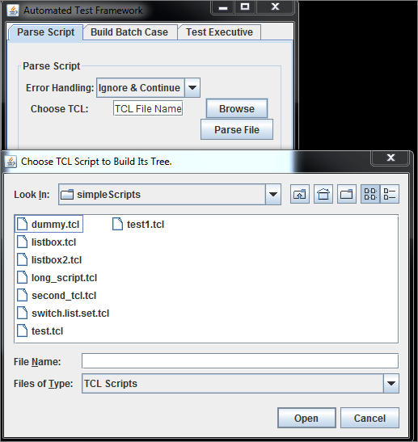
Figure 2: Choosing Tcl procedure

The tree is displayed in the Graph window (Figure 3) and list all possible case of a branch. We will refer to branch or case intermittently.
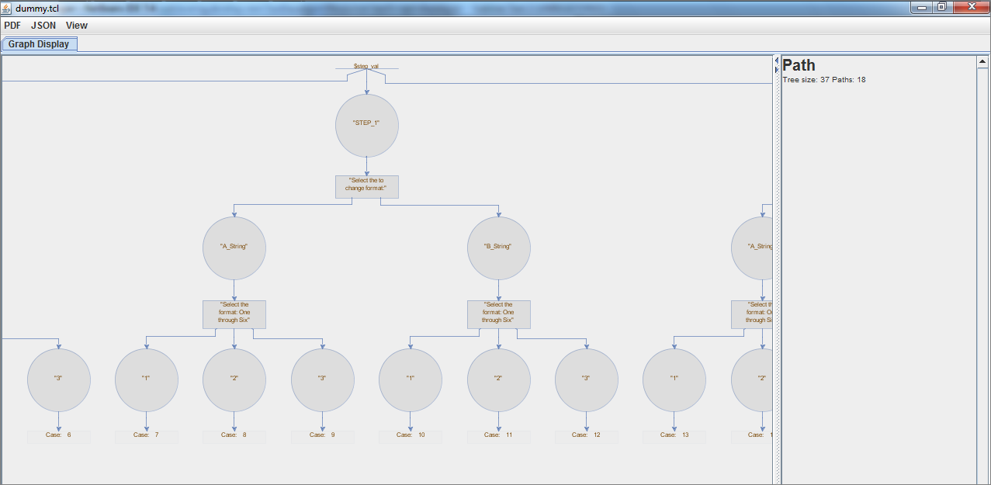
Figure 3: Graph Window

In order to select a case, the engineer will click on its last node. A branch is highlighted, a new tab is added displaying the selected case and the list of node values is displayed on the right pane of the Graph window.
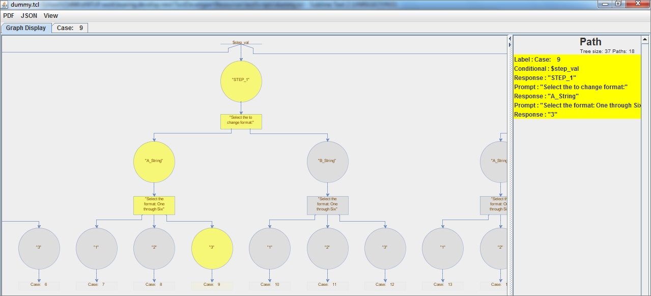
Figure 4: Branch Chosen
Let’s look at the menu options.
- Clicking on -> [Print] item will produce a .pdf document with an embedded image of the Tree in the selected tab.
- Clicking on item offers options to [zoom in] or [zoom out] into the graph, or [Clear] the selected cases.
- Clicking on item offers you two options to convert just the selected [case] or [all] the cases into a JSON file which encodes the action that would perform the test. A pop up window will allow the engineer to select will the DSS Scenario. (Figure 5), select your option.
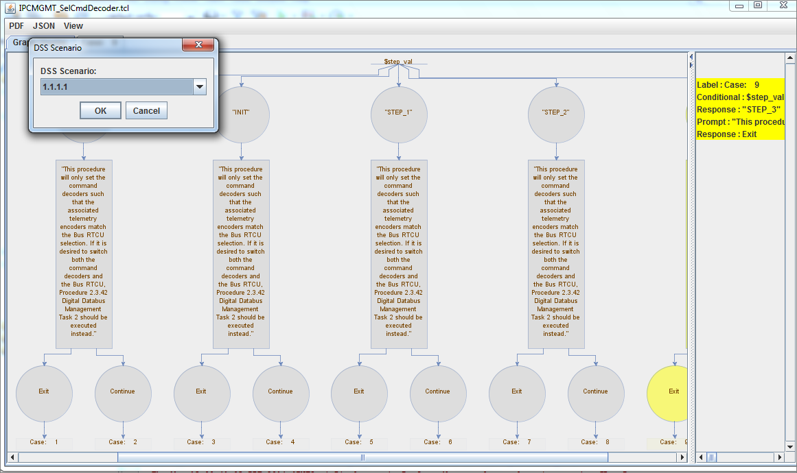
Figure 5: Choose DSS Scenario
Now click to generate the JSON case-file. A file picker will pop up and allow the engineer to choose the location to save your file. It is recommended that you keep the default file name for ease of traceability, the naming syntax is (Tcl_File_Name.Case_No.json). The JSON file (Figure 6) is saved in a JSON library.
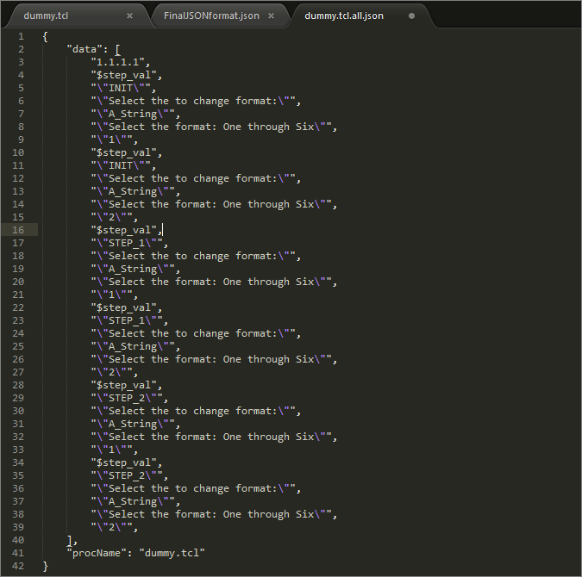
Figure 6: JSON File

Build Batch Case
To be developed.

Test Executive (TE)
The Test Executive (TE), the last tab of the tabbed pane will have two main options, “Browse” and “Run Case”. Browse will select a JSON file as a test case to run.
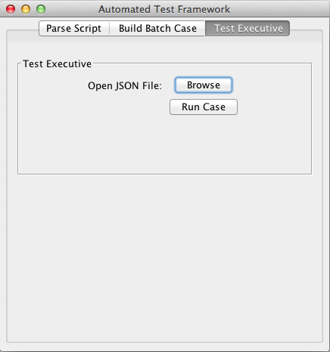
Figure 7: Selecting test case to run

There are a series of procedures before the TE can execute the test case. It must first initialize ACSC into the proper configuration. Once configured, it will parse the JSON into a list of procedures ready for execution. For each task, it will create an image that represents the text Sikuli must search for. The Sikuli library searches for that images and executes the required clicks/keyboard inputs. After completing each task it will log to the proper log file. If an error occurred, the Sikuli library will take a screenshot of the error and also log it. This log file is an HTML file that will allow to embed links to the screenshots.
If all the series of sequences properly executes, then the ASCS will run in the background executed by the Sikulli library. The result will allow the test engineer to return to a completed test case, that will confirm the proper Tcl script originally selected; verifying that it is correct and working as expected. If not things do not go as plain the test engineer will then know where to inspect the code in order to debug.

Section 4: Architecture and Design

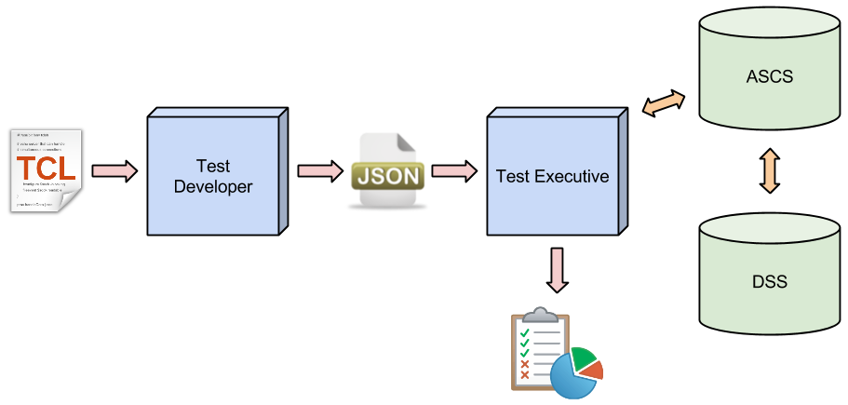
4.1 Design
The software is written in the Java programming language, which has all the tools required to automate the testing of software. Traditionally, an engineer is required to remain at their workstation to interact with the GUI (ASCS) that controls the 702 SP Satellite by responding to prompts from a list of commands encapsulated in a Tcl script. Please note that each combination of different interactions is also a test case. The ATF replaces the engineer, thus saving engineering time and costs, and optimizing testing of software.

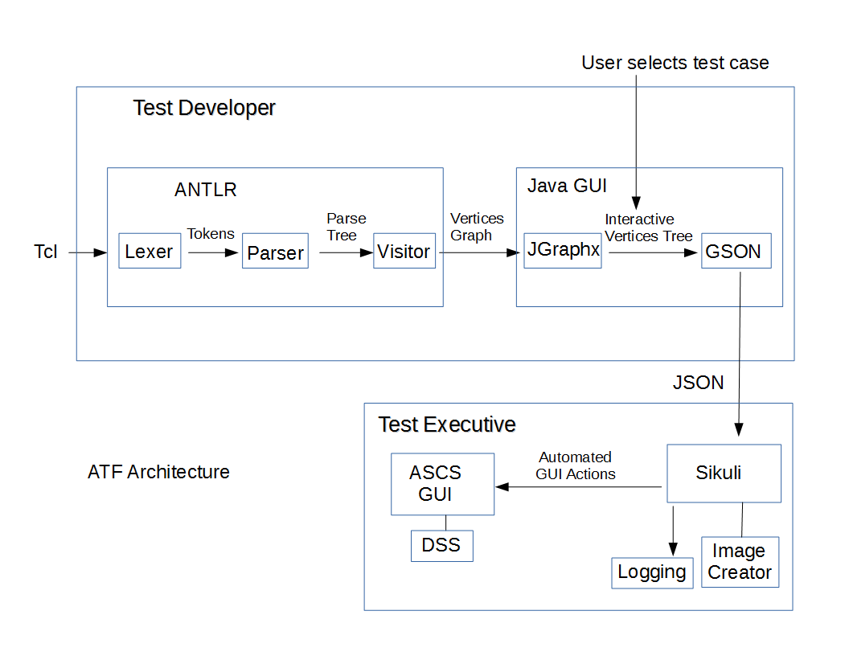
4. 2 Architecture
The automated testing software system, ATF, consists of three components. The first component is the Test Developer, which is a language application that parses a Tcl script into an interactive parse tree and list all of the possible test cases that offers users an interface to generate a translation of test cases to JSON objects. The object is the interface that allows communication between the Test Developer and the Test Executive. The second component is the Build Batch Case that provides an interface to link cases from different Tcl scripts. The third component, the Test Executive is a visual scripting application that automates interactions with the GUI elements of the satellite control software.
4.3 Test Developer Module
This application is a build with an intergration of ANTLR API. ANTLR is a tool to build language applications. First we define a grammar derived from samples of the language, Tcl scripts. Then the tool converts the grammar into programs and classes that recognize sentences in the language described by the grammar. These classes are CharStream, Lexer, Token, Parser, and ParseTree. The lexer processes characters into tokens (words or symbols) and passes them to the parser that checks syntax and creates a parse tree. ANTRL generates a parse-tree listener which we use to during the parse to build a graph. Then with the aid of JGraphx API we build an interactive UI graph where each branch is a test case. Each branch has a clickable action that in turn translates it into a JSON object representation using GSON API. Finally the JSON object is made available to the Test Executive module. All activies and errors are logged into in XML format (This will be done in HTML format on later development).

4.3.1 ANTLR
Grammar is a set of rules and each expression is the structure of a phrase. ANTLRWorks is an IDE that was used to create and edit the grammar. ANTLRWorks takes a Tcl script and parses it based on the grammar that we defined. When you input the Tcl script into ANTLRWorks and run it, the grammar generates tokens along with all the info for that token (e.g. token type, the text of the token, etc.). It also generates a parse tree of all the tokens.
- Parser rules contain one or more parser or combined grammar rules. Parser rules begin with a lowercase letter. Alternative rules are allowed and are separated by the vertical bar key or “pipe” key. Alternative rules that are surrounded by other parser/lexer rules are wrapped in parentheses. In the example below, setLocalVariable is the parser rule, and this example states that either conditionalTest or lrvVariable can follow localVariable.
setLocalVariable
: SET localVariable ( conditionalTest | lrvVariable )
;
- Lexer rules specify token definitions and more or less follow the syntax of parser rules except that lexer rules cannot have arguments, return values, or local variables. Lexer rules begin with a capital letter. In the example below, LISTBOX is an example of a literal lexer rule.
LISTBOX: ‘listbox’;
- Keywords: Something to look out for is the use of keywords in programming languages (e.g. if, else, for, etc.) and how to treat them. There are two options: the first option is to define them as we did with the LISTBOX literal lexer rule in the above example; the second option is to put the keyword ‘listbox’ in the parser rule itself.
- Another feature that was used in ANTLR were labels. Labels are defined using the # symbol:
userPrompt
: ASK askType askVar promptText (ID | STRING | OPT | header)+ # ask
;
ANTLR generates a visitor interface with a method for each labeled alternative name. This allows our java classes in the GUI to access these labels, thus extracting the prompts and responses that are displayed in the GUI interactive tree.

4.3.2 JGraphx
JGraphx is a Java library that provides visualisation and interaction with node-edge graphs. We use it to build an interactive graphical representation of a Tcl structure as a Tree. We simply pass to the library the graph built by ANTLR, define styles to draw the interactive UI and plugin the actions to its nodes. The implementation is done in class Display.drawTree(Vertex root, Object p, final mxGraph graph, int[] paths, Object parent, int posX, int posY, int nSize, int mode).

4.3.3 GSON
Gson is a Google Java library that we use to convert the Vertex Graph or a branch into its JSON representation. The implementation is done in class Display.writeJSONFile(Component c, String path, List<Vertex> procs) where the Component c is the client to open the file saver, and the path is the full path and name of the file to save, and the List<Vertex> is the java object to convert to JSON representation. One only needs to give pass this object as parameter to GSON.

4.3.4 Logging
We use java.util.logging.Logger to record activities and errors during testing. The logger is configured at application level for ease of configuration by defining the configuration loggin.properites file location in app.TclApplication class as follows:
System.setProperty("java.util.logging.config.file",".".concat(File.separator).concat("logging.properties"));
The configuration of the logger should be updated to HTML format per Boeing requirement.
4.3.5 GUI
The graphic interface is completely built with Swing library. The tabbed panel uses frames (JFrame), embedded panes (JPane) to define the three panes: Parse Script, Build Batch Case and Test Executive. JDialog are use to collect single items from the user and keep a modal object while choosing the item to prevent the user from taken another action. We use JFileChooser to browse and select either Tcl scripts to parse, or JSON files to build batch cases or choose a case to run with the Test Executive. Finally we use JGraphx to generate the interactive tree.
4.3.6 PDF Generation
We use iText library to create an image of the Tcl parse tree or a case to later embed ina PDF document. This tool is not fully functional only the image is working at the writing of this document.
4.4 Batch Process Module
This module will offer an interface to users to choose test cases in their JSON representation to build a batch process by selecting a set of cases that will be executed by the Test Developer in sequence of Tcl procedures. The user may define global instructions such as configuring the DSS scenario
4.5. Test Executive Module
Test Executive is a visual scripting application that automates interactions with the GUI elements of the satellite control software.
4.5.1 Sikuli
Sikuli automates anything you see on the screen. It uses image recognition to identify and control GUI components. It is useful when there is no easy access to a GUI's internal or source code.

4.5.2 Image Creator
The image creator uses the pillow python library to generate text into images. The engineer can use the image font type along with the color of the image’s background.

4.5.3 Logging
The logging functionality will export a log text file of any errors that might occur during the operations. It will also pin point the exact location of the error to allow the engineer to properly debug the problem.

Section 5: Conclusion
Development of the Automated Test Framework was a challenging and insightful journey into industry life. Our team has learned how to deal with clients, customers, team management, setbacks, limited resources, and most importantly with cooperation among each other. As a team we have a better understanding how to to parse information, definite grammars, creating GUI and it’s functionality options and used some of the tools used in the industry. We have come together to develop a product that is sustainable for future development. Our biggest success is our Test Developer because it meets all the functional requirements that we set out to do. The communication with our liaisons at the very beginning was extremely hard to grasp but we managed to all get on the same page and complete what needs to be done.
Our biggest setback however is the Test Executive. There were a good amount of hardware issue and approval with this portion of the project that made it difficult to further our development on this section. However, this pushed our team to become more creative and seek alternate solutions to the problem. Thankfully, we have brilliant software engineers on the team that suggested that further development on our personal computers and transfer them on the specialized computer.
Given the circumstances, our team has succeeded with the project. If the project were to continue for the future, the changes and suggestion is to give our team a trustworthy environment for the Test Executive side and allow our team not to be distracted from hitting our functional requirements for both aspect of the software.

Section 6: Resources
- ANTLR Parser generator
- ANTLRWorks Grammar tool
- JGraphX Java Swing diagramming tool
- Sikuli visual scripting tool
- iText 5.5.0 Programmable PDF Software
- GSON convert Java object into JSON data objects
- The ATF code and code documentation is Boeing proprietary

