Automated Test Framework
(ATF)
For the Boeing 702SP Spacecraft

CS 496 Software Development

Functional Requirements and Design Document

Prepared by:

Bryan Pham
Carlos Manzanos
Guillermo Cervantes
Loran Briggs
Mark Sargent

Advisor: Dr. Abbott

Liaisons:

Sen Yao
Franz Kerekes
Brian Jennings

May 30, 2014

Automated Test Framework
(ATF)

Prepared By:

Bryan Pham
Carlos Manzano
Guillermo Cervantes
Loran Briggs
Mark Sargent

Advisor: Dr. Abbott

Liaisons:

Sen Yao
Franz Kerekes
Brian Jennings

Approved By:

__________________ ___05/30/2014______
Who this may concern Date

Document Change Log

Update | Date Released | Changes
Draft #1 | 11/6/2013 | First Draft (Draft plan wasn’t a real draft plan)
Draft#2 | 11/7/2013 | Added architecture, description of the architecture, modules, requirements for the modules, first sprint schedule and the member’s entire task.
Draft#3 | 12/5/2013 | Revised Architecture
Draft#4 | 2/20/2014 | Added contents relating to both the Test Developer and Test Executive side. Cleared up any confusion regarding the Test Executive architecture.
Final |  | Delivery version

Table of Contents
 |  | Page
1.0 | Introduction | 5
1.1 | Purpose | 5
1.2 | Module Descriptions | 5
1.2.1 | Test Developer Overview | 5
1.2.2 | Test Executive Overview | 5
1.3 | ATF's Context Diagram (Level 0) | 6
1.4 | Hardware Overview | 6
2.0 | ATF Requirements | 7
3.0 | Detailed Function Description of ATF | 7
3.1 | Test Developer Details | 7

0.0 Pre-Installation Guide:

Description/Overview
The technology we used to parse Boeing Generated Tcl (generally pronounced “tickle”) scripts is ANTLR. ANTLR is a powerful and flexible tool for parsing formal languages. You can either create a .g4 file in a text editor and use command-line (shell) to run your grammar file, or you can download ANTLRWorks2. Our grammar was built/edited using the latter, but once built, we used the command-line to walk the tree looking for the rules we defined. If you wish to use command-line, instructions on how to do so can be found in the links provided under “References”.
ANTLRWorks2 is an IDE we used to create/edit the grammar. ANTLRWorks2 takes an input file and parses it based on the grammar we created. When you input the file to ANTLRWorks2, the grammar generates tokens along with all the info for that token (e.g. token type, the text of the token, etc.). It also generates a parse tree of all the tokens.
One of the ways we differentiate parser rules and lexer rules in our grammar is that parser rules begin with a lower case letter and lexer rules begin with an upper case letter.
One example of a lexer rule is:
INT: [0-9]+;
This basically says that INT can be defined as any single integer, or multiple integers in any order (e.g. 75649).
One example of a parser rule is:
setVariable : SET variableName ( STRING | INT );
- setVariable is the name of the parser rule
- SET is a lexer rule defined later in the grammar to represent the word "set"
- variableName is another parser rule
- STRING is a lexer rule that represents any string (any characters or integers or a combination of both, inside a pair of quotation marks)
- INT (see lexer rule from above)
Parser rules may also have alternative rules that are separated by the vertical bar key, or "pipe" key.
Something to look out for is the use of keywords for certain languages (in our case, Tcl) and how to treat them as identifiers. For example, including ‘if’ or ‘else’ in a parser rule, prompts an error. What you need to do is define “if” and “else” as lexers, as such:
parserRule : IF ‘{‘ conditional ‘}’ statement ELSE ‘{‘ statement ‘}’;
IF : ‘if’;
ELSE : ‘else’;
With “conditional” and “statement” being previously defined parser rules.

Functional Requirements
- The parser shall take as input a .tcl script
- The parser shall interpret the .tcl script and parse the script into different tokens based on the rules of the grammar
- The parser, through ANTLR, shall generate lots of other .java and .tokens files
- The parser shall allow the user to define certain parser rules so that ANTLR’s built-in tree-walker can trigger those definitions and create methods inside a Java class
- The parser shall output to the user a list of the tokens and/or a parse tree of those tokens

References
- https://github.com/antlr/antlr4
- http://www.antlr.org/
- Book: “The Definitive ANTLR 4 Experience” by Terence Parr

Acronyms
- Tcl Tool Command Language (file extension - .tcl)
- ANTLR ANother Tool for Language Recognition (file extension - .g4)
- IDE Integrated Development Environment

1.0 INTRODUCTION

1.1 Purpose

The scope of the project includes building a test framework for the Boeing 702SP Satellite. The spacecraft uses a programming scripting language called TCL to communicate with the local computers. The ASCS, which is a proprietary software that sends commands to the spacecraft through TCL Scripts.

The project examines the connection between the ASCS and the Satellite through a simulation set by the DSS. Manually testing the scripts is a long mundane process. The goals of the test framework aims to automate this testing process, which enables tests to be executed.

1.2 Module Descriptions

To accomplish this task we have split the project into two modules:

1.2.1 Test Developer (TD)

The purpose of the Test Developer is to create test cases for the test framework. The GUI functionality of the Test Developer provides the operator/user with a Java Tree that allows the operator/user the option to manually select which path they want. Once the path is selected, the path will be highlighted, tracing back to the root of the Java Tree. The selected path will be displayed on the right hand side of the GUI, allowing the operator to create multiple test cases during one session. Once the test cases are completed, the GUI provides an option to export the test cases into JSON Files.

1.2.2 Test Executive (TE)

The Test Executive will take JSON Files as input and automate the testing process on the ASCS. The Test Executive provides an option for the test engineer to select JSON Files to be simulated on the ASCS. The software will being the automation process by starting the ASCS and configures the environment to an appropriate starting state. The Test Executive will generate a list of error logs during the execution process.

1.3 ATF's Detailed Context Diagram (DFD Level 0)

ATF’s modules, Test Developer and Test Executive are summarized in the Detailed Context Diagram (DFD Level 0) given below. A more detailed Functional Description of the modules is given in Section 2 of this document.
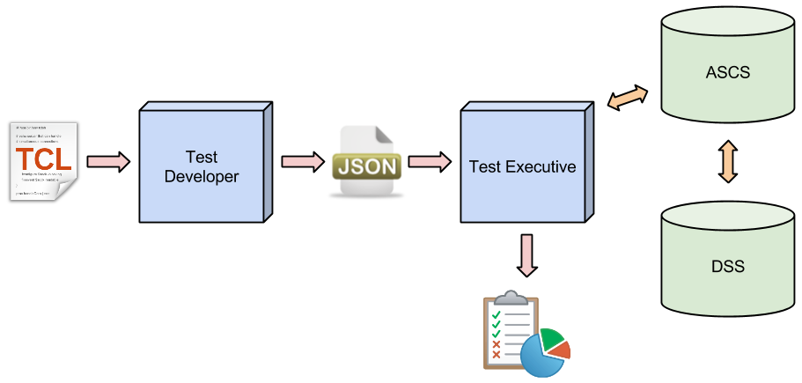
Figure 1-1: Level 0 DFD

1.4 Hardware Description Of the ATF

The ATF's software will require at least two Java Virtual Machines or two physical devices. The ASCS and the DSS must be placed on different JVMs or two device, they can’t be placed on a single operating system.

The architecture will allow the Test Executive to be running on the same environment as the ASCS machine. The Test Executive will be interacting with the ASCS on the same environment.

The Test Developer could be run on any physical devices or JVMs.

Add additional information as needed

2.0 ATF FUNTIONAL REQUIREMENTS

This section includes the complete set of functional requirements for the ATF modules. All requirements relate to the design modules out lined in Section 1.

Requirements Related to Module 1: Test Developer (TD)
2.1.1 | TD shall receive TCL Scripts from file picker.
2.1.2 | TD shall traverse entire file
2.1.3 | TD shall detect logical forks
2.1.4 | TD shall create a data structure for each type of fork
2.1.5 | TD shall create a data structure (tree) to represent entire file
2.1.6 | TD shall display this tree to the user
2.1.7 | TD shall allow the user to zoom in and out
2.1.8 | TD shall allow user to save tree as image
2.1.9 | TD shall allow user to select paths through tree
2.1.10 | TD shall highlight selected path
2.1.11 | TD shall display a text summary of selected path
2.1.12 | TD shall allow user to select multiple paths
2.1.13 | TD shall allow user to select all paths
2.1.14 | TD shall generate JSON representation for each path

Requirements Related to Module 2: Test Executive (TE)
2.2.1 | TE shall receive the JSON Files from file picker
2.2.2 | TE shall allow user to pick single or multiple test cases
2.2.3 | TE shall start ASCS to required state for test
2.2.4 | TE shall parse commands from JSON files
2.2.5 | TE shall execute commands on the ASCS
2.2.6 | TE shall record any errors accursing during execution
2.2.7 | TE shall generate a report
3.0 Detailed Function Description of ATF

This section will break down the main modules outlined in Section 1 into detailed sub modules to address the requirements outlined in Section 2.

2.1 Test Developer Description

The Test Developer will be split into two sub modules, the Parser and the Graphical User Interface (GUI).

2.1.1 Parser Submodule

The Parser submodule will be responsible for parsing the TCL scripts. To parse TCL we enlisted the help of the ANTLR tool. ANTLR is a powerful and flexible tool for defining and parsing formal languages. We define the TCL language separately from the parser using the ANTLRWORKS2 IDE. Then, once the language is defined we use the ANTLR tool to generate Java classes to parse the TCL script.

Basically, we define a grammar rule and a Java method that is executed each time the parser comes across our grammar rule. We used this process to generate a data structure that is similar to a doubly-linked list which we call the tree. This tree is then used in the GUI submodle.

2.1.2 Graphical User Interface

6.0 BSD TEST PLAN

6.1 INTRODUCTION
In this section the testing methodology to be used to V&V each of the requirements listed in section 3.0 has been identified. At points some additional testing may be required and they shall be documented as an attachment to this document.

The methodologies and testing strategies identified at this point include three major approaches with various variations to adapt to the BSD project:
- Testing using additional ad-hoc created software including a correlation-testing unit.
- Demonstration of the specified capability
- Inspection of the software code possibly using additional inspection techniques

6.2 FUNCTIONAL REQUIREMENTS VALIDATION MATRIX

BSD ' Functional and Performance Requirements Validation Matrix is given below.

Requirements Related to Module 1: Test Developer (TD)
Requirement No. | Requirement Description | Testing Methodology
2.1.1 | TD shall receive TCL Scripts from file picker. | Demonstration
2.1.2 | TD shall traverse entire file | Demonstration
2.1.3 | TD shall detect logical forks | Demonstration
2.1.4 | TD shall create a data structure for each type of fork | Demonstration
2.1.5 | TD shall create a data structure (tree) to represent entire file | Demonstration
2.1.6 | TD shall display this tree to the user | Demonstration
2.1.7 | TD shall allow the user to zoom in and out | Demonstration
2.1.8 | TD shall allow user to save tree as image | Demonstration
2.1.9 | TD shall allow user to select paths through tree | Demonstration
2.1.10 | TD shall highlight selected path | Demonstration
2.1.11 | TD shall display a text summary of selected path | Demonstration
2.1.12 | TD shall allow user to select multiple paths | Demonstration
2.1.13 | TD shall allow user to select all paths | Demonstration
2.1.14 | TD shall generate JSON representation for each path | Demonstration

Requirements Related to Module 2: Test Executive (TE)
Requirement No. | Requirement Description | Testing Methodology
2.2.1 | TE shall receive the JSON Files from file picker | In Progress
2.2.2 | TE shall allow user to pick single or multiple test cases | In Progress
2.2.3 | TE shall start ASCS to required state for test | In Progress
2.2.4 | TE shall parse commands from JSON files | In Progress
2.2.5 | TE shall execute commands on the ASCS | In Progress
2.2.6 | TE shall record any errors accursing during execution | In Progress
2.2.7 | TE shall generate a report | In Progress

A. ACRONYMS

ASCS – Proprietary Software that simulates a Boeing Satellite.
DSS - Proprietary Software that simulates a Boeing Satellite.
TD – Test Developer
TE – Test Executive
JVM – Java Virtual Machine

